Student Name: Abdulrahman Alhariri
Student ID: C2644873

Project Title: Predicting Incident Severity Using Random Forest

Table of Contents
- Introduction
- Data Preprocessing and Exploration
- Model Implementation
- Results
- Conclusion
- Code and Experiment Screenshots

1. Introduction
This project focuses on predicting the severity of gun violence incidents using machine learning techniques, specifically a Random Forest model. The dataset contains features such as state, number of guns involved, and incident severity.

2. Data Preprocessing
step 1: Load Libraries & Data
- Libraries Used:
  - Load necessary libraries for data manipulation and machine learning.
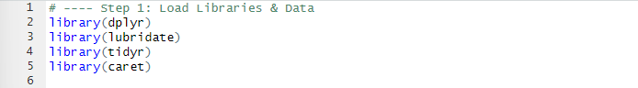
- Data Loading:
- Reads the dataset from the specified path.
Step 2: Preprocess Data
- Convert Date Column:
Converts the date column to a Date object for easier handling.

- Handle Missing Values:
Replace empty strings with NA.
- Drop Unnecessary Columns:
Removes irrelevant columns.
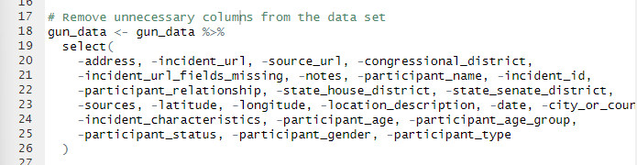
- Summarize Missing Values:
Check NA values per column
- Drop Critical Missing Data Rows:
Removes rows with NA in key columns.
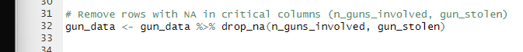

Step 3: Encode Categorical Variables
- Encode state as Factor:
Convert the state column to a factor.
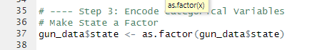
- Gun Type Mapping:
Define a mapping for gun types.

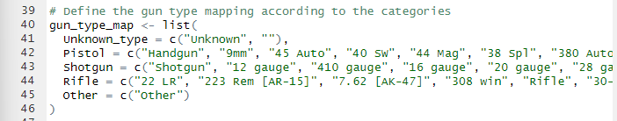

- Process gun_type Data:
Clean and split the gun_type column.
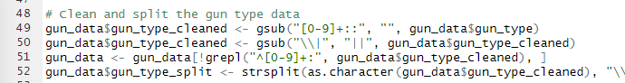

- Categorize Gun Types:
Assign categories to gun types.
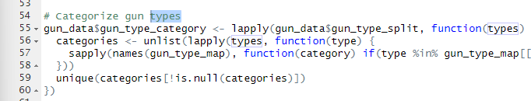

- Binary Matrix for Gun Types:
Create a binary matrix for gun type categories.
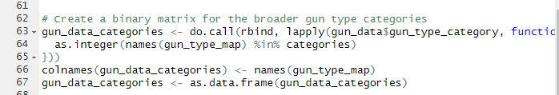

- Process gun_stolen Data:
Clean and process gun_stolen.
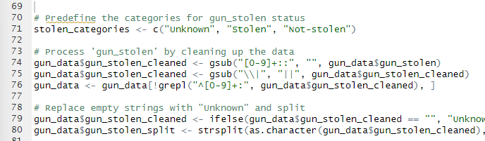

- Binary Matrix for gun_stolen:
Create binary matrix for gun_stolen statuses.
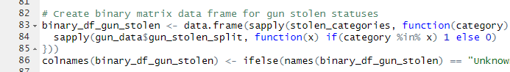

- Combine Encoded Data:
Merge binary matrices with the dataset and remove intermediate columns.
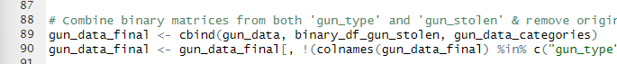

Step 4: Feature Engineering
- Create n_casualties:
Add a new column for total casualties.
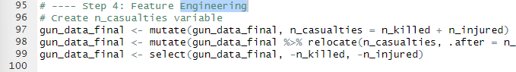

- Create severity:
Categorize severity based on casualties.
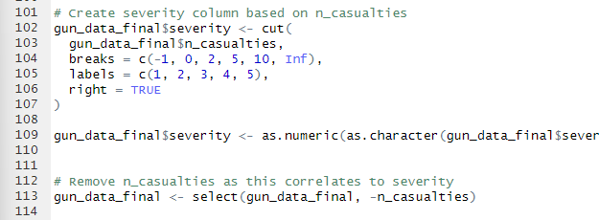

Step 5: Split Data
- Partition Data:
Split into training (80%) and testing (20%).

