Applied Machine Learning 

Student Name: Abdulrahman Alhariri
Student ID: C2644873

Project Title: Predicting Incident Severity Using Random Forest

Table of Contents
- Introduction
- Data Preprocessing
- Model Implementation
- Results
- Visualisation

1. Introduction
This project focuses on predicting the severity of gun violence incidents using machine learning techniques, specifically a Random Forest model. The dataset contains features such as state, number of guns involved, and incident severity.

2. Data Preprocessing
step 1: Load Libraries & Data
- Libraries Used:
  - Load necessary libraries for data manipulation and machine learning.

# ---- Step 1: Load Libraries & Data
library(dplyr)
library(lubridate)
library(tidyr)
library(caret)

- Data Loading:
- Reads the dataset from the specified path.

gun_data <- read.csv("/Gun_violence.csv", stringsAsFactors = FALSE)

Step 2: Preprocess Data
- Convert Date Column:
Converts the date column to a Date object for easier handling.

gun_data$date <- dmy(gun_data$date)

- Handle Missing Values:
Replace empty strings with NA.

gun_data[gun_data == ""] <- NA

- Drop Unnecessary Columns:
Removes irrelevant columns.

# Remove unnecessary columns from the data set
gun_data <- gun_data %>%
select(
-address, -incident_url, -source_url, -congressional_district,
-incident_url_fields_missing, -notes, -participant_name, -incident_id,
-participant_relationship, -state_house_district, -state_senate_district,
-sources, -latitude, -longitude, -location_description, -date, -city_or_county,
-incident_characteristics, -participant_age, -participant_age_group,
-participant_status, -participant_gender, -participant_type
)

- Summarize Missing Values:
Check NA values per column

colSums(is.na(gun_data))

- Drop Critical Missing Data Rows:
Removes rows with NA in key columns.

gun_data <- gun_data %>% drop_na(n_guns_involved, gun_stolen)

Step 3: Encode Categorical Variables
- Encode state as Factor:
Convert the state column to a factor.

gun_data$state <- as.factor(gun_data$state)

- Gun Type Mapping:
Define a mapping for gun types.

gun_type_map <- list(
Unknown_type = c("Unknown", ""),
Pistol = c("Handgun", "9mm", "45 Auto", "40 SW", "44 Mag", "38 Spl", "380 Auto", "32 Auto", "357 Mag", "25 Auto", "10mm"),
Shotgun = c("Shotgun", "12 gauge", "410 gauge", "16 gauge", "20 gauge", "28 gauge"),
Rifle = c("22 LR", "223 Rem [AR-15]", "7.62 [AK-47]", "308 win", "Rifle", "30-30 Win", "30-06 Spr", "300 Win"),
Other = c("Other")
)

- Process gun_type Data:
Clean and split the gun_type column.

gun_data$gun_type_cleaned <- gsub("[0-9]+::", "", gun_data$gun_type)
gun_data$gun_type_cleaned <- gsub("\\|", "||", gun_data$gun_type_cleaned)
gun_data <- gun_data[!grepl("^[0-9]+:", gun_data$gun_type_cleaned), ]
gun_data$gun_type_split <- strsplit(as.character(gun_data$gun_type_cleaned), "\\|\\|")

- Categorize Gun Types:
Assign categories to gun types.

gun_data$gun_type_category <- lapply(gun_data$gun_type_split, function(types) {
categories <- unlist(lapply(types, function(type) {
sapply(names(gun_type_map), function(category) if(type %in% gun_type_map[[category]]) category else NULL)
}))
unique(categories[!is.null(categories)])
})

- Binary Matrix for Gun Types:
Create a binary matrix for gun type categories.

gun_data_categories <- do.call(rbind, lapply(gun_data$gun_type_category, function(categories) {
as.integer(names(gun_type_map) %in% categories)
}))
colnames(gun_data_categories) <- names(gun_type_map)
gun_data_categories <- as.data.frame(gun_data_categories)

- Process gun_stolen Data:
Clean and process gun_stolen.

stolen_categories <- c("Unknown", "Stolen", "Not-stolen")
# Process 'gun_stolen' by cleaning up the data
gun_data$gun_stolen_cleaned <- gsub("[0-9]+::", "", gun_data$gun_stolen)
gun_data$gun_stolen_cleaned <- gsub("\\|", "||", gun_data$gun_stolen_cleaned)
gun_data <- gun_data[!grepl("^[0-9]+:", gun_data$gun_stolen_cleaned), ]

# Replace empty strings with "Unknown" and split
gun_data$gun_stolen_cleaned <- ifelse(gun_data$gun_stolen_cleaned == "", "Unknown", gun_data$gun_stolen_cleaned)
gun_data$gun_stolen_split <- strsplit(as.character(gun_data$gun_stolen_cleaned), "\\|\\|")

- Binary Matrix for gun_stolen:
Create binary matrix for gun_stolen statuses.

binary_df_gun_stolen <- data.frame(sapply(stolen_categories, function(category) {
sapply(gun_data$gun_stolen_split, function(x) if(category %in% x) 1 else 0)
}))
colnames(binary_df_gun_stolen) <- ifelse(names(binary_df_gun_stolen) == "Unknown", "Unknown_status", names(binary_df_gun_stolen))

- Combine Encoded Data:
Merge binary matrices with the dataset and remove intermediate columns.

gun_data_final <- cbind(gun_data, binary_df_gun_stolen, gun_data_categories)
gun_data_final <- gun_data_final[, !(colnames(gun_data_final) %in% c("gun_type", "gun_type_cleaned", "gun_type_split", "gun_stolen", "gun_stolen_cleaned", "gun_stolen_split", "gun_type_category"))]

Step 4: Feature Engineering
- Create n_casualties:
Add a new column for total casualties.

gun_data_final <- mutate(gun_data_final, n_casualties = n_killed + n_injured)
gun_data_final <- mutate(gun_data_final %>% relocate(n_casualties, .after = n_injured))
gun_data_final <- select(gun_data_final, -n_killed, -n_injured)

- Create severity:
Categorize severity based on casualties.

gun_data_final$severity <- factor(
cut(
gun_data_final$n_casualties,
breaks = c(-1, 0, 1, Inf),
labels = c(0, 1, 2),
right = TRUE
),
levels = c(0, 1, 2)
)
gun_data_final$severity <- as.numeric(as.character(gun_data_final$severity))
gun_data_final <- select(gun_data_final, -n_casualties)

- Numeric Serverity:

# gun_data_final$severity <- as.numeric(as.character(gun_data_final$severity))
gun_data_final$severity <- factor(gun_data_final$severity, levels = c("0", "1", "2"))

# Remove n_casualties as this correlates to severity
gun_data_final <- select(gun_data_final, -n_casualties)
Step 5: Split Data
- Partition Data:
Split into training (80%) and testing (20%).

train_indices <- createDataPartition(gun_data_final$severity, p = 0.8, list = FALSE)
train_data <- gun_data_final[train_indices, ]
test_data <- gun_data_final[-train_indices, ]

3. Model Implementation

Step 1: Reduce Data Size for Faster Training
- Set Seed for Reproducibility::
This ensures that the random sampling produces the same results every time the script is run.

set.seed(123)
- Reduce Training and Testing Data Size:
A smaller subset of the data is used to speed up the training process.

sample_size_train <- 20000 # Reduced training rows
sample_size_test <- 4000 # Reduced testing rows

- Sample Data:
Random samples of the specified sizes are taken from the training and testing datasets.

train_data <- train_data[sample(nrow(train_data), sample_size_train), ]
test_data <- test_data[sample(nrow(test_data), sample_size_test), ]

Step 2: Train a Random Forest Model

- Define Training Control:
Configures cross-validation to validate the model during training:
  - Method: 3-fold cross-validation (cv).
  - Progress Display: Real-time feedback (verboseIter = TRUE).

train_control <- trainControl(
method = "cv", # Cross-validation
number = 3, # Reduced number of folds to speed up training
verboseIter = TRUE # Show progress during training
)

- Train the Model:
A Random Forest model is trained on the reduced dataset using the caret package:
  - Target Variable: severity.
  - Predictors: All other variables.
  - Hyperparameter Tuning: Limited to two levels (tuneLength = 2) to speed up training.

rf_model <- train(
severity ~ .,
data = train_data,
method = "rf",
trControl = train_control,
tuneLength = 2, # Reduced tuneLength for faster training
metric = "Accuracy"
)

Output:
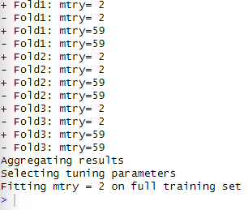

Step 3: Evaluate Model Performance
- Generate Predictions:
The model predicts severity for the test dataset.

test_predictions <- predict(rf_model, newdata = test_data))

- Align Factor Levels:
Converts both predicted and actual values into factors with matching levels to ensure compatibility.

train_data$severity <- factor(train_data$severity, levels = c(0, 1, 2))
test_data$severity <- factor(test_data$severity, levels = c(0, 1, 2))

- Confusion Matrix:
A confusion matrix evaluates the model's accuracy, precision, recall, and F1 score.

conf_matrix <- confusionMatrix(test_predictions, test_data$severity)

Step 4: Final Output
- Combine predictions and actual values:
Creates a DataFrame to compare predicted and actual values.

test_results <- data.frame(
Actual = test_data$severity,
Predicted = test_predictions
)
- Preview Results:
Displays the first few rows of the comparison.

head(test_results)

4. Resutls:
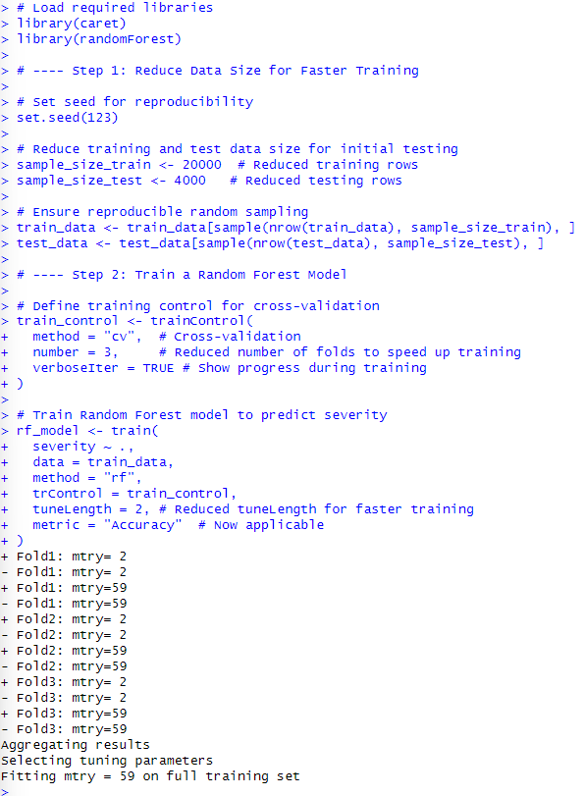
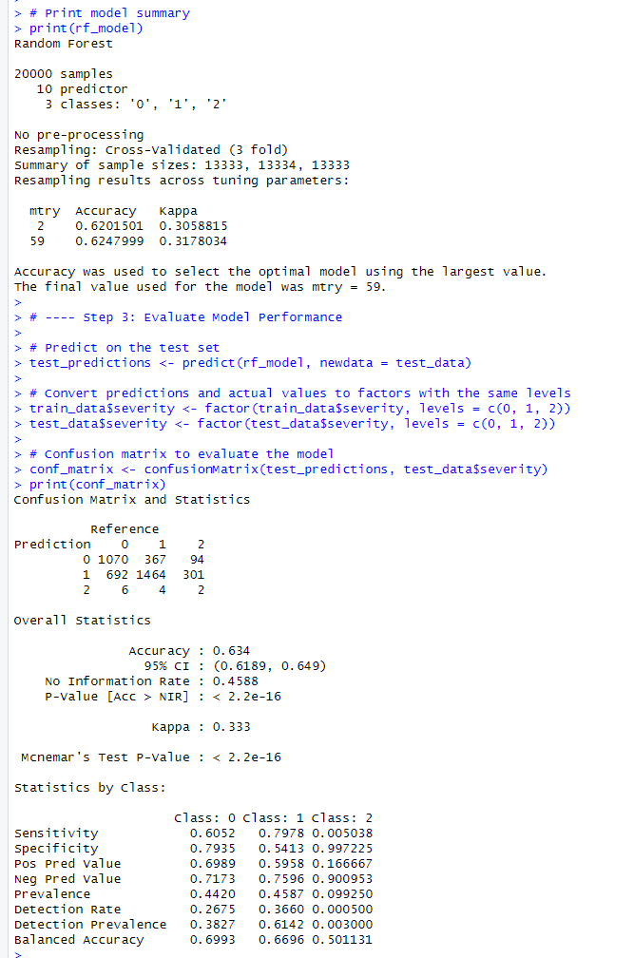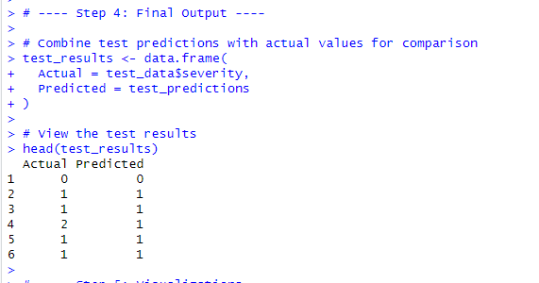

5. Visualisation
1. Confusion Matrix Heatmap
- Purpose: This heatmap provides a detailed view of the model's performance by visualizing how often the predicted severity matches the actual severity.
- Description: Each cell represents the frequency of predictions for a given actual class (y-axis) compared to predicted class (x-axis). Darker shades indicate higher frequencies.
- Insights: High values along the diagonal indicate strong predictive accuracy, where the model's predictions match the actual severity levels. Off-diagonal values represent misclassifications, which can highlight specific areas where the model struggles.

conf_matrix_table <- as.table(conf_matrix$table)
conf_matrix_df <- as.data.frame(conf_matrix_table)
colnames(conf_matrix_df) <- c("Prediction", "Reference", "Frequency")

ggplot(conf_matrix_df, aes(x = Prediction, y = Reference)) +
geom_tile(aes(fill = Frequency), color = "white") +
scale_fill_gradient(low = "white", high = "blue") +
geom_text(aes(label = Frequency), color = "black") +
labs(
title = "Confusion Matrix Heatmap",
x = "Predicted Class",
y = "Actual Class",
fill = "Frequency"
) +
theme_minimal()

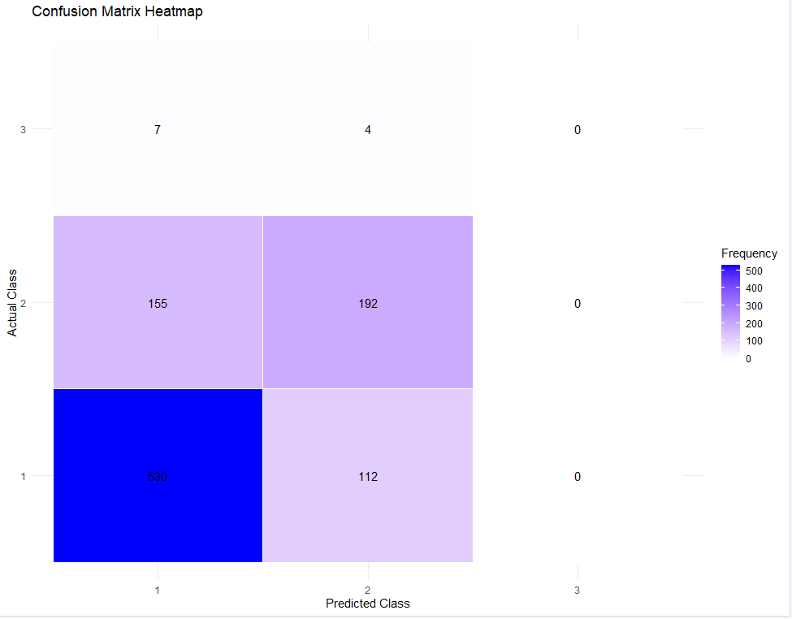

2. Feature Importance Plot
- Purpose: This plot ranks the importance of features in predicting incident severity, as determined by the Random Forest model.
- Description: Each bar represents a feature, with its length indicating the relative importance. Features contributing significantly to the predictions will have longer bars.
- Insights: The most important features provide actionable insights into what influences incident severity the most. For example, a feature like the number of guns involved might be highly influential, suggesting that interventions could focus on reducing access to guns.

varImp_rf <- varImp(rf_model)
plot(varImp_rf, main = "Feature Importance from Random Forest")

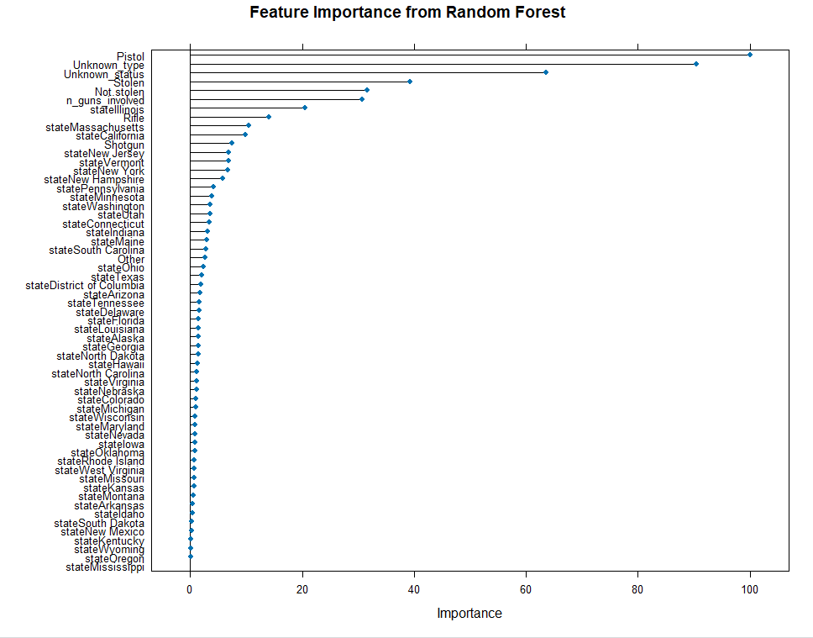

3. Predicted vs Actual Distribution
- Purpose: This bar chart compares the distribution of actual severity classes with the predicted classes to assess the model's classification tendencies.
- Description: Bars are grouped by actual classes, with different colors representing the predicted classes. This visualization helps identify any systemic biases in the model, such as over-predicting or under-predicting specific severity levels.
- Insights: A balanced distribution between actual and predicted classes indicates strong performance, whereas significant discrepancies might suggest areas for improvement, such as addressing class imbalance or refining feature engineering.

ggplot(test_results, aes(x = Actual, fill = Predicted)) +
geom_bar(position = "dodge") +
labs(
title = "Distribution of Actual vs Predicted Classes",
x = "Actual Class",
fill = "Predicted Class"
) +
theme_minimal()

