Driver& Vehicle License Department
(DVLD)
A Project 1 prepared as part of the requirements for the Bachelor of Science (B.Sc.) degree in the Department of Artificial Intelligence Engineering and Data Science

Authors:
Ahmad AL-Asfar
Hasan AL-Homsi Adnan AL-Masalmeh

Supervised by:

Dr. Kadan Juma
Eng. Muhammad Al-Balkhi

Damascus : $\frac{هـ1447-1448}{م 2025-2026}$
SUPERVISOR CERTIFICATION

I certify that the preparation of this project, entitled
“DVLD”
prepared by
“AHMAD – HASAN - ADNAN”
was carried out under my supervision at the Faculty of Artificial Intelligence Engineering in partial fulfillment of the requirements for the degree of B.Sc. in the Department of Artificial Intelligence Engineering and Data Science.

Name:

Date:

Signature:

كلمة شكر وتقدير
جرى إعداد هذا المشروع في كلية هندسة الذكاء الصنعي وعلوم البيانات في الجامعة السورية الخاصة، ضمن متطلبات إنجاز مشروع التخرج 1
أتقدم بجزيل الشكر والتقدير إلى الجامعة السورية الخاصة، ممثلةً بإدارتها وكادرها الأكاديمي والإداري، لما وفرته من بيئة علمية مناسبة وداعمة للبحث والتعلم والتطوير، وما قدمته خلال سنوات الدراسة من إمكانيات ومعرفة أسهمت في بناء مهاراتنا العلمية والعملية
كما أتوجه بخالص الشكر والامتنان إلى الدكتور كادان والمهندس محمد على إشرافه الكريم، وعلى ما قدمه من توجيهات علمية وملاحظات قيّمة ومتابعة مستمرة، كان لها الأثر الكبير في إنجاز هذا المشروع بالصورة المطلوبة.
وأتقدم بالشكر والثناء إلى جميع أعضاء الهيئة التدريسية في كلية هندسة الذكاء الصنعي وعلوم البيانات، تقديرًا لما بذلوه من جهود في التعليم والتوجيه، وما قدموه لنا من خبرات ومعارف خلال مسيرتنا الجامعية
ولا يفوتني أن أتقدم بالشكر لكل من مدّ لي يد العون، وساهم بشكل مباشر أو غير مباشر في إنجاز هذا المشروع، سواء من خلال النصيحة أو الدعم أو التشجيع
لكم جميعًا خالص الشكر والتقدير والاحترام

إهداء
إلى من كانا سندي الأول ومصدر قوتي،
إلى أهلي الأعزاء الذين لم يبخلوا عليّ بالدعم والدعاء والتشجيع، وكانوا دائمًا السبب الأكبر في استمراري ووصولي إلى هذه المرحلة
إلى والديّ الكريمين،
شكرًا لكل تعب، ولكل كلمة تشجيع، ولكل لحظة صبر ودعم قدمتموها لي خلال مسيرتي الدراسية
وإلى أصدقائي الذين كانوا بجانبي في أوقات التعب والضغط،
شكرًا لوقوفكم معي، ولما قدمتموه من مساعدة وتشجيع ودعم معنوي خلال إنجاز هذا المشروع
أهدي هذا العمل المتواضع لكل من آمن بي، وساندني، وكان له أثر طيب في رحلتي العلمية

الملخص

نظام إدارة ترخيص السائقين والمركبات (DVLD) عبارة عن منصة رقمية شاملة طُوّرت لتحديث وأتمتة خدمات رخص القيادة للمواطنين وموظفي الحكومة على حد سواء. يتألف المشروع من نظامين متكاملين: نظام إدارة سطح المكتب الذي يستخدمه الموظفون والإداريون داخليًا، وبوابة إلكترونية للمواطنين تُمكّنهم من الوصول إلى خدمات الترخيص عبر الإنترنت.

يدير تطبيق سطح المكتب العمليات الأساسية لإدارة ترخيص السائقين والمركبات، مثل طلبات رخص القيادة المحلية، وحجز مواعيد الاختبارات، وإدارة اختبارات القيادة، والرخص الموقوفة، والرخص الدولية، والتجديد، وخدمات الاستبدال، وصلاحيات المستخدمين، وإدارة المخالفات. تتيح البوابة الإلكترونية للمواطنين إنشاء حسابات، وتقديم طلبات رخص القيادة، ومتابعة الطلبات، والتفاعل مع النظام عن بُعد.

صُمّم النظام باستخدام بنية متعددة الطبقات تفصل بين طبقة العرض، وطبقة منطق الأعمال، وطبقة الوصول إلى البيانات. يتبع المشروع مبادئ هندسة البرمجيات، ويُطبّق ممارسات حديثة في تصميم واجهة المستخدم وتجربة المستخدم، مع دعم متعدد اللغات (العربية والإنجليزية)، والمصادقة، والتحقق، والتحكم في الوصول القائم على الأدوار.

يهدف النظام إلى تقليل الأعمال الورقية، وتحسين الكفاءة التشغيلية، وتعزيز تنظيم البيانات، وتزويد المواطنين بخدمات حكومية رقمية حديثة.
الكلمات المفتاحية:
نظام رخصة القيادة، بوابة المواطن، النظام الحكومي،
ASP.NET MVC
WinForms
SQL Server
التحكم في الوصول القائم على الأدوار، هندسة البرمجيات
Abstract

The DVLD (Driver and Vehicle Licensing Department) System is a comprehensive digital platform developed to modernize and automate driving license services for both citizens and government employees. The project consists of two integrated systems: a Desktop Management System used internally by employees and administrators, and a Citizen Web Portal that enables citizens to access licensing services online.
The desktop application manages core DVLD operations such as local driving license applications, test appointments, driving tests management, detained licenses, international licenses, renewals, replacement services, user permissions, and violations management. The web portal allows citizens to create accounts, submit driving license applications, track requests, and interact with the system remotely.
The system was designed using a layered architecture with separation between the Presentation Layer, Business Logic Layer, and Data Access Layer. The project follows Software Engineering principles and applies modern UI/UX practices with multilingual support (Arabic and English), authentication, validation, and role-based access control.
The system aims to reduce paperwork, improve operational efficiency, enhance data organization, and provide citizens with modern digital governmental services.
Keywords:
DVLD, Driving License System, Citizen Portal, Government System, ASP.NET MVC, WinForms, SQL Server, Role-Based Access Control, Software Engineering.

Table of Contents
Chapter 1 10
1.1 Project Overview 11
1.2 Problem Statement 11
1.3 Project Objectives 12
1.4 Project Scope 12
Constraints 13
Assumptions 13
1.5 Project Contribution 13
1.6 Research Methodology and Scientific Methods Used 14
1.7 Document Organization 15
1.8 Definitions and Basic Concepts 16
Chapter2 17
2.1 Selected Development Methodology and Justification 18
2.2 Project Time Plan 19
2.3 Risk Management 20
2.4 Project Team and Task Distribution 21
2.5 Quality Management 22
2.6 Project Management Tools Used 22
2.7 Monitoring and Continuous Evaluation Mechanisms 23
2.8 Software Configuration Management SCM 23
Chapter3 24
3.1 Previous Studies in Intelligent and Similar Systems 25
1. RTA – Roads and Transport Authority, Dubai 25
2. DMV – Department of Motor Vehicles, United States 25
3. DVLA – Driver and Vehicle Licensing Agency, United Kingdom 26
3.2 Modern Technologies and Frameworks in the Field 26
3.3 Comparative Analysis of Existing Systems and Products 27
3.4 Research Gap and Proposed Innovation 28
3.5 Theoretical Framework and Reference Studies 28
3.6 Modern and Future Trends in the Field 29
Chapter 4 30
4.1 Requirements Elicitation Methods 31
Interviews 31
Observation 31
Database Analysis 31
Workshops and Team Discussions 31
Requirement List Review 31
4.2 Stakeholders Identification and Needs Analysis 32
4.3 Functional Requirements 33
4.4 Non-Functional Requirements 34
4.5 Requirements Prioritization and Management 36
4.6 Main Use Case Diagrams 37
4.6.1 Use Case Descriptions 38
4.6.2 Activity Diagrams 48
4.6.3 Sequence Diagrams 57
4.6.4 Test Case Descriptions 65
4.6.5 Modeling According to the Used Methodology 72
4.7 User Stories, Story Mapping, and Product Backlog 73
4.7.1 User Stories 73
4.7.2 Story Mapping 75
4.7.3 Product Backlog 77
4.8 RTM Table 79
Chapter 5 81
5.1 Architectural Design Pattern Used 82
Layered Architecture 82
MVC Pattern 82
5.2 System Architecture Design 83
5.3 ER Diagram 84
Chapter 6 85
6.1 Software Tools and Libraries Used 86
6.2 Development Environment and Project Structure 86
6.3 Programming Languages and Frameworks 87
6.4 Database and Operating System 87
6.5 Test Cases Execution: 88
6.6 RTM Table 97
Chapter 7 99
Appendices 100
Appendix A: Requirements Elicitation Questionnaires 100
Appendix B: Detailed Design 100
References 102
Arabic and English References 102
Websites 102
Research Papers and Academic Resources 103

List of Tables
Table 1 RISK MANAGEMENT 23
Table 2 ROLE 24
Table 3 TEAM 24
Table 4 TOOL 25
Table 5 Comparative Analysis of Existing Systems and Products 30
Table 6 Stakeholders 35
Table 7 Functional Requirements 36
Table 8 Non-Functional Requirements 37
Table 9 Requirements Priority List 39
Table 10USE CASE Add Person 41
Table 11 USE CASE Delete Person 42
Table 12 USE CASE Update Person Information 42
Table 13 USE CASE Filter People 43
Table 14 USE CASE Create Employee Account 44
Table 15 USE CASE Filter Employees 45
Table 16 USE CASE Change Employee Password 46
Table 17 USE CASE Create Local License Application 46
Table 18 USE CASE Cancel Application 47
Table 19 USE CASE Delete Application 47
Table 20 USE CASE Update Application 48
Table 21 USE CASE View Application Details 48
Table 22 USE CASENUpdate Application Types 48
Table 23 USE CASE Test Managment 49
Table 24 USE CASE Issuing a local license 49
Table 25 Test Case Descriptions 67
Table 26 Story Mapping 77
Table 27 Product Backlog 79
Table 28 Initial RTM Table 81
Table 29 Test Cases Execution 90
Table 30 RTM 99
Table 31 Arabic and English References 104
Table 32 Websites 104

List of Figures
Figure 1 USE CASE 40
Figure 2 ACTIVITY ADD PERSON 50
Figure 3 ACTIVITY CTEATE EMPLOYE ACCOUNT 51
Figure 4 ACTIVITY FILTER EMPLOYEE 52
Figure 5 ACTIVITY CHANGE PASSWORD 52
Figure 6 ACTIVITY CREATE NEW APPLICATION 53
Figure 7 ACTIVITY CANCEL APPLICATION 54
Figure 8 ACTIVITY DELETE APPLICATION 54
Figure 9 ACTIVITY UPDATE APPLICATION 55
Figure 10 ACTIVITY FILTER APPLICATION 55
Figure 11 UPDATE APPLICATION TYPE 56
Figure 12 TEST APPLICATION 57
Figure 13 ISSUE LICENSE 57
Figure 14 Sequence ADD PERSON 58
Figure 15 ADD EMPLOYEE 58
Figure 16 Sequence CHANGE PASSWORD 59
Figure 17 Sequence DELETE APPLICATION 59
Figure 18 Sequence EDIT APPLICATION 60
Figure 19 Sequence SHOW APPLICATION 60
Figure 20 Sequence TEST APPLICATION 61
Figure 21 Sequence ISSUE LICENSE 62

فهرس المصطلحات والرموز
المصطلح | المقابل بالإنكليزية | رمز / اختصار
نظام إدارة رخص القيادة | Driving License Management System | DVLD
بوابة المواطن | Citizen Portal | -
تطبيق سطح المكتب | Desktop Application | -
تطبيق الويب | Web Application | -
قاعدة البيانات | Database | DB
الرقم الوطني | National Number | -
حساب المواطن | Citizen Account | -
تسجيل الدخول | Login | -
إنشاء حساب | Register | -
تغيير كلمة المرور | Change Password | -
طبقة منطق الأعمال | Business Logic Layer | BLL
طبقة الوصول إلى البيانات | Data Access Layer | DAL
نمط MVC | Model-View-Controller | MVC
طلب رخصة محلية | Local Driving License Application | LDLA
حالة الطلب | Application Status | -
فئة الرخصة | License Class | -
موعد الاختبار | Test Appointment | -
نتيجة الاختبار | Test Result | -
المستخدم | User | -
الصلاحيات | Permissions | -
مخطط الكيانات والعلاقات | Entity Relationship Diagram | ERD
دورة حياة تطوير البرمجيات | Software Development Life Cycle | SDLC
لغة الاستعلامات البنيوية | Structured Query Language | SQL
واجهة المستخدم | User Interface | UI

Chapter 1

Introduction

1.1 Project Overview
The Driving License Management System, known as DVLD, is a software system designed to organize and manage services related to driving licenses. These services include managing citizens’ personal information, processing driving license applications, scheduling driving tests, recording test results, and supporting license-related procedures.
The original system was implemented as a Desktop application using C#, .NET Framework, WinForms, and SQL Server. This Desktop system is mainly used by employees and administrators to manage internal operations such as people records, users, permissions, license applications, tests, and licenses.
As digital services became increasingly important, the need appeared to provide citizens with an online interface that allows them to access some services without depending completely on employee-side procedures. Therefore, this project extends the existing DVLD system by adding a Citizen Web Portal. The portal allows citizens to create accounts, log in using their national number, submit local driving license applications, change their passwords, and track their applications and related tests.
The project does not replace the existing Desktop application. Instead, it keeps the employee system as it is and adds a web-based citizen interface connected to the same SQL Server database.

1.2 Problem Statement
The main problem addressed by this project is that the existing DVLD system was mainly designed for employees. Citizens could not directly create accounts, submit local driving license applications, or track their application status online. This may lead to slower procedures, more dependency on employees, and less transparency for citizens regarding the status of their requests.
From a practical perspective, the system needs to support both employees and citizens. Employees require a stable Desktop application for internal management, while citizens need a simple web portal to access basic services electronically.
From an academic perspective, the project represents a practical application of software engineering principles. It includes requirements analysis, layered architecture, database integration, authentication, validation, multilingual user interface design, and testing. The project also demonstrates how an existing system can be extended without rebuilding it from scratch.

1.3 Project Objectives
The main objective of this project is to extend the existing DVLD system by developing a Citizen Web Portal connected to the current Desktop system and SQL Server database.
The project objectives are:
- To keep the existing Desktop application for employees and administrators.
- To create a Citizen Portal using ASP.NET Core MVC.
- To allow citizens to create accounts using their national number.
- To provide secure login functionality for citizens.
- To store citizen passwords securely using password hashing.
- To allow citizens to change their passwords.
- To allow citizens to submit local driving license applications.
- To allow citizens to view their applications and application statuses.
- To display test-related information for each application, such as test appointments, test results, and number of attempts.
- To support Arabic and English user interfaces.
- To reuse the existing database, Business Logic Layer, and Data Access Layer as much as possible.
- To reduce code duplication and maintain consistency between the Desktop system and the Web Portal.

1.4 Project Scope
The scope of this project includes two main parts:
The first part is the existing Desktop application, which remains responsible for employee and administrative operations. This includes managing people, users, permissions, applications, tests, licenses, and internal system procedures.
The second part is the new Citizen Web Portal, which provides citizens with limited online services. These services include account registration, login, password change, submitting local driving license applications, viewing application status, and viewing related test information.

Constraints
- The existing Desktop application should not be rebuilt from scratch.
- The Citizen Portal must use the existing SQL Server database.
- The existing Business Logic Layer and Data Access Layer should be reused as much as possible.
- The citizen side should not have access to employee or administrative functions.
- The system should remain simple and suitable for the project level.
- The web portal should support Arabic and English interfaces.

Assumptions
- Citizens already have personal records in the People table or can register their information.
- The national number is unique for each citizen.
- Employees continue using the Desktop application for internal processing.
- The Citizen Portal and Desktop application share the same database.
- The database contains the required lookup tables such as countries, license classes, application types, and test types.

1.5 Project Contribution
The main contribution of this project is extending an existing Desktop-based driving license management system by adding a Citizen Web Portal without replacing the original system. This approach provides a practical example of system extension and integration.
The project contributes by separating the system into two user-facing sides: one for employees and one for citizens. Employees continue to use the Desktop application, while citizens use the Web Portal for basic online services.
Another contribution is the reuse of the existing database and system layers. Instead of creating a completely new system, the project connects the web portal to the same SQL Server database and reuses the Business Logic Layer and Data Access Layer. This reduces development effort, avoids unnecessary duplication, and keeps the system behavior consistent.
The project also provides a practical example of applying ASP.NET Core MVC with a layered architecture in a real service-based system.

1.6 Research Methodology and Scientific Methods Used
The project follows a practical software engineering methodology based on analyzing the existing system, identifying the required citizen services, designing the needed extensions, implementing the Web Portal, and testing its functionality.
The methodology includes the following steps:
- Studying the existing Desktop DVLD system.
- Analyzing the current database structure.
- Identifying the citizen services required for the Web Portal.
- Determining the minimum required database changes, such as adding the CitizenAccounts table.
- Reusing the existing Business Logic Layer and Data Access Layer where possible.
- Designing the Citizen Portal using the MVC architectural pattern.
- Implementing the required features step by step.
- Testing the main functions, such as login, registration, license application submission, and application tracking.
The project uses a layered architecture approach, where the presentation layer is separated from the business logic and data access layers. This improves maintainability and makes the system easier to understand and extend.

1.7 Document Organization
This document is organized into several main chapters.
Chapter One presents a general introduction to the project, including the project background, problem statement, objectives, scope, contribution, methodology, document organization, and basic definitions.
Chapter Two describes the project development and management methodology. It explains the Scrum methodology used in the project, the project time plan, risk management, team roles, quality management, project management tools, monitoring mechanisms, and software configuration management.
Chapter Three presents the theoretical study, analysis, and previous studies. It discusses similar driving license systems such as RTA Dubai, DMV in the United States, and DVLA in the United Kingdom. It also includes a comparative analysis between these systems and the proposed DVLD system, in addition to the research gap and proposed innovation.
Chapter Four focuses on requirements analysis and specification. It includes requirements elicitation methods, stakeholder identification, functional requirements, non-functional requirements, requirement prioritization, use case diagrams, use case descriptions, activity diagrams, sequence diagrams, test case descriptions, user stories, story mapping, product backlog, and the requirements traceability matrix.
Chapter Five presents the high-level design of the system. It includes the system block diagram, the architectural design pattern, system architecture, database design, ER diagram, relational schema, constraints, and keys.
Chapter Six explains the implementation environment, tools, and technologies used in the project. It includes software tools and libraries, development environment, project structure, programming languages, frameworks, database, and operating system.
The final section includes appendices and references. The appendices contain supporting materials such as requirements elicitation questionnaires and class diagrams. The references include Arabic and English references, websites, and academic resources used during the project documentation.

1.8 Definitions and Basic Concepts
The following basic concepts are used throughout this project:
DVLD:
An abbreviation for Driving License Management System. It refers to the system used to manage driving license services.
Citizen Portal:
A web-based interface that allows citizens to create accounts, log in, submit local driving license applications, and track their requests.
Desktop Application:
The employee-side application used by staff and administrators to manage internal operations.
SQL Server Database:
The database system used to store and manage system data such as people, users, applications, licenses, tests, and citizen accounts.
Business Logic Layer:
The layer that contains the main rules and operations of the system, such as saving applications, finding people, and retrieving license classes.
Data Access Layer:
The layer responsible for communicating with the SQL Server database and executing database queries.
MVC:
Model-View-Controller, an architectural pattern used in the Citizen Portal to separate data, interface, and control logic.
Citizen Account:
An account created for a citizen to access the portal using the national number and password.
Local Driving License Application:
A request submitted by a citizen to apply for a local driving license.
Application Status:
The current state of an application, such as New, Cancelled, or Completed.
Test Appointment:
A scheduled appointment for a driving-related test, such as vision, written, or practical test.
Test Result:
The result of a test, which may indicate whether the applicant passed or failed.

Chapter2

Project Development and Management Methodology

2.1 Selected Development Methodology and Justification
The development methodology followed in this project was Scrum, which is an Agile framework used to manage software projects through short and organized development cycles called sprints. Scrum was suitable for this project because the system was developed step by step, and each feature was implemented, tested, and improved before moving to the next feature.
The project was based on an existing Desktop application and SQL Server database. Therefore, the goal was not to rebuild the whole system from scratch, but to extend the existing DVLD system by adding a Citizen Web Portal. Scrum helped the team divide the work into small manageable tasks such as account registration, login, password management, local driving license application submission, application tracking, and test progress display.
During the project, the work was organized into several sprints. At the beginning of each sprint, the required feature was selected and analyzed. Then the feature was implemented, tested, and reviewed. If errors appeared, such as database connection problems, validation issues, or project reference errors, they were fixed before continuing to the next sprint.
Scrum was selected for the following reasons:
- It supports step-by-step development.
- It allows the team to focus on one feature at a time.
- It helps discover and fix errors early.
- It is suitable for projects with changing or developing requirements.
- It supports continuous testing and improvement.
- It helped the team integrate the Citizen Portal with the existing Desktop system safely.
- It allowed the team to reuse the existing database, Business Logic Layer, and Data Access Layer without rebuilding the whole system.
In this project, Scrum provided a flexible and practical development approach. It helped organize the implementation process and ensured that each feature of the Citizen Portal was completed and tested before starting the next one.

2.2 Project Time Plan
The project was divided into several development phases. Each phase focused on a specific part of the system to keep the work organized and clear.
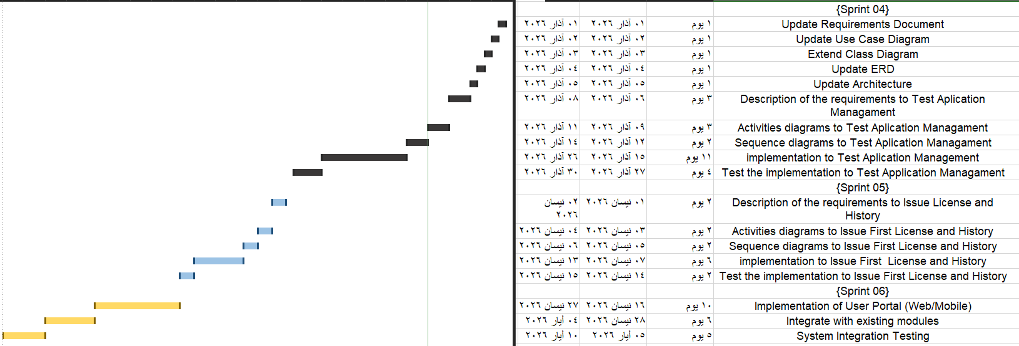

2.3 Risk Management
During the project, several risks were identified because the system depends on an existing Desktop application, existing database, and shared business logic. The following table summarizes the main risks and the strategies used to handle them.
Table 1RISK MANAGEMENT
Risk | Description | Impact | Mitigation Strategy
Database integration risk | The Web Portal may connect to a different or incorrect database | High | Verify connection string and test database queries
Existing code dependency risk | Business or Data Access classes may not work directly with the Web project | High | Add proper project references and rebuild the solution
Null value errors | Some fields such as CreatedByUserID may be null for citizen-submitted applications | Medium | Update code to support nullable values where required
UI/UX complexity | The citizen interface may become difficult to use | Medium | Use simple, organized, bilingual pages
Validation errors | User inputs may be incorrect or incomplete | Medium | Apply ViewModel validation and field-level error messages
Duplicate applications | A citizen may submit the same local license application more than once | Medium | Check for active applications before saving a new one
Language support issues | Arabic and English text direction may cause layout problems | Medium | Use RTL/LTR handling based on selected language
Build/reference errors | Web project may fail to load Business or DataAccess assemblies | High | Use Project References, clean bin/obj folders, and rebuild solution
Risk management was performed continuously during development. When an error appeared, it was analyzed, fixed, and tested before moving to the next feature.

2.4 Project Team and Task Distribution
The project team was responsible for analyzing, implementing, testing, and documenting the system. The tasks were distributed according to the main parts of the project.
Table 2ROLE
Role | Responsibilities
System Analyst | Analyze the existing DVLD system, identify citizen requirements, and define system scope
Database Designer | Study the current SQL Server database and propose minimum required changes
Backend Developer | Reuse and modify Business Logic Layer and Data Access Layer where needed
Web Developer | Implement the ASP.NET Core MVC Citizen Portal
UI Designer | Design Arabic/English web interfaces and improve user experience
Tester | Test login, registration, application submission, validation, and tracking features
Documentation Writer | Prepare the documents and final project documentation
Team Members:
Table 3TEAM
Student Name | Main Responsibility
[Ahmad] | [Database Designer/ Web Developer/ Documentation Writer]
[Hasan] | [System Analyst/ Database Designer/ UI Designer]
[Adnan] | [Backend Developer/ Tester]

2.5 Quality Management
Quality management in this project focused on ensuring that the system works correctly, is easy to use, and does not break the existing Desktop application. Since the project extends an existing system, maintaining compatibility was one of the most important quality goals.
- Validating user inputs in the Citizen Portal.
- Preventing duplicate national numbers during account creation.
- Storing citizen passwords using hashing instead of plain text.
- Reusing existing business logic to reduce code duplication.
- Keeping the Desktop application and Citizen Portal connected to the same database.
- Testing each feature after implementation.
- Handling Arabic and English interfaces with correct text direction.
- Keeping the citizen side separated from employee administrative functions.
- Displaying meaningful messages for validation and system errors.
Quality was evaluated by checking whether each feature meets its expected behavior. For example, login should only allow valid citizen accounts, local license application submission should save correct data, and the application tracking page should display the correct status and test progress

2.6 Project Management Tools Used
Table 4TOOL
Tool | Purpose
Visual Studio | Development environment for Desktop and Web projects
SQL Server | Database management system
SQL Server Management Studio | Managing tables, relationships, and testing SQL queries
ASP.NET Core MVC | Building the Citizen Web Portal
C# | Main programming language
WinForms | Existing Desktop application interface
ADO.NET | Database communication through the Data Access Layer
HTML, CSS, Bootstrap | Designing web pages
Browser Developer Tools | Testing web layout and interface behavior
Microsoft Word | Preparing project documentation

2.7 Monitoring and Continuous Evaluation Mechanisms
The project was monitored continuously by testing each completed feature before moving to the next one. This helped reduce errors and made the development process more controlled.
The evaluation process included:
- Running the Web Portal after each major code change.
- Testing registration with valid and invalid data.
- Checking that countries, license classes, and application types load correctly from the database.
- Testing login using national number and password.
- Testing password change functionality.
- Submitting local driving license applications and verifying that they are saved in the database.
- Checking that the Desktop application still works after database or business layer changes.
- Testing the “My Applications” page to ensure it displays application status, test appointments, test results, and attempts count.
- Reviewing the interface in both Arabic and English.
This continuous evaluation helped discover problems such as broken project references, missing database records, nullable field errors, and incorrect UI direction.

2.8 Software Configuration Management SCM
Software Configuration Management was important because the project contains multiple connected parts: the Desktop application, the Citizen Web Portal, the Business Logic Layer, the Data Access Layer, and the SQL Server database.
The SCM process focused on managing changes carefully to avoid breaking the existing system. The following practices were followed:
- Keeping the Desktop application and Citizen Portal as separate presentation projects.
- Sharing the Business Logic Layer and Data Access Layer between both systems.
- Using project references instead of copying DLL files manually.
- Rebuilding the solution after modifying shared classes.
- Avoiding unnecessary database changes.
- Adding only the required new table for citizen accounts.
- Testing both Desktop and Web projects after changes in shared layers.
- Keeping database changes documented, especially changes related to CitizenAccounts and nullable CreatedByUserID.
- Organizing files according to their responsibility, such as Controllers, Views, ViewModels, Business classes, and DataAccess classes.
The final project structure supports maintainability because each part of the system has a clear responsibility. The Desktop application remains responsible for employee operations, while the Citizen Portal provides online services for citizens.

Chapter3

Literature Review and Previous Studies

3.1 Previous Studies in Intelligent and Similar Systems
Several countries and governmental institutions have developed electronic systems to manage driving license services. These systems provide useful references for the DVLD Citizen Portal project because they show how driving license services can be digitized and offered to citizens through online platforms.

1. RTA – Roads and Transport Authority, Dubai
The Roads and Transport Authority (RTA) in Dubai, United Arab Emirates, provides advanced digital transportation services, including driving license services. Through RTA digital platforms and the RTA Dubai mobile application, users can access services such as renewing a driving license and booking vehicle test appointments. The UAE official government portal also refers to RTA Dubai as one of the authorities responsible for applying for new driving licenses or new license categories.
RTA represents an advanced example of digital government services because it focuses on reducing the need to visit physical service centers and provides mobile-based services for citizens and residents. Compared with the DVLD project, RTA is more advanced because it includes wider transportation services, online payments, mobile application support, and integrated smart services.
However, the DVLD Citizen Portal is similar to RTA in the idea of allowing users to access driving license services electronically. The difference is that the DVLD project focuses on extending an existing Desktop system by adding a Citizen Web Portal connected to the same SQL Server database.

2. DMV – Department of Motor Vehicles, United States
The Department of Motor Vehicles (DMV) is used in the United States at the state level. Each state has its own DMV or equivalent agency responsible for driver licenses, vehicle registration, identification cards, and related services. For example, the California DMV provides online services such as applying for a driver license or ID card, renewing a driver license, booking appointments, and checking the status of a driver license or ID card application.
The DMV system is a strong reference because it separates online citizen services from internal administrative processing. Citizens can complete many basic services online, while DMV employees continue to manage verification, approvals, records, and internal procedures.
Compared with the DVLD project, the DMV system is larger and covers more services, such as vehicle registration, REAL ID, license renewal, appointment management, and status checking. The DVLD Citizen Portal is smaller in scope, but it follows the same general concept: giving citizens a web interface to submit and track license-related services.

3. DVLA – Driver and Vehicle Licensing Agency, United Kingdom
The Driver and Vehicle Licensing Agency (DVLA) is the official agency responsible for driver and vehicle licensing in Great Britain, including England, Wales, and Scotland. The GOV.UK platform provides several online driving license services, such as renewing a driving license, applying for a first provisional driving license, and tracking the progress of a driving license application online.
DVLA is a useful reference because it provides clear online services for citizens and allows users to track the progress of applications using online services or application reference numbers. This is similar to the DVLD Citizen Portal feature that allows citizens to view their submitted applications, statuses, and related test progress.
Compared with DVLD, the DVLA system is more mature and nationally integrated. It includes official identity verification, online renewals, application tracking, and wider government service integration. The DVLD project is more limited but follows the same digital service direction by providing an online portal connected to an existing driving license management system.

3.2 Modern Technologies and Frameworks in the Field
Several modern technologies and frameworks are used in this project to support system development, database integration, and user interaction.
The existing Desktop application was developed using C#, .NET Framework, WinForms, and SQL Server. These technologies are suitable for internal administrative applications because they provide stable forms, database connectivity, and employee-side management tools.
The new Citizen Portal was developed using ASP.NET Core MVC. This framework is suitable for building web applications because it separates the system into three main parts: Model, View, and Controller. This separation improves code organization and maintainability.
The project also uses a layered architecture consisting of:
Layer | Description
Presentation Layer | Represents the Desktop application and Web Portal interfaces
Business Logic Layer | Contains the main system rules and operations
Data Access Layer | Communicates with SQL Server and executes database queries
SQL Server is used as the main database management system. It stores data related to citizens, users, applications, license classes, tests, test appointments, and citizen accounts.
The project also uses HTML, CSS, and Bootstrap concepts to design the web interface. In addition, session management is used to keep the citizen logged in while using the portal.

3.3 Comparative Analysis of Existing Systems and Products
The following table compares three real-world driving license service systems with the proposed DVLD Citizen Portal.
Table 5 Comparative Analysis of Existing Systems and Products
Comparison Aspect | RTA  Dubai | DMV  United  States | DVLA United Kingdom | DVLD
Citizen Online Portal | ✓ | ✓ | ✓ | ✓
Mobile Application | ✓ | ✓ | ✗ | ✗
Account Login | ✓ | ✓ | ✓ | ✓
License Application Services | ✓ | ✓ | ✓ | ✓
Application Status Tracking | ✓ | ✓ | ✓ | ✓
Test Appointment / Progress | ✓ | ✓ | ✓ | ✓
Online Payment | ✓ | ✓ | ✓ | ✓
Employee/Internal System | ✓ | ✓ | ✓ | ✓
Database Integration | ✓ | ✓ | ✓ | ✓
Large-Scale Government System | ✓ | ✓ | ✓ | ✗
Citizen-Friendly Services | ✓ | ✓ | ✓ | ✓
Shared Desktop + Web Structure | ✗ | ✗ | ✗ | ✓
Violations and Seizures Management | ✗ | ✗ | ✗ | ✓

3.4 Research Gap and Proposed Innovation
The main gap in the original system was the absence of a citizen-facing web interface. The Desktop application was suitable for employees but did not allow citizens to create accounts, submit local driving license applications, or track application status online.
Another gap was the need to improve accessibility while avoiding a complete rebuild of the existing system. Rebuilding the whole system as a web application would require more time and could introduce more risks. Therefore, the project focuses on extending the current system instead of replacing it.
The proposed innovation is the development of a Citizen Web Portal that works beside the existing Desktop application and shares the same SQL Server database. This provides a practical balance between modernization and system stability.
The innovation in this project can be summarized as follows:
- Adding a new Citizen Portal to an existing Desktop-based system.
- Reusing the existing database and system layers.
- Allowing citizens to log in using their national number.
- Supporting secure password storage using hashing.
- Allowing citizens to submit local driving license applications online.
- Displaying application status and related test progress.
- Supporting Arabic and English interfaces.
- Keeping employee operations separated from citizen services.
This approach makes the project practical, scalable, and suitable for real institutional environments.

3.5 Theoretical Framework and Reference Studies
The theoretical foundation of this project is based on several software engineering concepts.
First, the project applies the concept of layered architecture. This architecture separates the system into presentation, business logic, and data access layers. The benefit of this separation is that each layer has a clear responsibility, which makes the system easier to maintain and extend.
Second, the Citizen Portal follows the MVC pattern. The Model represents the data and validation rules, the View represents the user interface, and the Controller handles user requests and connects the View with the business logic. This pattern is widely used in web applications because it improves organization and readability.
Third, the project applies database integration concepts. Both the Desktop application and the Citizen Portal use the same SQL Server database. This ensures that applications submitted by citizens can later be processed by employees through the Desktop application.
Fourth, the project uses authentication and authorization concepts. Citizens can access the portal only after logging in using their national number and password. Password hashing is used to avoid storing passwords as plain text.
Fifth, the project applies validation concepts to ensure that entered data is correct. For example, required fields, national number format, email format, age condition, and password strength are checked before saving data.
These concepts support the development of a reliable and organized system that connects a web portal with an existing administrative application.

3.6 Modern and Future Trends in the Field
Modern public service systems are moving toward digital transformation, where citizens can access services online instead of visiting offices for every procedure. Citizen portals are becoming an important part of this transformation because they provide easier access, faster request submission, and better transparency.
In the field of driving license management, future systems may include more advanced features such as:
- Online payment integration for application and test fees.
- SMS or email notifications for test appointments and application updates.
- Electronic document upload and verification.
- Mobile application support.
- Digital license preview or electronic certificate services.
- Dashboards for employees and administrators.
- Advanced reporting and statistics.
- Integration with national identity systems.
- AI-based support for answering citizen questions.
The current DVLD project represents a first step toward this digital transformation. It provides the basic online services needed by citizens while keeping the existing Desktop system stable for employees. In future work, the system can be extended with notifications , administrative dashboards, and mobile application support.

Chapter 4

Requirements Analysis and Specification

4.1 Requirements Elicitation Methods
Requirements elicitation is an important step in software engineering because it helps identify what the system should do and what users expect from it. In this project, requirements were collected and analyzed based on the existing DVLD Desktop application, the current database structure, and the new needs related to the Citizen Web Portal.
Several methods were used to collect and understand the requirements:

Interviews
Interviews were considered one of the main methods for understanding the system. The team discussed the current workflow of the DVLD system, especially how employees manage people records, applications, tests, and licenses. These discussions helped identify which functions should remain in the Desktop application and which functions should be added to the Citizen Portal.

Observation
The existing Desktop application was observed to understand how employees interact with the system. The team studied the current forms and operations, such as person management, user management, application management, test appointments, test results, and license issuance.

Database Analysis
The SQL Server database was analyzed to understand the existing tables and relationships. Important tables such as People, Users, Applications, LocalDrivingLicenseApplications, LicenseClasses, TestAppointments, Tests, TestTypes, and Countries were reviewed. This helped the team decide how the Citizen Portal could be connected to the same database without rebuilding the system.

Workshops and Team Discussions
Team discussions were used to decide the project scope and the best development approach. The team agreed that the Desktop application should remain for employees, while a new Web Portal should be added for citizens. This decision reduced development risk and allowed the project to reuse existing business logic.

Requirement List Review
A requirement list was prepared and reviewed. The requirements included employee-side functions such as managing people, employees, applications, tests, and licenses, in addition to citizen-side functions such as creating a local license application and viewing application information.

4.2 Stakeholders Identification and Needs Analysis
Stakeholders are the people or groups who interact with the system or are affected by it. In the DVLD project, the main stakeholders include citizens, license officers, test officers, system administrators, and the institution administration.
Table 6 Stakeholders
Stakeholder | Role in the System | Main Needs
Citizen | Uses the Citizen Portal | Create account, log in, submit local license application, view application status, view test progress, change password
License Officer | Uses the Desktop application | Manage people records, create and process local license applications, view application information, issue licenses
Test Officer | Uses the Desktop application | Schedule vision, written, and street tests, edit appointments, record test results
System Administrator | Uses the Desktop application | Manage employees/users, edit application types, edit test types, control system accounts
Institution Administration | Supervises the system | Improve service organization, reduce errors, and provide better tracking of applications
Development Team | Builds and maintains the system | Understand requirements, implement features, test system, and document the project

Stakeholder Needs Analysis
Citizens need a simple and clear web interface that allows them to access services without using the employee Desktop application. They need to create accounts, log in using their national number, submit local license applications, and track the status of their requests.
License officers need the Desktop application to remain stable because it is responsible for internal license procedures. They need to view and process applications submitted either internally or through the Citizen Portal.
Test officers need tools for managing test appointments and recording test results. These results should also be visible to the citizen through the portal.
System administrators need control over users, application types, and test types. They are responsible for managing system settings and employee accounts.

4.3 Functional Requirements
Functional requirements describe the main services and actions that the system must provide. The following table presents the functional requirements of the DVLD system, including both the existing Desktop application and the new Citizen Portal.
Table 7 Functional Requirements
Req ID | Functional Requirement | Category | Actor
FR-01 | The system shall allow the License Officer to add a new person. | Person Management | License Officer
FR-02 | The system shall allow the License Officer to update person data. | Person Management | License Officer
FR-03 | The system shall allow the License Officer to delete a person. | Person Management | License Officer
FR-04 | The system shall allow the License Officer to view person data. | Person Management | License Officer
FR-05 | The system shall allow the License Officer to search for a person. | Person Management | License Officer
FR-06 | The system shall allow the System Admin to delete an employee account. | Employee Management | System Admin
FR-07 | The system shall allow the System Admin to change an employee password. | Employee Management | System Admin
FR-08 | The system shall allow the System Admin to create a new employee account. | Employee Management | System Admin
FR-09 | The system shall allow the System Admin to view employee data. | Employee Management | System Admin
FR-10 | The system shall allow the System Admin to update employee data. | Employee Management | System Admin
FR-11 | The system shall allow the System Admin to search for an employee. | Employee Management | System Admin
FR-12 | The system shall allow system users to log in. | User Account Management | System User
FR-13 | The system shall allow system users to view their current user information. | User Account Management | System User
FR-14 | The system shall allow system users to change their current password. | User Account Management | System User
FR-15 | The system shall allow system users to log out. | User Account Management | System User
FR-16 | The system shall allow the System Admin to view application type data. | Application Management | System Admin
FR-17 | The system shall allow the System Admin to edit application types. | Application Management | System Admin
FR-18 | The system shall allow the License Officer to view application information. | Application Management | License Officer
FR-19 | The system shall allow the License Officer to create a new local license application for a person. | Application Management | License Officer
FR-20 | The system shall allow the License Officer to delete a local license application. | Application Management | License Officer
FR-21 | The system shall allow the License Officer to cancel a local license application. | Application Management | License Officer
FR-22 | The system shall allow the License Officer to update a local license application. | Application Management | License Officer
FR-23 | The system shall allow the System Admin to view and manage test type data. | Test Management | System Admin
FR-24 | The system shall allow the Test Officer to manage vision, written, and street tests. | Test Management | Test Officer
FR-25 | The system shall allow the License Officer to issue a first-time license for a qualified person. | License Management | License Officer
FR-26 | The system shall allow the License Officer to view license information. | License Management | License Officer
FR-27 | The system shall allow the citizen to submit a local driving license application through the Citizen Portal. | Citizen Portal | Citizen
FR-28 | The system shall allow the citizen to view application details, status, tests, and progress. | Citizen Portal | Citizen
FR-29 | The system shall allow the citizen to create a citizen account using national number and personal information. | Citizen Account Management | Citizen
FR-30 | The system shall allow the citizen to log in to the Citizen Portal using national number and password. | Citizen Account Management | Citizen
FR-31 | The system shall allow the citizen to change the account password. | Citizen Account Management | Citizen
FR-32 | The system shall support Arabic and English interfaces in the Citizen Portal. | Language Support | Citizen
FR-33 | The system shall validate citizen registration fields such as national number, email, age, gender, image, country, and password.

4.4 Non-Functional Requirements
Non-functional requirements describe how the system should behave. They focus on quality attributes such as performance, security, usability, reliability, and maintainability.
Table 8 Non-Functional Requirements
Req ID | Category | Non-Functional Requirement
NFR-01 | Performance | The Citizen Portal pages should load within a reasonable time under normal usage conditions.
NFR-02 | Performance | Login, registration, and application tracking operations should respond quickly when the database connection is available.
NFR-03 | Performance | The system should retrieve citizen applications and test progress without unnecessary database duplication.
NFR-04 | Security | Citizen passwords shall be stored using hashing and not as plain text.
NFR-05 | Security | The system shall require login before accessing protected citizen pages.
NFR-06 | Security | Citizens shall only be able to view and manage their own information and applications.
NFR-07 | Security | Employee administrative functions shall remain available only through the Desktop application and authorized users.
NFR-08 | Security | The system shall validate user inputs to reduce invalid data and common input errors.
NFR-09 | Usability | The Citizen Portal interface shall be simple, organized, and easy to use.
NFR-10 | Usability | The Citizen Portal shall support Arabic and English text.
NFR-11 | Usability | The interface shall support right-to-left direction for Arabic and left-to-right direction for English.
NFR-12 | Usability | Validation messages shall be clear and related to the field that caused the error.
NFR-13 | Reliability | The Desktop application should continue working after adding the Citizen Portal.
NFR-14 | Reliability | The Web Portal and Desktop application shall use the same SQL Server database to maintain data consistency.
NFR-15 | Maintainability | The system shall reuse the existing Business Logic Layer and Data Access Layer when possible.
NFR-16 | Maintainability | The Citizen Portal shall follow ASP.NET Core MVC structure to organize controllers, views, and view models.
NFR-17 | Compatibility | The Web Portal shall be compatible with modern web browsers.
NFR-18 | Scalability | The system design should allow adding future services such as notifications, online payment, or mobile application support.

4.5 Requirements Prioritization and Management
Requirements prioritization helps the team decide which features should be implemented first. In this project, requirements were prioritized based on their importance to the system, the citizen portal scope, and the dependency between features.
The requirements were classified using the MoSCoW method:
Priority | Meaning
Must Have | Essential requirements that must be implemented for the system to work
Should Have | Important requirements that improve the system but are not critical for the first version
Could Have | Useful requirements that can be added if time allows
Won’t Have Now | Requirements that are out of the current scope and can be future work
Requirements Priority List
Table 9 Requirements Priority List
Priority | Requirements
Must Have | Citizen registration, citizen login, password hashing, submit local license application, view applications, view application status, maintain Desktop application functionality
Should Have | Change password, bilingual interface, validation messages, view test appointments, test results, and attempts
Could Have | Improved UI design, dashboard cards, detailed citizen profile page
Won’t Have Now | Online payment, SMS/email notifications, mobile application, integration with national identity systems
Requirements Management Mechanism
Requirements were managed step by step during implementation. Each feature was treated as a separate task and was tested after development. When a problem appeared, such as database connection errors, missing lookup data, nullable fields, or reference errors between projects, it was fixed before moving to the next feature.
The main requirement changes during the project included:
- Adding a CitizenAccounts table for citizen login.
- Connecting the Citizen Portal to the same SQL Server database.
- Reusing the existing Business Logic Layer and Data Access Layer.
- Allowing citizen-submitted applications to be processed later by employees through the Desktop application.
- Adding application tracking for citizens.
- Adding test progress display, including appointments, results, and number of attempts.
- Supporting Arabic and English interfaces.
This approach helped keep the project organized and reduced the risk of changing the existing Desktop system.

4.6 Main Use Case Diagrams
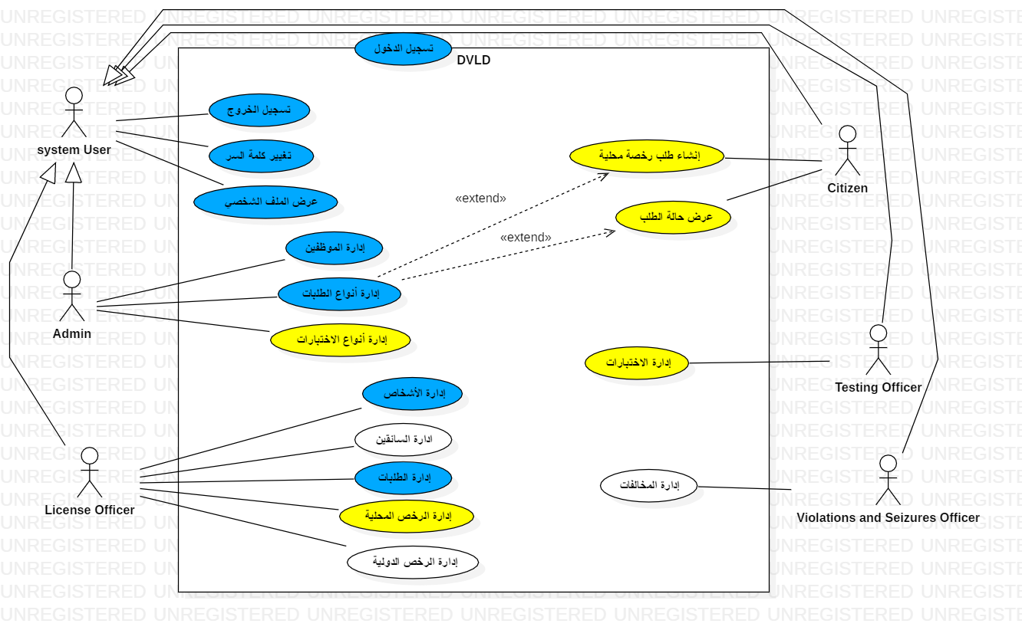
Figure 1 USE CASE

4.6.1 Use Case Descriptions
Table 10 USE CASE Add Person
Add Person | Use Case Title
License Officer | Actors
Login | Preconditions
1. The License Officer clicks on the People icon.  2. The system displays an interface with the list of existing people.  3. The License Officer clicks the Add Person button.  4. The system displays the "Add Person" interface.  5. The License Officer enters the information of the person to be added.  6. The License Officer clicks the Save button.  7. The system displays a success message confirming the addition. | Main Flow
During Step 5:  1. If the License Officer enters a National ID that already exists, the system displays an error alert and requires it to be changed.  2. If the License Officer enters an Email in an incorrect format, the system displays an error alert and requires a valid format.  During Step 6:  3. If any mandatory field is left empty, the system displays an error alert and forces the License Officer to fill in all required fields. | Alternative Flow
None | Postcondition

Table 11 USE CASE Delete Person
Delete Person | Use Case Title
License Officer | Actors
Login | Preconditions
1. The License Officer clicks on the People icon.  2. The system displays an interface with the list of existing people.  3. The License Officer selects the target person and clicks the Delete Person button.  4. The system displays a confirmation message for the deletion.  5. The License Officer clicks the Confirm button.  6. The system displays a success message confirming the deletion. | Main Flow
At Step 4:  1. If the License Officer clicks Cancel, the system aborts the deletion process.  At Step 5:  2. If there is data linked/associated with the person to be deleted, the system displays a message preventing the deletion due to existing related records. | Alternative Flow
None | Postcondition
Table 12 USE CASE Update Person Information
Update Person Information | Use Case Title
License Officer | Actors
Login | Preconditions
1. The License Officer clicks on the People icon.  2. The system displays an interface with the list of existing people.  3. The License Officer selects the target person and clicks the Update Person Information button.  4. The system displays the Edit interface.  5. The License Officer enters the new information.  6. The License Officer clicks the Save button.  7. The system displays a success message confirming the update process. | Main Flow
During Step 5:  1. If the License Officer enters an Email in an incorrect format, the system displays an error alert and requires a valid format.  During Step 6:  2. If any mandatory field is left empty, the system displays an error alert and forces the user to fill in all required fields. | Alternative Flow
None | Postcondition

Table 13 USE CASE Filter People
Use Case Title | Filter People
Actors | License Officer
Preconditions | Login
Main Flow | 1. The License Officer clicks on the People icon.  2. The system displays the interface with the existing people and shows a Filter Type selection field.  3. The License Officer selects ID from the list of options.  4. The system displays a text input field.  5. The License Officer starts typing the ID they wish to search for in the field.  6. The system displays the record matching the entered ID.
Alternative Flow | 1. If the License Officer selects "None", the system hides the search field and displays all existing records.  2. If the License Officer selects a text-based filter type, the system displays the records matching the entered data in real-time while typing
Postcondition | None

Table 14 USE CASE Create Employee Account
Create Employee Account | Use Case Title
Admin | Actors
Login | Preconditions
1. The Admin clicks on the Employees icon.  2. The system displays an interface with the list of existing employees. 3. The Admin clicks the Create Employee Account button.  4. The system displays the first page of the account creation interface.  5. The Admin searches for the person for whom they want to create an account.  6. The system displays the person's information.  7. The Admin clicks the Next button.  8. The system displays the account information entry page.  9. The Admin enters the account details and clicks the Save button.  10. The system displays a success message confirming the operation | Main Flow
At Step 6:  1. If the person is not found, the system displays an error message.  At Step 9:  2. If the Admin enters a Username that already exists, the system displays an error notification: "Username already exists."  3. If the Admin enters a Password Confirmation that does not match the password, the system displays an error notification and forces the Admin to match them. | Alternative Flow
None | Postcondition

Table 15 USE CASE Filter Employees
Use Case Title | Filter Employees
Actors | Admin
Preconditions | Login
Main Flow | 1. The Admin clicks on the Employees icon.  2. The system displays an interface with the list of existing employees and a Filter Type selection field.  3. The Admin selects ID from the list of options.  4. The system displays a text input field.  5. The Admin starts typing the ID they wish to search for in the field.  6. The system displays the record matching the entered ID.
Alternative Flow | 1. If the Admin selects "None", the system hides the search field and displays all existing records.  2. If the Admin selects a text-based filter type, the system displays the records matching the entered data in real-time while typing.  3. If the Admin selects the "Is Active" filter type, the system displays a new selection field (Dropdown) instead of the text field:  I - If the Admin selects "Yes", the system displays all active records.  II - If the Admin selects "No", the system displays all inactive records.
Postcondition | None

Table 16 USE CASE Change Employee Password
Change Employee Password | Use Case Title
Admin | Actors
Login | Preconditions
1. The Admin clicks on the Employees icon.  2. The system displays an interface with the list of existing employees.  3. The Admin selects the target employee and clicks the Change Employee Password button.  4. The system displays the Change Employee Password interface.  5. The Admin enters the Current (Old) Password.  6. The Admin enters the New Password and the Password Confirmation.  7. The Admin clicks the Save button.  8. The system displays a success message confirming the operation. | Main Flow
At Step 5:  1. If the Admin enters an incorrect Old Password, the system displays an error notification and requires the correct password to be entered. At Step 6:  2. If the Admin enters a Password Confirmation that does not match the new password, the system displays an error notification and forces the Admin to match them. | Alternative Flow
None | Postcondition
Table 17 USE CASE Create Local License Application
Create Local License Application | Use Case Title
License Officer | Actors
Login | Preconditions
1. The License Officer clicks on the Applications icon.  2. The system displays an interface with the existing applications.  3. The License Officer clicks the Create New Application button.  4. The system displays the first page of the application creation interface.  5. The License Officer enters the ID or National No. of the person and clicks the Search button.  6. The system displays the person's information.  7. The License Officer clicks the Next button.  8. The system displays the application information entry page.  9. The License Officer selects the License Class to be requested and clicks the Save button.  10. The system displays a success message confirming the operation. | Main Flow
At Step 6:  1. If the person is not found, the system displays an error message.  At Step 9:  2. If the person already has an active application of the same type, the system displays an error message.  3. If the person already holds a license of the same class, the system displays an error message. | Alternative Flow
None | Postcondition

Table 18 USE CASE Cancel Application
Cancel Application | Use Case Title
License Officer | Actors
Login | Preconditions
1. The Employee opens the Manage Applications screen.  2. The Employee selects the target application from the list.  3. The Employee clicks the Cancel Application button.  4. The system displays a confirmation message.  5. The Employee clicks the Confirm button.  6. The system records the Last Edit Date and displays a success message. | Main Flow
During Step 4: The Employee declines the confirmation  1. The system displays the cancellation confirmation message.  2. The Employee selects Cancel/No.  3. The system closes the confirmation message without changing the application status. | Alternative Flow
None | Postcondition
Table 19 USE CASE Delete Application
Delete Application | Use Case Title
License Officer | Actors
Login | Preconditions
1. The Employee opens the Manage Applications screen.  2. The Employee selects the application to be deleted and clicks the Delete button.  3. The system displays a confirmation message for the deletion.  4. The Employee confirms the deletion process.  5. The system verifies that the application status is "New" and that it is not linked to any tests.  6. The system displays a success message confirming the operation. | Main Flow
Cancel Deletion Process:  1. The Employee selects the Cancel button.  2. The system returns the Employee to the previous screen without changing any data.  Application Linked to Tests:  1. The Employee attempts to delete an application that has an associated test or is already completed/finished.  2. The system displays an error message: "Cannot delete the application because it is linked to tests."  3. The system returns to the application view without any changes. | Alternative Flow
None | Postcondition

Table 20 USE CASE Update Application
Update Application | Use Case Title
License Officer | Actors
Login | Preconditions
1. The Employee opens the Manage Applications screen.  2. The Employee selects the target application to be updated and clicks Edit.  3. The system displays the Edit interface.  4. The system allows the Employee to update editable fields, such as License Class and Application Date.  5. The Employee enters the required modifications.  6. The Employee clicks the Save button.  7. The system displays a message: "Application updated successfully." | Main Flow
2. If the person already has an active application of the same type, the system displays an error message.  3. If the person already holds a license of the same class, the system displays an error message. | Alternative Flow
None | Postcondition
Table 21 USE CASE View Application Details
View Application Details | Use Case Title
License Officer | Actors
Login | Preconditions
1. The Employee opens the Manage Applications screen.  2. The Employee selects a specific application from the list or search results.  3. The system displays the details interface for the selected application.  4. The Employee can take additional actions, such as Update (Edit). | Main Flow
None | Alternative Flow
None | Postcondition
Table 22 USE CASENUpdate Application Types
Update Application Types | Use Case Title
Admin | Actors
Login | Preconditions
1. The Admin opens the Manage Application Types screen.  2. The Admin selects an application type from the list and clicks the Edit button.  3. The system displays the Edit interface.  4. The Admin modifies the information.  5. The Admin clicks the Save button.  6. The system displays a message: "Application type updated successfully." | Main Flow
None | Alternative Flow
None | Postcondition

Table 23 USE CASE Test Managment
Test Managment | Use Case Title
Employee | Actors
Login | Preconditions
1-The test administrator clicks the Manage Requests icon.  2-The system displays the Requests interface.  3-The test administrator clicks the Tests icon.  4-The system displays the Tests interface and shows the person's previous appointments for the selected test, if any.  5-If the test administrator chooses to add a new appointment:  I. The system displays the Add Appointment interface.  II. The test administrator selects the test date and clicks the Save button.  III. The system displays a success message.  6-If the test administrator chooses to modify an appointment:  I. The system displays the Modify Appointment interface.  II. The test administrator modifies the test date and clicks the Save button.  III. The system displays a success message.  7-If the test administrator chooses to set the test result:  I. The system displays the Set Test Result interface.  II. The test administrator sets the person's result (Pass or Fail) and clicks the Save button.  III. The system displays a success message. | Main Flow
Alternative flow at step 5:  1- If the person has passed the specified test or has a valid appointment, the system displays a rejection message. | Alternative Flow
None | Postcondition
Table 24 USE CASE Issuing a local license
Issuing a local license | Use Case Title
License Officer | Actor
Login | Pre Condition
1- The License Officer clicks the "Manage Applications" icon.  2- The system displays the Applications Interface.  3- The License Officer clicks Issue License button.  4- The system displays the Issue License interface.  5- The License Officer write the Notes if needed and click save button.  6- The system displays Success process message . | Main Flow
None | Alternative Flow
None | Exit Condition

4.6.2 Activity Diagrams
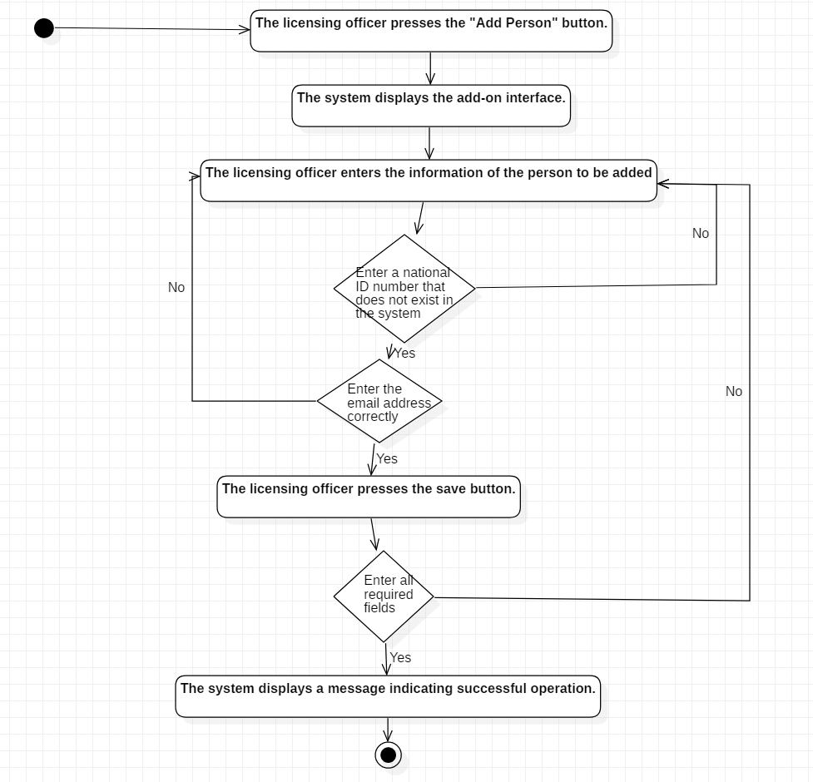
Figure 2 ACTIVITY ADD PERSON

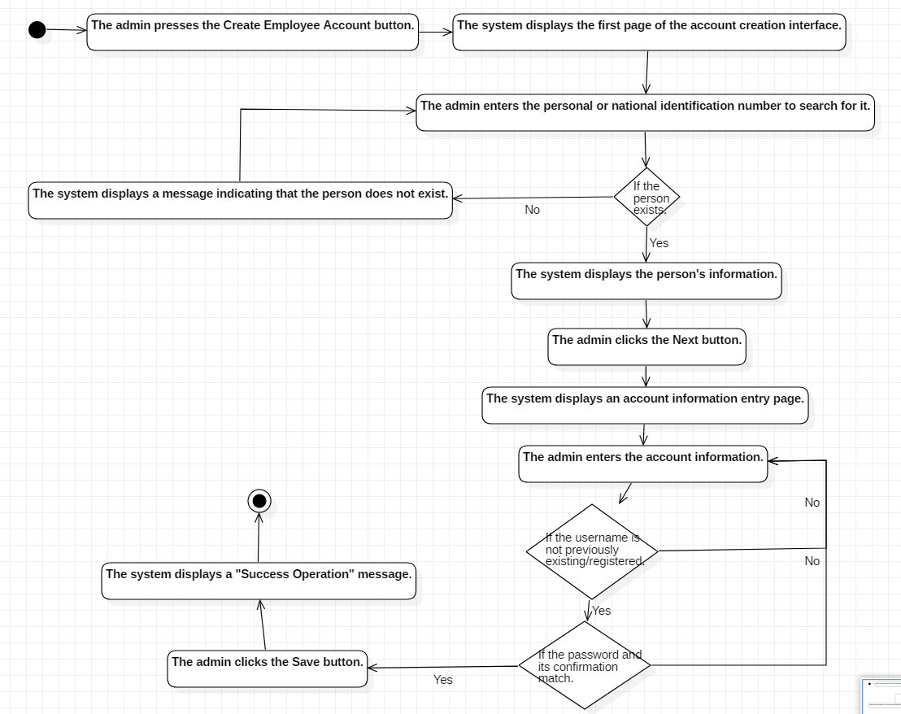
Figure 3 ACTIVITY CTEATE EMPLOYE ACCOUNT

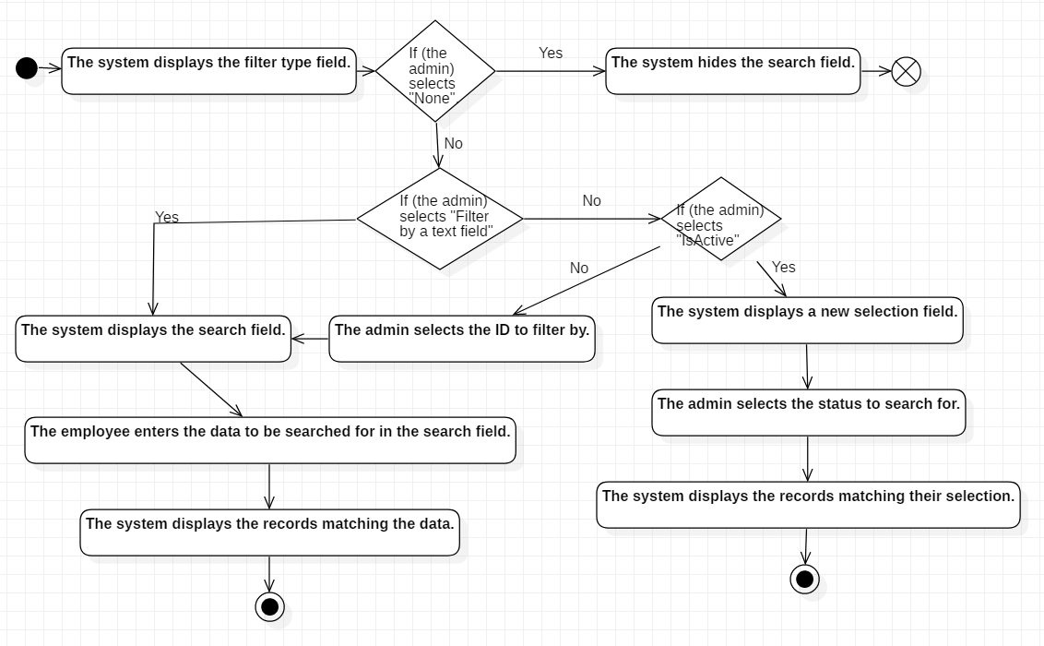
Figure 4 ACTIVITY FILTER EMPLOYEE
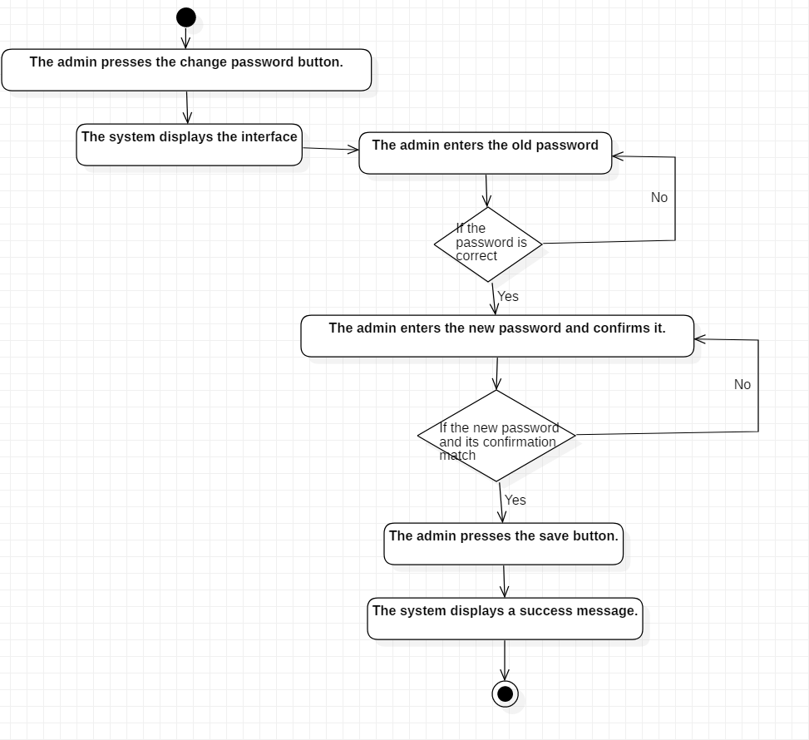
Figure 5 ACTIVITY CHANGE PASSWORD

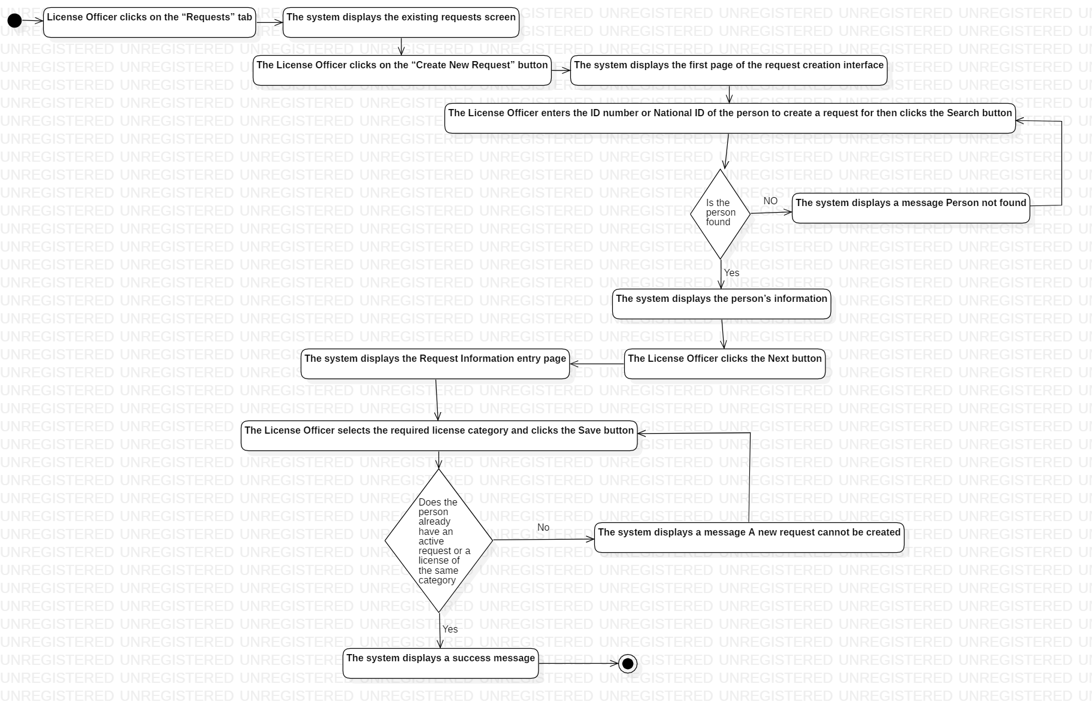
Figure 6 ACTIVITY CREATE NEW APPLICATION
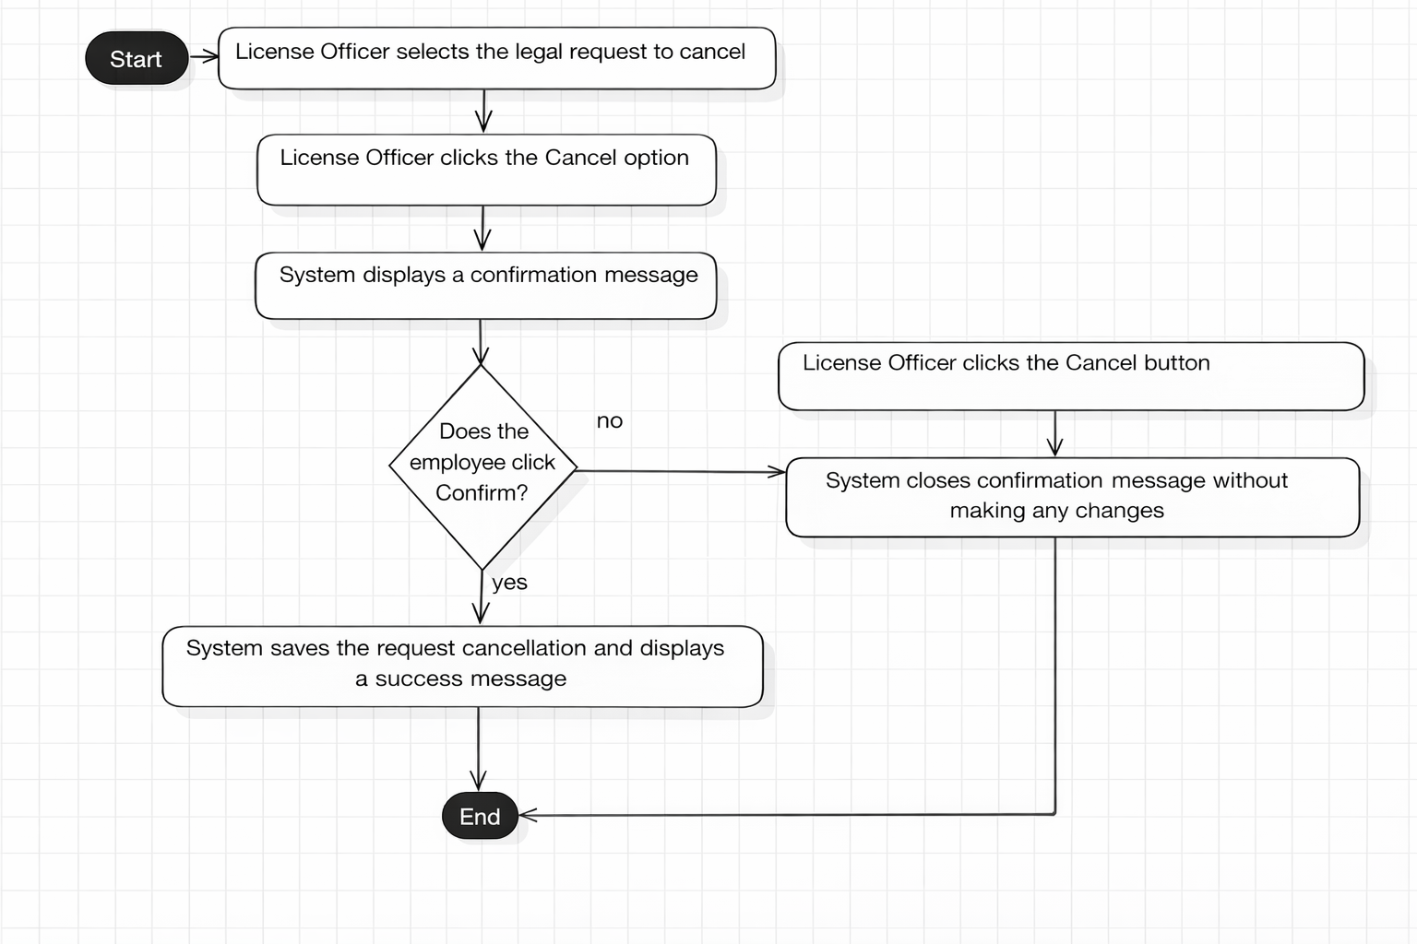
Figure 7 ACTIVITY CANCEL APPLICATION
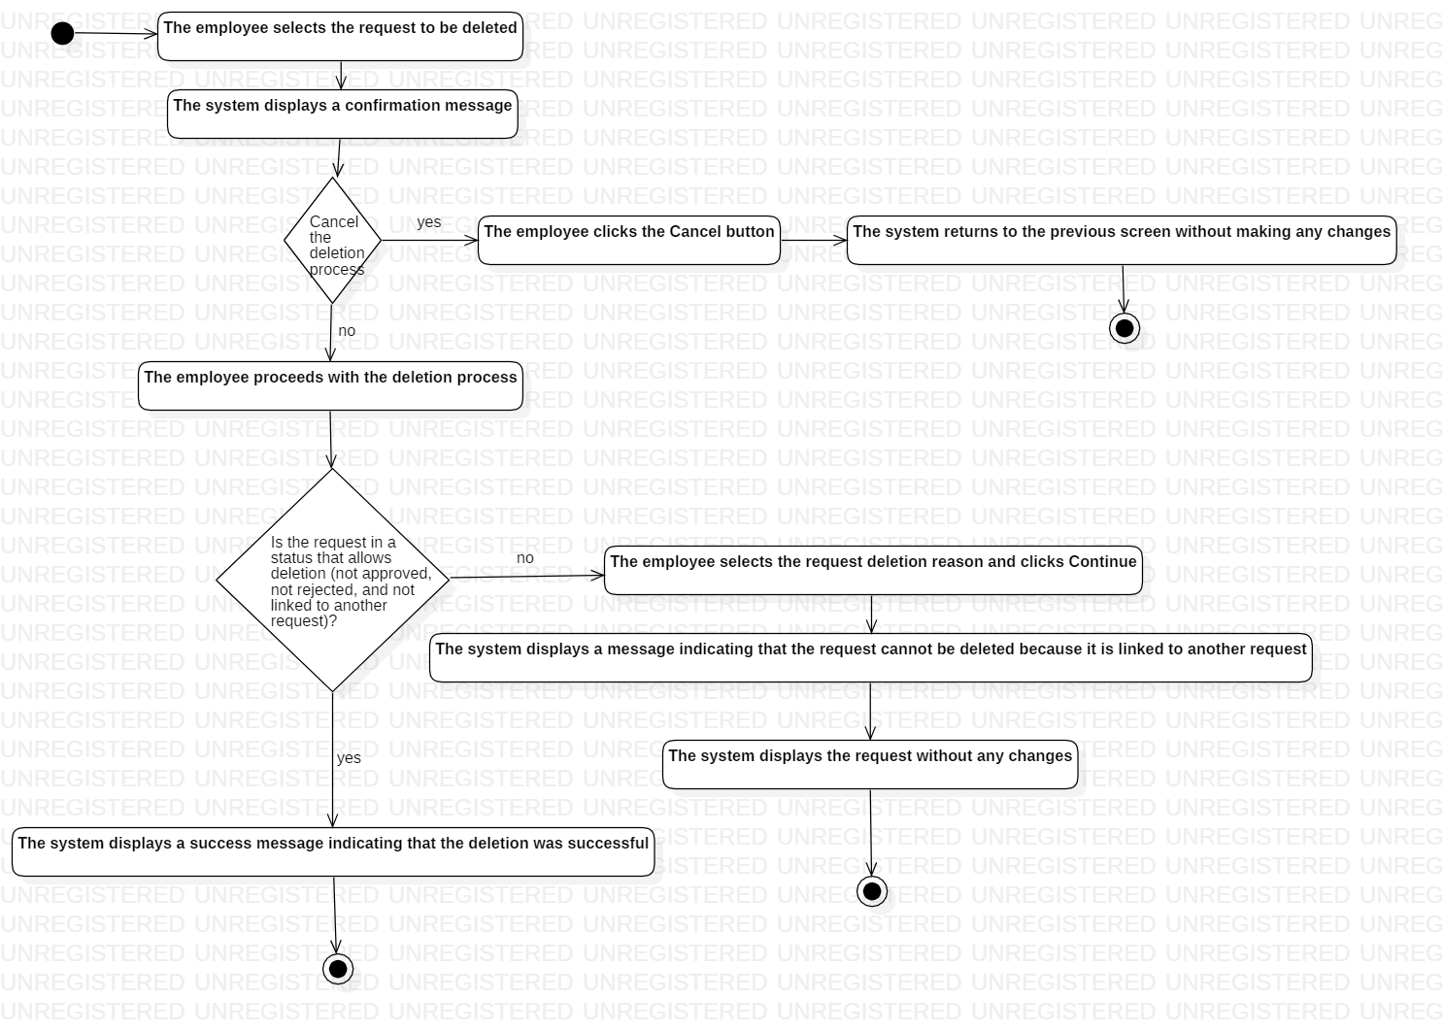
Figure 8 ACTIVITY DELETE APPLICATION
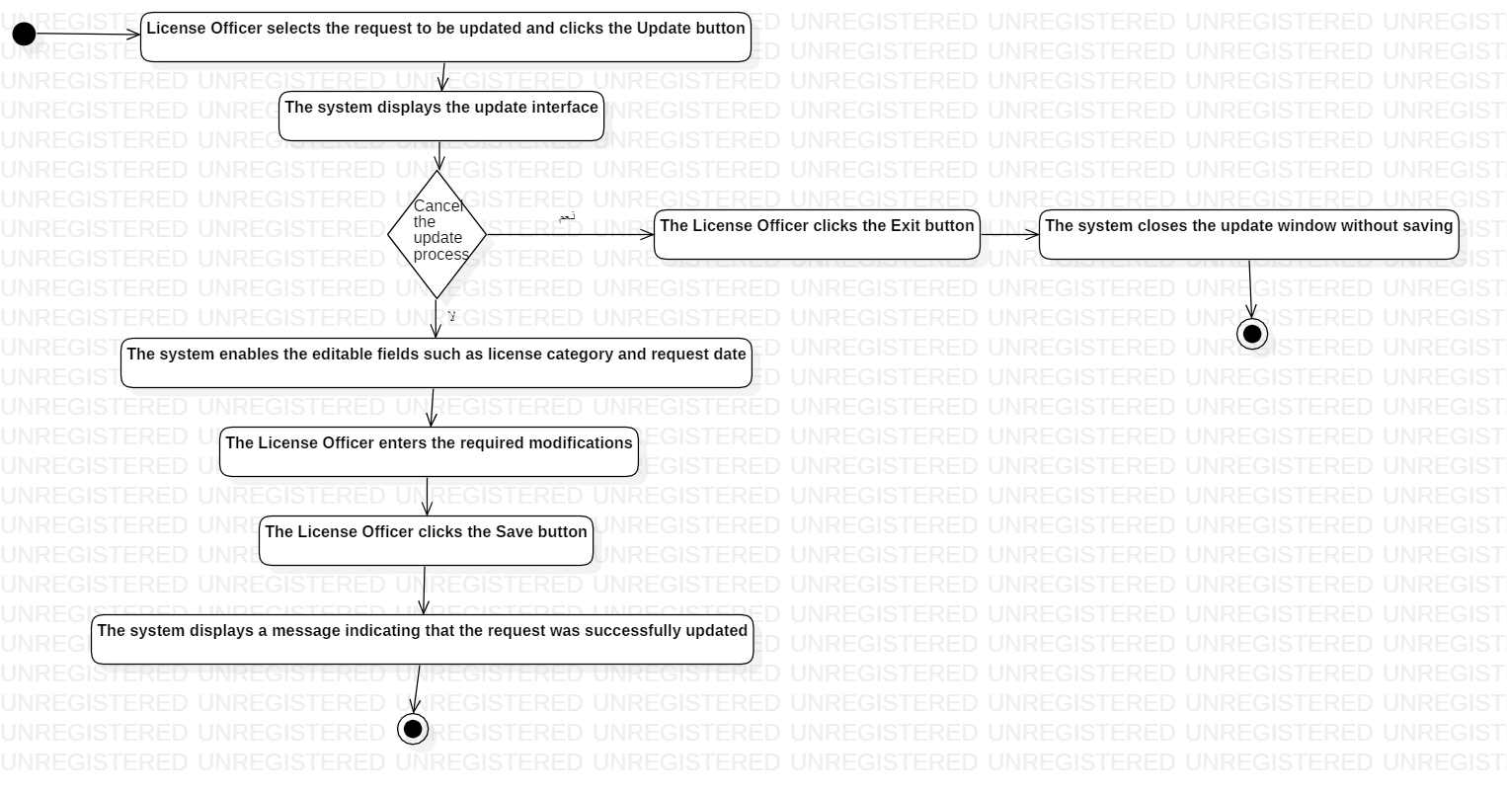
Figure 9 ACTIVITY UPDATE APPLICATION
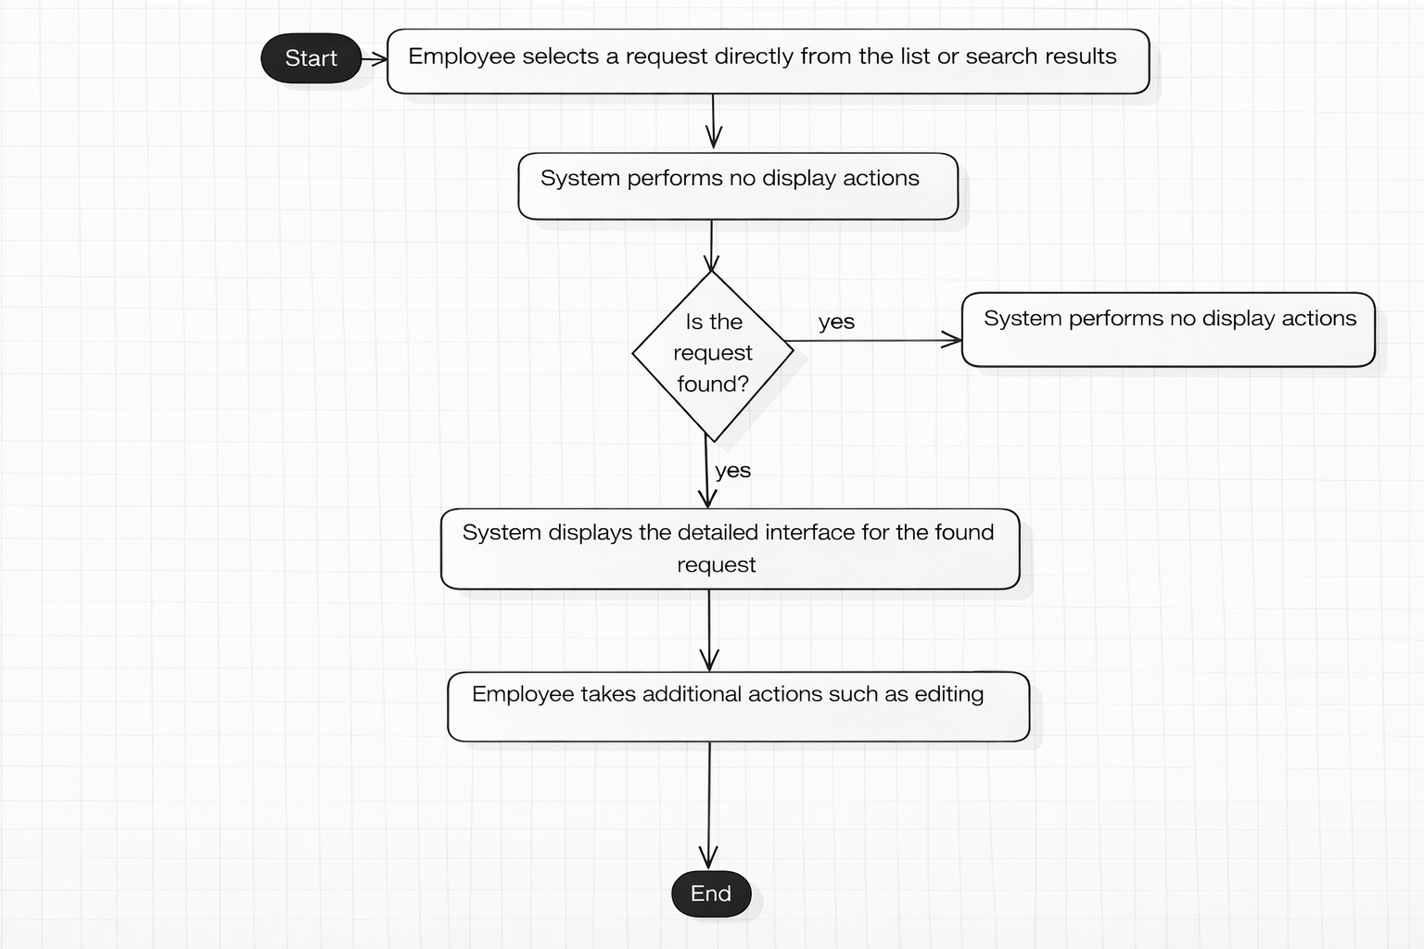
Figure 10 ACTIVITY FILTER APPLICATION
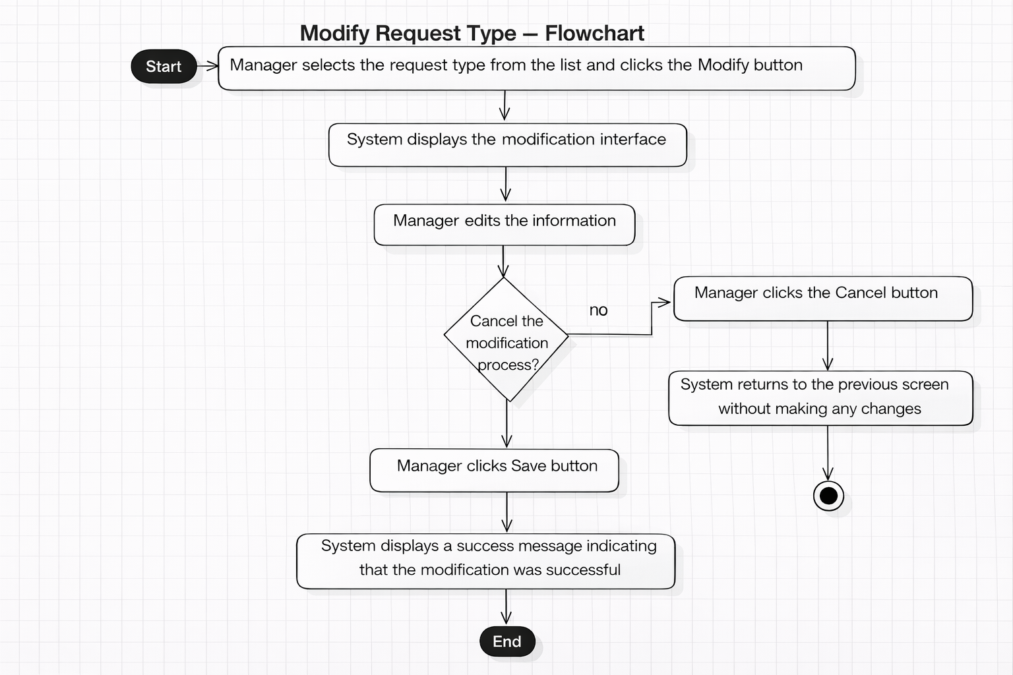
Figure 11 UPDATE APPLICATION TYPE
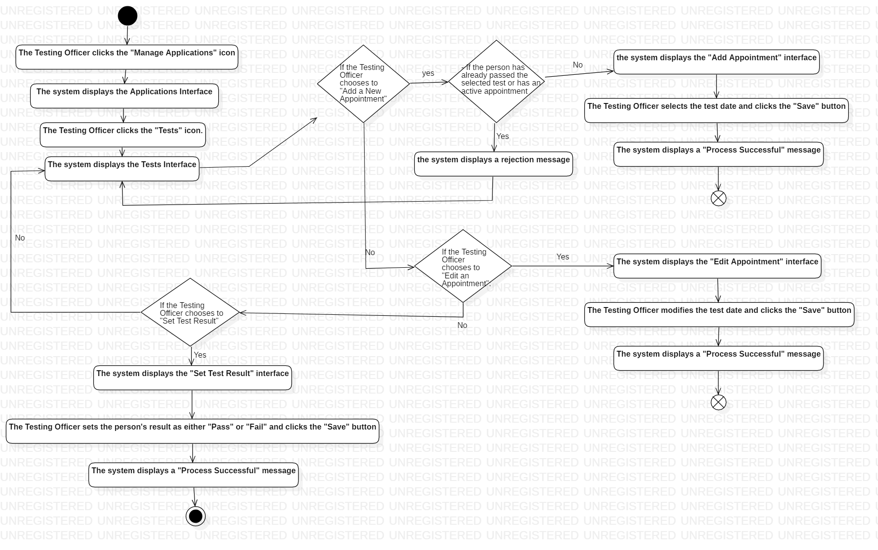
Figure 12 TEST APPLICATION
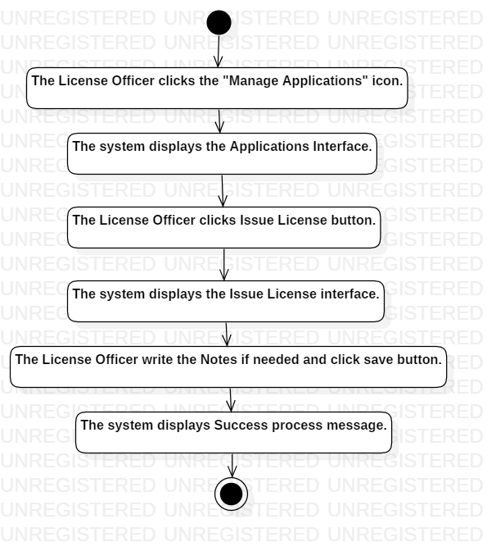
Figure 13 ISSUE LICENSE

4.6.3 Sequence Diagrams
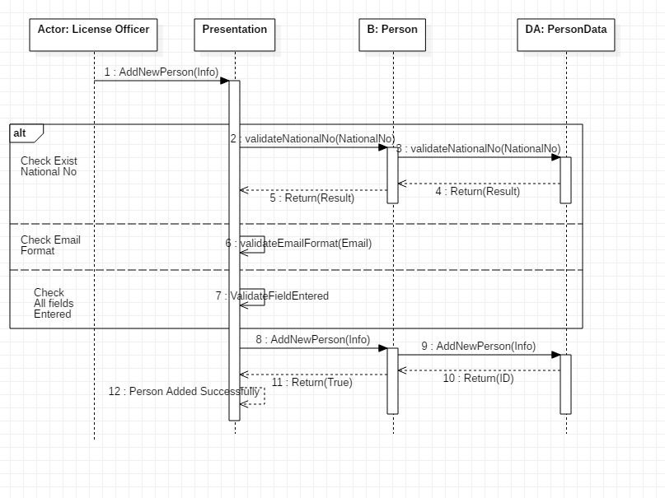
Figure 14 Sequence ADD PERSON
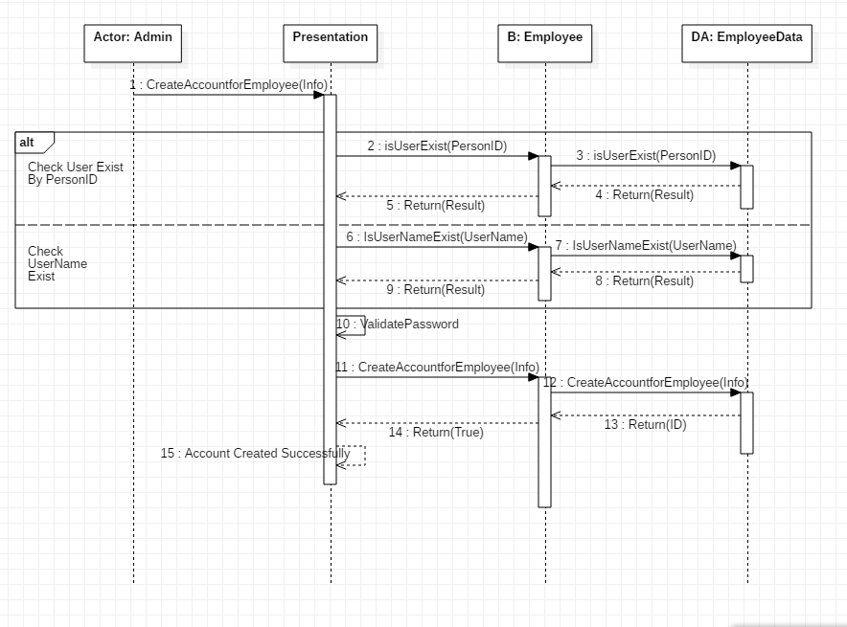
Figure 15 ADD EMPLOYEE
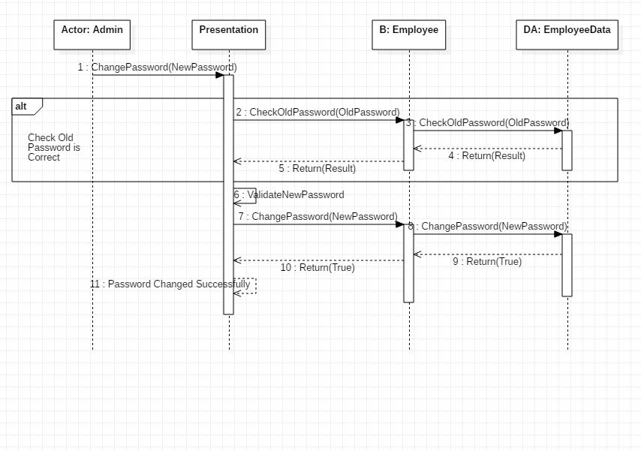
Figure 16 Sequence CHANGE PASSWORD

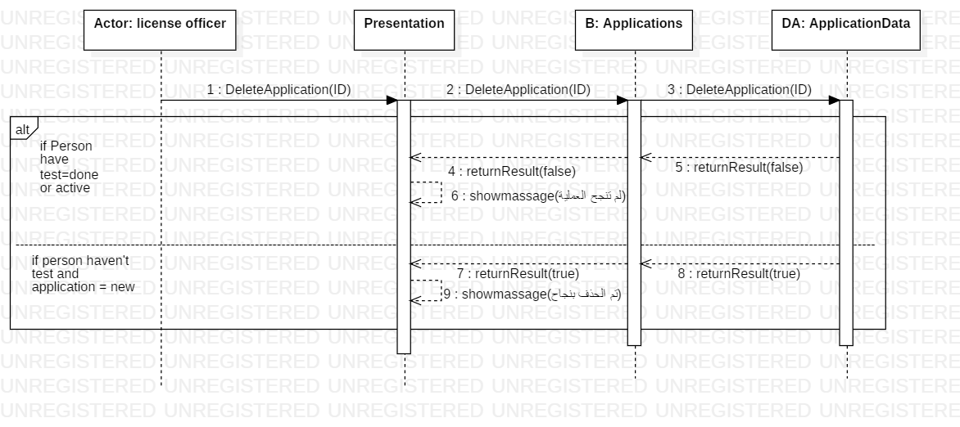
Figure 17 Sequence DELETE APPLICATION

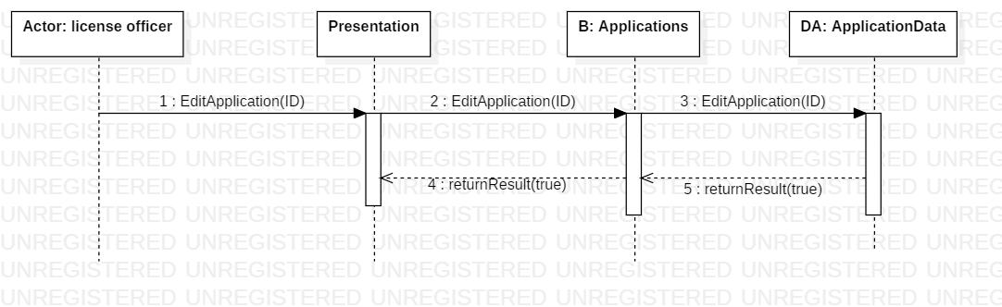
Figure 18 Sequence EDIT APPLICATION

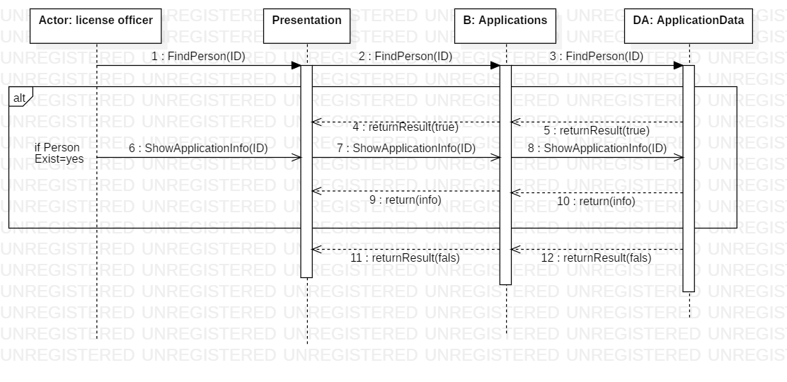
Figure 19 Sequence SHOW APPLICATION

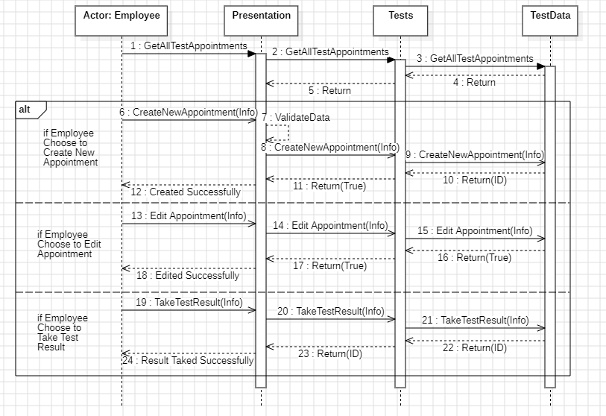
Figure 20 Sequence TEST APPLICATION
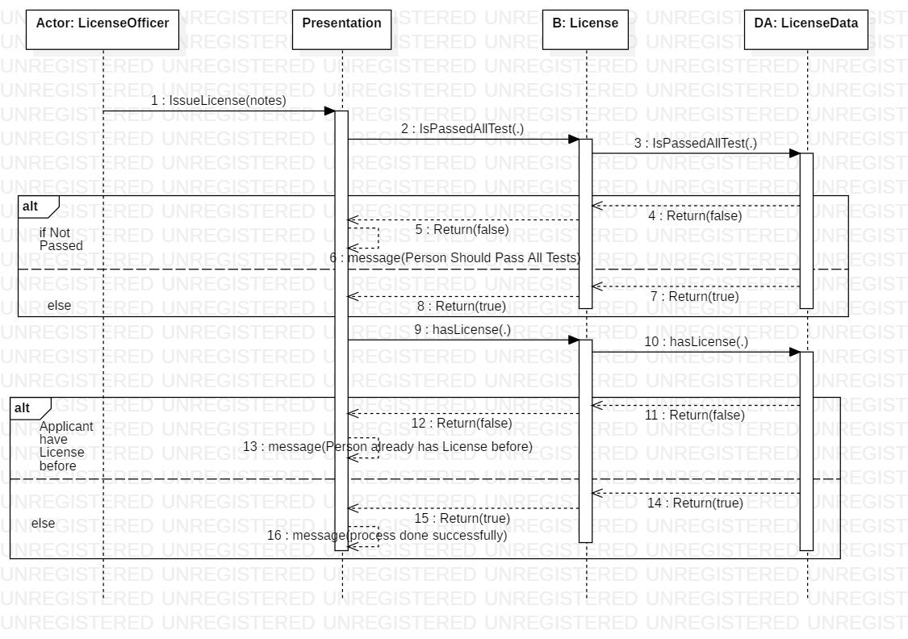
Figure 21 Sequence ISSUE LICENSE

4.6.4 Test Case Descriptions
Table 25 Test Case Descriptions
TC_01 | ID
Entering a correct username and password. | Title
1- Open the Login interface.  2- Enter the username and password.  3- Click the Login button. | Test Steps
Login successful. | Expected Result

TC_02 | ID
Entering an incorrect username or password. | Title
1- Open the Login interface.  2- Enter the username and password.  3- Click the Login button. | Test Steps
A login failure message appears. | Expected Result

TC_03 | ID
Leaving the username or password field empty. | Title
1- Open the Login interface.  2- Leave one of the two fields empty.  3- Click the Login button. | Test Steps
A login failure message appears due to an empty field. | Expected Result

TC_04 | ID
Logging in with an inactive account. | Title
1- Open the Login interface.  2- Enter the username and password.  3- Click the Login button. | Test Steps
A login failure message appears because the account is inactive. | Expected Result

TC_05 | ID
Adding a person and filling in all data correctly. | Title
1- Open the Add Person interface.  2- Fill in the required data.  3- Click the Save button. | Test Steps
Person added successfully. | Expected Result

TC_06 | ID
Entering a National No. that already exists while adding a person. | Title
1- Open the Add Person interface  2- Fill in the data (using a duplicate National No.). | Test Steps
A notification appears stating that the National No. already exists. | Expected Result

TC_07 | ID
Entering an email with an incorrect format while adding a person. | Title
1- Open the Add Person interface  2- Fill in the data . | Test Steps
A notification appears: "Please enter a valid email address." | Expected Result

TC_08 | ID
Leaving a required field empty while adding a person. | Title
1- Open the Add Person interface.  2- Fill in the data (leaving at least one required field empty).  3- Click the Save button. | Test Steps
A message appears: "Please fill in all required fields." | Expected Result

TC_09 | ID
Deleting a person who has not made any applications. | Title
1- Open the Manage People interface.  2- Select the target person.  3- Delete the person. | Test Steps
A success message appears. | Expected Result

TC_10 | ID
Deleting a person who has already made applications. | Title
1- Open the Manage People interface.  2- Select the target person.  3- Delete the person. | Test Steps
A failure message appears (indicating the person cannot be deleted due to linked records). | Expected Result

TC_11 | ID
Creating an account for an employee already existing as a person in the system with correct data entry. | Title
1- Open the Create Employee Account interface.  2- Search for the person.  3- Click the Next button.  4- Fill in the required account data.  5- Click the Save button. | Test Steps
A success message appears. | Expected Result

TC_12 | ID
Creating an account for an employee who does not exist as a person in the system. | Title
1- Open the Create Employee Account interface.  2- Search for the person. | Test Steps
A message appears: "Person not found." | Expected Result

TC_13 | ID
Mismatch between password and confirmation during employee account creation. | Title
1- Open the Create Employee Account interface.  2- Search for the person.  3- Click the Next button.  4- Fill in the data (entering different values in the password and confirmation fields). | Test Steps
A notification appears: "Passwords do not match." | Expected Result

TC_14 | ID
Deleting an employee who has not performed any tasks/actions. | Title
1- Open the Manage Employees interface.  2- Select the target employee.  3- Delete the employee. | Test Steps
A success message appears. | Expected Result

TC_15 | ID
Changing an employee's password and entering the old password correctly. | Title
1- Open the Change Password interface.  2- Fill in the required data.  3- Click the Save button. | Test Steps
A success message appears. | Expected Result

TC_16 | ID
Changing an employee's password and entering the old password incorrectly. | Title
1- Open the Change Password interface.  2- Fill in the data (including an incorrect old password). | Test Steps
A notification appears: "Incorrect password." | Expected Result

TC_17 | ID
Creating a local license and selecting a category for a first-time applicant. | Title
1- Open the Create Local License interface.  2- Fill in the required data.  3- Click the Save button. | Test Steps
A success message appears. | Expected Result

TC_18 | ID
Creating a local license and selecting a category for a person who already has an active application for the same category. | Title
1- Open the Create Local License interface.  2- Fill in the required data.  3- Click the Save button. | Test Steps
A message appears: "You cannot submit an application because the person already has an active application." | Expected Result

TC_19 | ID
Creating a local license and selecting a category for a person who already holds a license in the same category. | Title
1- Open the Create Local License interface.  2- Fill in the required data.  3- Click the Save button. | Test Steps
A message appears: "You cannot submit an application because the person already has a license in the same category." | Expected Result

TC_20 | ID
Deleting an application for a person who has not taken the tests yet. | Title
1- Open the Manage Applications interface.  2- Select the target application.  3- Delete the application. | Test Steps
A success message appears. | Expected Result

TC_21 | ID
Deleting an application for a person after they have completed the tests. | Title
1- Open the Manage Applications interface.  2- Select the target application.  3- Delete the application. | Test Steps
A failure message appears (indicating the application cannot be deleted because it is linked to existing test records). | Expected Result

TC_22 | ID
Canceling an application. | Title
1- Open the Manage Applications interface.  2- Select the target application.  3- Click on Cancel Application. | Test Steps
A success message appears. | Expected Result

TC_23 | ID
Appointment booking for the test | Title
1- Open the test management interface  2- Click the "Add Appointment" button  3- Select the appointment date  4- Click the "Save" button | Test Steps
A success message appears. | Expected Result

TC_24 | ID
Booking a test appointment for a user who already has an active appointment | Title
1- Open the test management interface  2- Click the "Add Appointment" button  3- Click the "Save" button | Test Steps
Displaying a "Transaction Failed" message due to an existing request | Expected Result

TC_25 | ID
Booking a test appointment for a person who has already passed the test | Title
1- Open the test management interface  2- Click the "Add Appointment" button  3- Click the "Save" button | Test Steps
Displaying a "Transaction Failed" message because the person has already passed this type of test | Expected Result

TC_26 | ID
Modifying a person's test appointment | Title
1- Open the test management interface  2- Open the appointment modification interface  3- Select the new appointment date  4- Click the "Save" button | Test Steps
A success message appears. | Expected Result

TC_27 | ID
Setting the test result for a person | Title
1- Open the test management interface  2- Open the test result entry interface  3- Set the person's test result  4- Click the "Save" button | Test Steps
A success message appears. | Expected Result

TC_28 | ID
Issuing a license to a person for the first time | Title
1- Open the request management interface  2- Select the request and click the "Issue License" button  3- Enter notes, if any  4- Click the "Save" button | Test Steps
A success message appears. | Expected Result

TC_29 | ID
Displaying all licenses for a person | Title
1- Open the request management interface  2- Select the request and click the "View Person's History" button | Test Steps
Displaying all licenses owned by the selected person | Expected Result

4.6.5 Modeling According to the Used Methodology
Since the project follows the Scrum methodology, the requirements were modeled and organized as user stories, product backlog items, and sprint tasks. Each feature was analyzed, implemented, tested, and reviewed during a specific sprint.

4.7 User Stories, Story Mapping, and Product Backlog

4.7.1 User Stories
01- As a license officer, I want to add a new person so that I can register their information in the system.
02- As a license officer, I want to edit an existing person’s information so that I can correct or update their data.
03- As a license officer, I want to view a person’s information so that I can verify their details.
04- As a license officer, I want to delete a person so that I can remove unnecessary records.
05- As a license officer, I want to filter people by name or national No ........ so that I can quickly find the required person.
06- As an admin, I want to create an account for a new employee so that they can access the system.
07- As an admin, I want to update employee information so that I can ensure their records remain accurate and current.
08- As an admin, I want to view employee information so that I can verify their details.
09- As a manager, I want to delete an employee so that I can ensure system security and prevent unauthorized access after they leave.
10- As an admin, I want to filter employees so that I can quickly find the required employee.
11- As an admin, I want to change employee’s password so that I can keep their account secure.
12- As a system user, I want to log in so that I can access the system.
13- As a system user, I want to view my account information so that I can verify my personal details.
14- As a system user, I want to change my password from my account page so that I can maintain security.
15- As a system user, I want to log out so that I can end my current session.
16- As an admin, I want to manage application types so that I can efficiently monitor categories and quickly update their details to keep the system running smoothly.
17- As a license officer, I want to view application information so that I can verify details.
18- As a license officer, I want to submit a local driving license request for a person so that they can obtain a local license.
19- As a license officer, I want to delete a local license application so that I can remove unnecessary requests.
20- As a license officer, I want to cancel a local license application so that I can stop the process if no longer needed.
21- As a license officer, I want to edit a local license application so that I can change the license class of this application.
22- As an employee, I want to filter applications by person’s name or status ..... so that I can quickly find the required application.
23 – as an admin, I want to manage test types so that the system maintains accurate and up-to-date information about available tests.
24 - as a test officer, I want to manage vision, written, and street tests so that applicants can complete the required examinations and their results are properly recorded
25- as a license officer, I want to create a first-time driving license for a person so that qualified applicants can legally drive
26- as a license officer, I want to view license information so that I can verify license details when needed
27- as a citizen, I want to create an application for a local license so that I can start the licensing process
28- as a citizen, I want to view my application information so that I can track the progress and details of my application.
29- As a citizen, I want to create a citizen account using my national number and personal information so that I can access the Citizen Portal services.
30- As a citizen, I want to log in to the Citizen Portal using my national number and password so that I can access my account securely.
31- As a citizen, I want to change my account password so that I can keep my account secure.
32- As a citizen, I want to use the portal in Arabic or English so that I can interact with the system in my preferred language.
33- As a citizen, I want the registration form to validate my entered data so that incorrect or incomplete information is not saved.

4.7.2 Story Mapping
Table 26 Story Mapping
User Activity | User Task | Related User Story | Priority | System Part
Person Management | Add a new person record | US-01 | Must | Desktop
Person Management | Edit person information | US-02 | Must | Desktop
Person Management | View person information | US-03 | Must | Desktop
Person Management | Delete person record | US-04 | Should | Desktop
Person Management | Search and filter people | US-05 | Must | Desktop
Employee Management | Create employee account | US-06 | Must | Desktop
Employee Management | Update employee information | US-07 | Must | Desktop
Employee Management | View employee information | US-08 | Must | Desktop
Employee Management | Delete employee account | US-09 | Should | Desktop
Employee Management | Search and filter employees | US-10 | Must | Desktop
User Account Management | Change employee password | US-11 | Must | Desktop
User Account Management | Employee login | US-12 | Must | Desktop
User Account Management | View current user information | US-13 | Should | Desktop
User Account Management | Change own password | US-14 | Must | Desktop
User Account Management | Logout | US-15 | Must | Desktop
Application Type Management | View and manage application types | US-16 | Should | Desktop
Application Management | View application information | US-17 | Must | Desktop
Application Management | Submit local license application for person | US-18 | Must | Desktop
Application Management | Delete local license application | US-19 | Should | Desktop
Application Management | Cancel local license application | US-20 | Should | Desktop
Application Management | Edit local license application | US-21 | Should | Desktop
Application Management | Search and filter applications | US-22 | Must | Desktop
Test Type Management | View and manage test types | US-23 | Should | Desktop
Test Management | Manage vision, written, and street tests | US-24 | Must | Desktop
License Management | Issue first-time driving license | US-25 | Must | Desktop
License Management | View license information | US-26 | Must | Desktop
Citizen Portal | Submit local driving license application | US-27 | Must | Web Portal
Citizen Portal | View application details, status, tests, and progress | US-28 | Must | Web Portal
Citizen Account Management | Create citizen account | US-29 | Must | Web Portal
Citizen Account Management | Login using national number and password | US-30 | Must | Web Portal
Citizen Account Management | Change citizen password | US-31 | Should | Web Portal
Citizen Portal Interface | Switch between Arabic and English | US-32 | Should | Web Portal
Citizen Registration Validation | Validate citizen registration fields | US-33 | Must | Web Portal

4.7.3 Product Backlog
Table 27 Product Backlog
Backlog ID | Product Backlog Item | Type | Actor | Priority | Related Sprint
PB-01 | Add a new person record to the system. | User Story | License Officer | Must | Sprint 1
PB-02 | Edit an existing person’s information. | User Story | License Officer | Must | Sprint 1
PB-03 | View person information. | User Story | License Officer | Must | Sprint 1
PB-04 | Delete a person record when allowed. | User Story | License Officer | Should | Sprint 1
PB-05 | Search and filter people by name or national number. | User Story | License Officer | Must | Sprint 1
PB-06 | Create a new employee account. | User Story | Admin | Must | Sprint 2
PB-07 | Update employee information. | User Story | Admin | Must | Sprint 2
PB-08 | View employee information. | User Story | Admin | Must | Sprint 2
PB-09 | Delete an employee account when allowed. | User Story | Manager / Admin | Should | Sprint 2
PB-10 | Search and filter employees. | User Story | Admin | Must | Sprint 2
PB-11 | Change an employee’s password. | User Story | Admin | Must | Sprint 2
PB-12 | Log in to the system. | User Story | System User | Must | Sprint 2
PB-13 | View current account information. | User Story | System User | Should | Sprint 2
PB-14 | Change password from the user account page. | User Story | System User | Must | Sprint 2
PB-15 | Log out from the system. | User Story | System User | Must | Sprint 2
PB-16 | View and manage application types. | User Story | Admin | Should | Sprint 3
PB-17 | View application information. | User Story | License Officer | Must | Sprint 3
PB-18 | Submit a local driving license application for a person. | User Story | License Officer | Must | Sprint 3
PB-19 | Delete a local driving license application when allowed. | User Story | License Officer | Should | Sprint 3
PB-20 | Cancel a local driving license application. | User Story | License Officer | Should | Sprint 3
PB-21 | Edit a local driving license application. | User Story | License Officer | Should | Sprint 3
PB-22 | Search and filter applications by name, status, or other criteria. | User Story | Employee | Must | Sprint 3
PB-23 | View and manage test types. | User Story | Admin | Should | Sprint 4
PB-24 | Manage vision, written, and street tests. | User Story | Test Officer | Must | Sprint 4
PB-25 | Issue a first-time driving license for qualified applicants. | User Story | License Officer | Must | Sprint 5
PB-26 | View license information. | User Story | License Officer | Must | Sprint 5
PB-27 | Submit a local driving license application through the Citizen Portal. | User Story | Citizen | Must | Sprint 6
PB-28 | View citizen application details, status, tests, and progress. | User Story | Citizen | Must | Sprint 6
PB-29 | Create a citizen account using national number and personal information. | User Story | Citizen | Must | Sprint 6
PB-30 | Log in to the Citizen Portal using national number and password. | User Story | Citizen | Must | Sprint 6
PB-31 | Change citizen account password. | User Story | Citizen | Should | Sprint 6
PB-32 | Support Arabic and English interfaces in the Citizen Portal. | UI / Feature | Citizen | Should | Sprint 6
PB-33 | Validate citizen registration fields such as national number, email, age, gender, image, country, and password. | Validation Task | Citizen | Must | Sprint 6

4.8 Initial RTM Table
Table 28 Initial RTM Table
Req-ID | Use Cases | Analysis | System Design | Detailed Design | Coding | Test Cases
RE-FR-PM-01 | UC_01 | PM-AN |  |  |  | TC_05  TC_06  TC_07  TC_08
RE-FR-PM-02 | UC_02 | PM-AN |  |  |  | —
RE-FR-PM-03 | UC_03 | PM-AN |  |  |  | TC_09  TC_10
RE-FR-PM-04 | UC_04 | PM-AN |  |  |  | —
RE-FR-PM-05 | UC_05 | PM-AN |  |  |  | —
RE-FR-EM-06 | UC_06 | EM-AN |  |  |  | TC_14
RE-FR-EM-07 | UC_07 | EM-AN |  |  |  | TC_15  TC_16
RE-FR-EM-08 | UC_08 | EM-AN |  |  |  | TC_11  TC_12  TC_13
RE-FR-EM-09 | UC_09 | EM-AN |  |  |  | —
RE-FR-EM-10 | UC_10 | EM-AN |  |  |  | —
RE-FR-UA-11 | UC_11 | UA-AN |  |  |  | —
RE-FR-UA-12 | UC_12 | UA-AN |  |  |  | TC_01  TC_02  TC_03  TC_04
RE-FR-UA-13 | UC_13 | UA-AN |  |  |  | —
RE-FR-UA-14 | UC_14 | UA-AN |  |  |  | TC_15  TC_16
RE-FR-UA-15 | UC_15 | UA-AN |  |  |  | —
RE-FR-AM-16 | UC_16 | AM-AN |  |  |  | —
RE-FR-AM-17 | UC_17 | AM-AN |  |  |  | —
RE-FR-AM-18 | UC_18 | AM-AN |  |  |  | —
RE-FR-AM-19 | UC_19 | AM-AN |  |  |  | TC_17  TC_18  TC_19
RE-FR-AM-20 | UC_20 | AM-AN |  |  |  | TC_20  TC_21
RE-FR-AM-21 | UC_21 | AM-AN |  |  |  | TC_22
RE-FR-AM-22 | UC_22 | AM-AN |  |  |  | —
RE-FR-TM-23 | UC_23 | TM-AN |  |  |  | —
RE-FR-TM-24 | UC_24 | TM-AN |  |  |  | TC_23  TC_24  TC_25  TC_26  TC_27
RE-FR-LM-25 | UC_25 | LM-AN |  |  |  | TC_28
RE-FR-LM-26 | UC_26 | LM-AN |  |  |  | TC_29
RE-FR-CP-27 | UC_27 | CP-AN |  |  |  | TC_17  TC_18  TC_19
RE-FR-CP-28 | UC_30 | CP-AN |  |  |  | —
RE-FR-CA-29 | UC_31 | CA-AN |  |  |  | —
RE-FR-CA-30 | UC_32 | CA-AN |  |  |  | TC_01  TC_02  TC_03  TC_04
RE-FR-CA-31 | UC_33 | CA-AN |  |  |  | TC_15  TC_16
RE-FR-LG-32 | UC_34 | LG-AN |  |  |  | —
RE-FR-VA-33 | UC_35 | VA-AN |  |  |  | TC_06  TC_07  TC_12  TC_13

Chapter 5

System Design

5.1 Architectural Design Pattern Used
The system uses a Layered Architecture combined with the MVC pattern in the Citizen Web Portal.

Layered Architecture
The original DVLD system was already designed using a layered structure. This structure separates the system into three main layers:
Layer | Description
Presentation Layer | Represents the user interfaces, including the Desktop Application and the Citizen Web Portal
Business Logic Layer | Contains the main system rules and operations
Data Access Layer | Handles communication with the SQL Server database
This architecture was suitable for the project because the goal was to reuse the existing system logic and database instead of rebuilding everything from the beginning.

MVC Pattern
The Citizen Web Portal uses the ASP.NET Core MVC pattern. MVC divides the web application into three main parts:
MVC Part | Role in the System
Model / ViewModel | Represents data and validation rules
View | Represents the HTML web pages shown to the citizen
Controller | Receives user requests and connects the View with the Business Logic Layer
For example, the AccountController handles login, registration, and password change requests. The HomeController handles the citizen dashboard, profile page, local license application page, and application tracking page.

5.2 System Architecture Design
The DVLD system architecture consists of the following main components:
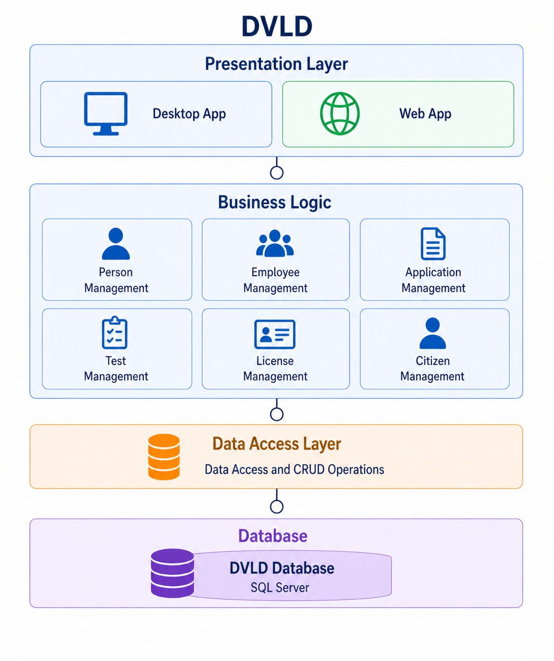

5.3 ER Diagram
The Entity Relationship Diagram represents the main entities in the DVLD system and the relationships between them.
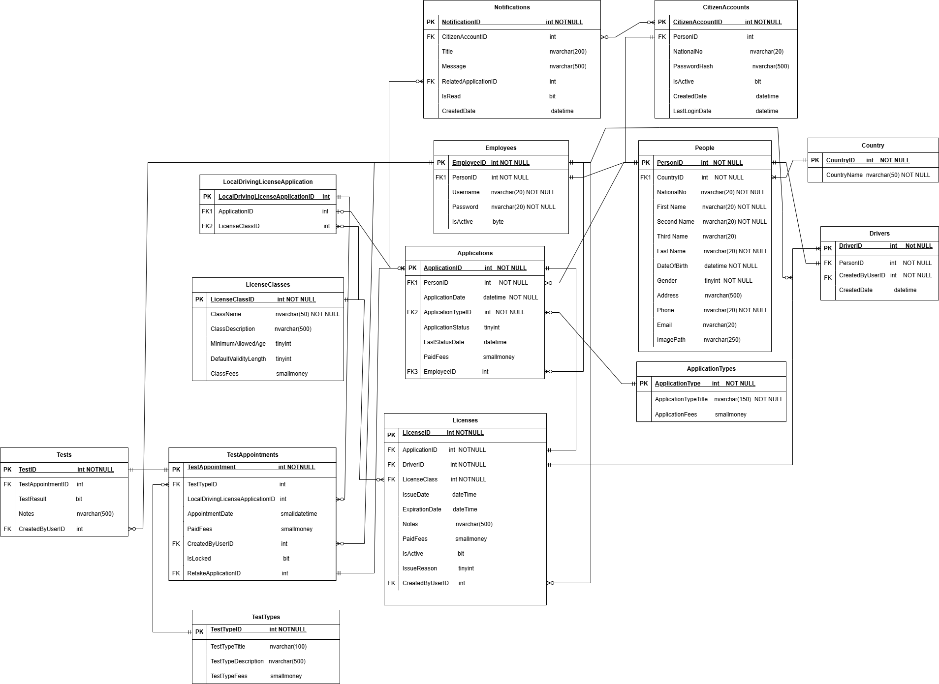

Chapter 6

Practical Implementation

6.1 Software Tools and Libraries Used
Tool / Library | Purpose
Visual Studio | Main IDE for developing the Desktop and Web projects
SQL Server | Database management system
SQL Server Management Studio | Database design, queries, and table management
C# | Main programming language
.NET Framework | Runs the existing Desktop application
WinForms | Builds the employee Desktop interface
ASP.NET Core MVC | Builds the Citizen Web Portal
ADO.NET | Connects the application layers with SQL Server
HTML / CSS | Builds and styles web pages
Data Annotations | Validates ViewModel input fields
Session Management | Manages citizen login sessions
Web Browser | Tests the Citizen Portal

6.2 Development Environment and Project Structure
The project is organized using a layered structure. The existing Desktop application is kept for employees, while a new ASP.NET Core MVC Citizen Portal is added for citizens.

Project Part | Description
Desktop Application | Used by employees to manage people, applications, tests, and licenses
DVLD_Buisness | Contains business rules and main system operations
DVLD_DataAccess | Handles database communication
DVLD.CitizenPortal | Provides citizen services through a web interface

6.3 Programming Languages and Frameworks
Technology | Used For
C# | Main system programming
SQL | Database queries
.NET Framework | Existing Desktop application
WinForms | Desktop user interface
ASP.NET Core MVC | Citizen Web Portal
HTML | Web page structure
CSS | Web page styling
ADO.NET | Database connection
The Citizen Portal uses the MVC pattern:
MVC Part | Role
Model / ViewModel | Data and validation
View | User interface
Controller | Handles requests and connects views with business logic

6.4 Database and Operating System
Component | Used Technology
Database | SQL Server
Operating System | Windows
IDE | Visual Studio
Desktop Runtime | .NET Framework
Web Runtime | ASP.NET Core
Browser | Modern Web Browser
The same SQL Server database is used by both the Desktop application and the Citizen Portal. This allows citizens’ requests to be submitted through the Web Portal and processed later by employees through the Desktop application.

6.5 Test Cases Execution: Table 29 Test Cases Execution
TC_01 | ID
Entering a correct username and password. | Title
1- Open the Login interface.  2- Enter the username and password.  3- Click the Login button. | Test Steps
Login successful. | Expected Result
Login successful. | Actual Result
Pass | Pass/Fail

TC_02 | ID
Entering an incorrect username or password. | Title
1- Open the Login interface.  2- Enter the username and password.  3- Click the Login button. | Test Steps
A login failure message appears. | Expected Result
A login failure message appears. | Actual Result
Pass | Pass/Fail

TC_03 | ID
Leaving the username or password field empty. | Title
1- Open the Login interface.  2- Leave one of the two fields empty.  3- Click the Login button. | Test Steps
A login failure message appears due to an empty field. | Expected Result
A login failure message appears due to an empty field. | Actual Result
Pass | Pass/Fail

TC_04 | ID
Logging in with an inactive account. | Title
1- Open the Login interface.  2- Enter the username and password.  3- Click the Login button. | Test Steps
A login failure message appears because the account is inactive. | Expected Result
A login failure message appears because the account is inactive. | Actual Result
Pass | Pass/Fail

TC_05 | ID
Adding a person and filling in all data correctly. | Title
1- Open the Add Person interface.  2- Fill in the required data.  3- Click the Save button. | Test Steps
Person added successfully. | Expected Result
Person added successfully. | Actual Result
Pass | Pass/Fail
TC_06 | ID
Entering a National No. that already exists while adding a person. | Title
1- Open the Add Person interface  2- Fill in the data (using a duplicate National No.). | Test Steps
A notification appears stating that the National No. already exists. | Expected Result
A notification appears stating that the National No. already exists. | Actual Result
Pass | Pass/Fail

TC_07 | ID
Entering an email with an incorrect format while adding a person. | Title
1- Open the Add Person interface  2- Fill in the data . | Test Steps
A notification appears: "Please enter a valid email address." | Expected Result
A notification appears: "Please enter a valid email address." | Actual Result
Pass | Pass/Fail

TC_08 | ID
Leaving a required field empty while adding a person. | Title
1- Open the Add Person interface.  2- Fill in the data (leaving at least one required field empty).  3- Click the Save button. | Test Steps
A message appears: "Please fill in all required fields." | Expected Result
A message appears: "Please fill in all required fields." | Actual Result
Pass | Pass/Fail
TC_09 | ID
Deleting a person who has not made any applications. | Title
1- Open the Manage People interface.  2- Select the target person.  3- Delete the person. | Test Steps
A success message appears. | Expected Result
A success message appears. | Actual Result
Pass | Pass/Fail

TC_10 | ID
Deleting a person who has already made applications. | Title
1- Open the Manage People interface.  2- Select the target person.  3- Delete the person. | Test Steps
A failure message appears (indicating the person cannot be deleted due to linked records). | Expected Result
A failure message appears (indicating the person cannot be deleted due to linked records). | Actual Result
Pass | Pass/Fail

TC_11 | ID
Creating an account for an employee already existing as a person in the system with correct data entry. | Title
1- Open the Create Employee Account interface.  2- Search for the person.  3- Click the Next button.  4- Fill in the required account data.  5- Click the Save button. | Test Steps
A success message appears. | Expected Result
A success message appears. | Actual Result
Pass | Pass/Fail

TC_12 | ID
Creating an account for an employee who does not exist as a person in the system. | Title
1- Open the Create Employee Account interface.  2- Search for the person. | Test Steps
A message appears: "Person not found." | Expected Result
A message appears: "Person not found." | Actual Result
Pass | Pass/Fail

TC_13 | ID
Mismatch between password and confirmation during employee account creation. | Title
1- Open the Create Employee Account interface.  2- Search for the person.  3- Click the Next button.  4- Fill in the data (entering different values in the password and confirmation fields). | Test Steps
A notification appears: "Passwords do not match." | Expected Result
A notification appears: "Passwords do not match." | Actual Result
Pass | Pass/Fail

TC_14 | ID
Deleting an employee who has not performed any tasks/actions. | Title
1- Open the Manage Employees interface.  2- Select the target employee.  3- Delete the employee. | Test Steps
A success message appears. | Expected Result
A success message appears. | Actual Result
Pass | Pass/Fail

TC_15 | ID
Changing an employee's password and entering the old password correctly. | Title
1- Open the Change Password interface.  2- Fill in the required data.  3- Click the Save button. | Test Steps
A success message appears. | Expected Result
A success message appears. | Actual Result
Pass | Pass/Fail

TC_16 | ID
Changing an employee's password and entering the old password incorrectly. | Title
1- Open the Change Password interface.  2- Fill in the data (including an incorrect old password). | Test Steps
A notification appears: "Incorrect password." | Expected Result
A notification appears: "Incorrect password." | Actual Result
Pass | Pass/Fail

TC_17 | ID
Creating a local license app and selecting a category for a first-time applicant. | Title
1- Open the Create Local License interface.  2- Fill in the required data.  3- Click the Save button. | Test Steps
A success message appears. | Expected Result
A success message appears. | Actual Result
Pass | Pass/Fail

TC_18 | ID
Creating a local license app and selecting a category for a person who already has an active application for the same category. | Title
1- Open the Create Local License interface.  2- Fill in the required data.  3- Click the Save button. | Test Steps
A message appears: "You cannot submit an application because the person already has an active application." | Expected Result
A message appears: "You cannot submit an application because the person already has an active application." | Actual Result
Pass | Pass/Fail

TC_19 | ID
Creating a local license app and selecting a category for a person who already holds a license in the same category. | Title
1- Open the Create Local License interface.  2- Fill in the required data.  3- Click the Save button. | Test Steps
A message appears: "You cannot submit an application because the person already has a license in the same category." | Expected Result
A message appears: "You cannot submit an application because the person already has a license in the same category." | Actual Result
Pass | Pass/Fail

TC_20 | ID
Deleting an application for a person who has not taken the tests yet. | Title
1- Open the Manage Applications interface.  2- Select the target application.  3- Delete the application. | Test Steps
A success message appears. | Expected Result
A success message appears. | Actual Result
Pass | Pass/Fail

TC_21 | ID
Deleting an application for a person after they have completed the tests. | Title
1- Open the Manage Applications interface.  2- Select the target application.  3- Delete the application. | Test Steps
A failure message appears (indicating the application cannot be deleted because it is linked to existing test records). | Expected Result
A failure message appears (indicating the application cannot be deleted because it is linked to existing test records). | Actual Result
Pass | Pass/Fail

TC_22 | ID
Canceling an application. | Title
1- Open the Manage Applications interface.  2- Select the target application.  3- Click on Cancel Application. | Test Steps
A success message appears. | Expected Result
A success message appears. | Actual Result
Pass | Pass/Fail

TC_23 | ID
Appointment booking for the test | Title
1- Open the test management interface  2- Click the "Add Appointment" button  3- Select the appointment date  4- Click the "Save" button | Test Steps
A success message appears. | Expected Result
A success message appears. | Actual Result
Pass | Pass/Fail

TC_24 | ID
Booking a test appointment for a user who already has an active appointment | Title
1- Open the test management interface  2- Click the "Add Appointment" button  3- Click the "Save" button | Test Steps
Displaying a "Transaction Failed" message due to an existing request | Expected Result
Displaying a "Transaction Failed" message due to an existing request | Actual Result
Pass | Pass/Fail

TC_25 | ID
Booking a test appointment for a person who has already passed the test | Title
1- Open the test management interface  2- Click the "Add Appointment" button  3- Click the "Save" button | Test Steps
Displaying a "Transaction Failed" message because the person has already passed this type of test | Expected Result
Displaying a "Transaction Failed" message because the person has already passed this type of test | Actual Result
Pass | Pass/Fail

TC_26 | ID
Modifying a person's test appointment | Title
1- Open the test management interface  2- Open the appointment modification interface  3- Select the new appointment date  4- Click the "Save" button | Test Steps
A success message appears. | Expected Result
A success message appears. | Actual Result
Pass | Pass/Fail

TC_27 | ID
Setting the test result for a person | Title
1- Open the test management interface  2- Open the test result entry interface  3- Set the person's test result  4- Click the "Save" button | Test Steps
A success message appears. | Expected Result
A success message appears. | Actual Result
Pass | Pass/Fail

TC_28 | ID
Issuing a license to a person for the first time | Title
1- Open the request management interface  2- Select the request and click the "Issue License" button  3- Enter notes, if any  4- Click the "Save" button | Test Steps
A success message appears. | Expected Result
A success message appears. | Actual Result
Pass | Pass/Fail

TC_29 | ID
Displaying all licenses for a person | Title
1- Open the request management interface  2- Select the request and click the "View Person's History" button | Test Steps
Displaying all licenses owned by the selected person | Expected Result
Displaying all licenses owned by the selected person | Actual Result
Pass | Pass/Fail

6.6 RTM Table
Table 30 RTM
Req-ID | Use Cases | Analysis | System Design | Detailed Design | Coding | Test Cases
RE-FR-PM-01 | UC_01 | PM-AN | AM-DL-01 |  | source | TC_05  TC_06  TC_07  TC_08
RE-FR-PM-02 | UC_02 | PM-AN | AM-DL-01 |  | source | —
RE-FR-PM-03 | UC_03 | PM-AN | AM-DL-01 |  | source | TC_09  TC_10
RE-FR-PM-04 | UC_04 | PM-AN | AM-DL-01 |  | source | —
RE-FR-PM-05 | UC_05 | PM-AN | AM-DL-01 |  | source | —
RE-FR-EM-06 | UC_06 | EM-AN | AM-DL-01 |  | source | TC_14
RE-FR-EM-07 | UC_07 | EM-AN | AM-DL-01 |  | source | TC_15  TC_16
RE-FR-EM-08 | UC_08 | EM-AN | AM-DL-01 |  | source | TC_11  TC_12  TC_13
RE-FR-EM-09 | UC_09 | EM-AN | AM-DL-01 |  | source | —
RE-FR-EM-10 | UC_10 | EM-AN | AM-DL-01 |  | source | —
RE-FR-UA-11 | UC_11 | UA-AN | AM-DL-01 |  | source | —
RE-FR-UA-12 | UC_12 | UA-AN | AM-DL-01 |  | source | TC_01  TC_02  TC_03  TC_04
RE-FR-UA-13 | UC_13 | UA-AN | AM-DL-01 |  | source | —
RE-FR-UA-14 | UC_14 | UA-AN | AM-DL-01 |  | source | TC_15  TC_16
RE-FR-UA-15 | UC_15 | UA-AN | AM-DL-01 |  | source | —
RE-FR-AM-16 | UC_16 | AM-AN | AM-DL-01 |  | source | —
RE-FR-AM-17 | UC_17 | AM-AN | AM-DL-01 |  | source | —
RE-FR-AM-18 | UC_18 | AM-AN | AM-DL-01 |  | source | —
RE-FR-AM-19 | UC_19 | AM-AN | AM-DL-01 |  | source | TC_17  TC_18  TC_19
RE-FR-AM-20 | UC_20 | AM-AN | AM-DL-01 |  | source | TC_20  TC_21
RE-FR-AM-21 | UC_21 | AM-AN | AM-DL-01 |  | source | TC_22
RE-FR-AM-22 | UC_22 | AM-AN | AM-DL-01 |  | source | —
RE-FR-TM-23 | UC_23 | TM-AN | AM-DL-01 |  | source | —
RE-FR-TM-24 | UC_24 | TM-AN | AM-DL-01 |  | source | TC_23  TC_24  TC_25  TC_26  TC_27
RE-FR-LM-25 | UC_25 | LM-AN | AM-DL-01 |  | source | TC_28
RE-FR-LM-26 | UC_26 | LM-AN | AM-DL-01 |  | source | TC_29
RE-FR-CP-27 | UC_27 | CP-AN | AM-DL-01 |  | source | TC_17  TC_18  TC_19
RE-FR-CP-28 | UC_30 | CP-AN | AM-DL-01 |  | source | —
RE-FR-CA-29 | UC_31 | CA-AN | AM-DL-01 |  | source | —
RE-FR-CA-30 | UC_32 | CA-AN | AM-DL-01 |  | source | TC_01  TC_02  TC_03  TC_04
RE-FR-CA-31 | UC_33 | CA-AN | AM-DL-01 |  | source | TC_15  TC_16
RE-FR-LG-32 | UC_34 | LG-AN | AM-DL-01 |  | source | —
RE-FR-VA-33 | UC_35 | VA-AN | AM-DL-01 |  | source | TC_06  TC_07  TC_12  TC_13

Chapter 7

Appendices and References

Appendices
The appendices include supporting materials related to requirements collection, system analysis, and detailed design. These materials are separated from the main chapters because they provide additional details that support the project documentation.

Appendix A: Requirements Elicitation Questionnaires
This appendix includes the questionnaires and questions used to collect the system requirements from the main stakeholders. The purpose of these questionnaires was to understand the needs of citizens, license officers, test officers, system administrators, and institution management.
Area | Sample Questions
Citizen Services | What services should be provided through the Citizen Portal?
Account Management | Should citizens log in using their national number?
Application Submission | What information is required to submit a local driving license application?
Application Tracking | What application details should citizens be able to view?
Test Information | Should citizens view test appointments, results, and attempts?
User Interface | Should the portal support Arabic and English?
Security | How should passwords and user sessions be protected?

Appendix B: Detailed Design
This appendix includes the detailed design diagrams that describe the internal structure of the DVLD system. It focuses mainly on class diagrams and the relationships between the main objects.

Appendix B.1: Class Diagrams and Detailed Relationships
The class diagram represents the main classes used in the system and shows how they are related. The DVLD system follows a layered structure, where the presentation layer is separated from the Business Logic Layer and the Data Access Layer.
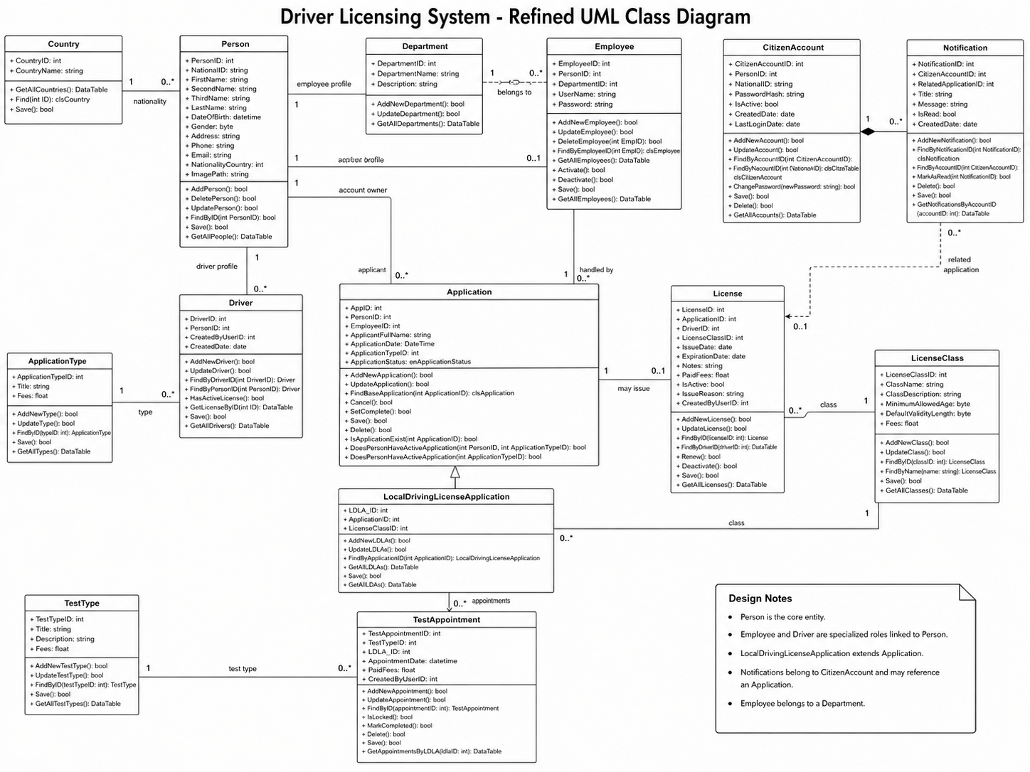

References

Arabic and English References
Table 31 Arabic and English References
No. | Reference
1 | Sommerville, I. Software Engineering. Pearson Education.
2 | Pressman, R. S. Software Engineering: A Practitioner’s Approach. McGraw-Hill.
3 | IEEE. Software Requirements Specification Guidelines.
4 | Schwaber, K., & Sutherland, J. The Scrum Guide.

Websites
Table 32 Websites
No. | Website / Source | Purpose
1 | Microsoft Learn - ASP.NET Core MVC Documentation | Used as a reference for ASP.NET Core MVC concepts and web application structure. Microsoft describes ASP.NET Core MVC as a framework for building web apps and APIs using the MVC design pattern.
2 | Microsoft Learn - SQL Server Documentation | Used as a reference for SQL Server database concepts and development documentation.
3 | Scrum Guides | Used as a reference for Scrum methodology, including Scrum roles, events, artifacts, and rules.
4 | RTA Dubai / UAE Government Portal | Used as a reference example for digital driving license services in Dubai and the UAE.
5 | GOV.UK / DVLA Driving Licence Services | Used as a reference example for online driving licence services in the United Kingdom.

Research Papers and Academic Resources
No. | Research Area
1 | Software Requirements Engineering
2 | Layered Software Architecture
3 | Web-Based Government Services
4 | Database Integration in Enterprise Systems
5 | Authentication and Password Security
6 | Usability in Web Portals

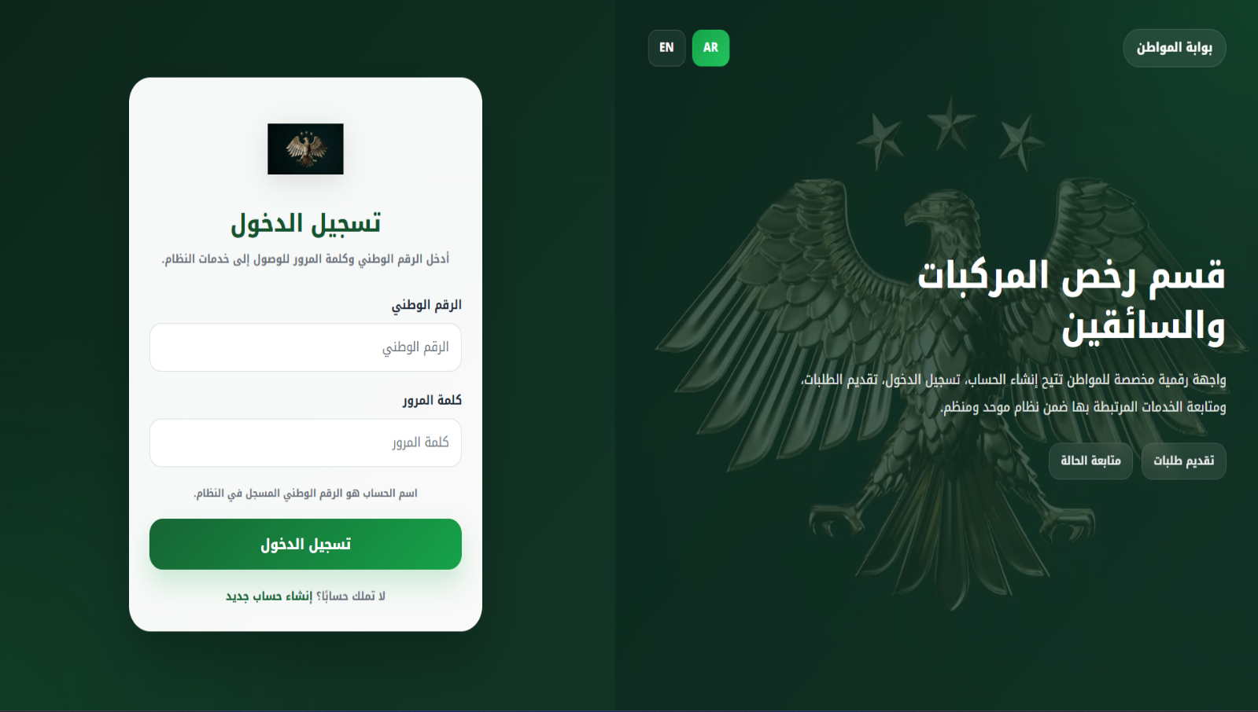
B2: User Experience Design (Prototypes, Structural Diagrams) User Experience and User Interface Design Final System Screenshots

