

Electrical and Computer Engineering

COMPUTER ORGANIZATION AND MICROPROCESSOR

ENCS2380

Instructor:

Dr.Ayman Hroub

Done by:

Alhasan Manasra - 1211705

Hamza Al shaer - 1211162

Hamzah Alqam - 1211173

Date of Submission: 18-6- 2023

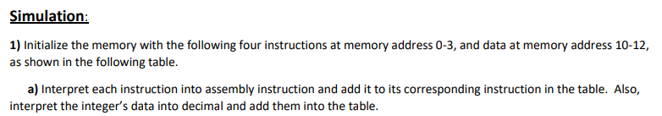

|  |  |  |
| --- | --- | --- |
| Memory Address | Content | Content interpretation: assembly instruction +  data in decimal |
| 0 | 0x180A | Load [10] |
| 1 | 0x580B | Mull [11] |
| 3 | 0x3005 | ADD #5 |
| 4 | 0x280C | Store [12] |
| ******** | ********* | ****** Data ************************** |
| 10 | 0x0009 | 9 |
| 11 | 0xFFFC | -4 |
| 12 | 0x0000 | 0 |



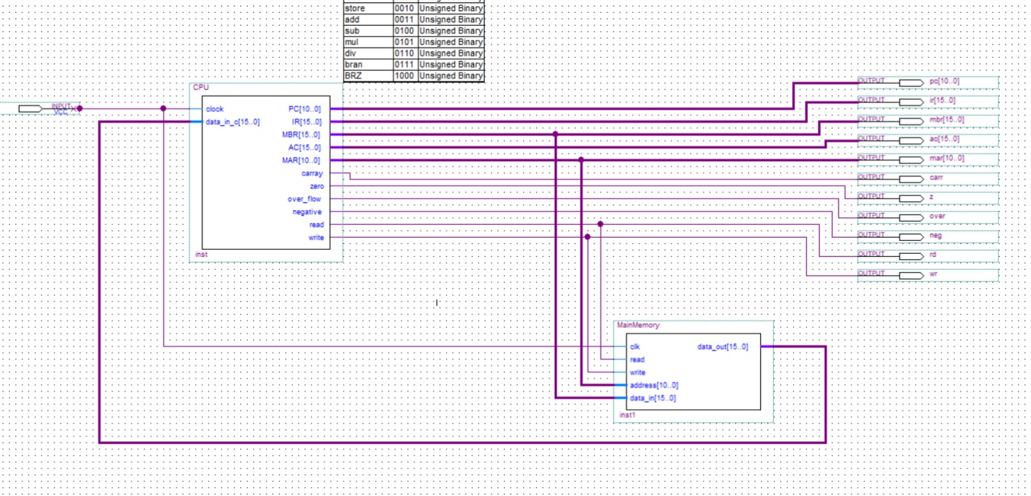

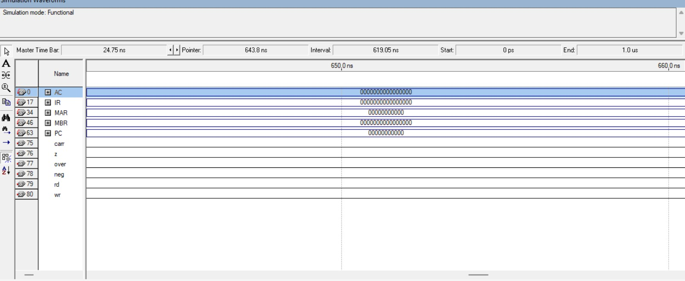

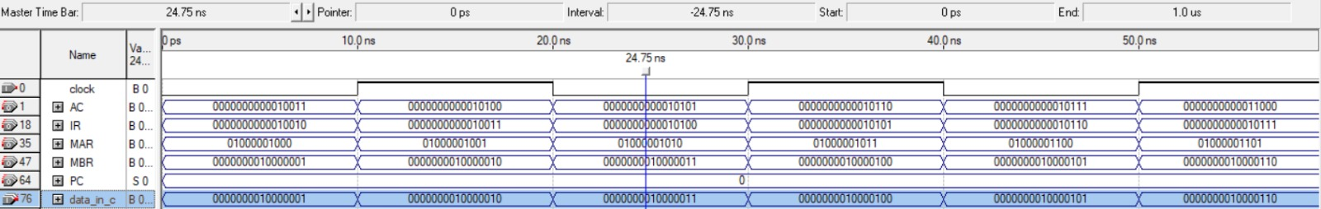

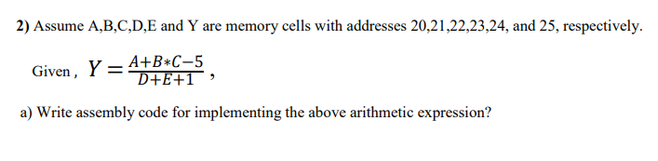

***Solution :-***

**Load [21];**

**Mul [22];**

**ADD [20];**

**Sub #5;**

**Store [21];**

**Load [23];**

**ADD [24];**

**ADD #1;**

**Store [24];**

**Load [21];**

**Div [24];**

**Store [25];**



|  |  |
| --- | --- |
| **address** | **content** |
| 0 | 0001 1000 0001 0101 |
| 1 | 0101 1000 0001 0110 |
| 2 | 0011 1000 0001 0100 |
| 3 | 0100 0000 0000 0101 |
| 4 | 0010 1000 0001 0101 |
| 5 | 0001 1000 0001 0111 |
| 6 | 0011 1000 0001 1000 |
| 7 | 0011 0000 0000 0001 |
| 8 | 0010 1000 0001 1000 |
| 9 | 0001 1000 0001 0101 |
| 10 | 0110 1000 0001 1000 |
| 11 | 0010 1000 0001 1001 |

***Solution :-***

