

Завдання 1

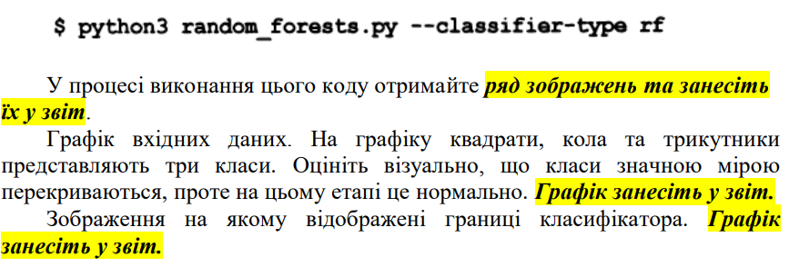

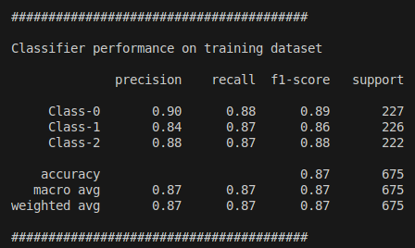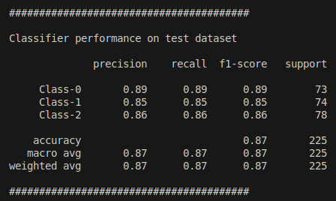

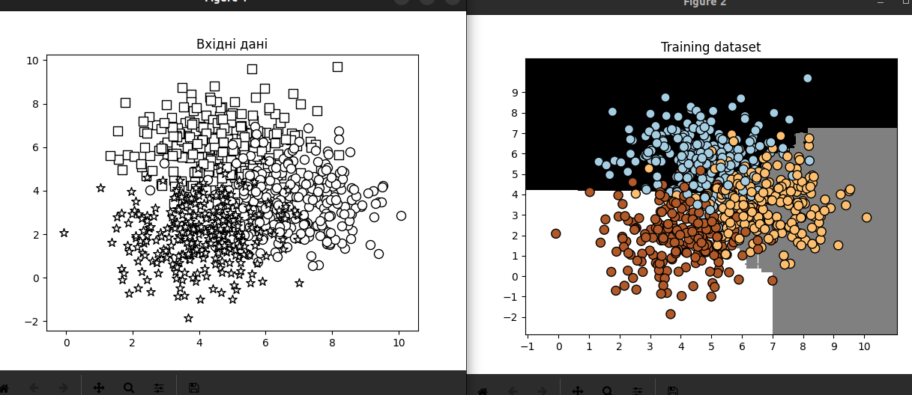

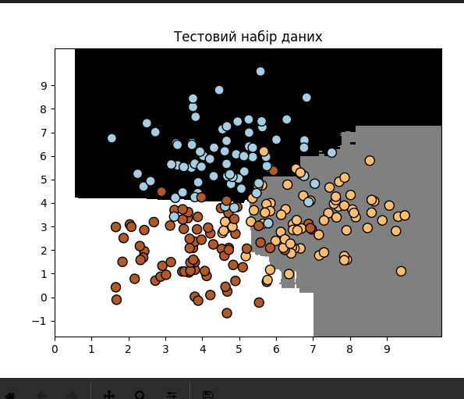

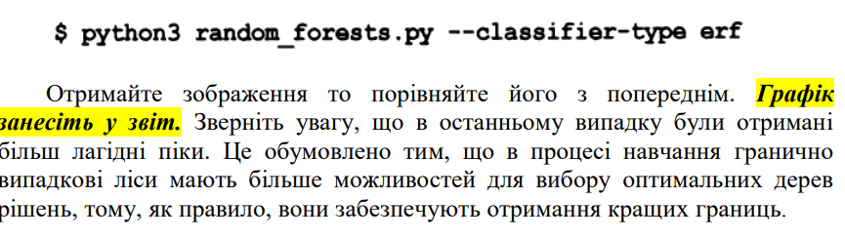

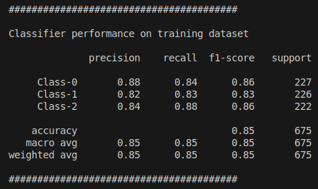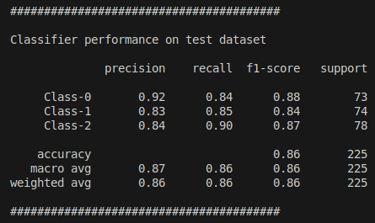

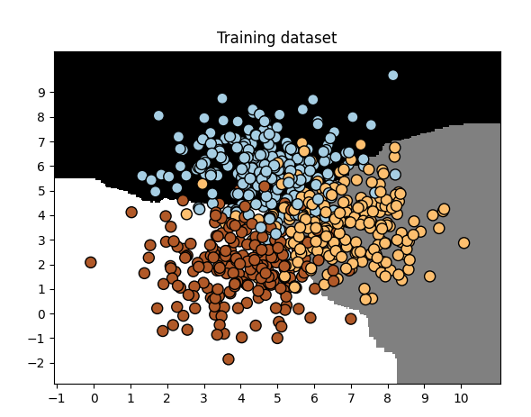

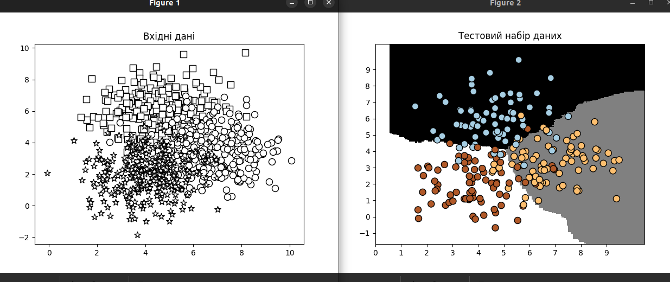

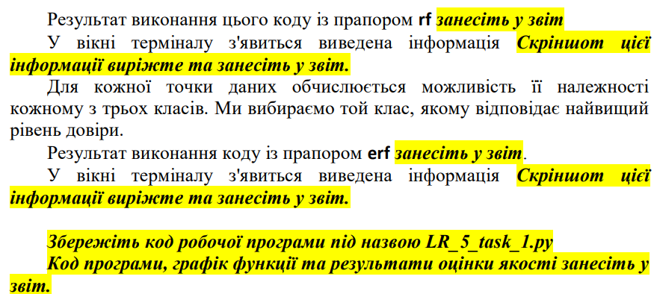

RF:

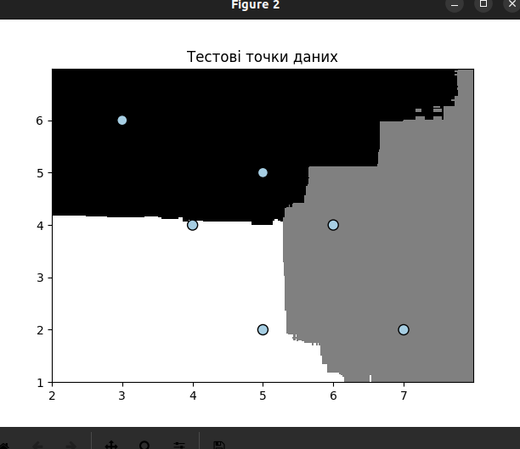

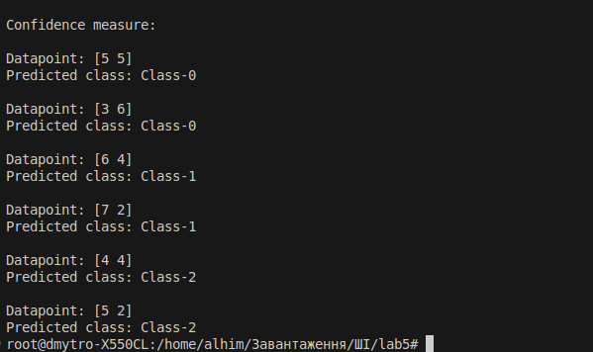

ERF:

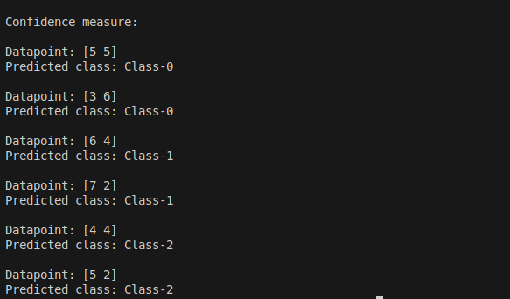

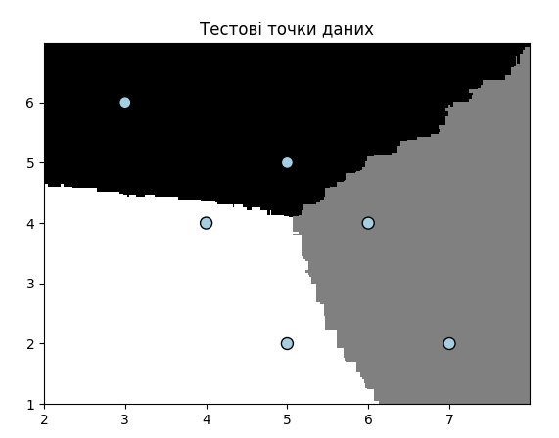

Лістинг:

import argparse

import numpy as np

import matplotlib.pyplot as plt

from sklearn.metrics import classification_report

from sklearn.model_selection import train_test_split # Updated import

from sklearn.ensemble import RandomForestClassifier, ExtraTreesClassifier

from utilities import visualize_classifier

def build_arg_parser():

parser = argparse.ArgumentParser(description='Classify data using ensemble learning techniques')

parser.add_argument('--classifier-type', dest='classifier_type', required=True, choices=['rf', 'erf'],

help="Type classifier to use; can be either 'rf' or 'erf'")

return parser

if __name__ == '__main__':

args = build_arg_parser().parse_args()

classifier_type = args.classifier_type

input_file = 'data_random_forests.txt'

data = np.loadtxt(input_file, delimiter=',')

X, y = data[:, :-1], data[:, -1]

class_0 = np.array(X[y == 0])

class_1 = np.array(X[y == 1])

class_2 = np.array(X[y == 2])

plt.figure()

plt.scatter(class_0[:, 0], class_0[:, 1], s=75,

facecolors='white', edgecolors='black',

linewidth=1, marker='s')

plt.scatter(class_1[:, 0], class_1[:, 1], s=75,

facecolors='white', edgecolors='black',

linewidth=1, marker='o')

plt.scatter(class_2[:, 0], class_2[:, 1], s=75,

facecolors='white', edgecolors='black',

linewidth=1, marker='*')

plt.title('Вхідні дані')

X_train, X_test, y_train, y_test = train_test_split(X, y, test_size=0.25, random_state=2)

params = {'n_estimators': 100, 'max_depth': 4,'random_state': 0}

if classifier_type == 'rf':

classifier = RandomForestClassifier (**params)

else:

classifier = ExtraTreesClassifier (**params)

classifier.fit(X_train, y_train)

#visualize_classifier(classifier, X_train, y_train, 'Training dataset')

y_test_pred = classifier.predict(X_test)

#visualize_classifier(classifier, X_test, y_test, 'Тестовий набір даних')

class_names = ['Class-0', 'Class-1', 'Class-2']

print("\n" + "#"*40)

print ("\nClassifier performance on training dataset\n")

print (classification_report(y_train, classifier.predict (X_train), target_names=class_names) )

print ("#"*40 + "\n")

print ("#"*40)

print ("\nClassifier performance on test dataset\n")

print (classification_report(y_test, y_test_pred, target_names=class_names) )

print ("#"*40 + "\n")

test_datapoints = np.array([[5, 5], [3, 6], [6, 4],[7, 2], [4, 4], [5, 2]])

print ("\nConfidence measure:")

for datapoint in test_datapoints:

probabilities = classifier.predict_proba ([datapoint] ) [0]

predicted_class = 'Class-' + str (np.argmax (probabilities) )

print ('\nDatapoint:', datapoint)

print ('Predicted class:', predicted_class)

visualize_classifier(classifier, test_datapoints, [0]*len(test_datapoints), 'Тестові точки даних')

plt.show()

**Завдання 2.2. Обробка дисбалансу класів**

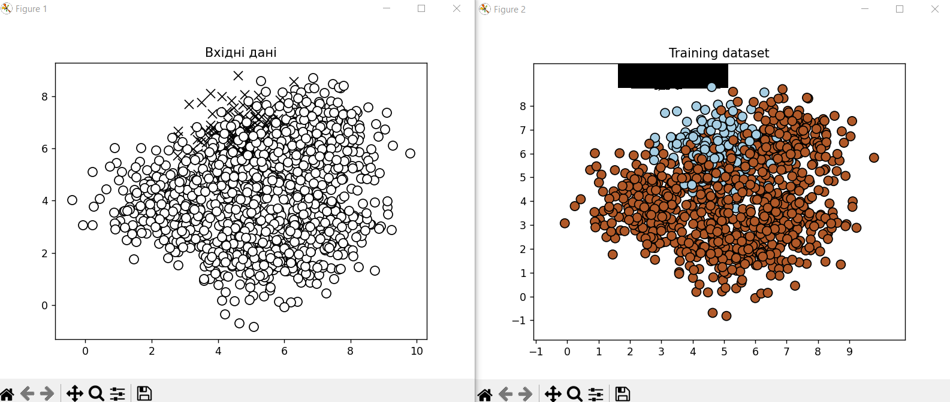

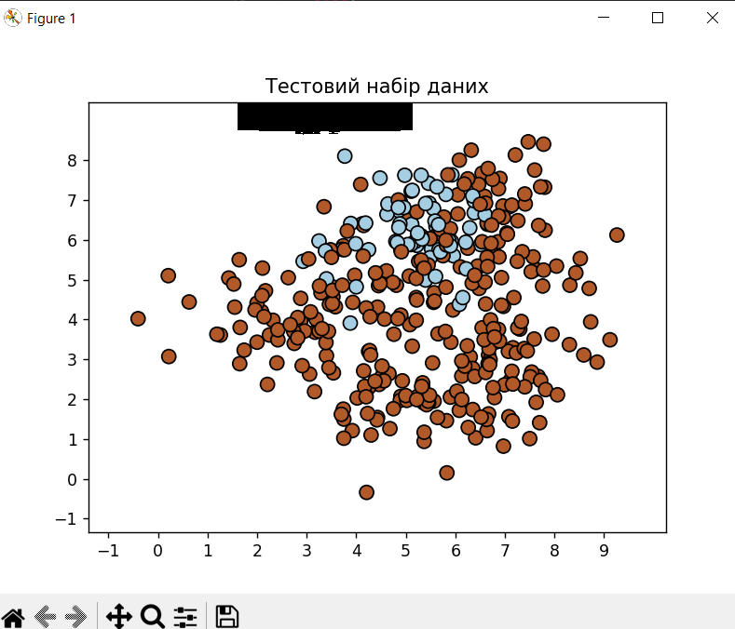

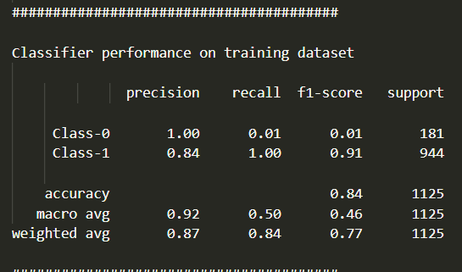

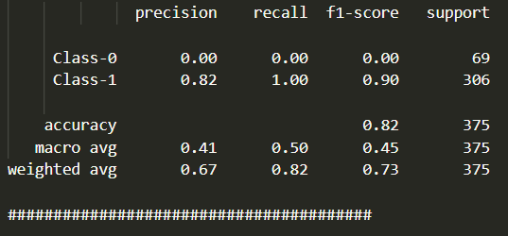

Тепер запустимо програму з команди:



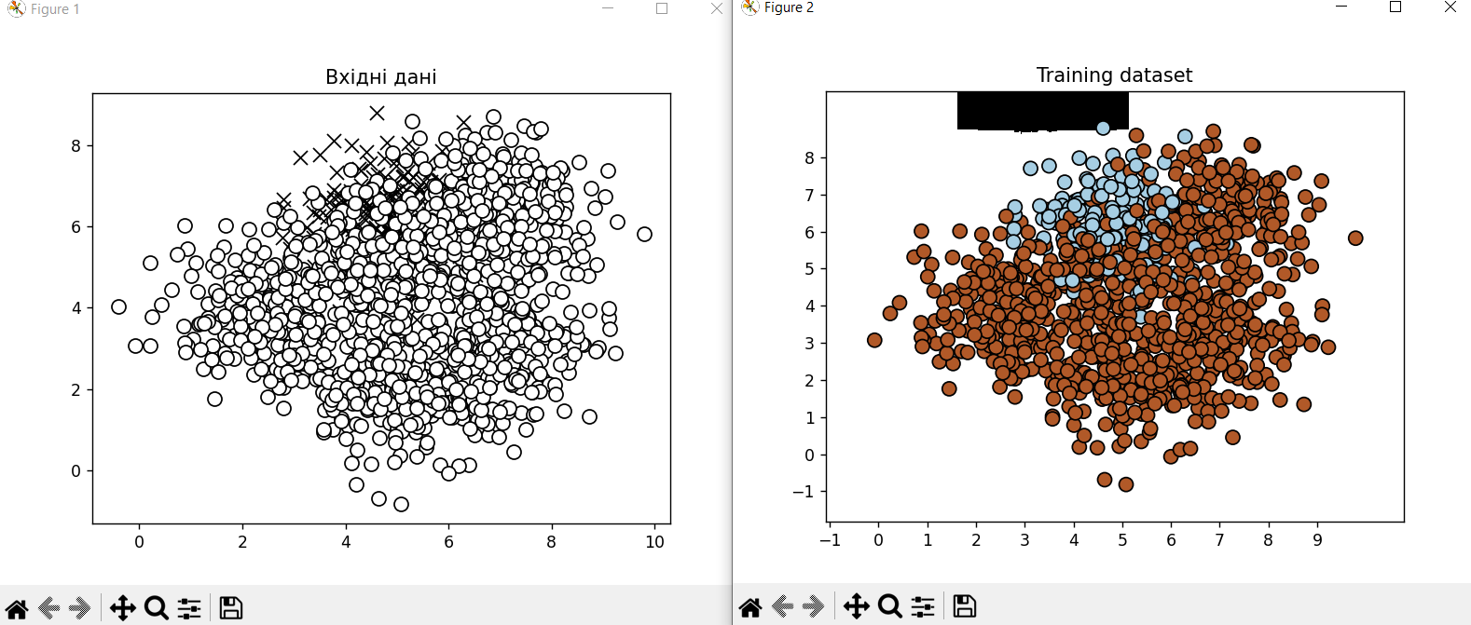

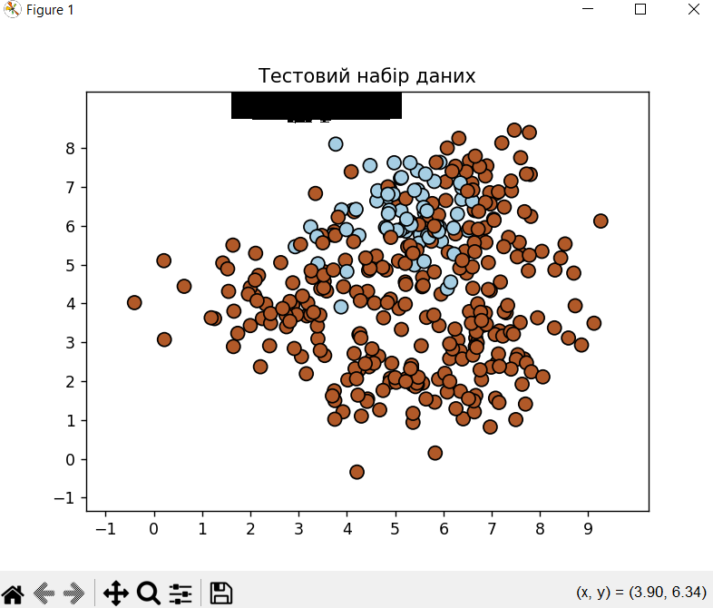

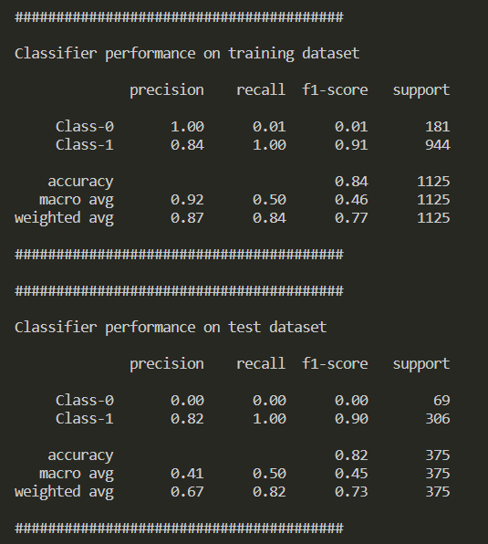

Тепер з використанням 

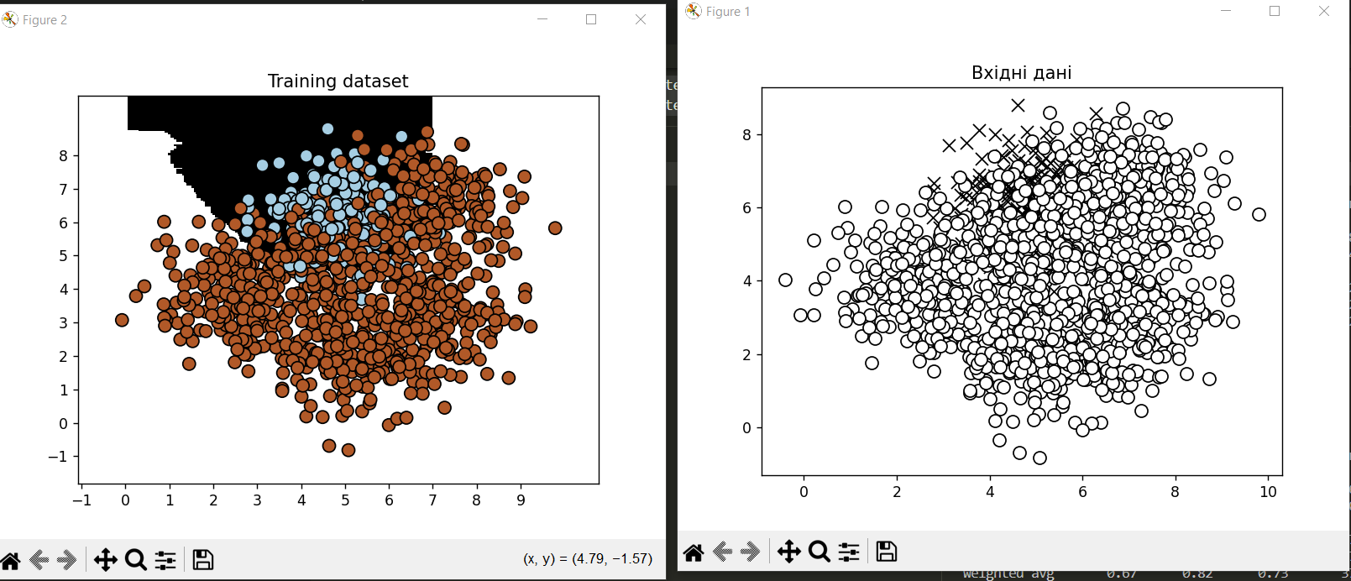

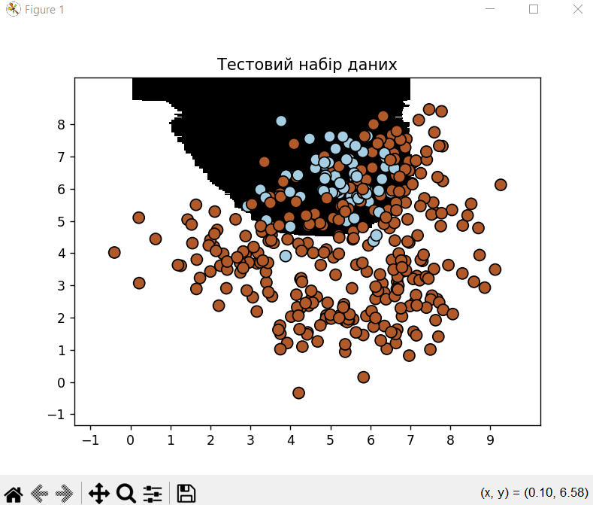

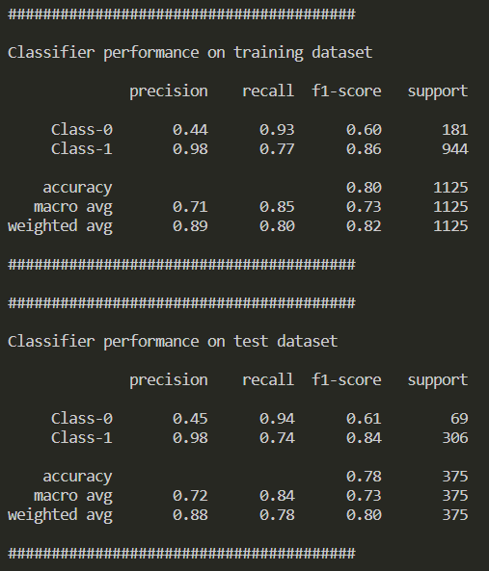

Лістинг:

import sys

import numpy as np

import matplotlib.pyplot as plt

from sklearn.ensemble import ExtraTreesClassifier

from sklearn.model_selection import train_test_split

from sklearn.metrics import classification_report

from utilities import visualize_classifier

input_file = 'data_imbalance.txt'

data = np.loadtxt(input_file, *delimiter*=',')

X, y = data[:, :-1], data[:, -1]

class_0 = np.array(X[y == 0])

class_1 = np.array(X[y == 1])

plt.figure()

plt.scatter(class_0[:, 0], class_0[:, 1], *s*=75,

*facecolors*='black', *edgecolors*='black',

*linewidth*=1, *marker*='x')

plt.scatter(class_1[:, 0], class_1[:, 1], *s*=75,

*facecolors*='white', *edgecolors*='black',

*linewidth*=1, *marker*='o')

plt.title("Вхідні дані")

X_train, X_test, y_train, y_test = train_test_split(X, y, *test_size*=0.25, *random_state*=5)

params = {'n_estimators': 100, 'max_depth': 4, 'random_state': 0}

if len(sys.argv) > 1:

    if sys.argv[1] == 'balance':

        params['class_weight'] = 'balanced'

    else:

        raise ValueError("Invalid input argument; should be 'balance'")

classifier = ExtraTreesClassifier(**params)

classifier.fit(X_train, y_train)

visualize_classifier(classifier, X_train, y_train, 'Training dataset')

y_test_pred = classifier.predict(X_test)

visualize_classifier(classifier, X_test, y_test, 'Тестовий набір даних')

class_names = ['Class-0', 'Class-1']

print("\n" + "#" * 40)

print("\nClassifier performance on training dataset\n")

print(classification_report(y_train, classifier.predict(X_train), *target_names*=class_names))

print("#" * 40 + "\n")

print("#" * 40)

print("\nClassifier performance on test dataset\n")

print(classification_report(y_test, y_test_pred, *target_names*=class_names))

print("#" * 40 + "\n")

plt.show()

**Завдання 2.3. Знаходження оптимальних навчальних параметрів за допомогою сіткового пошуку**

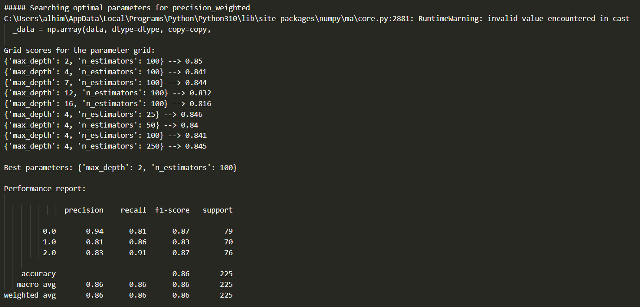

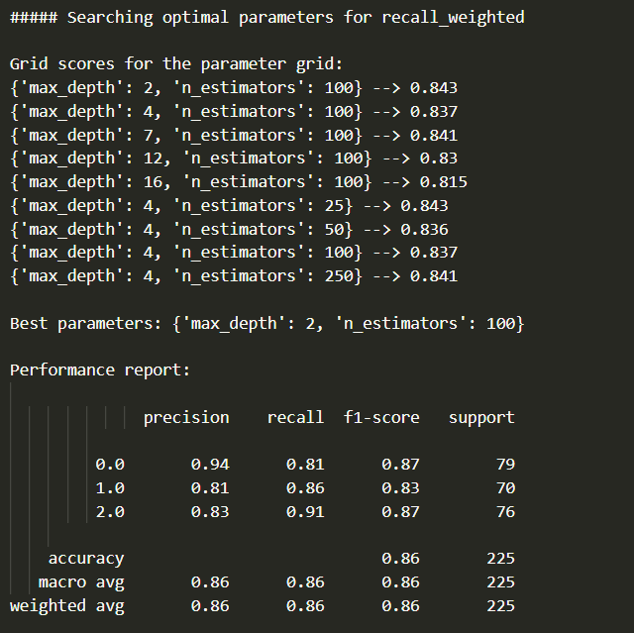

Лістинг:

import numpy as np

import matplotlib.pyplot as plt

from sklearn.metrics import classification_report

from sklearn.model_selection import train_test_split, GridSearchCV

from sklearn.ensemble import ExtraTreesClassifier

from utilities import visualize_classifier

input_file = 'data_random_forests.txt'

data = np.loadtxt(input_file, *delimiter*=',')

X, y = data[:, :-1], data[:, -1]

class_0 = np.array(X[y == 0])

class_1 = np.array(X[y == 1])

class_2 = np.array(X[y == 2])

X_train, X_test, y_train, y_test = train_test_split(X, y, *test_size*=0.25, *random_state*=5)

parameter_grid = [

    {'n_estimators': [100], 'max_depth': [2, 4, 7, 12, 16]},

    {'max_depth': [4], 'n_estimators': [25, 50, 100, 250]}

]

metrics = ['precision_weighted', 'recall_weighted']

for metric in metrics:

    print("\n##### Searching optimal parameters for", metric)

    classifier = GridSearchCV(ExtraTreesClassifier(*random_state*=0), parameter_grid, *cv*=5, *scoring*=metric)

    classifier.fit(X_train, y_train)

    print("\nGrid scores for the parameter grid:")

    for params, avg_score in zip(classifier.cv_results_['params'], classifier.cv_results_['mean_test_score']):

        print(params, '-->', round(avg_score, 3))

    print("\nBest parameters:", classifier.best_params_)

    y_pred = classifier.predict(X_test)

    print("\nPerformance report: \n")

    print(classification_report(y_test, y_pred))

**Завдання 2.4. Обчислення відносної важливості ознак**

Код з завдання було змінено з даної причини:



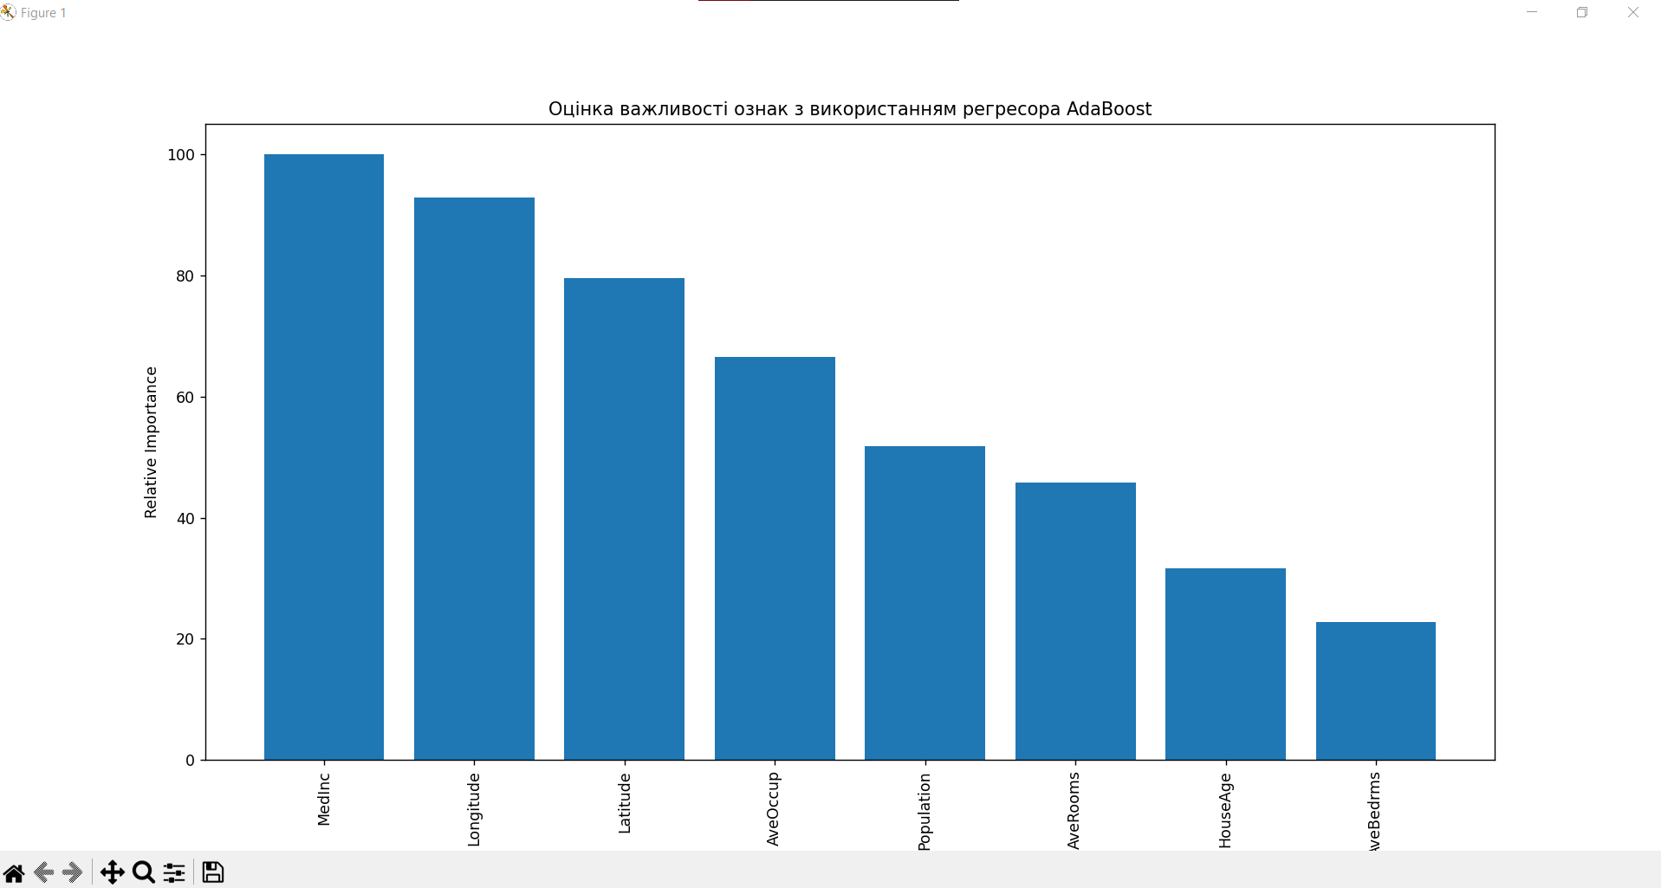

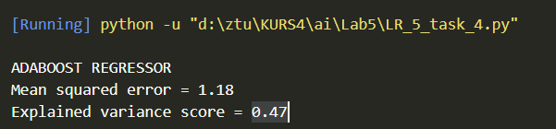

Лістинг:

import numpy as np

import matplotlib.pyplot as plt

from sklearn.tree import DecisionTreeRegressor

from sklearn.ensemble import AdaBoostRegressor

from sklearn.datasets import fetch_california_housing

from sklearn.metrics import mean_squared_error, explained_variance_score

from sklearn.model_selection import train_test_split

from sklearn.utils import shuffle

# Load the California housing dataset

housing_data = fetch_california_housing()

X, y = shuffle(housing_data.data, housing_data.target, *random_state*=7)

X_train, X_test, y_train, y_test = train_test_split(X, y, *test_size*=0.2, *random_state*=7)

regressor = AdaBoostRegressor(DecisionTreeRegressor(*max_depth*=4), *n_estimators*=400, *random_state*=7)

regressor.fit(X_train, y_train)

y_pred = regressor.predict(X_test)

mse = mean_squared_error(y_test, y_pred)

evs = explained_variance_score(y_test, y_pred)

print("\nADABOOST REGRESSOR")

print("Mean squared error =", round(mse, 2))

print("Explained variance score =", round(evs, 2))

feature_importances = regressor.feature_importances_

feature_names = housing_data.feature_names

feature_importances = 100.0 * (feature_importances / max(feature_importances))

index_sorted = np.flipud(np.argsort(feature_importances))

pos = np.arange(index_sorted.shape[0]) + 0.5

plt.figure()

plt.bar(pos, feature_importances[index_sorted], *align*='center')

plt.xticks(pos, np.array(feature_names)[index_sorted], *rotation*=90)

plt.ylabel("Relative Importance")

plt.title("Оцінка важливості ознак з використанням регресора AdaBoost")

plt.show()

**Завдання 2.5. Прогнозування інтенсивності дорожнього руху за допомогою класифікатора на основі гранично випадкових лісів**



Лістинг:

import numpy as np

import matplotlib.pyplot as plt

from sklearn.metrics import classification_report, mean_absolute_error

from sklearn.model_selection import train_test_split

from sklearn import preprocessing

from sklearn.ensemble import ExtraTreesRegressor

input_file = 'traffic_data.txt'

data = []

with open(input_file, 'r') as f:

    for line in f.readlines():

        items = line[:-1].split(',')

        data.append(items)

data = np.array(data)

label_encoder = []

X_encoded = np.empty(data.shape)

for i, item in enumerate(data[0]):

    if item.isdigit():

        X_encoded[:, i] = data[:, i]

    else:

        label_encoder.append(preprocessing.LabelEncoder())

        X_encoded[:, i] = label_encoder[-1].fit_transform(data[:, i])

X = X_encoded[:, :-1].astype(int)

y = X_encoded[:, -1].astype(int)

X_train, X_test, y_train, y_test = train_test_split(X, y, *test_size*=0.25, *random_state*=5)

params = {'n_estimators': 100, 'max_depth': 4, 'random_state': 0}

regressor = ExtraTreesRegressor(**params)

regressor.fit(X_train, y_train)

y_pred = regressor.predict(X_test)

print("Mean absolute error:", round(mean_absolute_error(y_test, y_pred), 2))

test_datapoint = ['Saturday', '10:20', 'Atlanta', 'no']

test_datapoint_encoded = [-1] * len(test_datapoint)

count = 0

for i, item in enumerate(test_datapoint):

    if item.isdigit():

        test_datapoint_encoded[i] = int(test_datapoint[i])

    else:

        test_datapoint_encoded[i] = int(label_encoder[count].transform([item])[0])

        count = count + 1

test_datapoint_encoded = np.array(test_datapoint_encoded)

print("Predicted traffic:", int(regressor.predict([test_datapoint_encoded])[0]))

GIT: https://github.com/Alhim616/AI_Labs_Yanushevych