*Laporan Struktur Data dan Algoritma*

**TUGAS 2**

Disusun untuk memenuhi

Tugas Matakuliah Struktur Data dan Algoritma

Oleh :

**ALHUSNA HANIFAH**

**2208107010060**



**JURUSAN INFORMATIKA**

**FAKULTAS MATEMATIKA DAN ILMU PENGETAHUAN ALAM**

**UNIVERSITAS SYIAH KUALA**

**DARUSSALAM, BANDA ACEH**

**2024**

**LAPORAN**

Tabel Hasil Evaluasi

|  |  |  |
| --- | --- | --- |
| **Jenis algoritma** | **Jumlah bilangan** | **Waktu eksekusi (ms)** |
| Bubble Sort | 100K | 21904.00 |
| 200K | 90598.00 |
| 300K | 200194.00 |
| 400K | 357578.00 |
| 500K | 548305.00 |
| 600K | 788524.00 |
| 700K | 1073760.00 |
| 800K | 1401798.00 |
| 900K | 1777047.00 |
| 1000K | 2190241.00 |
| Selection Sort | 100K | 9070.00 |
| 200K | 35438.00 |
| 300K | 79523.00 |
| 400K | 141335.00 |
| 500K | 220784.00 |
| 600K | 317613.00 |
| 700K | 427848.00 |
| 800K | 555661.00 |
| 900K | 703067.00 |
| 1000K | 867550.00 |
| Insertion Sort | 100K | 4880.00 |
| 200K | 19065.00 |
| 300K | 42667.00 |
| 400K | 75851.00 |
| 500K | 118429.00 |
| 600K | 170582.00 |
| 700K | 232332.00 |
| 800K | 303148.00 |
| 900K | 383225.00 |
| 1000K | 473874.00 |

Hasil Run Program

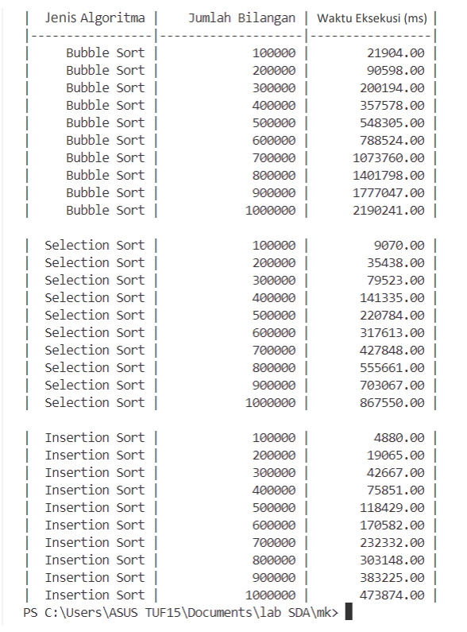

Spesifikasi Laptop

* **ASUS TUF15**

Processor: Intel core i5-10300H

RAM:8 GB DDR4 3200MHz

Graphics: GTX 1650

Penyimpanan: 512GB SSD

Refresh Rate: 144 Hz

Link Video cara menjalankan kode program

<https://drive.google.com/file/d/1PbbFrO3DflRDf_7KTolh7bJRflSO3PC4/view?usp=sharing>