Operations of Stacks, Queues, Trees and Graphs
Demonstration of Searching and Sorting of Arrays using Bubble Sort and Quicksort
Demonstration of Trees Traversal (Inorder / Preorder / Postorder)

By:
Ali, Muhammad Gabriel M.
Baroja, Stephen Cllyod P.
De los Angeles, Bj E.
Jamolin, Jay-Bee A.
Pollido, Arjay A.
Sarmiento, Regie G.

A Compilation Paper
Submitted in Partial Fulfillment of the Requirements
for the Degree of Bachelor of Science in Computer Science
In the Faculty of College of Computer Studies
At Kolehiyo ng Lungsod ng Lipa
Marawoy Lipa City

November 20, 2025

Supervised by Mr. Bobet R. Lanto
DSA Instructor

Table of Content

- Introduction ……………………………………………………………………………………..
03 00 0405050606070707
- Algorithms ……………………………………………………………….……………………….
- Stacks .……………………………………………………………………………………
- Queue ………………………………………………………………..…………………..
- Trees ………………………………………………………………………………………
- Bubble Sort………………………………………………………..…………………….
- Quicksort ………………………………………………………………………………..
- Tree traversal (Inorder, Preorder, Postorder) …………………….……………...
- Binary Tree..................................................………………………...………….
Graph......................................................................................................
- Source Code with Sample Output
a. Queues ……………………………………………………………………………..……
080911121314160017
b. Stacks ………………………………………………………………….………………..
c. Trees ………………………………………………………………..……………………
d. Graphs ………………………………………………………………….……………….
e. Bubble Sort ……………………………………………………………………………..
f. Quicksort …………………………………………………………………..…………...
g. Tree traversal (Inorder, Preorder, Postorder) …………………………….…….

- Bibliography / References

Introduction
Data Structures and Algorithms (DSA) serve as the essential foundation of computer science, influencing the design, efficiency, and performance of software systems. As students of computing, it is important not only to understand the theoretical concepts behind these structures but also to experience their behavior through practical implementation. This project aims to provide a hands-on demonstration of key data structures—Stacks, Queues, Trees, and Graphs—alongside fundamental algorithmic techniques such as Bubble Sort, QuickSort, and Tree Traversals (Inorder, Preorder, Postorder).

To organize these demonstrations effectively, we developed a console-based launcher system. This launcher serves as a unified access point for all modules, allowing users to navigate each demonstration through a structured and interactive menu. Rather than executing each program independently, the launcher integrates all operations under one system, streamlining the learning experience and providing a consistent interface throughout the project.
The project covers the following essential operations:
This project aims to develop an interactive Data Structures and Algorithms Visualizer designed to support learning through graphical execution. Specifically, the project intends to:
- Implement a modular visualizer capable of simulating fundamental data structures and algorithms.
- Provide visual interaction for the following operations:
  - Stack: Push, Pop, Peek
  - Queue: Enqueue, Dequeue
  - Tree: Node insertion and traversal (In-order, Pre-order, Post-order)
  - Graph: Breadth-First Search traversal
  - Sorting: Bubble Sort and QuickSort visualization
- Integrate logs and step-based outputs to display real-time execution feedback.
- Enhance learning efficiency by offering adjustable controls such as input values and animation speed.
- Present algorithm behavior using visual animation rather than console output alone.
Through this implementation, we aim to illustrate how these structures behave, how algorithms manipulate data, and how traversal and sorting processes operate internally. By providing a consolidated interface through the launcher, our system offers an accessible and interactive way for learners to explore core DSA concepts. The project ultimately supports a deeper understanding of computational thinking and reinforces the significance of data structures in solving real-world problems.

Algorithm
This section outlines the key algorithms used in our data structure demonstrations. Each table summarizes the purpose and step-by-step procedures behind the operations of stacks, queues, trees, graphs, and the sorting methods applied in the program. These algorithms serve as the foundation for the features implemented in our launcher and provide a clear reference before presenting the actual source code and outputs in the next section.
Stacks
- Push
Item | Details
Purpose | Adds an element to the top of the stack.
Algorithm Steps | 1. Check if there’s a value. If none, generate a random  2. Display to the visualizer  3. Otherwise, increment the top index.  4. Insert the new element at the top position.

- Pop
Item | Details
Purpose | Adds an element to the top of the stack.
Algorithm Steps | 1. Check if theres elements.  2. If none, display error  3. Otherwise, increment the top index.  4. Insert the new element at the top position.

Queues
- Enqueue
Item | Details
Purpose | Removes the front element from the circular queue.
Algorithm Steps | 1. Check if the queue is empty.  2. If empty, display a message and stop.  3. Move the front pointer to the next index using circular increment.
- Dequeue
Item | Details
Purpose | Removes the front element from the circular queue.
Algorithm Steps | 1. Check if the queue is empty.  2. If empty, display a message and stop.  3. Remove the element at the front index.  4. Move the front pointer to the next index using circular increment.  5. Decrease the element count.
- Display
Item | Details
Purpose | Shows all elements currently stored in the queue.
Algorithm Steps | 1. Check if the queue is empty.  2. If empty, display “Queue is empty.”  3. Otherwise, start from front and print each element sequentially for count items.

Bubble Sort
- Sorting Procedure
Item | Details
Purpose | Sorts an array using repeated comparisons and swaps.
Algorithm Steps | 1. Determine the array length n.  2. Loop from index 0 to n–2.  3. Compare each pair of adjacent elements.  4. Swap if out of order.  5. Repeat until the array is fully sorted.

QuickSort
- Sorting Procedure
Item | Details
Purpose | Sorts an array using divide-and-conquer principles.
Algorithm Steps | 1. Select a pivot element.  2. Partition the array into left (less than pivot) and right (greater than pivot) sub-arrays.  3. Recursively apply QuickSort to the left sub-array.  4. Recursively apply QuickSort to the right sub-array.  5. Continue until sub-arrays have one or zero elements.

Tree Traversal
- Inorder
Item | Details
Purpose | Visits nodes in sorted ascending order for BSTs.
Algorithm Steps | 1. Traverse left subtree.  2. Visit the root.  3. Traverse right subtree.
- Preorder
Item | Details
Purpose | Useful for copying the tree or generating prefix expressions.
Algorithm Steps | 1. Visit the root.  2. Traverse left subtree.  3. Traverse right subtree.
- Postorder
Item | Details
Purpose | Useful for deleting the tree or generating postfix expressions.
Algorithm Steps | 1. Traverse left subtree.  2. Traverse right subtree.  3. Visit the root.

Binary Tree
- Insert Operations
Item | Details
Purpose | Inserts a value into the binary search tree.
Algorithm Steps | 1. If the tree is empty, create a new root node.  2. Otherwise, compare the value with the current node.  3. If smaller, recursively move to the left subtree.  4. If greater, recursively move to the right subtree.  5. Insert the node when an empty position is found.

Graph
- Breadth-First Search
Item | Details
Purpose | Traverses the graph level-by-level starting from a chosen node.
Algorithm Steps | 1. Select a starting node.  2. Initialize a queue and a visited set.  3. Mark the start node as visited and enqueue it.  4. While queue is not empty: • Dequeue a node. • Print or process it. • Enqueue all unvisited adjacent nodes.

Source code with sample output
Queue
This subsection presents the essential React methods used to demonstrate the operations of a Circular Queue in our program. The queue allows insertion (enqueue), deletion (dequeue), and viewing of its current elements through the display function. These operations are integrated into the launcher to show how a circular queue manages its indices and handles overflow and underflow conditions. The code below highlights the core logic behind these operations.
import { useState } from 'react';  import { motion } from 'framer-motion';  import VisualizerLayout from './VisualizerLayout';  export default function QueueVisualizer({ onBack }: { onBack: () => void }) {  const [queue, setQueue] = useState<number[]>([]);  const [inputValue, setInputValue] = useState('');  const [logs, setLogs] = useState(['Queue initialized. Ready.']);  const enqueue = () => {  const v = Number(inputValue) || Math.floor(Math.random() * 50) + 1;  setQueue(prev => [...prev, v]);  setLogs(prev => [`Enqueued: ${v}`, ...prev]);  setInputValue('');  };  const dequeue = () => {  if (!queue.length) return setLogs(prev => ['Queue Empty', ...prev]); | const removed = queue[0];  setQueue(prev => prev.slice(1));  setLogs(prev => [`Dequeued: ${removed}`, ...prev]);  };  return (  <VisualizerLayout  title="QUEUE VISUALIZER"  onBack={onBack}  controls={/* enqueue buttons */}  visualArea={/* horizontal animated queue */}  consoleOutput={logs.map(l => `> ${l}`)}  />  );  }

How the Code Works
The program uses an integer array to simulate a circular queue. The front and rear indices track where elements are removed and added.
- The enqueue method checks if the queue is full. If not, it moves the rear pointer forward using modular arithmetic and inserts the new value.
- The dequeue method checks if the queue is empty. If not, it removes the value at front and advances the pointer.
- The display method prints all current elements by looping from front for count steps, wrapping around the array when needed.
This design allows efficient use of array space without shifting elements.

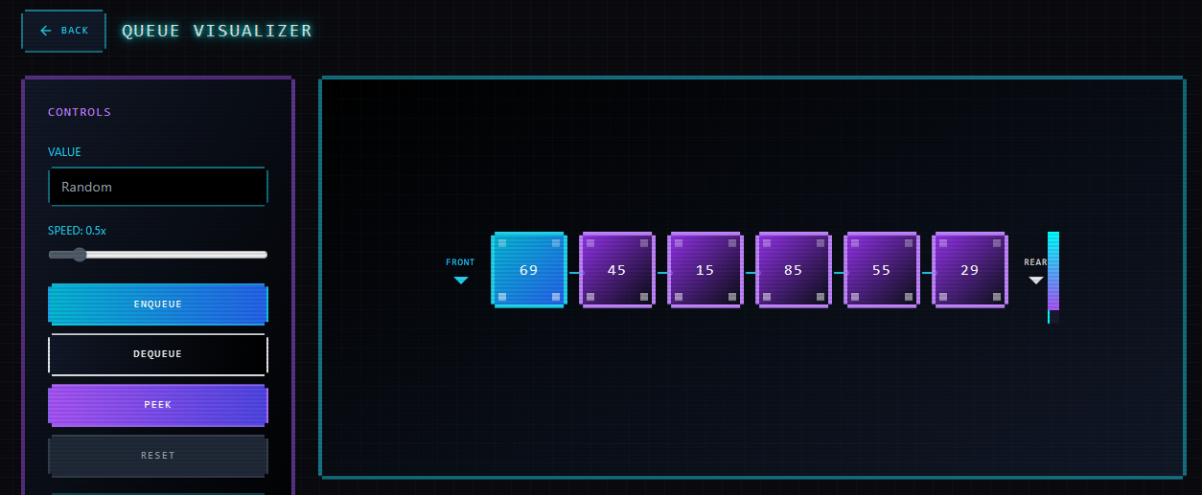
Stacks
This subsection presents the primary React methods used to demonstrate the Stack data structure. The stack operates using the Last-In, First-Out (LIFO) principle, allowing elements to be added only at the top (push) and removed only from the top (pop). The display method shows the current state of the stack. These methods represent the core functionality used in the Stack demonstration within the program launcher.

import { useState } from 'react';  import { motion, AnimatePresence } from 'framer-motion';  import VisualizerLayout from './VisualizerLayout';  interface StackItem {  id: number;  value: number;  }  export default function StackVisualizer({ onBack }: { onBack: () => void }) {  const [stack, setStack] = useState<StackItem[]>([]);  const [inputValue, setInputValue] = useState('');  const [logs, setLogs] = useState(['Stack initialized. Ready to push items.']);  const [animationSpeed, setAnimationSpeed] = useState(0.5);  const addLog = (msg: string) => {  const t = new Date().toLocaleTimeString();  setLogs(prev => [`[${t}] ${msg}`, ...prev].slice(0, 20));  };  );  }  const handlePush = () => {  const value = inputValue || Math.floor(Math.random() * 99) + 1;  const item = { id: Date.now(), value: | Number(value) };  setStack(prev => [...prev, item]);  addLog(`PUSH: Added ${value}`);  setInputValue('');  };  const handlePop = () => {  if (!stack.length) return addLog('ERROR: Stack is empty.');  const popped = stack[stack.length - 1];  setStack(prev => prev.slice(0, -1));  addLog(`POP: Removed ${popped.value}`);  };  const handlePeek = () => {  if (!stack.length) return addLog('PEEK: Empty');  addLog(`TOP → ${stack[stack.length - 1].value}`);  };  const handleReset = () => {  setStack([]); setLogs(['Stack reset.']);  };  return (  <VisualizerLayout  title="STACK VISUALIZER"  onBack={onBack}  controls={/* buttons and settings */}  visualArea={/* animated stack UI */}  consoleOutput={/* log output */}  />
How the Code Works
The stack is implemented using a fixed-size array and an integer top pointer that marks the position of the most recently inserted element.
- The push method checks if the stack is full. If not, it increments top and stores the new value at that index.
- The pop method verifies whether the stack has elements. If it does, it retrieves the value at top and then decreases the pointer, effectively removing it.
- The display method prints all stored elements from index 0 up to top, showing the current structure of the stack.
This structure ensures that elements are added and removed strictly from the top, following the LIFO behavior.
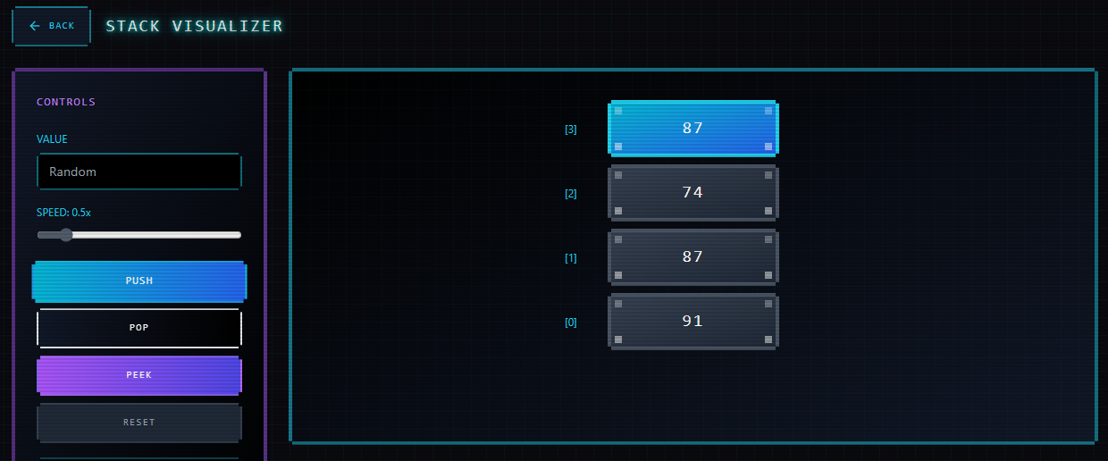
Trees
This subsection presents the essential React methods used to demonstrate Binary Search Tree (BST) operations. The BST stores values in a structured manner where smaller values go to the left subtree and larger values go to the right subtree. The demonstration includes node insertion and three traversal methods: Inorder, Preorder, and Postorder. These features correspond directly to what is shown in the launcher under the Trees option.
import { useState } from 'react';  import { motion } from 'framer-motion';  import VisualizerLayout from './VisualizerLayout';  interface Node { value: number; left?: Node; right?: Node; }  export default function TreeVisualizer({ onBack }: { onBack: () => void }) {  const [tree, setTree] = useState<Node | null>(null);  const [logs, setLogs] = useState(['Binary Tree initialized']);  const insert = (root: Node | null, val: number): Node => {  if (!root) return { value: val };  if (val < root.value) root.left = insert(root.left!, val);  else root.right = insert(root.right!, val);  return root;  }; | const handleInsert = (v: number) => {  setTree(prev => insert(prev, v));  setLogs(prev => [`Inserted -> ${v}`, ...prev]);  };  return (  <VisualizerLayout  title="TREE VISUALIZER"  onBack={onBack}  controls={/* insert + traversal */}  visualArea={/* SVG tree nodes animation */}  consoleOutput={logs}  />  );  }

How the Code Works
This implementation uses a Node class to represent tree nodes containing a value and references to their left and right children. The insert method adds values recursively based on BST rules: smaller values go left, larger values go right.
The three traversal methods work as follows:
- Inorder visits the left subtree first, then the root, and finally the right subtree. This produces sorted output for a BST.
- Preorder prints the root first, then the left subtree, then the right subtree. This order is useful for constructing or copying the tree structure.
- Postorder processes the left subtree, then the right subtree, and prints the root last. This is commonly used when deleting nodes or evaluating expressions.
All methods print their results in a single line, matching what will appear in your program demo.
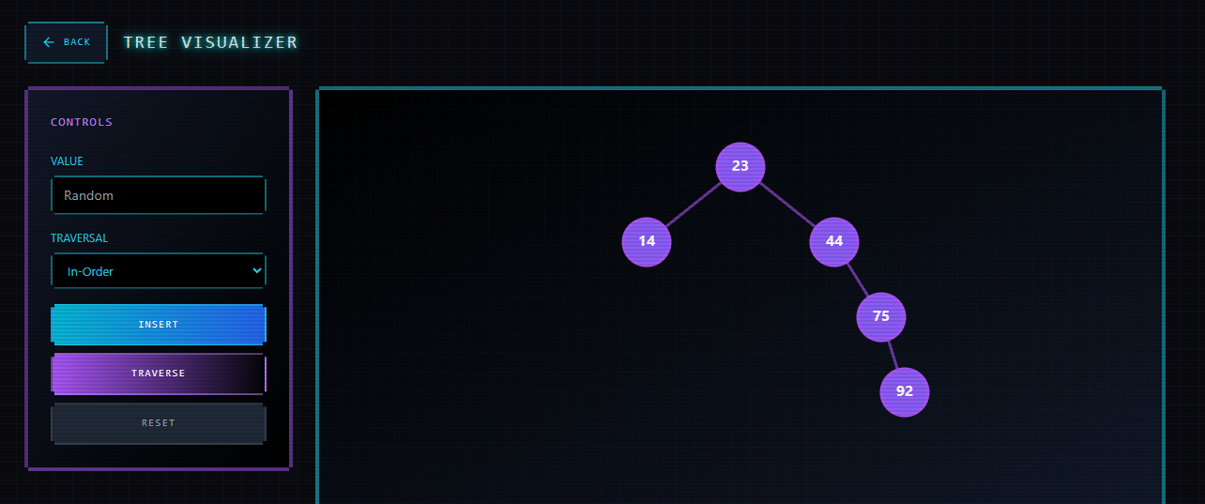
Graph
This subsection presents the essential React methods used to demonstrate graph operations using an adjacency list representation. The graph allows edges to be added between nodes and provides a Breadth-First Search (BFS) traversal to explore nodes level by level. These methods correspond directly to the features shown in the Graph option of the launcher.
// simplified for documentation

const BFS = (graph, start) => {
let visited = new Set();
let queue = [start];

while(queue.length){
let node = queue.shift();
visited.add(node);
log(`Visited: ${node}`);

graph[node].forEach(n=>{
if(!visited.has(n)) queue.push(n);
});
}
};
How the Code Works
The graph is implemented using a HashMap where each key represents a node, and each value is a list containing its adjacent nodes, forming an adjacency list.
- The addEdge method creates nodes if they do not already exist and connects the source node to the destination node.
- The display method prints each node along with the list of nodes it is directly connected to.
- The bfs method performs a Breadth-First Search starting from a specified node. It uses a queue to explore neighbors level by level and a visited set to prevent revisiting nodes.
This structure demonstrates how graphs manage relationships and perform traversal operations in a systematic, layer-based manner.
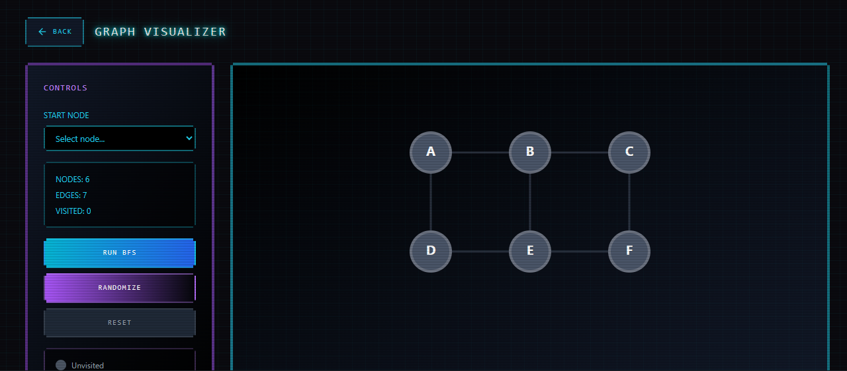

Bubble Sort
This subsection presents the essential React implementation of the Bubble Sort algorithm. Bubble Sort is a simple comparison-based sorting technique that repeatedly steps through the list, compares adjacent elements, and swaps them if they are in the wrong order. The method below is used in the sorting demonstration of our launcher, providing a clear example of how basic sorting algorithms operate.
const bubbleSort = async () => {
for(let i=0;i<array.length;i++){
for(let j=0;j<array.length-i-1;j++){
if(arr[j]>arr[j+1]) swap();
log(`Compared ${arr[j]} & ${arr[j+1]}`);
}
}
};

How the Code Works
The Bubble Sort algorithm compares each pair of adjacent values and swaps them if they are out of order. Each full pass "bubbles" the largest remaining element toward the end of the array.
- The outer loop controls how many passes are made.
- The inner loop performs the comparisons and swaps.
- The display method prints the array before and after sorting.
This implementation clearly demonstrates how Bubble Sort processes the entire array multiple times until all elements are ordered from smallest to largest.

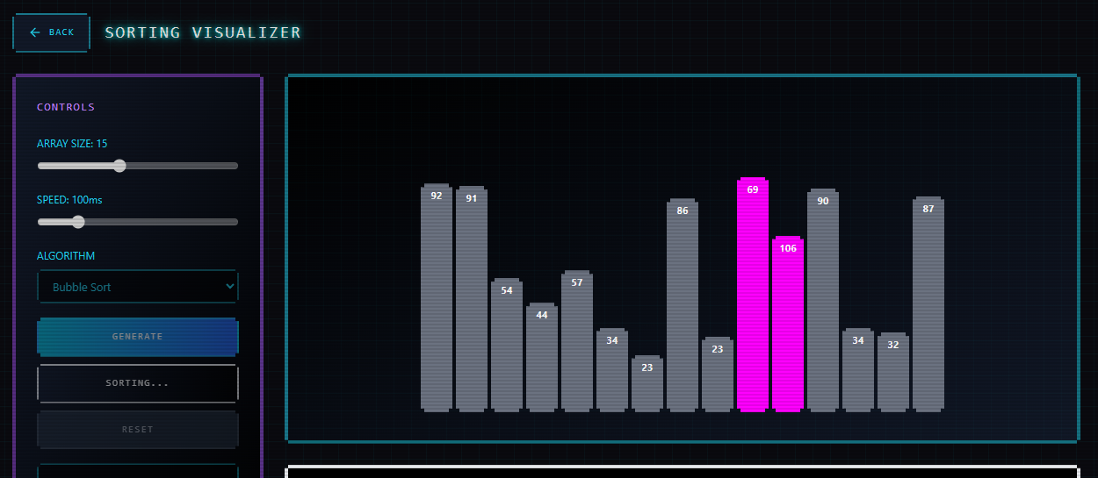
Quicksort
This subsection presents the essential React implementation of the QuickSort algorithm. QuickSort is a divide-and-conquer sorting technique that selects a pivot, partitions the array into two smaller sub-arrays, and recursively sorts them. It is faster than Bubble Sort for larger datasets and demonstrates an efficient recursive sorting process within our launcher program.
const bubbleSort = async () => {
for(let i=0;i<array.length;i++){
for(let j=0;j<array.length-i-1;j++){
if(arr[j]>arr[j+1]) swap();
log(`Compared ${arr[j]} & ${arr[j+1]}`);
}
}
};

How the Code Works
QuickSort selects a pivot (in this case, the last element) and rearranges the array so that:
- All elements smaller than the pivot move to its left.
- All elements larger than the pivot move to its right.
This partitioning process splits the array into two sub-arrays, which are then sorted recursively.
- The quickSort method handles the recursive calls.
- The partition method arranges elements around the pivot and returns its final position.
- The display method can be used to show the array before and after sorting in the demonstration.
This implementation efficiently sorts arrays and illustrates a fundamental divide-and-conquer algorithm.
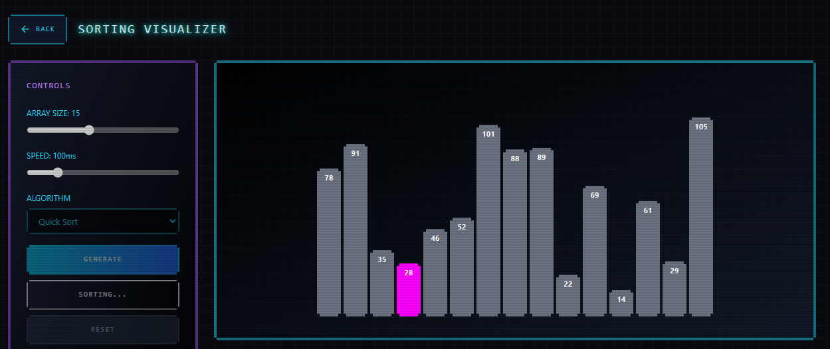

Bibliography / References (APA Style)
Cormen, T. H., Leiserson, C. E., Rivest, R. L., & Stein, C. (2009). Introduction to algorithms (3rd ed.). MIT Press.
Goodrich, M. T., Tamassia, R., & Goldwasser, M. H. (2014). Data structures and algorithms in React (6th ed.). Wiley.
Weiss, M. A. (2012). Data structures and algorithm analysis in React (3rd ed.). Pearson.
Wirth, N. (1976). Algorithms + data structures = programs. Prentice-Hall.
Oracle. (n.d.). React documentation. https://docs.oracle.com/Reactse/
GeeksforGeeks. (n.d.). Data structures and algorithms. https://www.geeksforgeeks.org/


Prepared and submitted to:

BOBET R. LANTO, LPT
Instructor I

