



RISC-V Architecture

Lab Manual # 18
RISC-V Datapath Implementation
(I-Type and R-Type Instructions)

Name | Muddassir Ali Siddiqui
Instructor | Sir Imran & Sir Umer
Date | 27th Aug 2025

In-Lab Tasks: (Write your lab task & screenshots here)

ALU
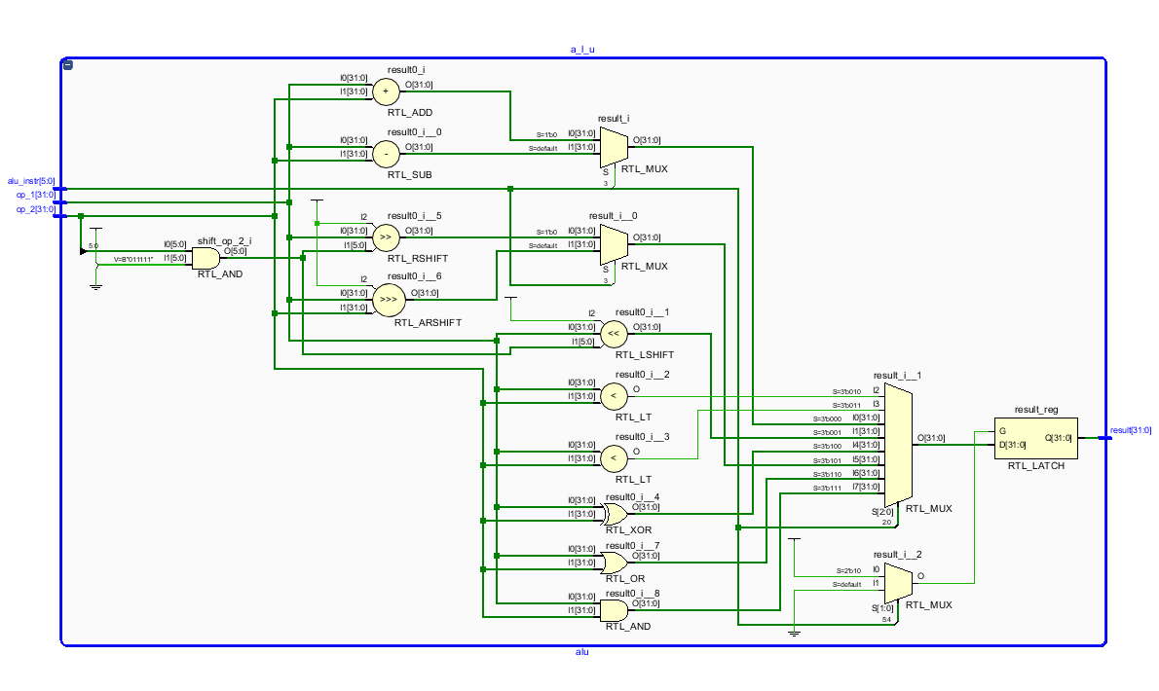

ALU Control:
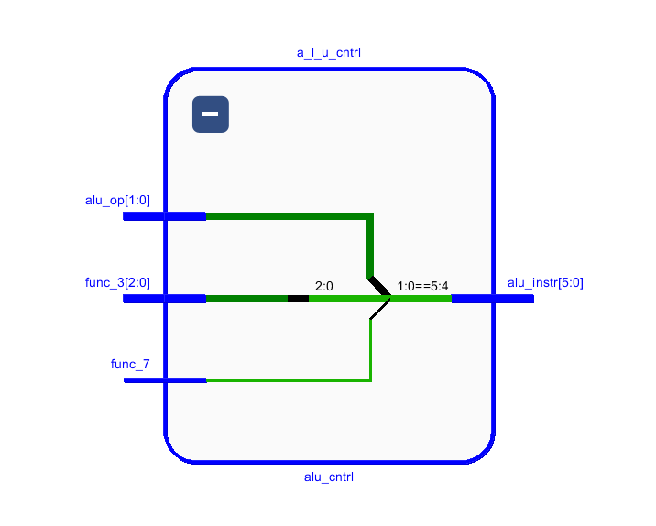

Instruction Memory:
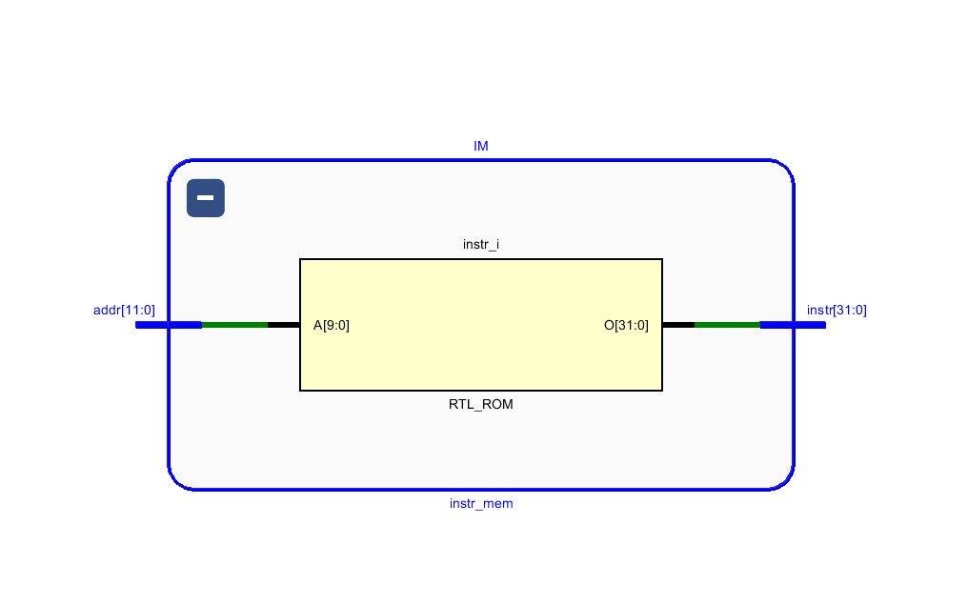

Immediate Generation:
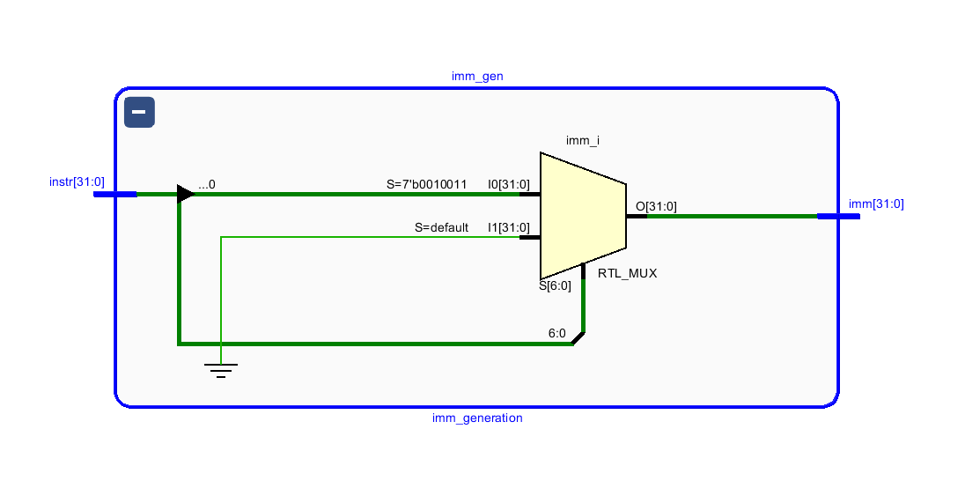

Register File:
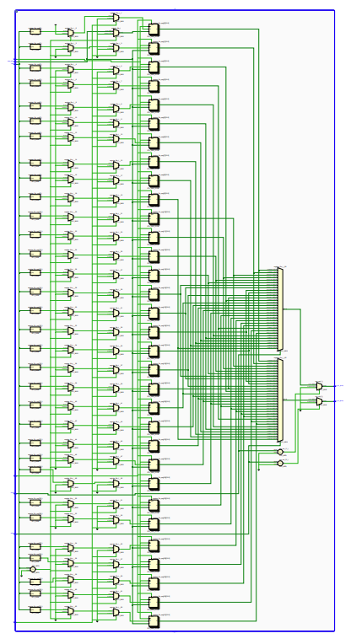

Program Counter:
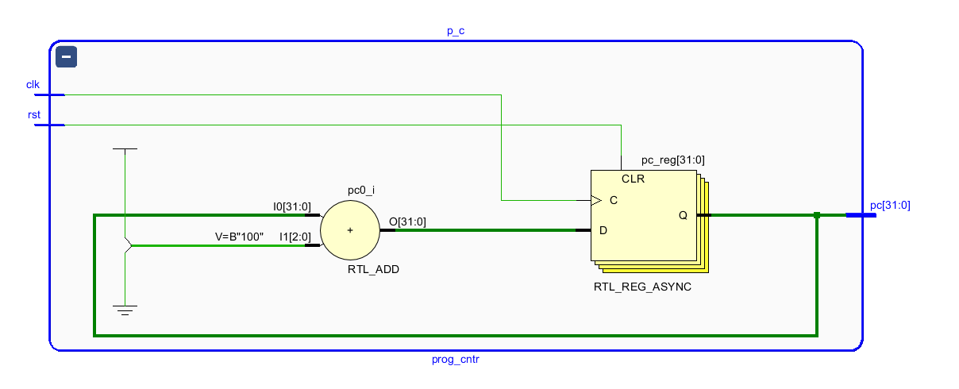

Top:

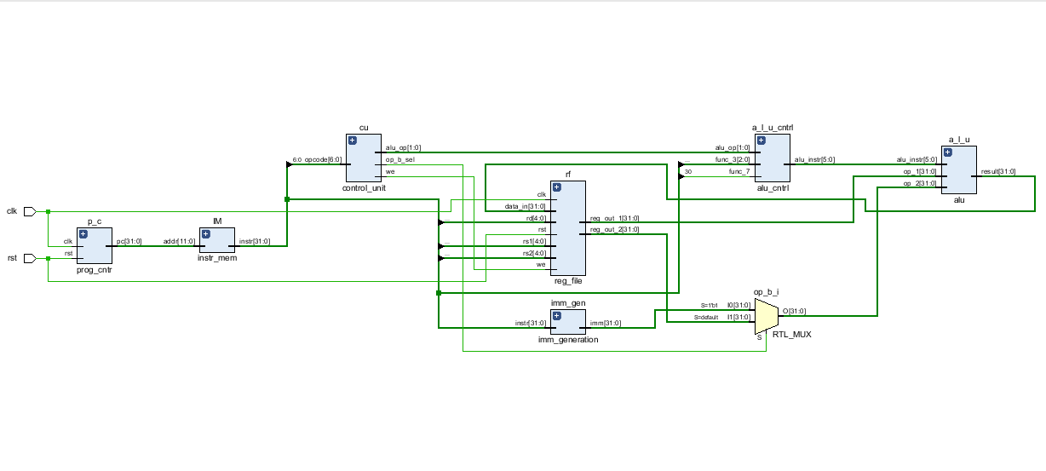

Waveforms
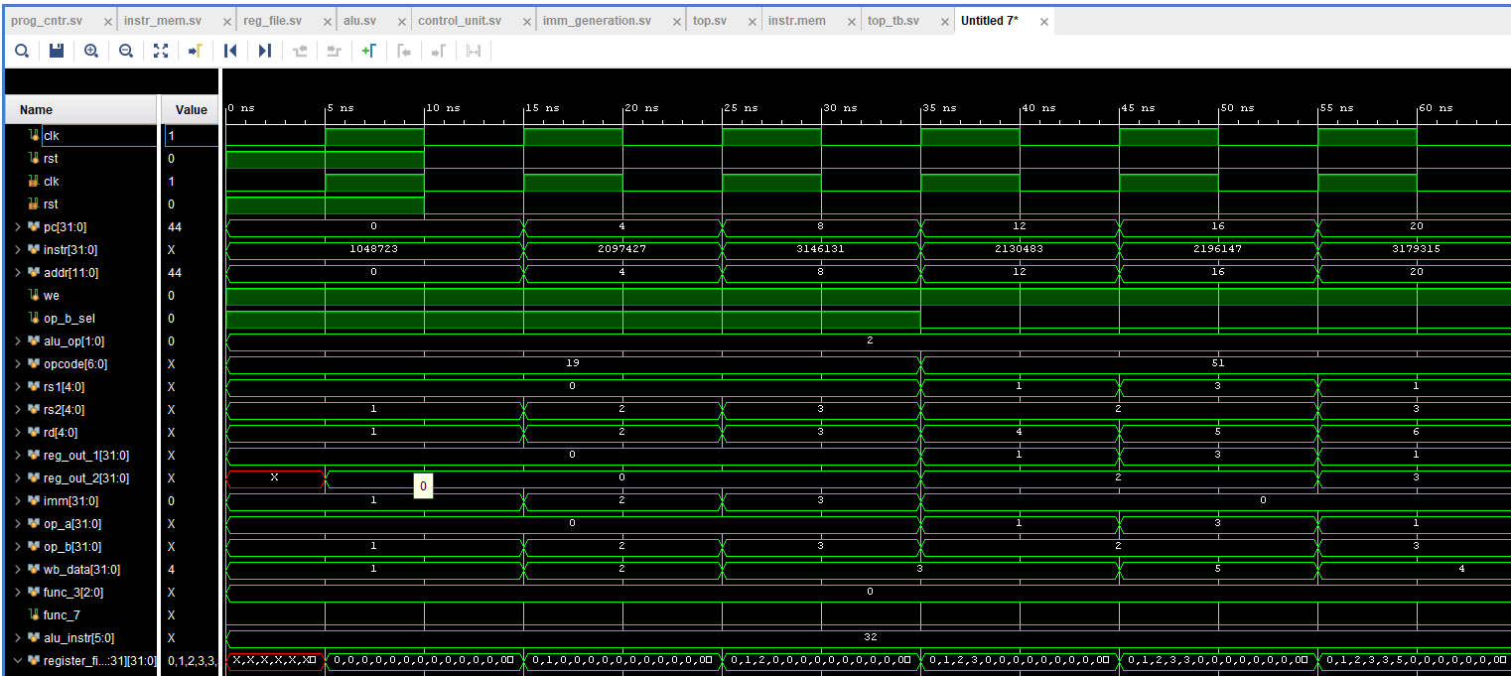
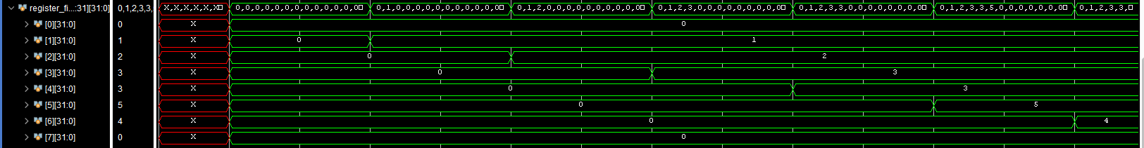

Critical Analysis: (Write you critical analysis / conclusion here)

In the current stage of development, the RV32I single-cycle processor core has been partially implemented. The instruction memory module has been designed to fetch 32-bit instructions from an external hex file, and the control unit has been developed to decode the fetched instruction. At this point, the design is limited to handling R-type and I-type instructions, allowing the control signals for arithmetic, logical, and immediate-based operations to be generated. A basic fetch–decode path is functional, confirming that the instruction flow through the memory and control unit is established.

