



RISC-V Architecture

Lab Manual # 19
RISC-V Datapath Implementation
(Loads, Stores and Jumps)

Name | Muddassir Ali Siddiqui
Instructor | Sir Imran & Sir Umer
Date | 28th Aug 2025

In-Lab Tasks: (Write your lab task & screenshots here)

Top
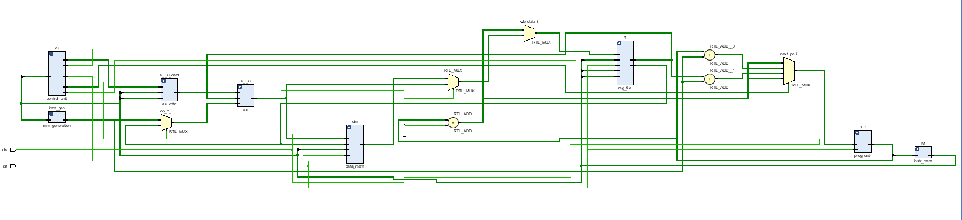

Assembly Code:
j second

li x1, 0x100 # load address of mybyte into x1
sw x12, 0(x1) # store byte from x12 into mybyte

lw x2 0(x1)

lb x2 0(x1)
lb x3 1(x1)
lb x4 2(x1)
lb x5 3(x1)
end:

li x1, 0x100 # load address of mybyte into x1
sw x12, 0(x1) # store byte from x12 into mybyte

lw x2 0(x1)

lb x2 0(x1)
lb x3 1(x1)
lb x4 2(x1)
lb x5 3(x1)

.text
.globl main
main:
j first
second:
addi x12, x0, 0xDE # x12 = 125
slli x12, x12, 8
addi x12, x12, 0xAD # x12 = 125
slli x12, x12, 8
addi x12, x12, 0xBE # x12 = 125
slli x12, x12, 8
addi x12, x12, 0xAF # x12 = 125
j end

first:
addi x12, x0, 0x12 # x12 = 125
slli x12, x12, 8
addi x12, x12, 0x34 # x12 = 125
slli x12, x12, 8
addi x12, x12, 0x56 # x12 = 125
slli x12, x12, 8
addi x12, x12, 0x78 # x12 = 125

j second

Waveforms
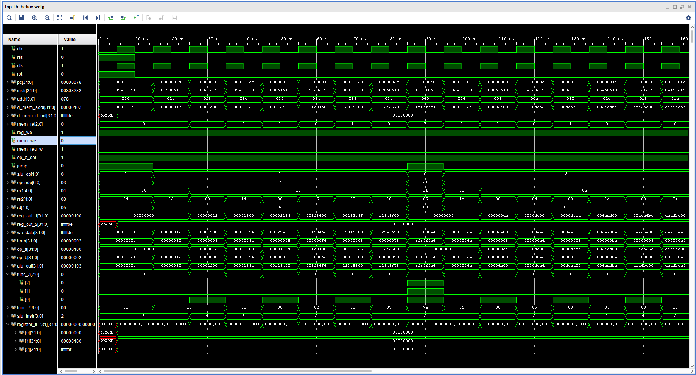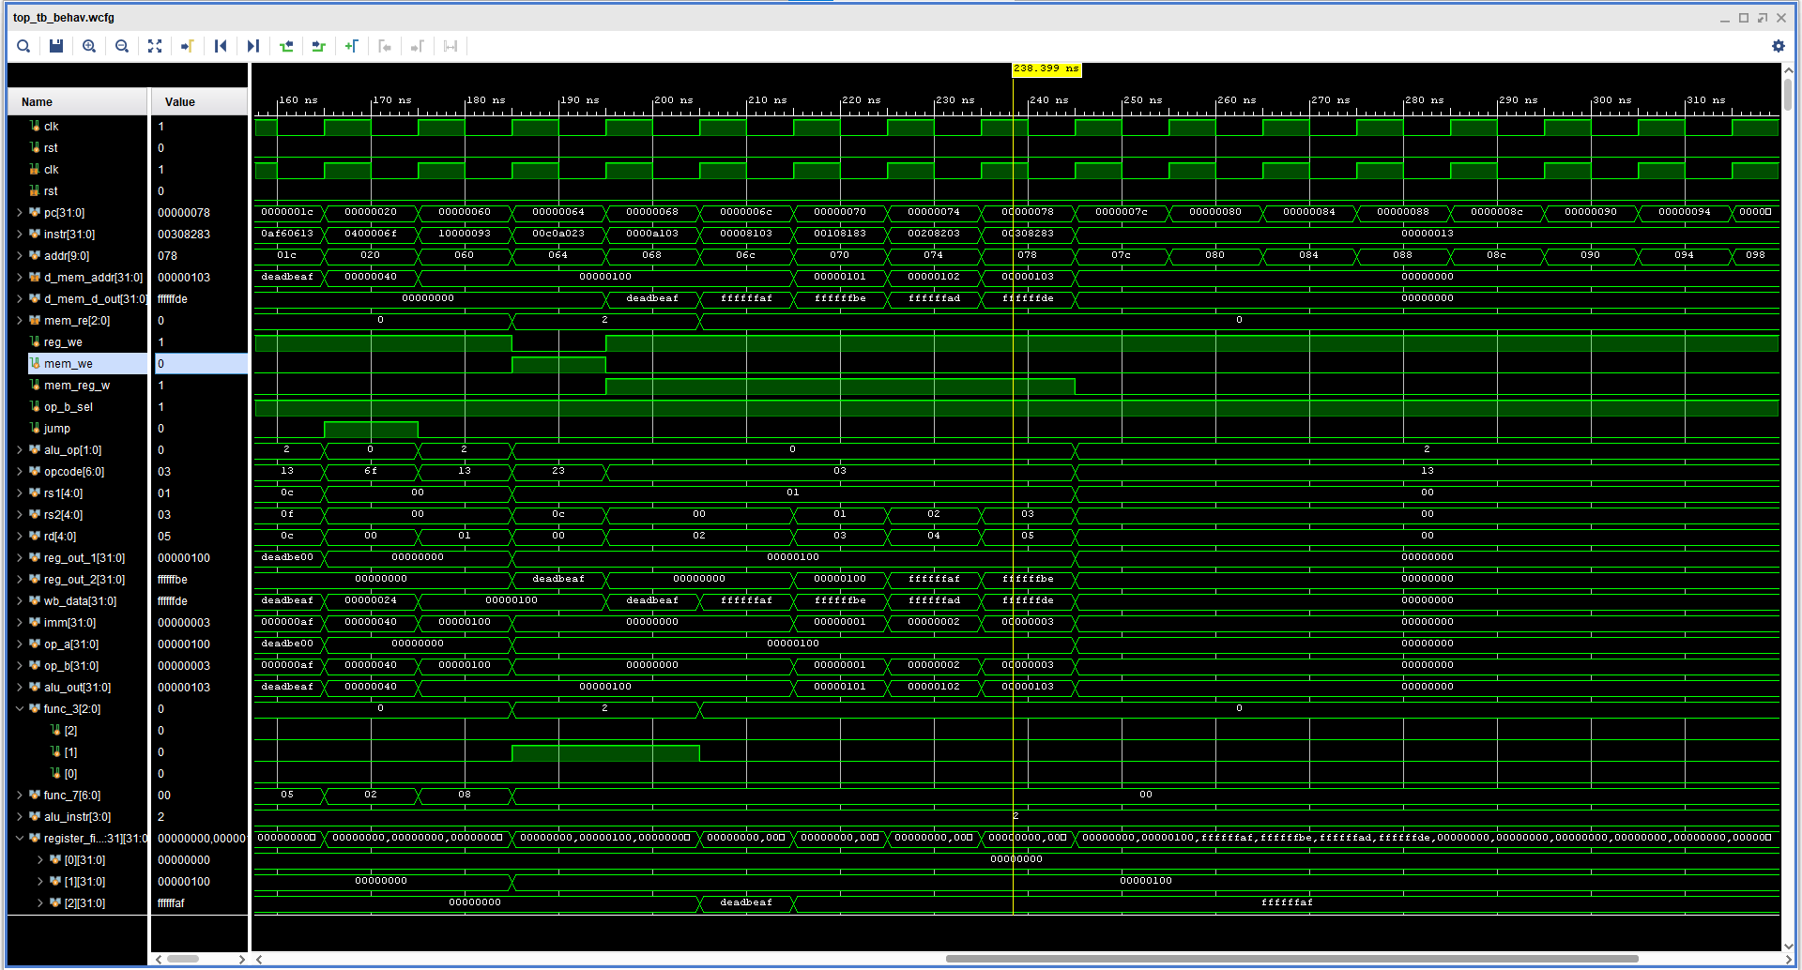
Register File Output: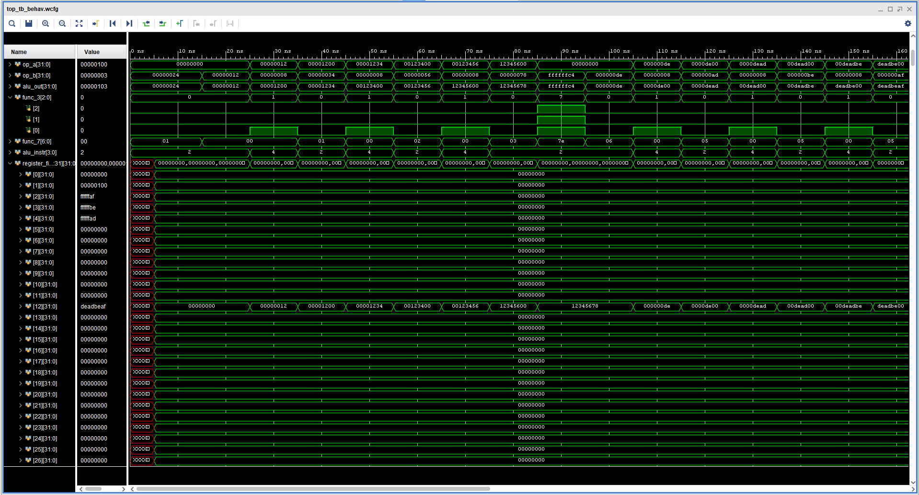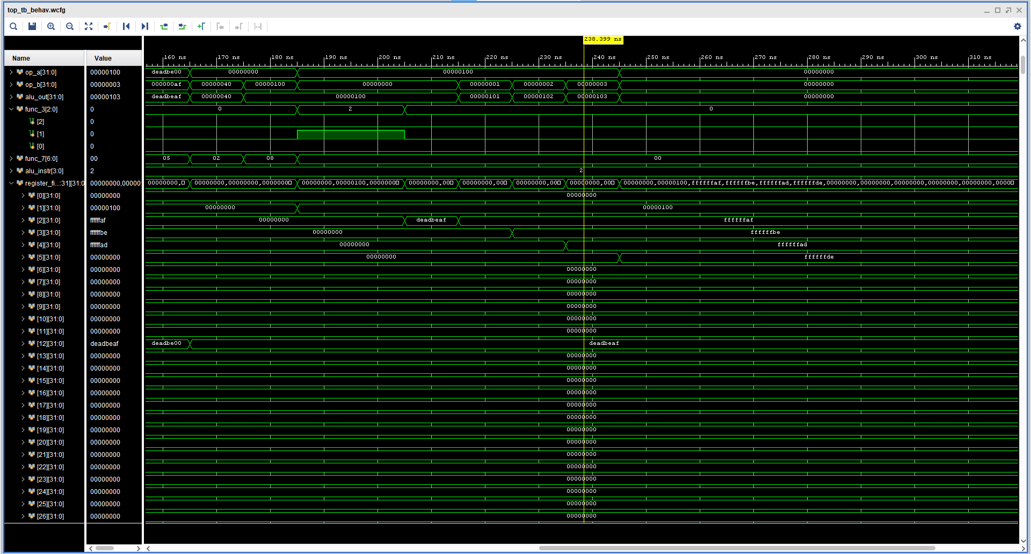
Data Memory:

Venus Results
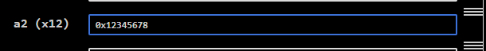
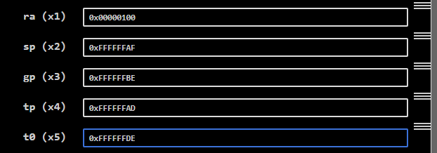

Critical Analysis: (Write you critical analysis / conclusion here)

In this lab, I implemented a simplified RV32I core in SystemVerilog with support for load/store instructions (LW, SW) and jump operations (JAL, JALR). The design integrates the program counter, instruction memory, register file, ALU, immediate generator, data memory, and control unit into a functional datapath. A key challenge was handling the data memory, which is byte-addressable but word-aligned, ensuring correct access during load and store operations. Correct write-back logic was developed to handle ALU results, memory outputs, and PC+4 for jumps. The program counter update mechanism with pc_sel and jump signals enables proper sequential execution and jump handling. Overall, the lab demonstrates the successful execution of a functional subset of the RV32I ISA, providing a solid base for extending the processor further.

