



RISC-V Architecture

Lab Manual # 20
RISC-V Datapath Implementation
(Upper Immediate and Branches)

Name | Muddassir Ali Siddiqui
Instructor | Sir Imran & Sir Umer
Date | 29th Aug 2025

In-Lab Tasks: (Write your lab task & screenshots here)

Given Venus Code:
# Test the RISC-V processor:
# add, sub, and, or, slt, addi, lw, sw, beq, jal
# If successful, it should write the value 25 to address 100
#
# RISC-V Assembly Description Address Machine Code
main: addi x2, x0, 5 # x2 = 5 0 00500113
addi x3, x0, 12 # x3 = 12 4 00c00193
addi x7, x3, -9 # x7 = (12 - 9) = 3 8 f f718393
or x4, x7, x2 # x4 = (3 OR 5) = 7 C 0023e233
and x5, x3, x4 # x5 = (12 AND 7) = 4 10 0041f2b3
add x5, x5, x4 # x5 = 4 + 7 = 11 14 004282b3
beq x5, x7, end # shouldn’t be taken 18 02728663
slt x4, x3, x4 # x4 = (12 < 7) = 0 1C 40720333
beq x4, x0, around # should be taken 20 00020663
addi x5, x0, 0 # shouldn’t execute 24 00000293
around: slt x4, x7, x2 # x6 = (3 < 5) = 1 28 004323b3
add x7, x4, x5 # x6 = (1 + 11) = 12 2C 0062a2b3
sub x7, x7, x2 # x7 = (12 - 5) = 7 30 0023a3b3
sw x7, 84(x3) # [96] = 7 34 0471aa23
lw x2, 96(x0) # x2 = [96] = 7 38 06012083
add x9, x2, x5 # x9 = (7 + 11) = 18 3C 005104b3
jal x3, end # jump to end, x3 = 0x44 40 008000ef
addi x2, x0, 1 # shouldn’t execute 44 00100113
end: add x2, x2, x9 # x2 = (7 + 18) = 25 48 00910133
sw x2, 0x20(x3) # [100] = 25 4C 0621a023
done: beq x2, x2, done # infinite loop 50 00210063

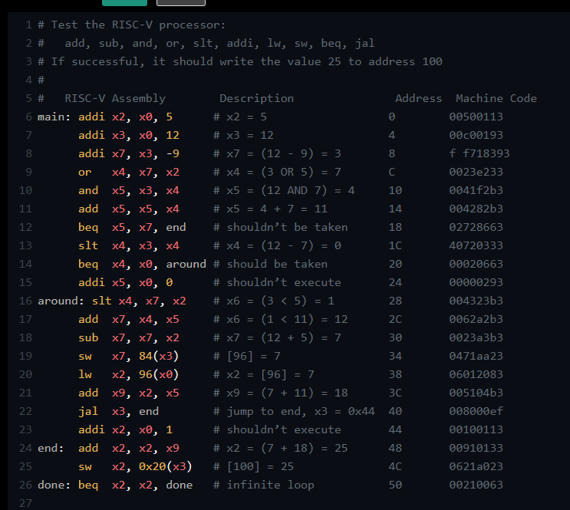

Instruction Memory:

After 5 iterations:
Venus Output:
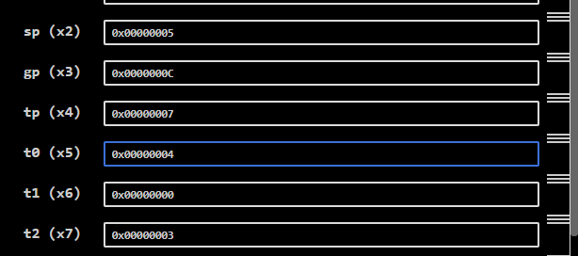
My RTL Output:
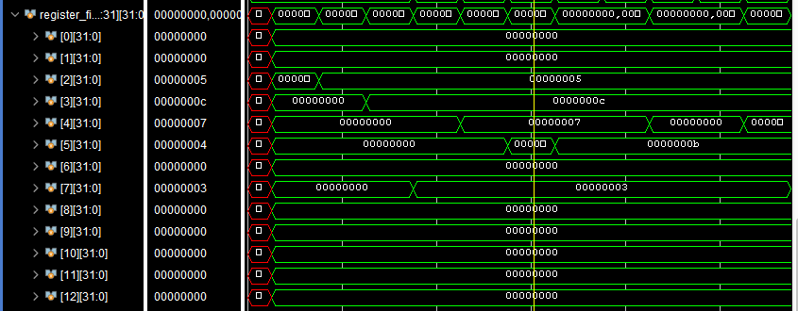

After 12 iterations:
Venus Output:
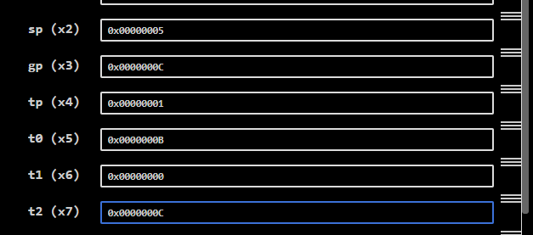
My RTL Output:
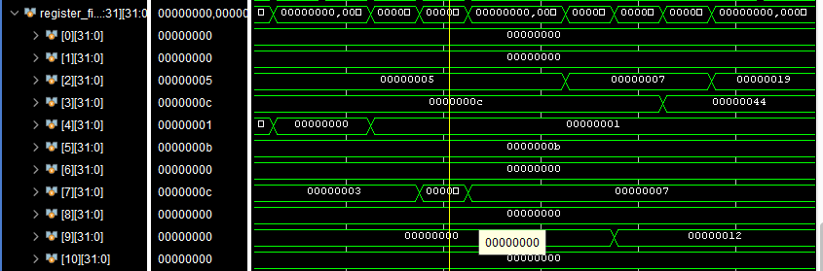

After 18 iterations:
Venus Output:
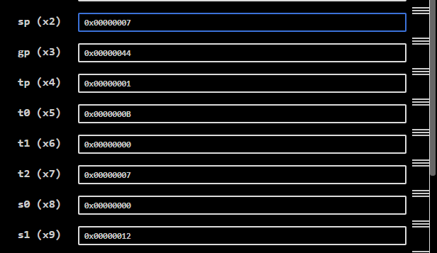
My RTL Output:
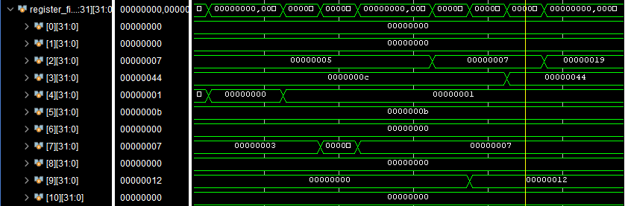

Final result:
Venus Output:
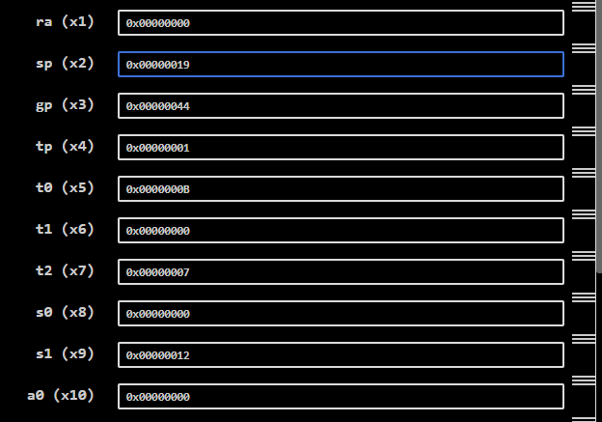
My RTL Output:
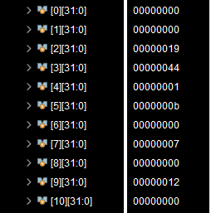

All Signals:
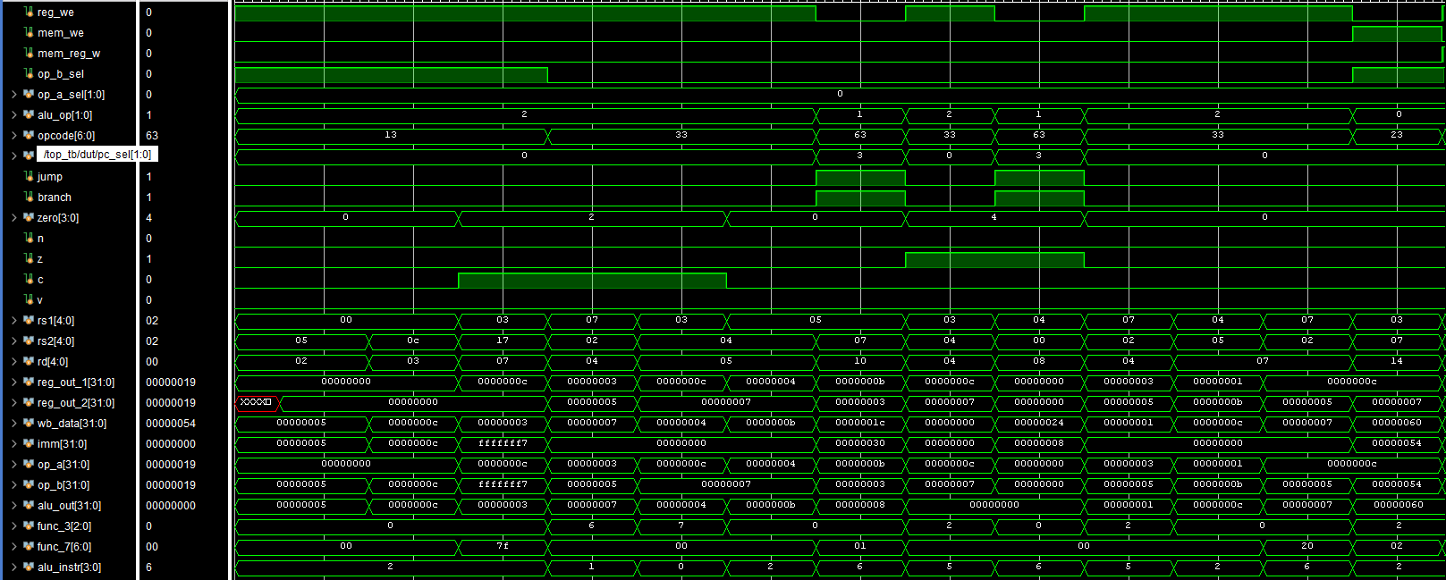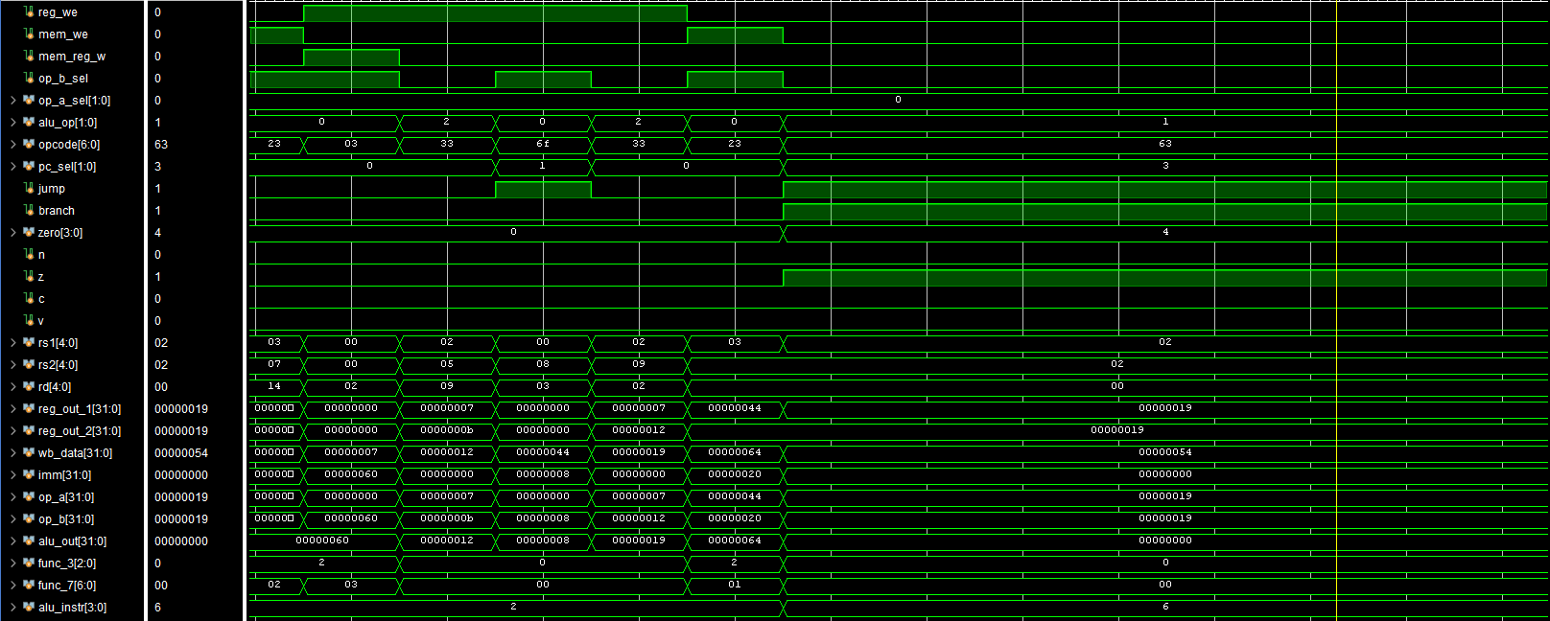
This is infinite loop instruction always here exist.
Jump signal is high for jump by jal.
ALU uses operand b to apply operations, so it selects either register file’s input or immediate.
ALU uses operand a to apply operations, so it selects either register file’s input or pc.
Branch signal is high and if true then jump is also high.

Data Memory:

Ox64 is 96 in decimal but divided by 4 got 24, that’s why it stores at location 24.

TCL report:
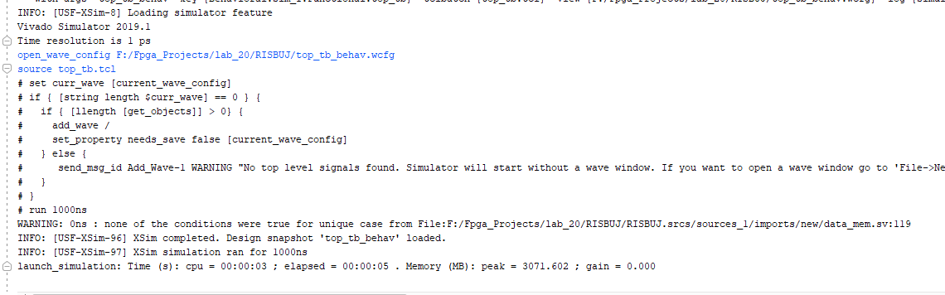

Schematic:

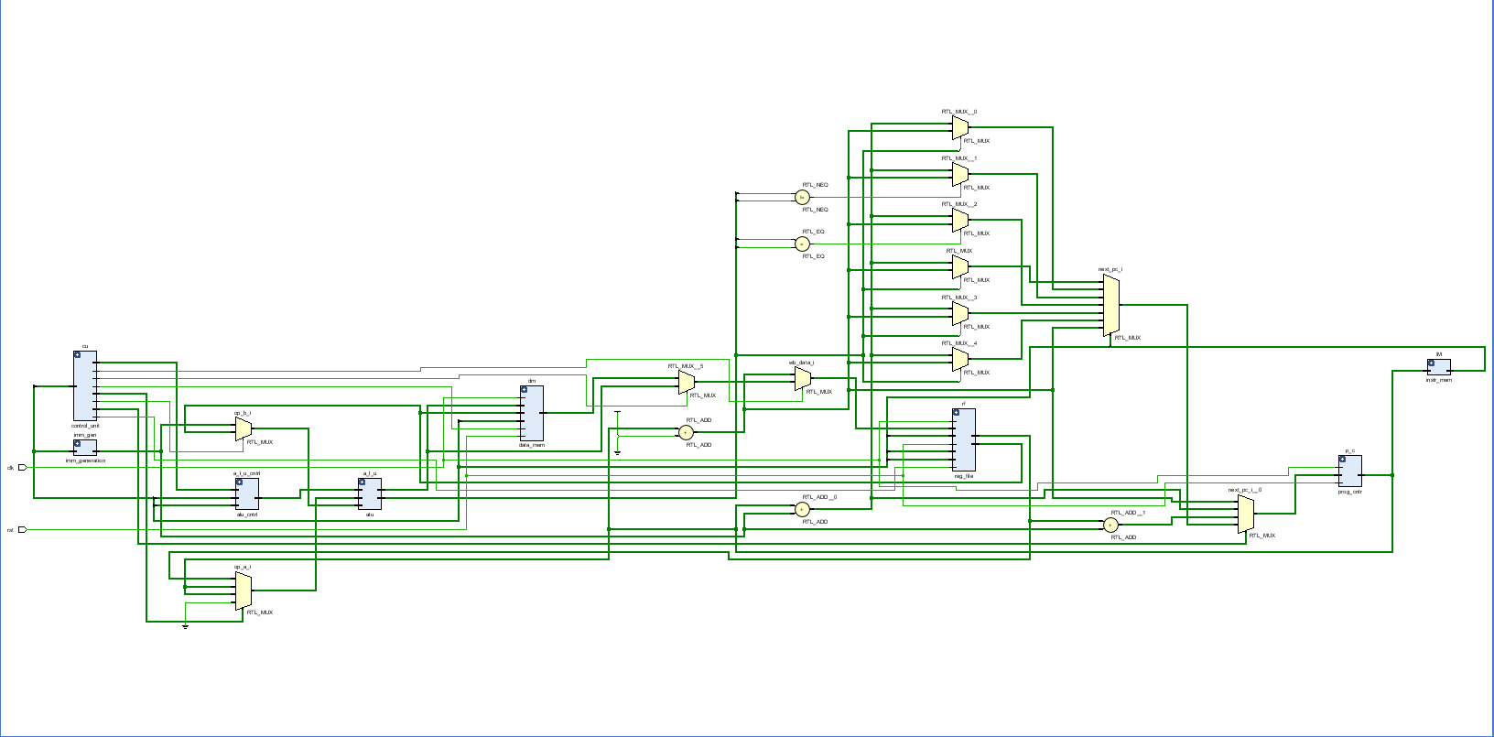

Critical Analysis: (Write you critical analysis / conclusion here)

By designing and simulating the processor, I was able to understand the execution of fundamental instructions such as arithmetic, logic, load/store, and control flow. The lab highlighted the simplicity and modularity of the RV32I design, making it both educational and efficient for hardware realization. Through this exercise, I gained hands-on experience with Datapath, control signals, and instruction decoding, reinforcing theoretical concepts with practical application. Overall, this implementation deepened my understanding of processor design and laid a strong foundation for exploring more advanced RISC-V extensions.
In conclusion, the implementation of the RISC-V RV32I base architecture provided practical insight into how an instruction set architecture (ISA) operates at the hardware level.

