



RISC-V Architecture

Lab Manual # 21 – Pipelining

Name | Muddassir Ali Siddiqui
Instructor | Sir Imran & Sir Umer
Date | 1st Sep 2025

In-Lab Tasks: (Write your lab task & screenshots here)

Schematics:

IF-ID Stage:
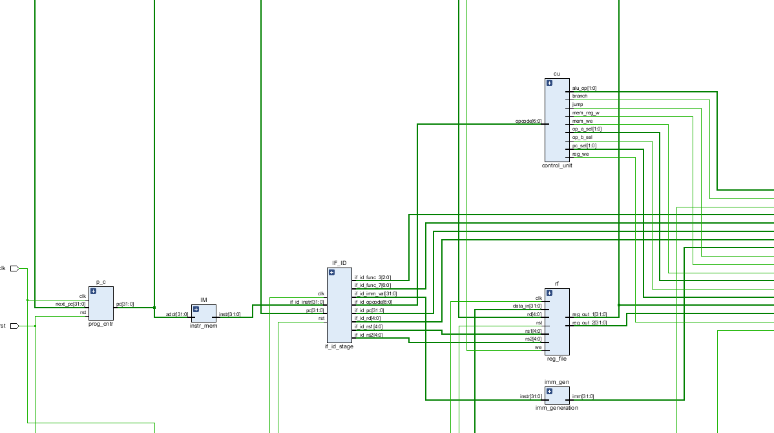

ID-EX Stage:
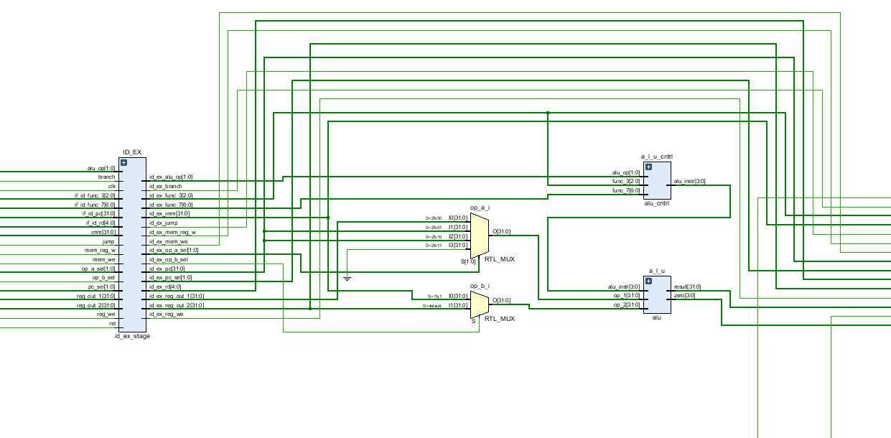

EX-MEM Stage:
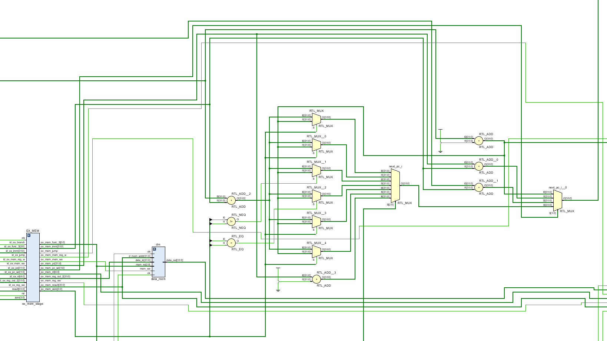
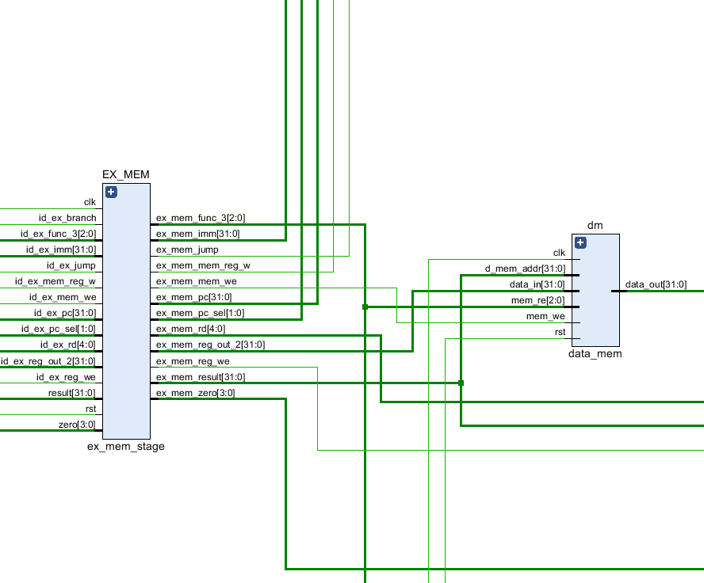

MEM-WB Stage:
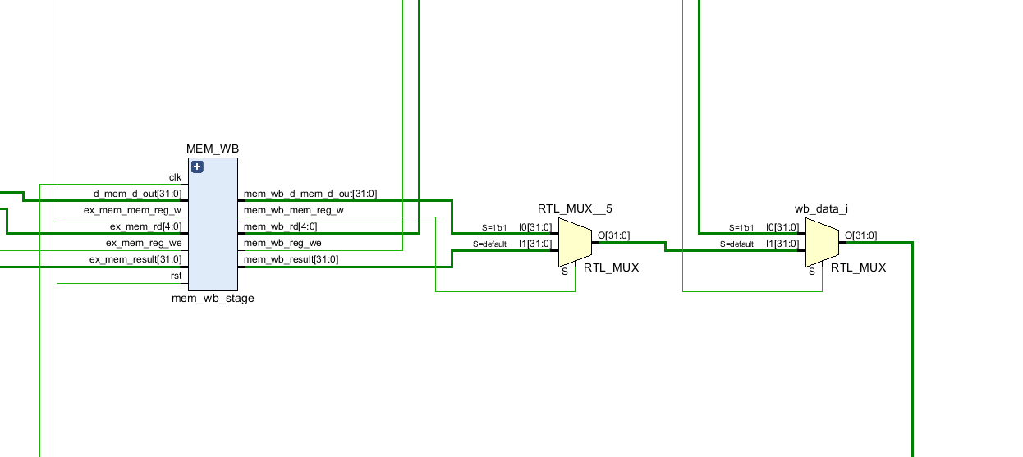

TOP-5-Stage-Pipeline:
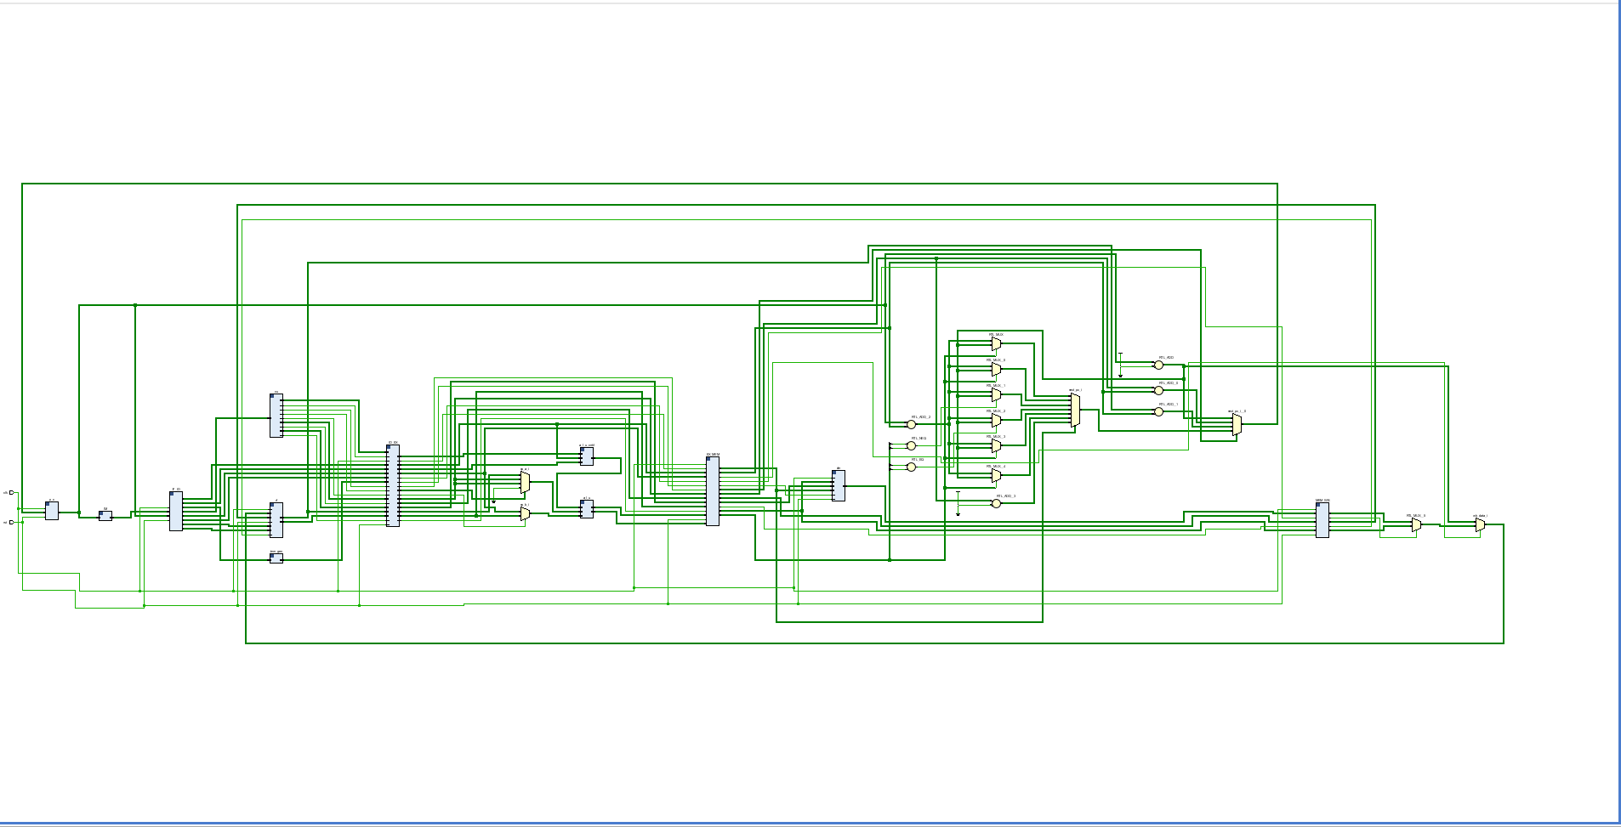
EX-MEM
MEM-WB
ID-EX
IF-ID

Simulation:
Venus Code:
addi x3, x0, 100 # x3 = 100
addi x7, x0, 7 # x7 = 7
nop # wait for x3, x7 to be ready
nop
nop
nop
sw x7, 84(x3) # MEM[100+84] = x7
nop
nop
nop
lw x5, 84(x3) # x5 = MEM[100+84]
nop # wait for lw result
nop
nop
nop
add x6, x5, x7 # x6 = x5 + x7
addi x10, x0, 10 # x10 = 10
nop
nop
nop
nop
add x11, x6, x10 # x11 = x6 + x10

# ---- Branch Section ----
addi x12, x0, 17 # x12 = 17
addi x13, x0, 17 # x13 = 17
nop # let x12, x13 settle
nop
nop
nop # let x12, x13 settle
nop
nop
beq x12, x13, LABEL # branch if x12 == x13
nop # delay slot (not in RISC-V, but keep pipeline safe)
nop
nop
nop

# fall-through if branch not taken
addi x14, x0, 99 # x14 = 99
nop
nop
nop
nop
jal x0, EXIT # jump to exit

LABEL:
addi x14, x0, 111 # x14 = 111 (executed if branch taken)
nop
nop
nop
nop

EXIT:
addi x15, x0, 55 # x15 = 55 (program end marker)
Screenshots:
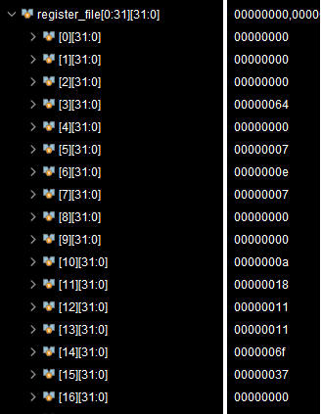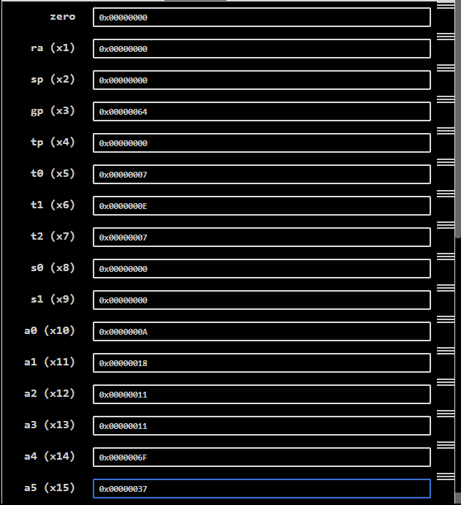
These are results comparison. Now the results are incredibly true.

Critical Analysis: (Write you critical analysis / conclusion here)

In this lab, I implemented a pipelined version of the single-cycle processor by introducing pipeline registers for all five stages. The registers IF-ID, ID-EX, EX-MEM, and MEM-WB were added to transfer instruction and data signals across pipeline stages. To handle hazards at this stage, I inserted 4 NOPs after each instruction in the assembly program. With this approach, the pipeline executed instructions correctly and produced the expected results. The successful implementation verified the working of pipeline registers in maintaining instruction flow. This lab helped me understand how pipelining improves instruction throughput and prepares the base for hazard detection and forwarding mechanisms in later designs.

