



RISC-V Architecture

Lab Manual # 23
Handling Control Hazards

Name | Muddassir Ali Siddiqui
Instructor | Sir Imran & Sir Umer
Date | 5th Sep 2025

In-Lab Tasks: (Write your lab task & screenshots here)

Schematics:

IF-ID Stage:
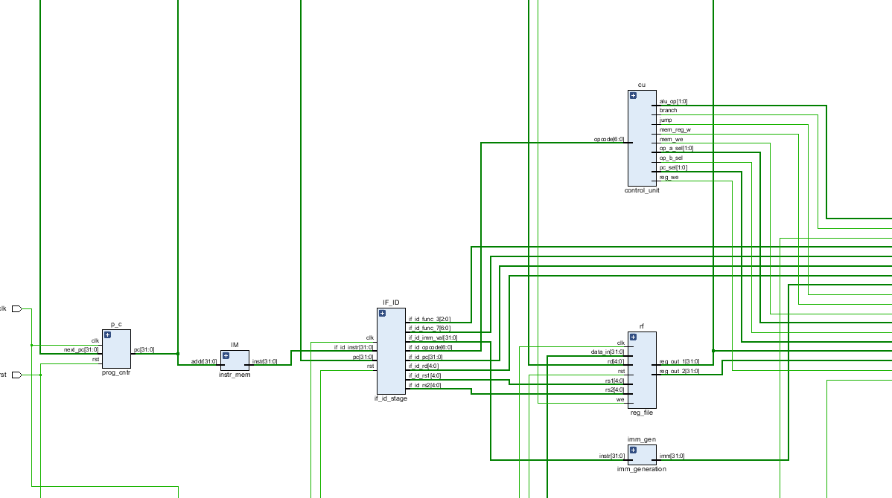

ID-EX Stage:
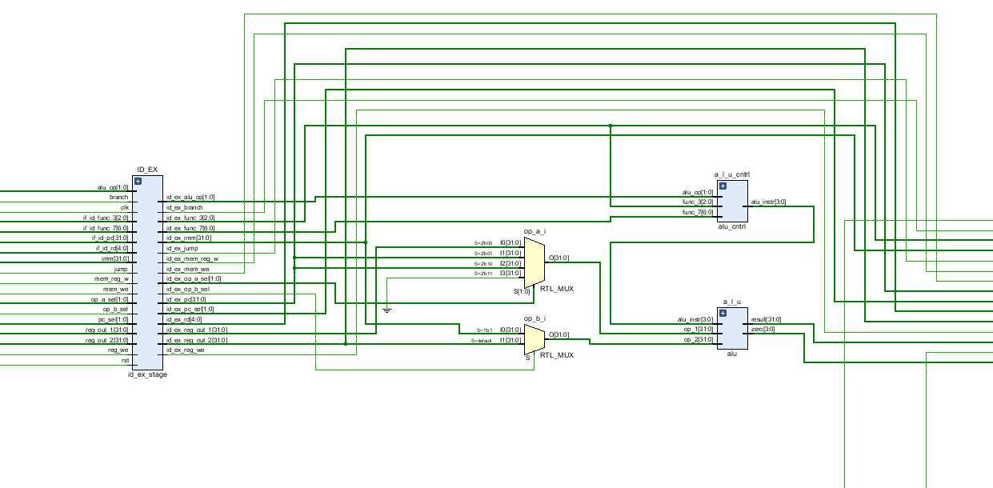

EX-MEM Stage:
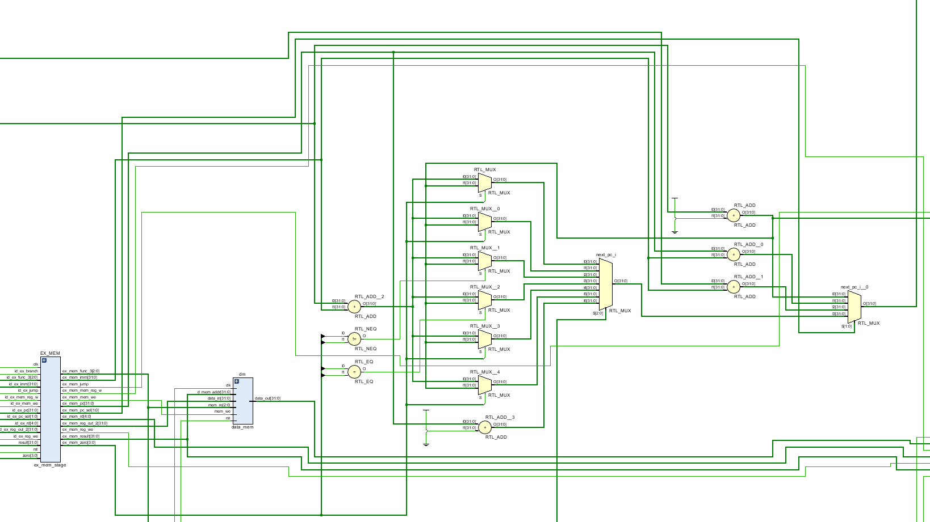
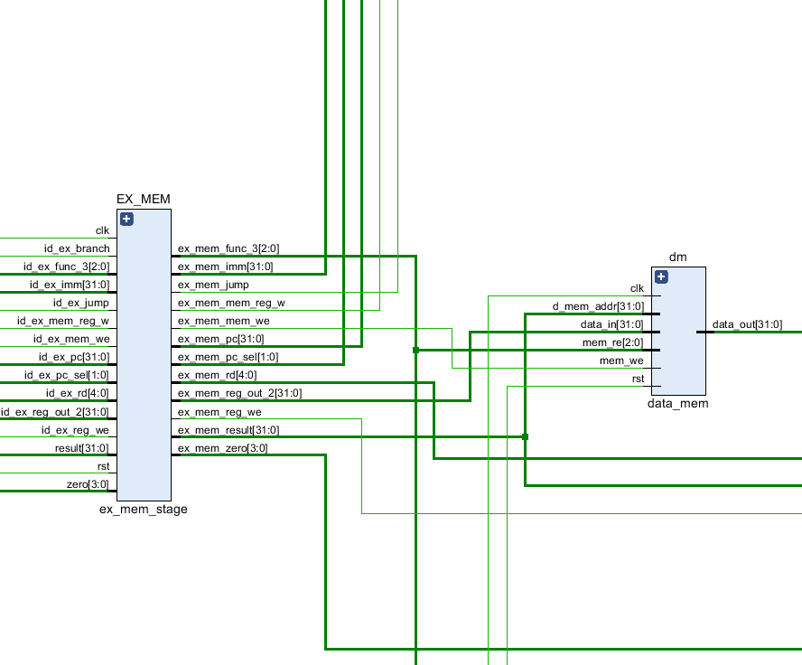

MEM-WB Stage:
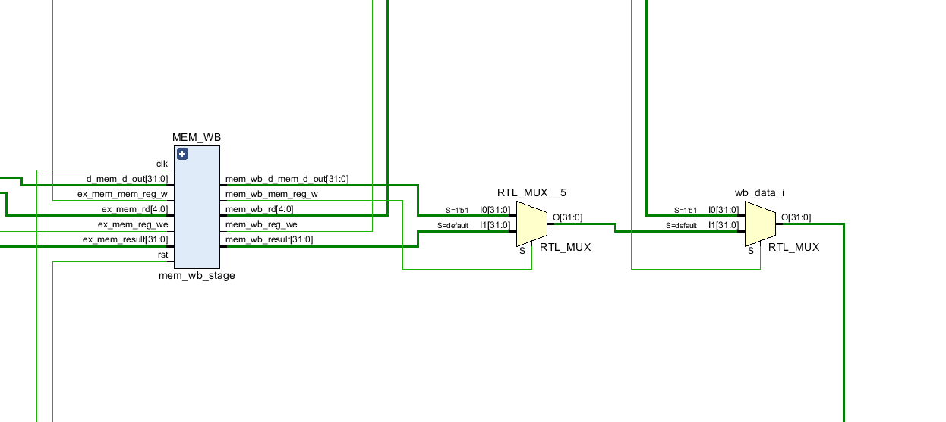

Forwarding Unit:
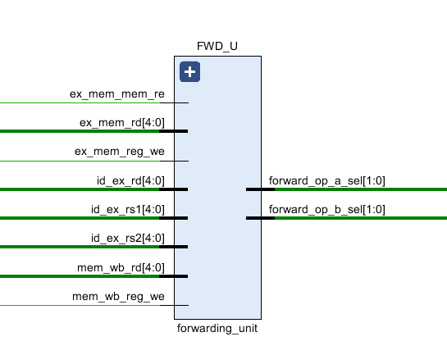
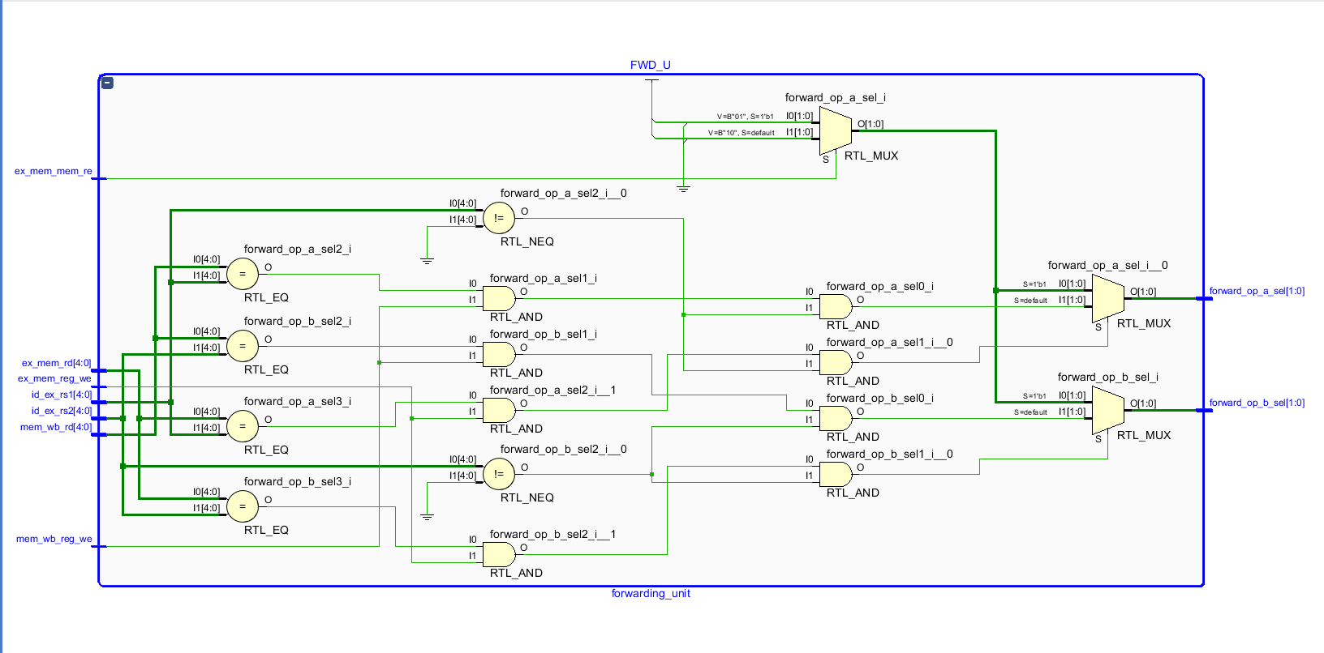

Hazard Detection Unit:
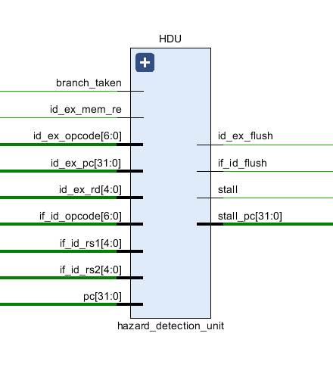
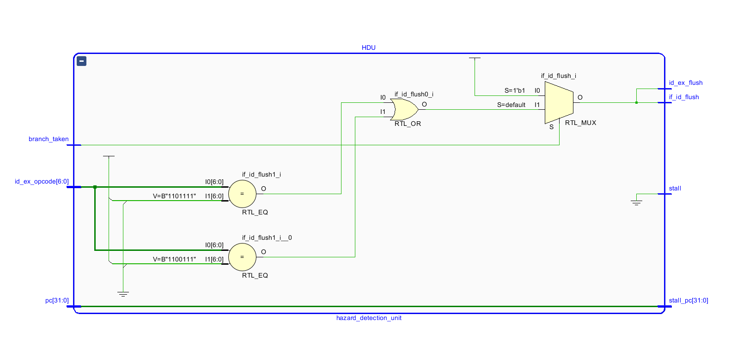

TOP-5-Stage-Pipeline with handling data Hazards:
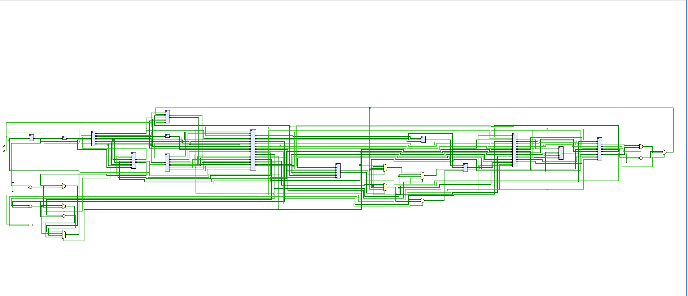
IF-ID
HDU
ID-EX
FWD_U
EX-MEM
MEM-WB

Simulation:
Venus Code:
addi x1, x0, 0x100
sw x1, 0(x1)
lw x2, 0(x1)
addi x3, x2, 0x100 # x3 = 100
add x7, x3, x3 # x7 = 7
addi x1, x0, 0x10
add x2, x1, x1
add x3, x1, x2
add x4, x1, x3
add x5, x1, x4
add x6, x1, x5
Screenshots:
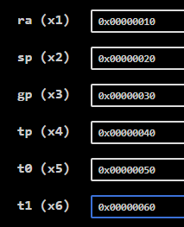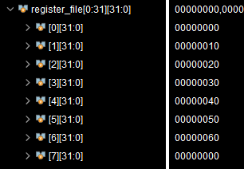
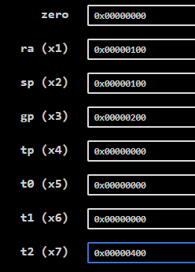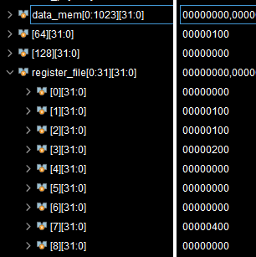
These are results comparison. You will observe that the results are incredibly true.

RISC V Tester:

Given Venus Code:
# Test the RISC-V processor:
# add, sub, and, or, slt, addi, lw, sw, beq, jal
# If successful, it should write the value 25 to address 100
#
# RISC-V Assembly Description Address Machine Code
main: addi x2, x0, 5 # x2 = 5 0 00500113
addi x3, x0, 12 # x3 = 12 4 00c00193
addi x7, x3, -9 # x7 = (12 - 9) = 3 8 f f718393
or x4, x7, x2 # x4 = (3 OR 5) = 7 C 0023e233
and x5, x3, x4 # x5 = (12 AND 7) = 4 10 0041f2b3
add x5, x5, x4 # x5 = 4 + 7 = 11 14 004282b3
beq x5, x7, end # shouldn’t be taken 18 02728663
slt x4, x3, x4 # x4 = (12 < 7) = 0 1C 40720333
beq x4, x0, around # should be taken 20 00020663
addi x5, x0, 0 # shouldn’t execute 24 00000293
around: slt x4, x7, x2 # x6 = (3 < 5) = 1 28 004323b3
add x7, x4, x5 # x6 = (1 + 11) = 12 2C 0062a2b3
sub x7, x7, x2 # x7 = (12 - 5) = 7 30 0023a3b3
sw x7, 84(x3) # [96] = 7 34 0471aa23
lw x2, 96(x0) # x2 = [96] = 7 38 06012083
add x9, x2, x5 # x9 = (7 + 11) = 18 3C 005104b3
jal x3, end # jump to end, x3 = 0x44 40 008000ef
addi x2, x0, 1 # shouldn’t execute 44 00100113
end: add x2, x2, x9 # x2 = (7 + 18) = 25 48 00910133
sw x2, 0x20(x3) # [100] = 25 4C 0621a023
done: beq x2, x2, done # infinite loop 50 00210063

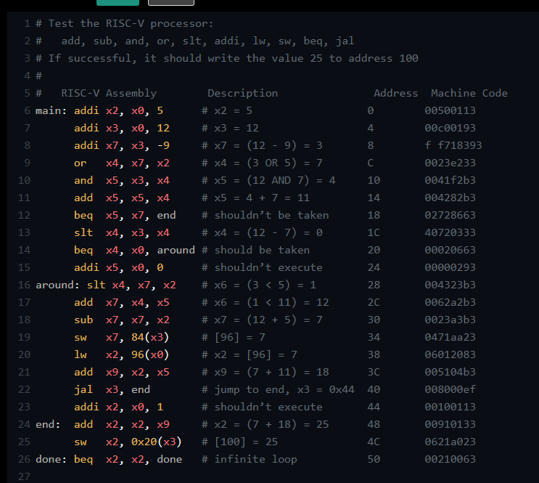

Instruction Memory:

After 5 iterations:
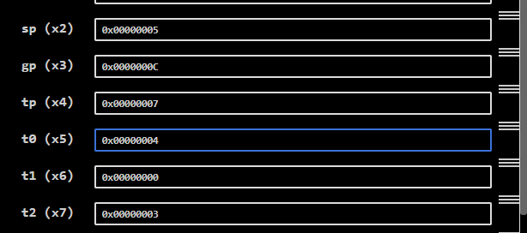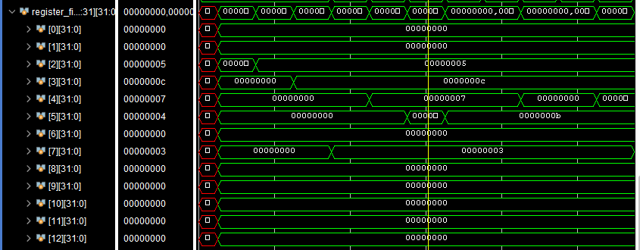

After 12 iterations:
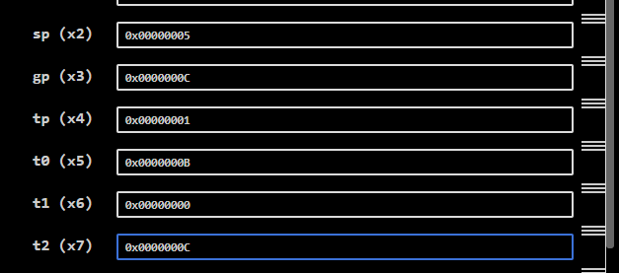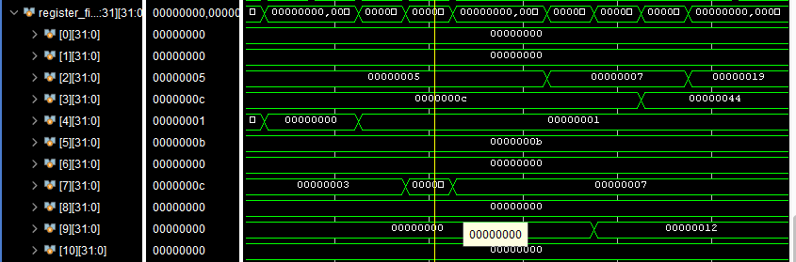

After 18 iterations:
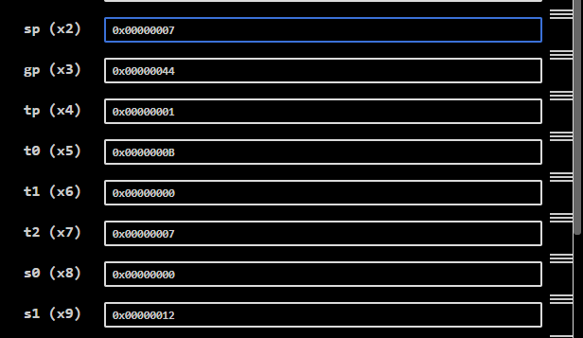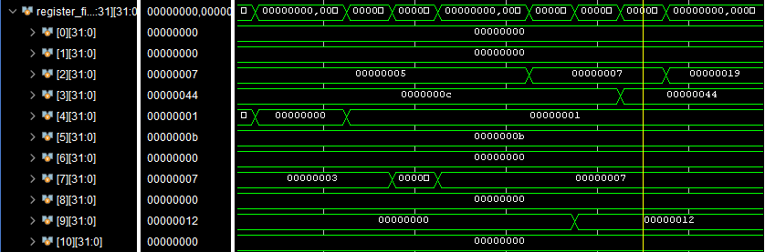

Final result:
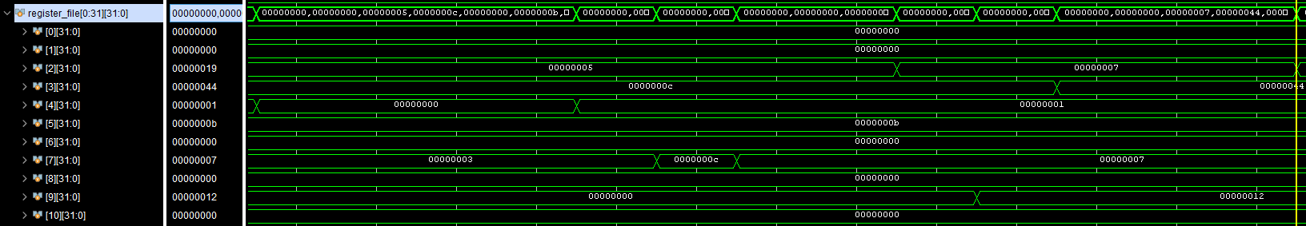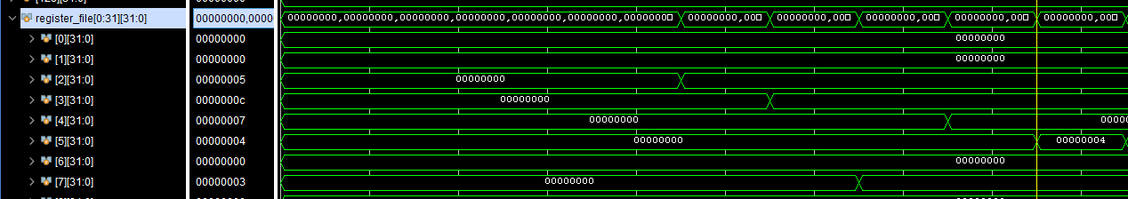
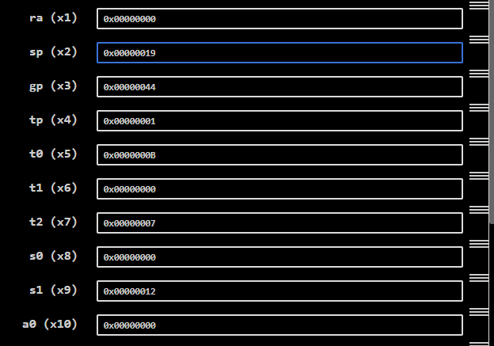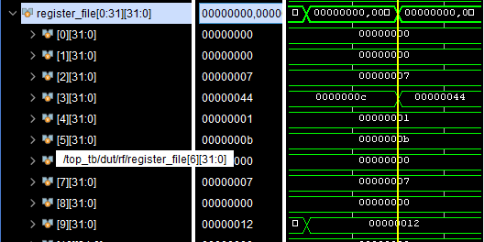

Branch Hazards:
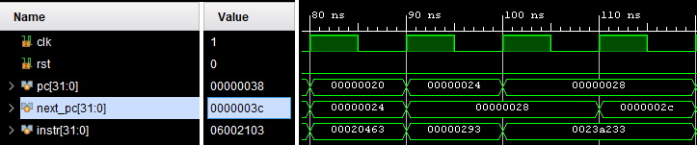
Here the branch is taken so I flush out the first 2 registers if_id and id_ex, but the jump address is also the second address here that’s why the long cycle of same pc = 28.
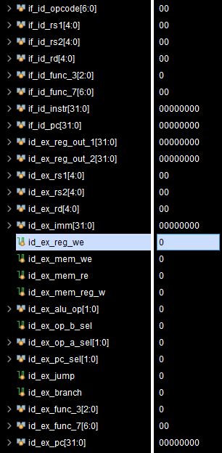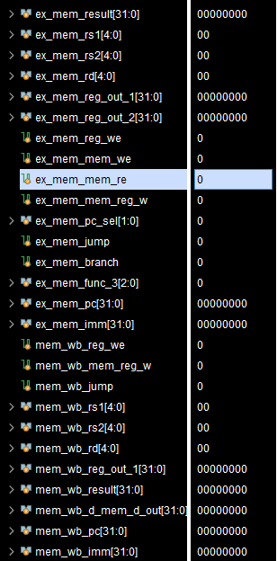
This is the output of 2 cycles which flush the registers.

Critical Analysis: (Write you critical analysis / conclusion here)

In this lab, I successfully implemented the complete 5-stage pipelined RISC-V processor (IF, ID, EX, MEM, WB). By integrating hazard detection, forwarding, and stalling mechanisms, the design now supports smooth instruction execution with minimal performance penalties. The pipeline improves throughput by allowing multiple instructions to overlap in execution, while control logic ensures correctness even in the presence of hazards. This implementation demonstrates the practical balance between efficiency and reliability in modern processor architectures.

