



RISC-V Architecture

Weekly Task
RISC-V – UART Integration
and Digital Clock Testing

Name | Muddassir Ali Siddiqui
Instructor | Sir Imran & Sir Umer
Date | 8th Sep 2025

In-Lab Tasks: (Write your lab task & screenshots here)

Single Cycle Core:
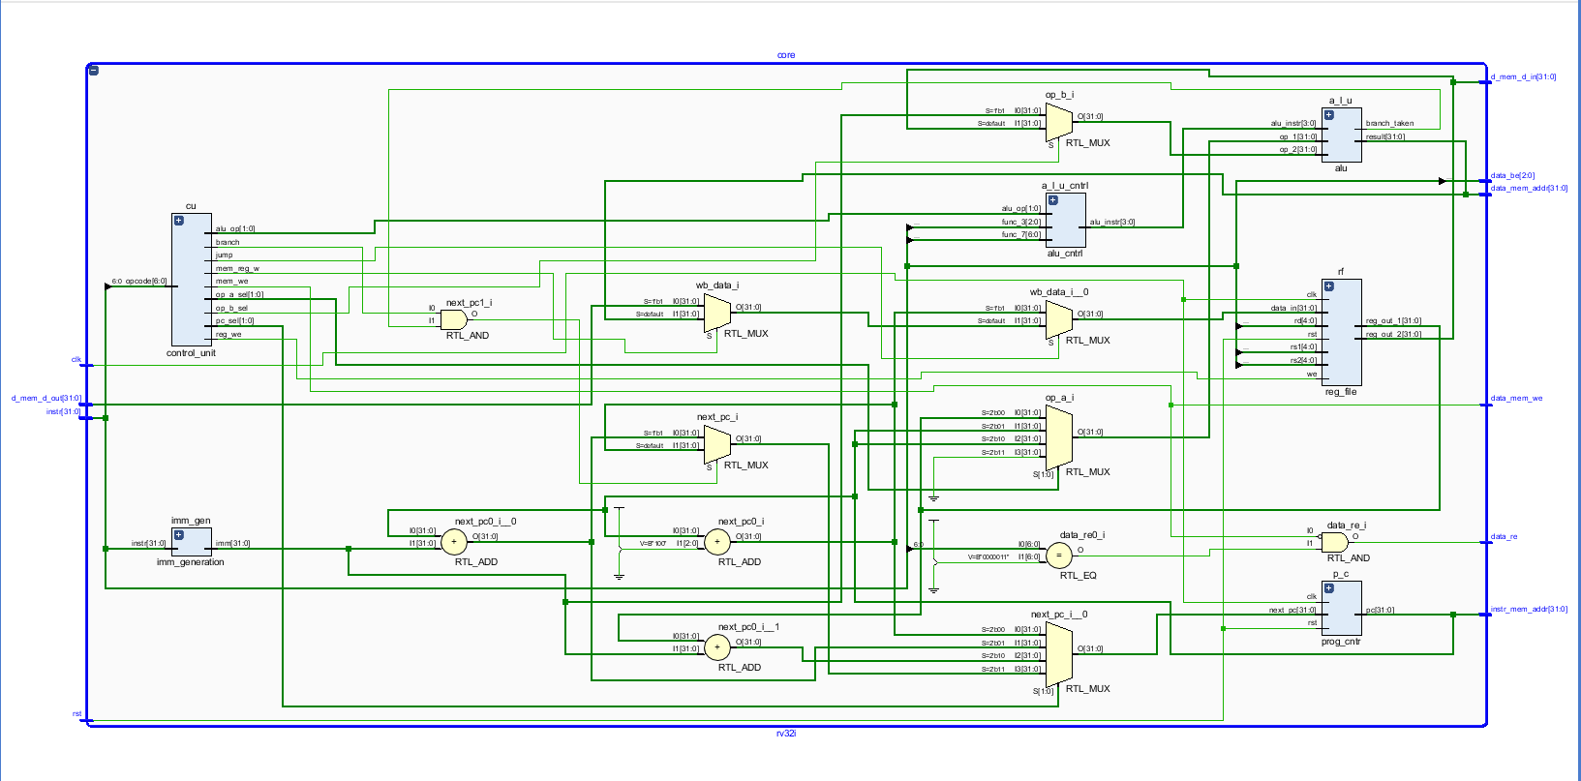

Memory Map Unit:
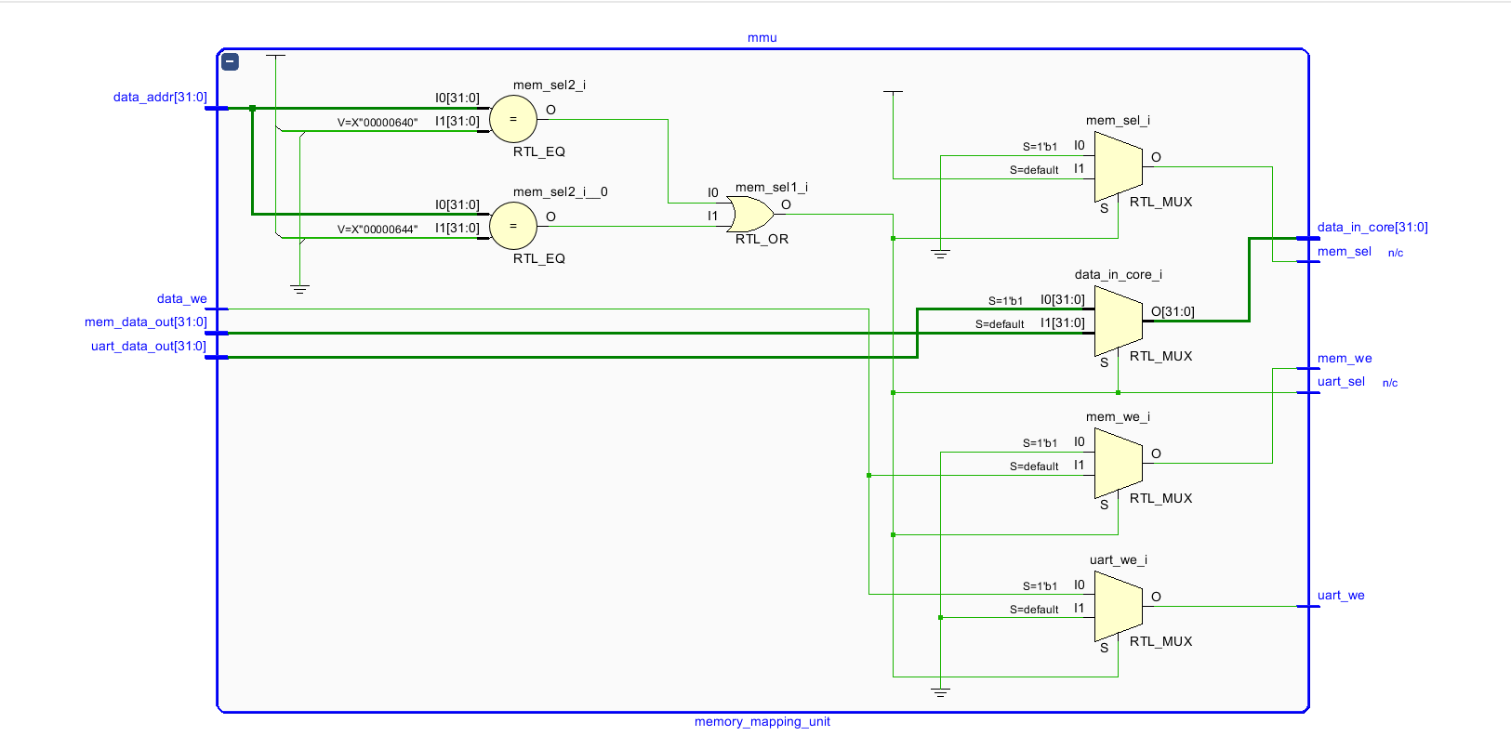

UART:
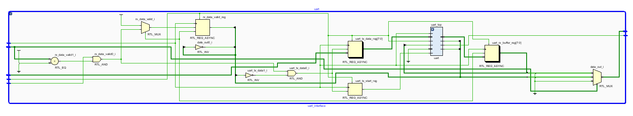

SoC Top:
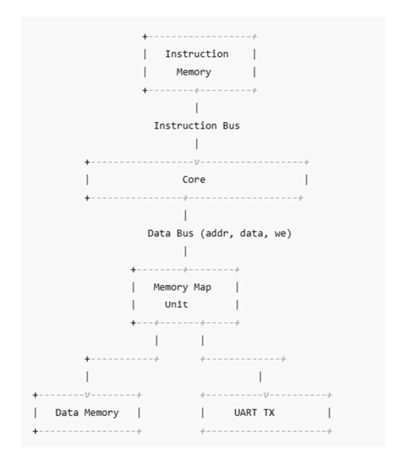
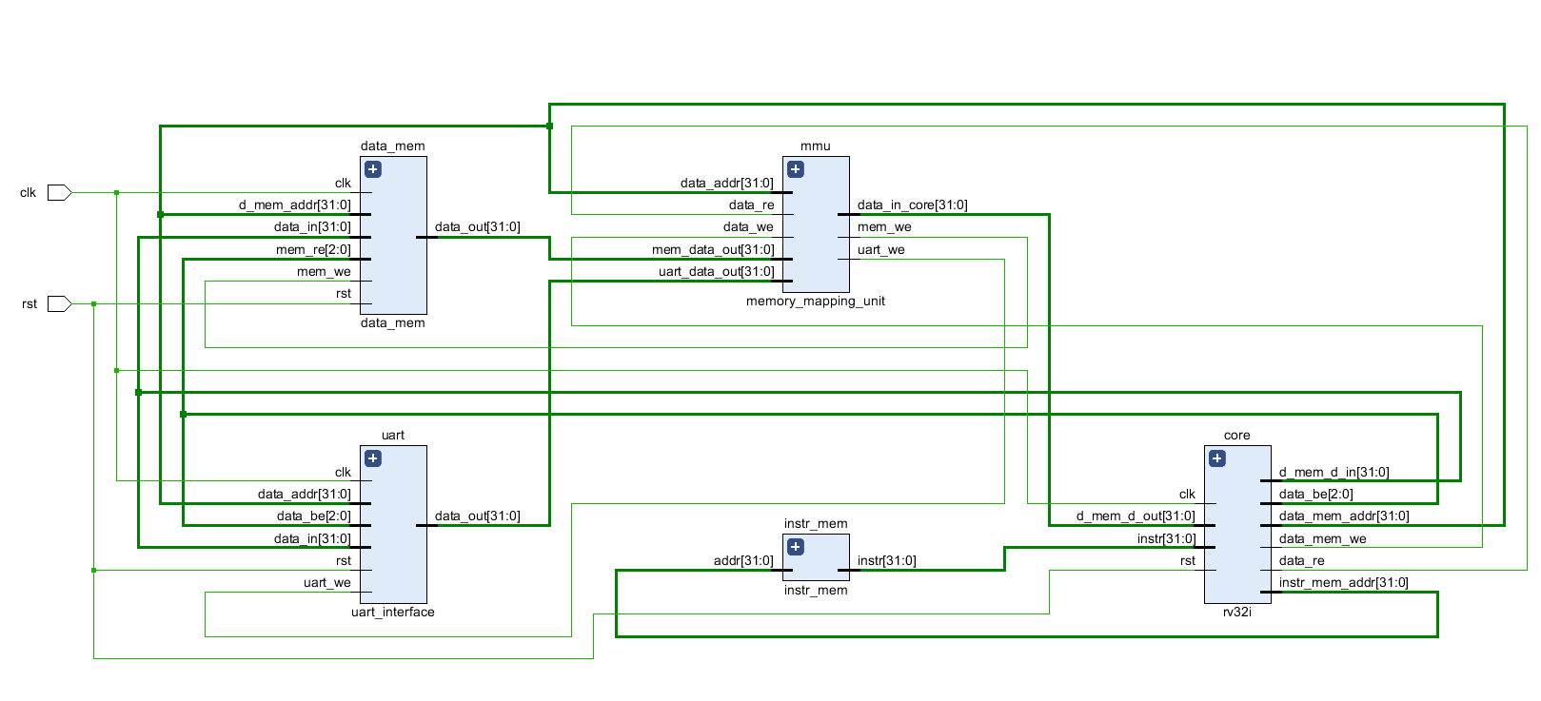

Venus Code:
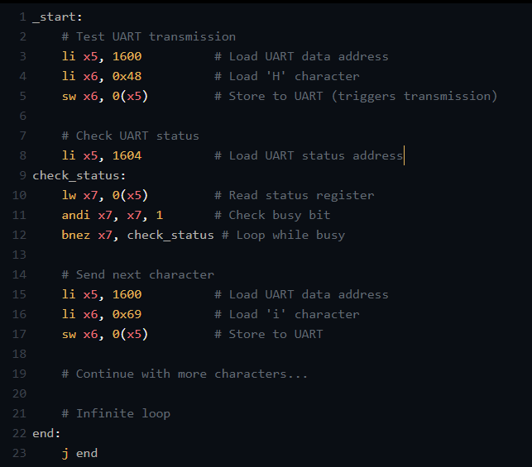

Verification:
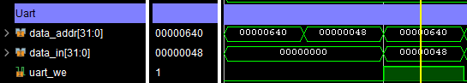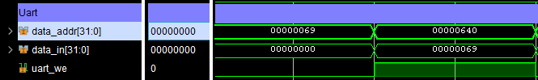
First, we store the ascii of character ‘H’ at location of 1600, which means it goes in UART not the Data Memory.
So MMU decides where it should go and it is seen that it goes well.
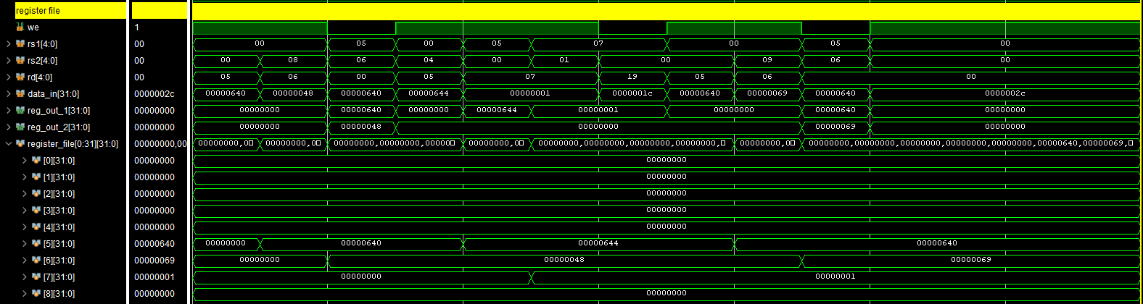
This is our register file when we load and in Venus at the address 1604 there will be empty but in our soc it is present in UART, and it loads successfully.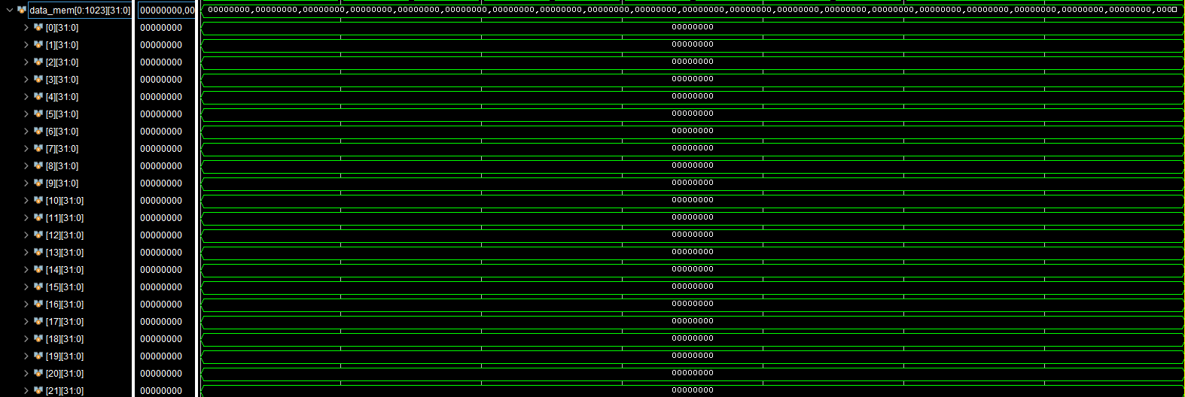
While data memory remain empty according to given assembly code.

Critical Analysis: (Write you critical analysis / conclusion here)

In this lab, I integrated a single-cycle RV32I core into an SoC by separating instruction and data memories from the processor and instantiating them in the SoC top. A memory-mapped unit was designed to decode addresses and route load/store operations either to memory or to the UART peripheral. This allowed the processor to communicate with external devices through standard memory-mapped I/O. The modular design improves flexibility, making it easier to extend the SoC with additional peripherals. Overall, the lab demonstrated how a processor, memory, and I/O devices are combined to form a complete SoC.

