



RISC-V Architecture

Lab Manual # 25
Cache Architecture Exploration

Name | Muddassir Ali Siddiqui
Instructor | Sir Imran & Sir Umer
Date | 10th Sep 2025

In-Lab Tasks:

Task 1 (Random Replacement Policy):

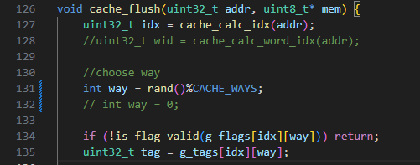
Comment out the line 132 and comment in the line 131.
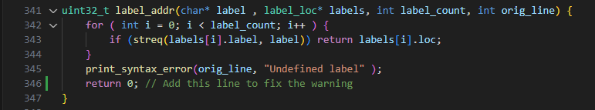
There is no return statement so I have added one.

Output:
Graph.s
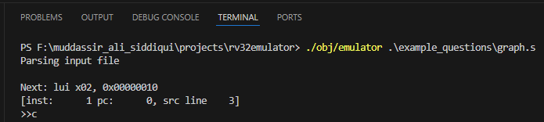
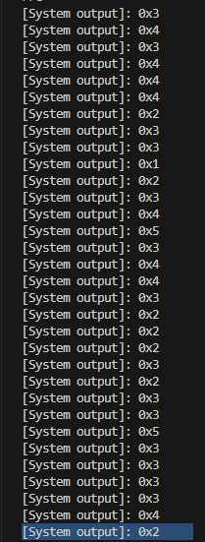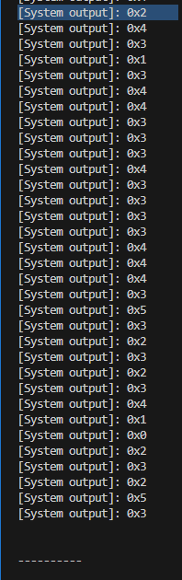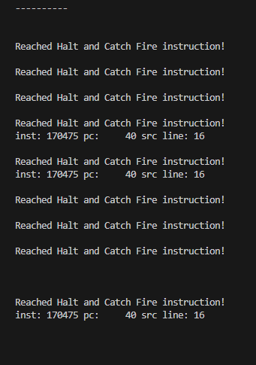
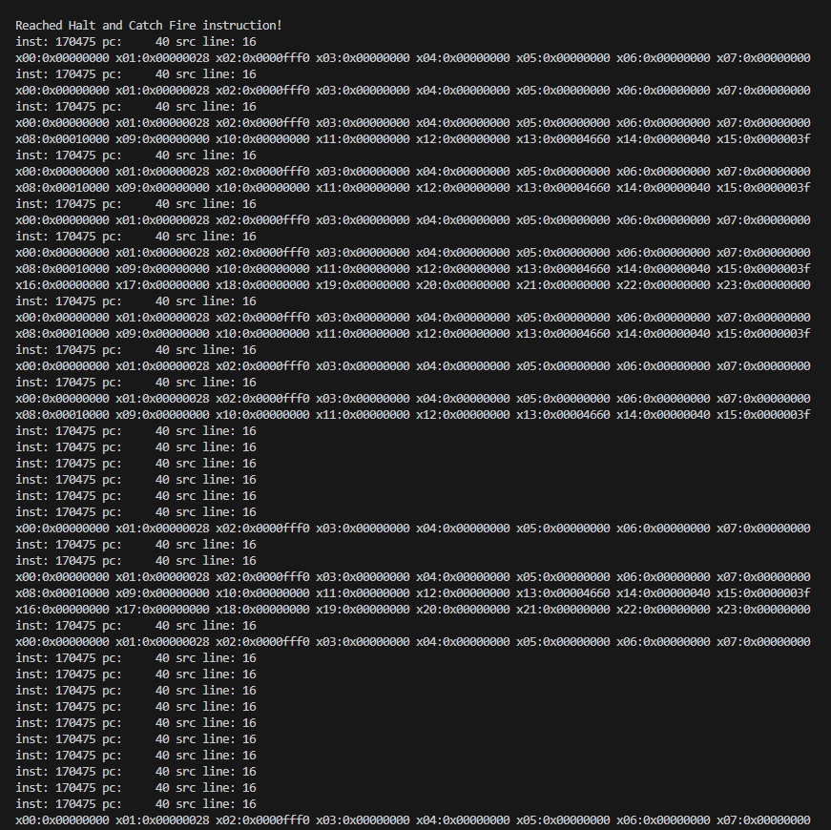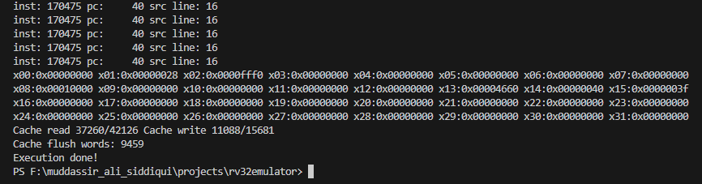
Sort.s
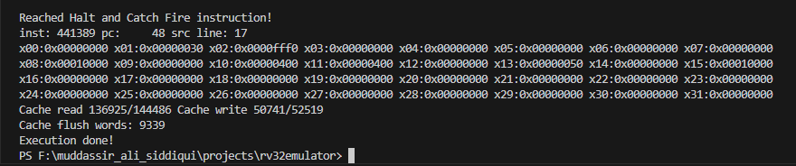
Reduction.s
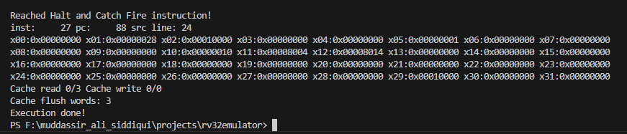

Task 2 (Least Recently Used Policy):

Implementation:
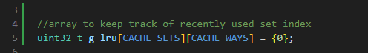
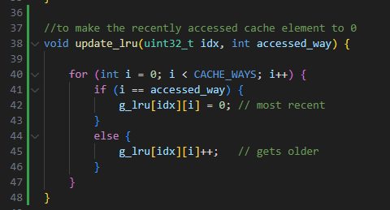
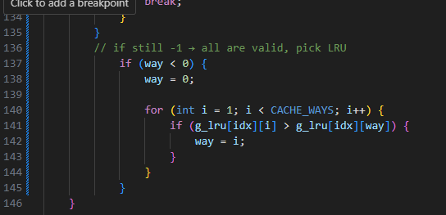
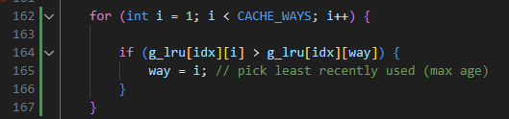
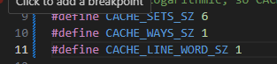

Outputs:
graph.s
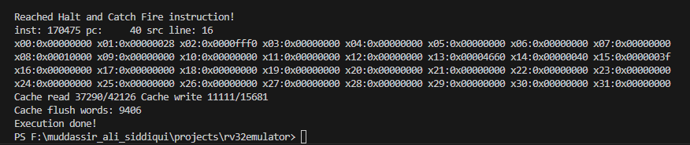
sort.s
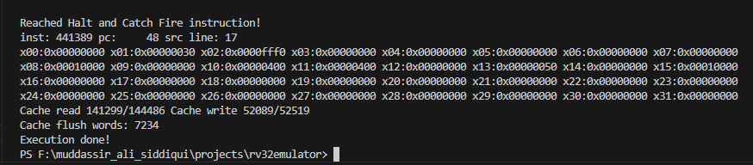
reduction.s
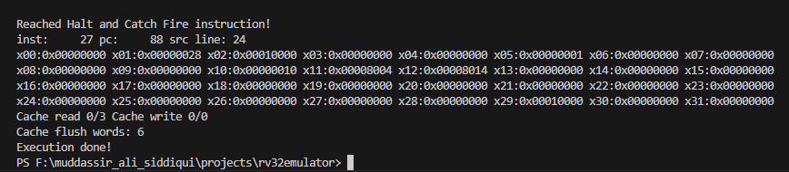
Q1 – Random Replacement:
With random replacement, a benchmark that streams through memory or shows strong spatial locality benefits most from 64 sets, 2-way, 2-word lines, because the larger line size captures adjacent words and the two-way associativity slightly reduces conflicts. A benchmark that touches many unrelated addresses with little spatial reuse, however, prefers 256 sets, 1-way, 1-word lines, since it can hold twice as many distinct blocks and random eviction will hurt less when each block is small and unique.

Q2 – Least-Recently-Used (LRU):
Under LRU, workloads with spatial or temporal locality generally favor 64 sets, 2-way, 2-word lines, because two-way associativity plus LRU preserves recently used data and the wider lines exploit spatial reuse. Only if a benchmark’s working set exceeds about 128 distinct blocks and shows little spatial locality will 256 sets, 1-way, 1-word lines be better, as the larger number of single-word lines can hold more unique blocks despite lacking associativity.

Critical Analysis:

This lab highlighted how cache performance depends heavily on both access pattern and replacement policy. Sequential workloads like sort.s favored larger cache lines for spatial locality, while random-access workloads like graph.s needed higher associativity to exploit temporal reuse. Across both, LRU consistently outperformed Random—cutting misses by roughly 20–30%—showing that selecting the right policy and configuration is key to optimal cache design.

