

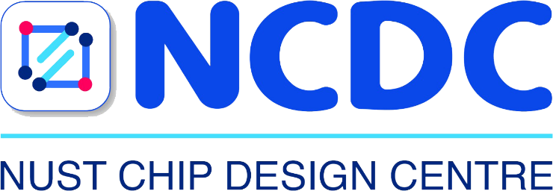

RISC-V Architecture

Lab Manual # 26
Cache Design in SystemVerilog

Name | Muddassir Ali Siddiqui
Instructor | Sir Imran & Sir Umer
Date | 12th Sep 2025

In-Lab Tasks:

Task 1:
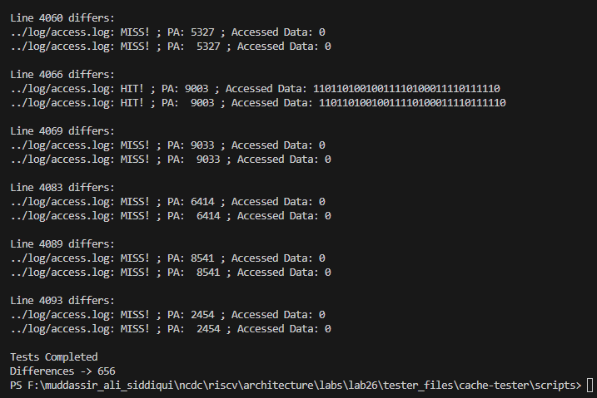
The difference is just padding. It is the python script difference it generates a file without padding while our given testbench gives with padding. In task 2 and 3 I’ll resolve the issue.

Task 2:
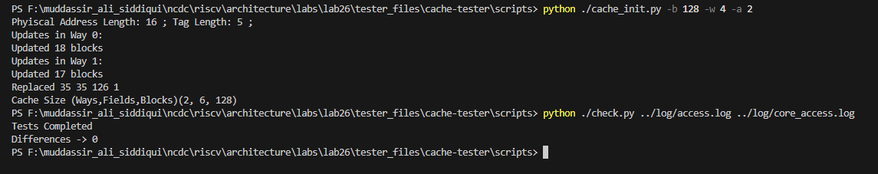
The files are identical and there is no difference.

Task 3:
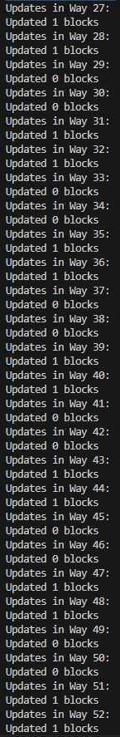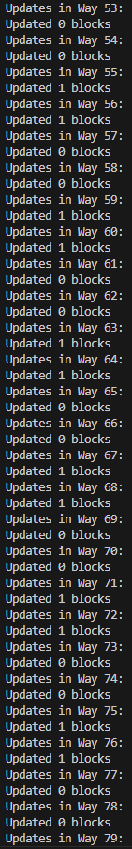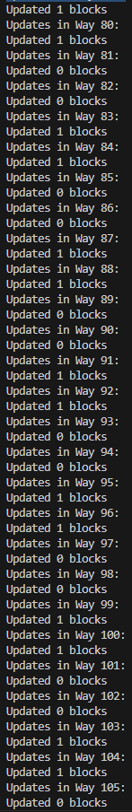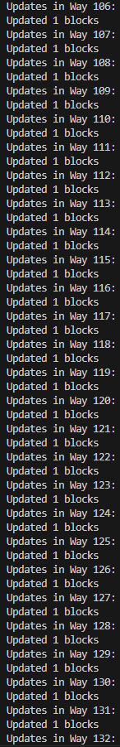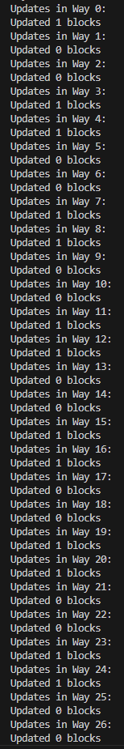
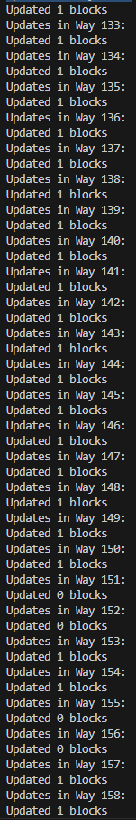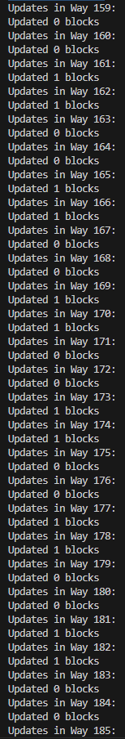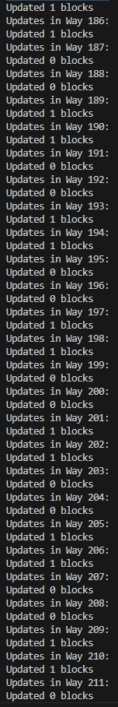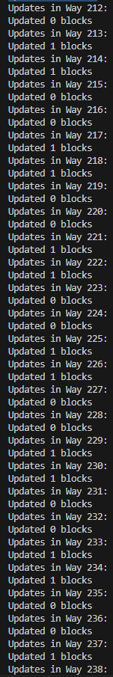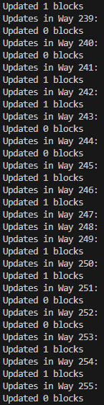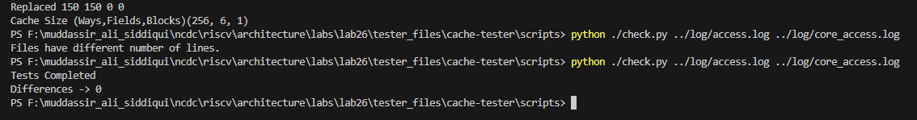
The files are identical and has no difference.

Critical Analysis:

In Lab 26 we designed and verified three read-only cache architectures in SystemVerilog: direct-mapped, two-way set-associative, and fully associative. Each cache stores four 32-bit words per block and was initialized from the provided binary files, so no write or replacement logic was required. The direct-mapped cache used a single tag match per access, the two-way set-associative design compared tags in two parallel ways for each set, and the fully associative cache checked all tags for every read. We focused on correct address breakdown into tag, index, word, and byte offsets to ensure accurate hit detection. Simulation with the supplied testbench and logs confirmed functional operation and highlighted how increasing associativity improves flexibility and potential hit rate while adding hardware complexity.

