Q. Consider a program's memory reference stream below:

r1 w1 r1 w1 r2 w2 r2 w2 r3 w3 r3 w3 r2 w2 w2 r2

All of the references in the stream are to the same memory location where r/w indicates read or write, and the digit refers to the processor issuing the reference.
Compare the cost of executing the trace on a bus-based machine for the MSI-invalidate
and MOESI protocols and explain the differences.
The cost is the total number of cycles required to execute all accesses in the trace.
Assume that all caches are initially empty, and use the following cost
model:
• read/write cache hit with no bus access = 1 cycle
• cache accesses requiring simple transaction on bus (BusUpgr, BusUpdt) = 20 cycles
• misses requiring whole cache block transfer = 150 cycles

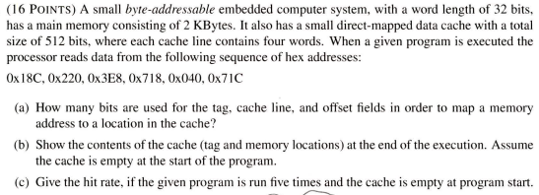

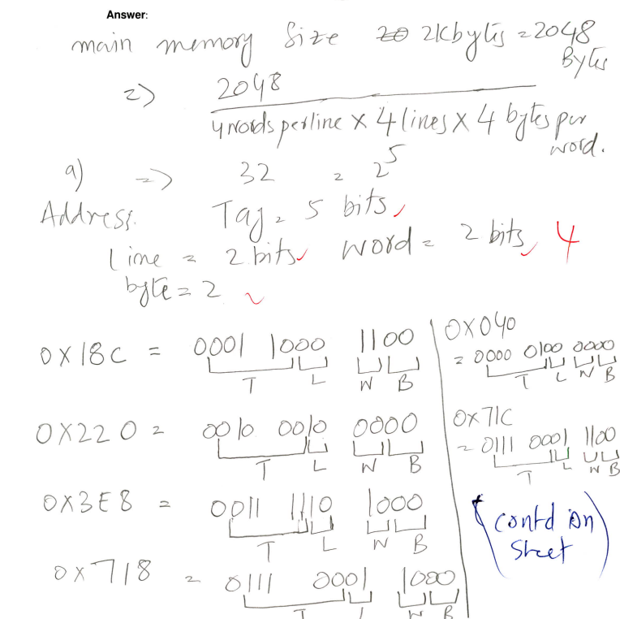
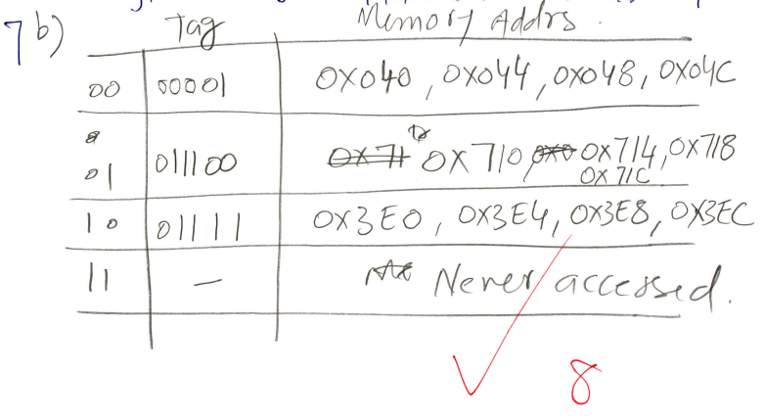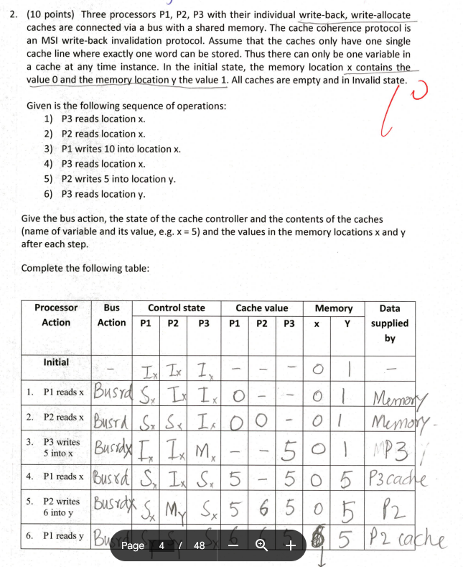

Q. Suppose there’s a computer system with virtual memory of size 64G bytes and physical memory of 16G bytes. The page size is 4K bytes. Assume there’s a single page table. Each page table entry consists of physical page number, a valid bit, a dirty bit and a reference bit. Answer the following questions:

Why is a Translation Look Aside Buffer (TLB) used when implementing virtual memory?

How many bits are needed for the virtual address, physical address, page offset, virtual page number and physical page number?

What is the size of the (memory required for) page table?

