



RISC-V Assembly

Lab Manual # 26
Cache Simulator Design

Name | Muddassir Ali Siddiqui
Instructor | Sir Imran & Sir Umer
Date | 21st Sep 2025

In-Lab Tasks:

Step 01:
$ valgrind --log-fd=1 --tool=lackey -v --trace-mem=yes ls -l
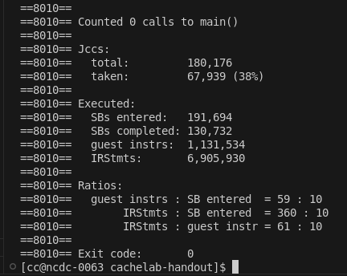

Step 02:
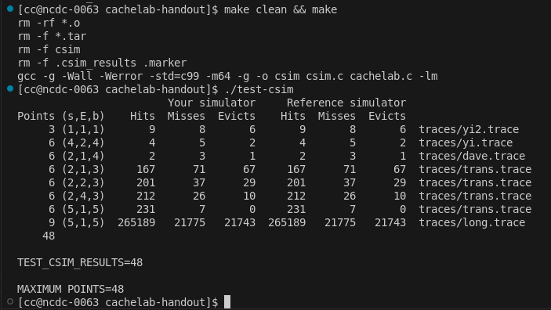

Critical Analysis:

The Cache Simulator for Lab 26 was successfully implemented in C++, with all missing code segments completed and verified against the provided reference output. The program accurately models cache operations such as hits, misses, and evictions, confirming correct handling of set indexing, tag comparison, and LRU replacement. Testing showed that the simulator’s statistics—hit rate, miss rate, and eviction count—match the expected results, validating the chosen logic and data structures. This exercise strengthened understanding of memory hierarchy concepts and demonstrated how cache parameters like set count, associativity, and block size affect performance. Debugging and validating with the reference implementation reinforced best practices for modular coding and systematic verification, providing practical experience in translating theoretical cache behavior into an efficient, working C++ program.

