



Shell Scripting

Lab Manual # 27

Name | Muddassir Ali Siddiqui
Instructor | Sir Junaid
Date | 22nd Sep 2025

In-Lab Tasks:

Task 1:
I wrote a shell script that stores a hard-coded array of integers and sorts it in ascending order using the Bubble Sort algorithm. The script repeatedly compares adjacent elements and swaps them if they are out of order until the entire array is sorted. The terminal output displays the array before and after sorting.
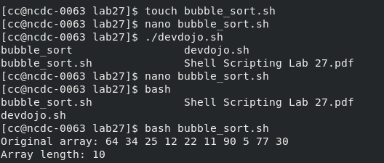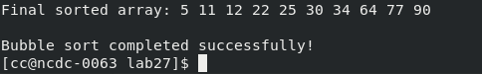

Task 2:
This script prompts the user for a desired password length and then generates a random string containing uppercase and lowercase letters, digits, and special characters. It ensures true randomness and prints the generated password to the terminal.
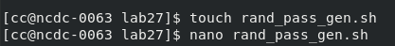
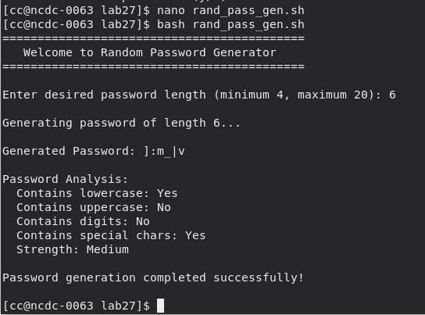


Task 3:
I developed a script that mimics basic Git functionality with three functions: init, add, and status.
- init is run once at the beginning to create a hidden backup folder, setting up the directory for version tracking.
- add copies any new or updated files from the working directory into this hidden folder, effectively staging them.
- status compares the current working directory with the hidden backup to show which files are new, modified, or deleted, giving a Git-like status report.
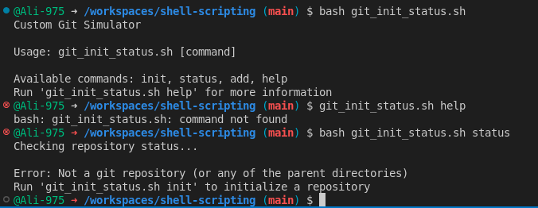
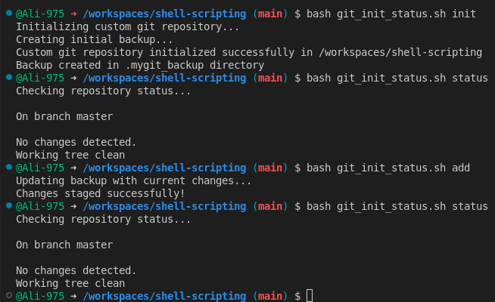
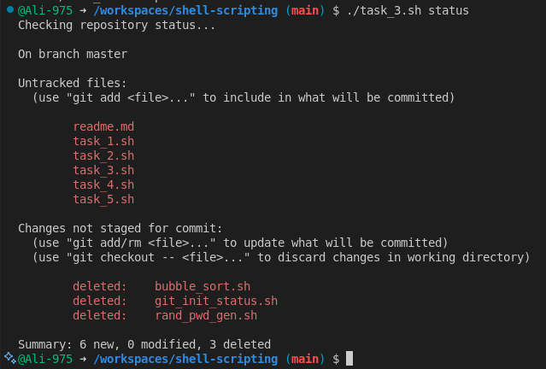
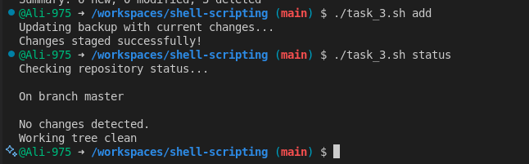

Task 4:
This script scans a files/ directory, creates subfolders for .pdf, .c, and .h files, and moves files into their respective subdirectories. After segregation, it compresses each subdirectory into a .zip archive and places the archives back into the files/ folder for organized storage.
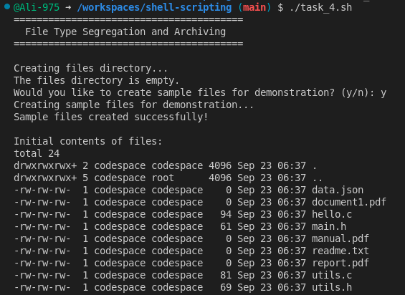
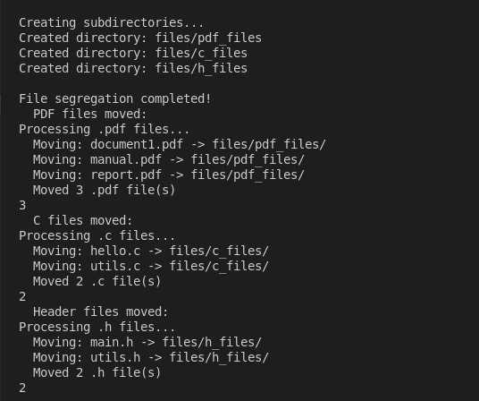
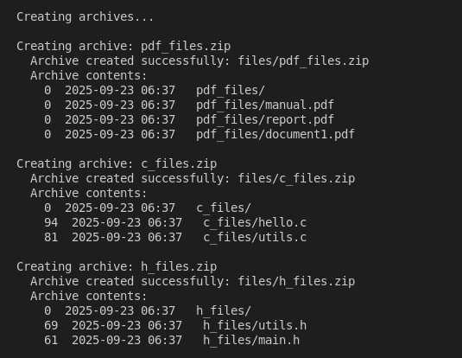
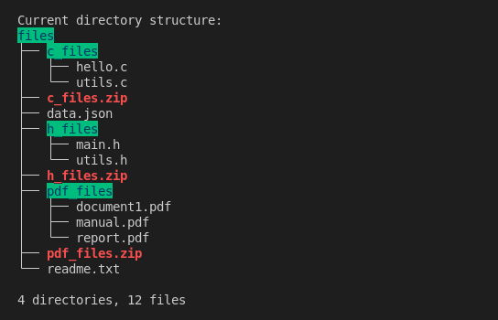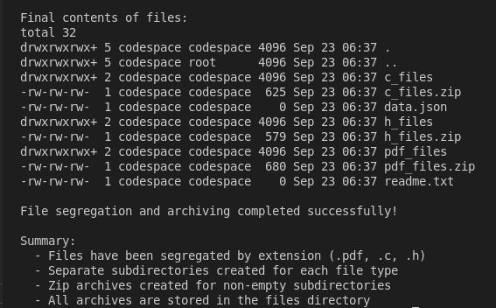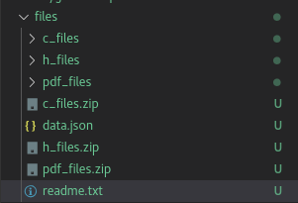

Task 5:
The script recursively searches the source/ directory for executable files. For every subdirectory, it lists the executables it contains and logs the same output to source/executables.log. This provides both on-screen results and a persistent record.
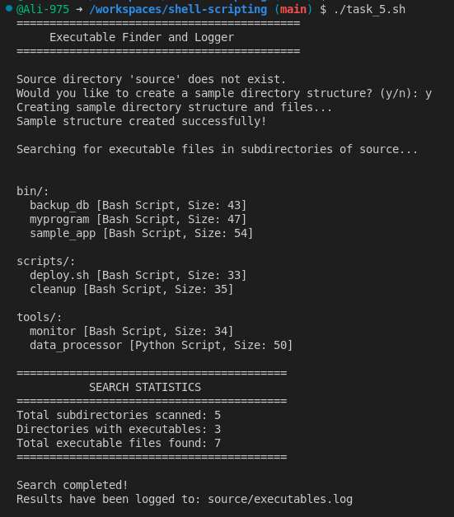
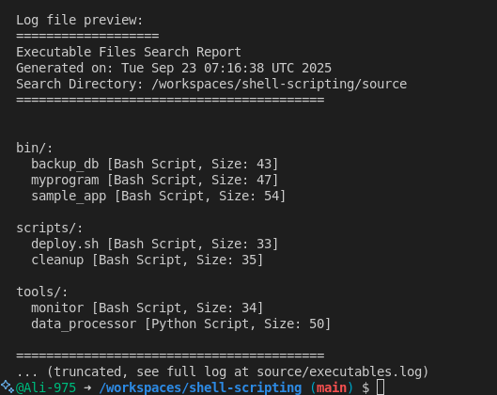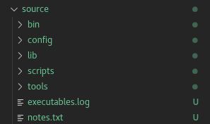

Critical Analysis:

In Lab 27, I implemented and tested five practical shell scripts. These tasks covered core Linux concepts such as sorting algorithms, random data generation, file and directory manipulation, backup and change detection, and recursive searching with logging. Together, they strengthened my scripting skills, improved my understanding of Git-like workflows, and demonstrated how to automate everyday system administration tasks efficiently.

