



Shell Scripting

Lab Manual # 29
Python Scripting

Name | Muddassir Ali Siddiqui
Instructor | Sir Junaid
Date | 24th Sep 2025

In-Lab Tasks:

Task 3:

The goal of Task 3 was to remove the repetitive manual work of creating a Digital IC project’s folder tree.
Using Python’s os and pathlib libraries, we listed the six standard sub-directories—rtl, tb, scripts, docs, synthesis, and simulation.
The script first ensures a parent folder called files exists at the desired location, then loops through the list to create each child directory.
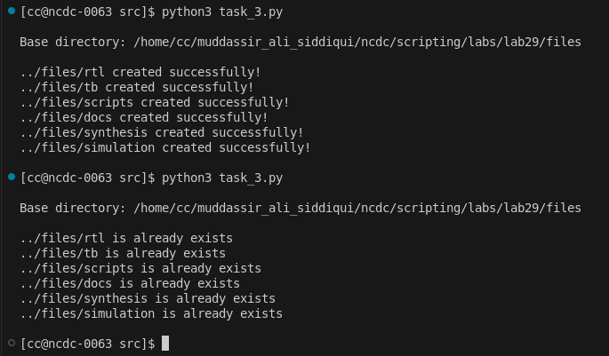
A key part of the method is Path.mkdir(exist_ok=True).
This call creates the directory only if it is missing and silently skips it if it already exists.
While doing so, the script prints a status message: created successfully when a folder is new, or already exists when the folder is present.
This guarantees a consistent directory layout every time the script runs and prevents accidental overwrites, making it ideal for setting up multiple design projects.

Task 4:

Task 4 builds on the structure created in Task 3 by automatically generating a SystemVerilog module template inside the rtl folder.
The script accepts the module name as a command-line argument, for example python task_4_module_template.py alu
It calculates the correct path to files/rtl, creates the folder hierarchy if it is missing (parents=True, exist_ok=True), and then writes a new <module_name>.sv file.
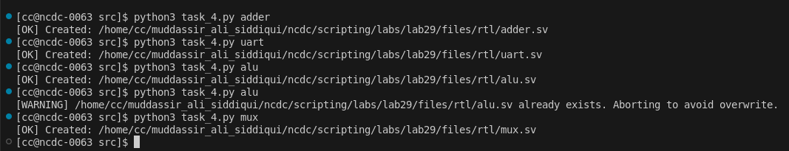
Inside the file, a simple skeleton is inserted: a timescale directive, header comments, the module declaration with the provided name, and an empty port list.
Before writing, the script checks whether the file already exists to avoid overwriting existing code, warning the user if it does.
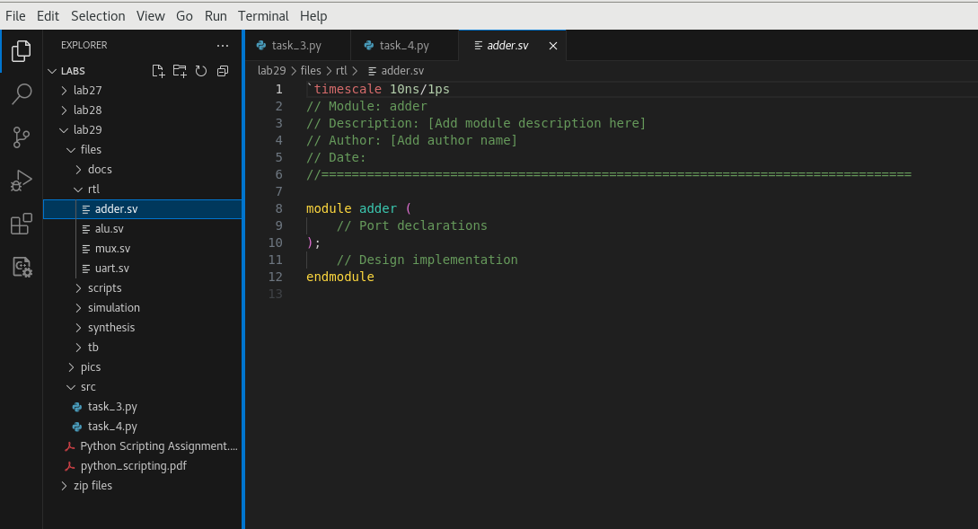
This automation ensures that every new design module starts from a consistent, documented template and that it is always stored in the correct RTL directory defined by Task 3.

Critical Analysis:

Lab 29 demonstrated how Python can automate routine setup tasks in digital IC design. In Task 3 we scripted the creation of a complete project hierarchy—files/rtl, tb, scripts, docs, synthesis, and simulation—while reporting whether each folder was newly made or already present. Task 4 then generated a ready-to-edit SystemVerilog module inside the rtl folder, creating any missing directories and avoiding overwrites. Together these steps remove repetitive manual work, reduce errors, and ensure every project starts from a clean, consistent structure, showcasing Python’s ability to streamline hardware-design workflows.

