



RISC-V Assembly

Lab Manual # 12
Introduction to RISC-V Assembly & Custom Processor Design

Name | Muddassir Ali Siddiqui
Instructor | Sir Imran & Sir Umer
Date | 13th Aug 2025

In-Lab Tasks: (Write your lab task & screenshots here)
Part 1:

Task1
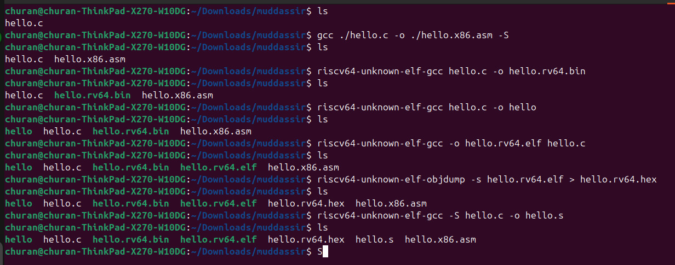

Task 2

Unique Assembler Directives
Directive | Purpose
.file "hello.c" | Records the source file name for debugging.
.option nopic | Disables Position Independent Code (absolute addresses instead).
.attribute arch, ... | Specifies target RISC-V architecture and extensions.
.attribute unaligned_access, 0 | Declares unaligned memory access is not supported.
.attribute stack_align, 16 | Ensures stack is always 16-byte aligned (ABI requirement).
.text | Marks start of the text (code) section.
.section .rodata | Switches to read-only data section for constants/strings.
.align 3 | Aligns data to an 8-byte boundary (2³ = 8).
.string "Muddassir_Ali_Siddiqui" | Stores a null-terminated string constant.
.align 2 | Aligns following code/data to 4-byte boundary (2² = 4).
.globl main | Makes main visible to linker as a global symbol.
.type main, @function | Declares main as a function symbol.
.size main, .-main | Defines the size of main function.
.ident "GCC: ..." | Embeds compiler identification string.
.section .note.GNU-stack,"",@progbits | Marks stack as non-executable for security.

Unique Base Instructions
addi
lui
ld
sd

Unique Labels
.LCO:
main:

Unique Pseudo instruction and their corresponding base instructions.
call printf auipc ra, %pcrel_hi(printf); jalr ra, %pcrel_lo(printf)(ra)
li a5, 0 addi a5, x0, 0
mv a0, a5 addi a0, a5, 0
jr ra jalr x0, 0(ra)

Task 3
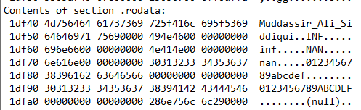
Part 2:

Task 1:
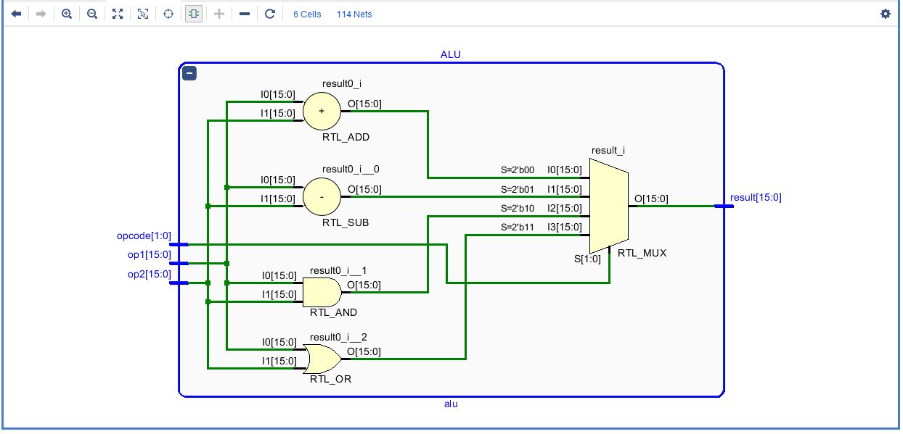

Task 2:
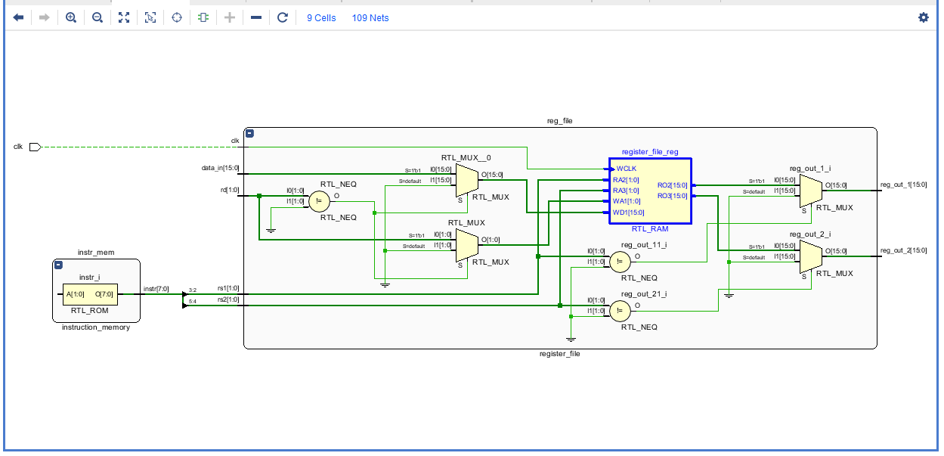

Task 3:
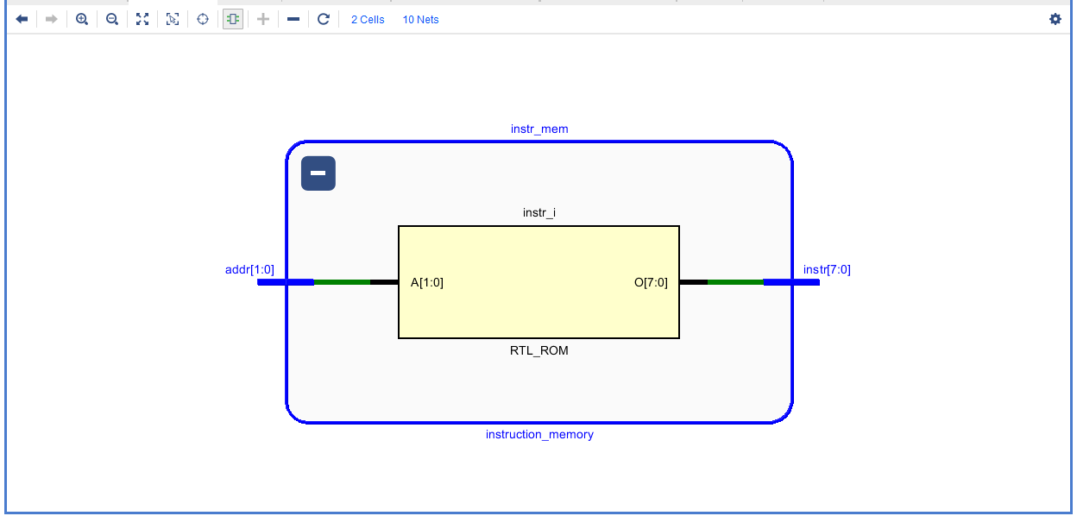

Task 4:
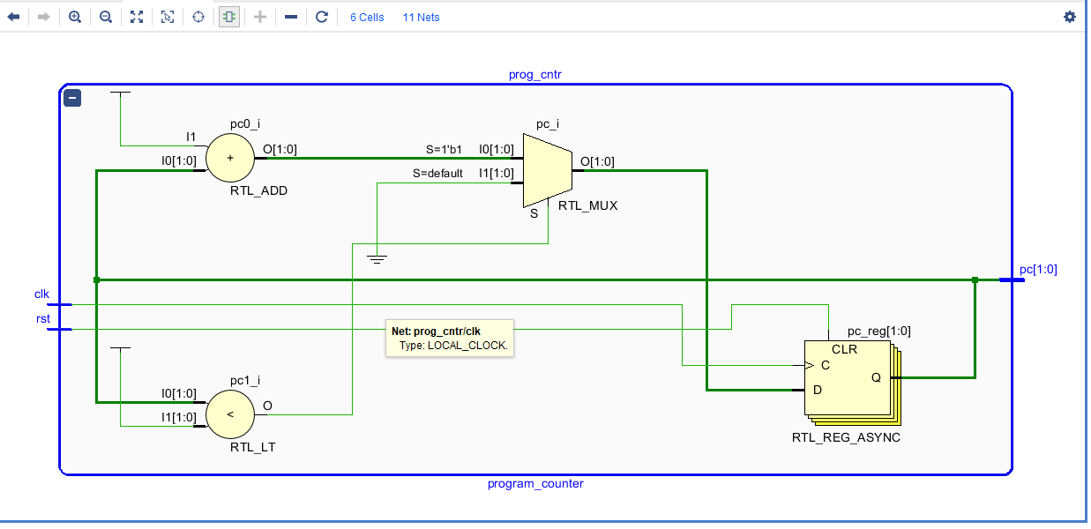

Task 5:
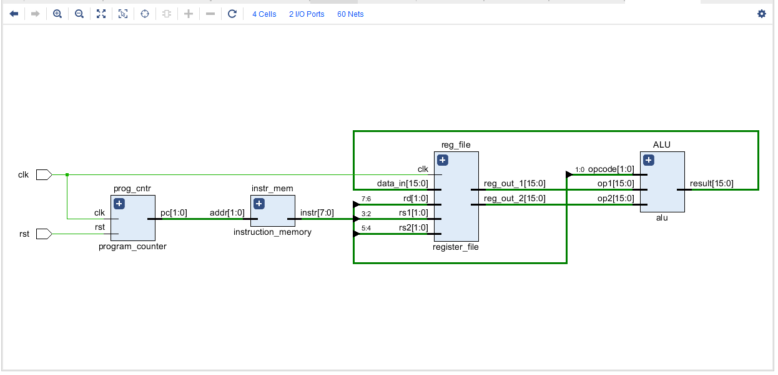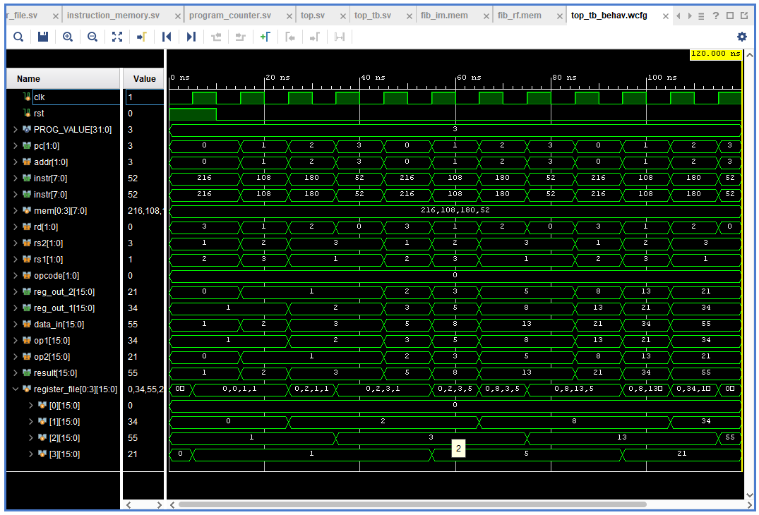

Critical Analysis: (Write you critical analysis / conclusion here)

In this lab, we designed and implemented the fundamental modules of a simple processor, including a 16-bit ALU, a 16-bit Register File with four registers, an 8-bit Instruction Memory, and a Program Counter capable of addressing up to 4 instructions. All components were parameterized to allow flexibility in width and depth. After integration at the top level, the processor was initialized with fib_im.mem and fib_rf.mem, successfully executing the instructions. This lab provided practical insight into how parameterized hardware blocks interact to form a working microprocessor.

