



RISC-V Assembly

Lab Manual # 13
Data Transfer, Decision Making, Logical Ops

(Arrays in RISC-V Assembly, Bit Manipulation and Implementation of factorial function)

Name | Muddassir Ali Siddiqui
Instructor | Sir Imran & Sir Umer
Date | 13th Aug 2025

In-Lab Tasks: (Write your lab task & screenshots here)

Exercise 2:
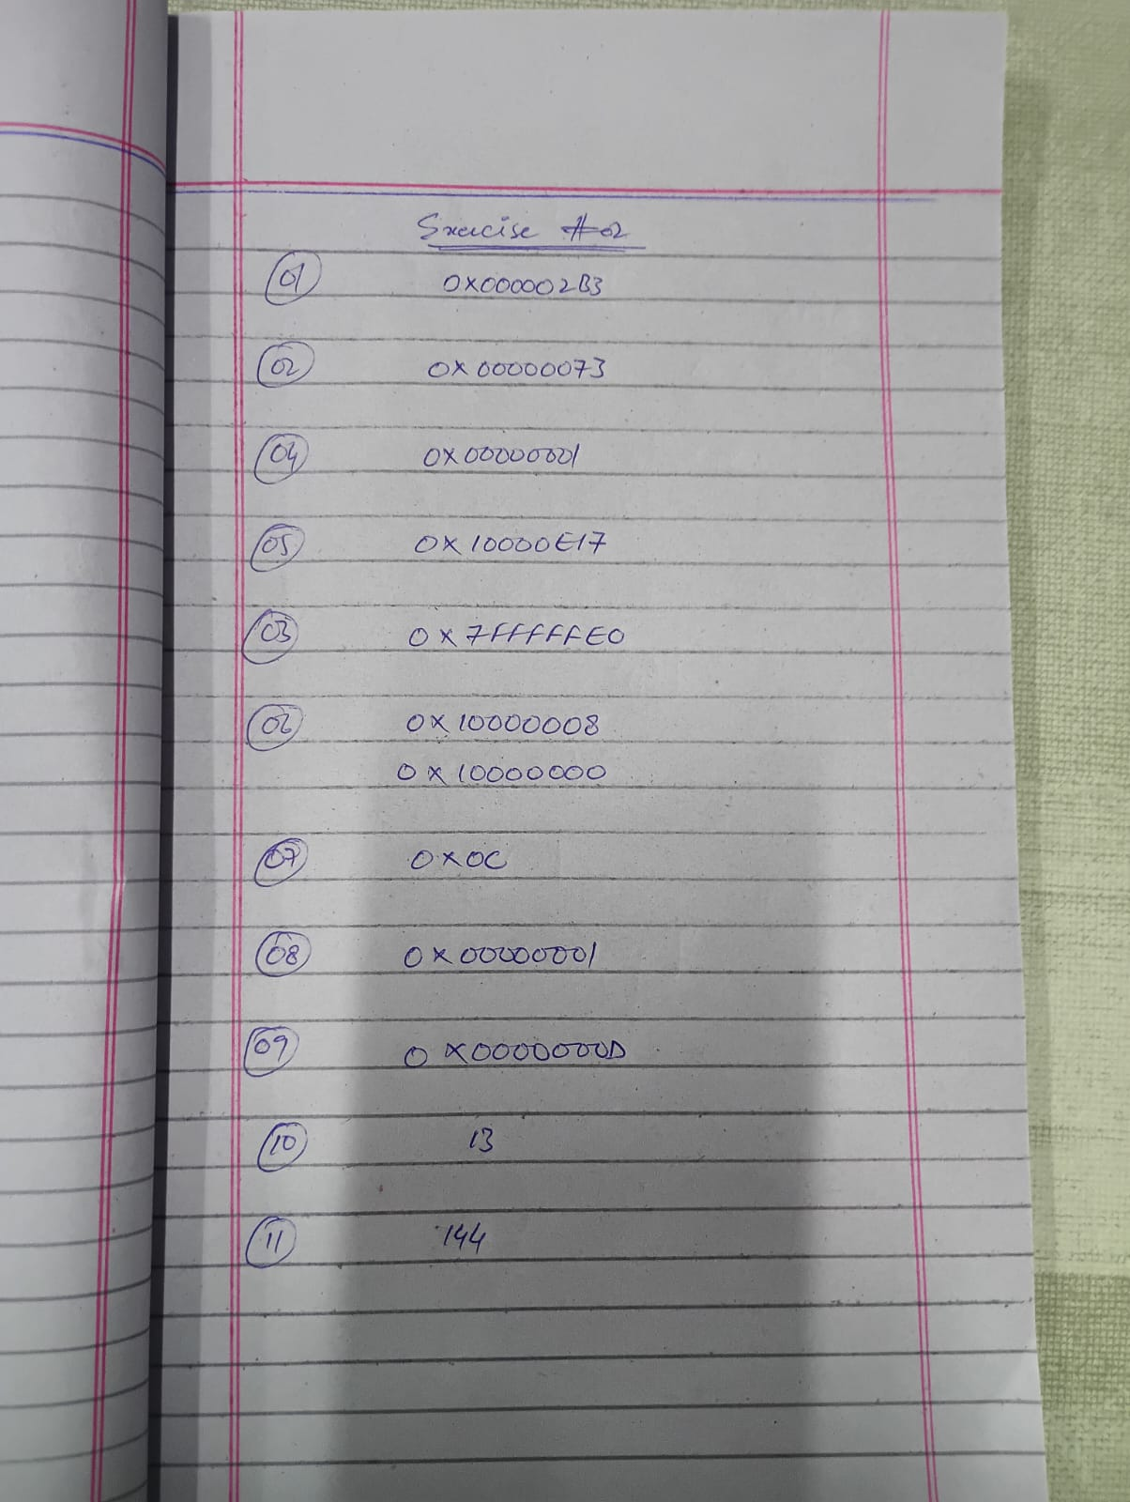

Task 1:
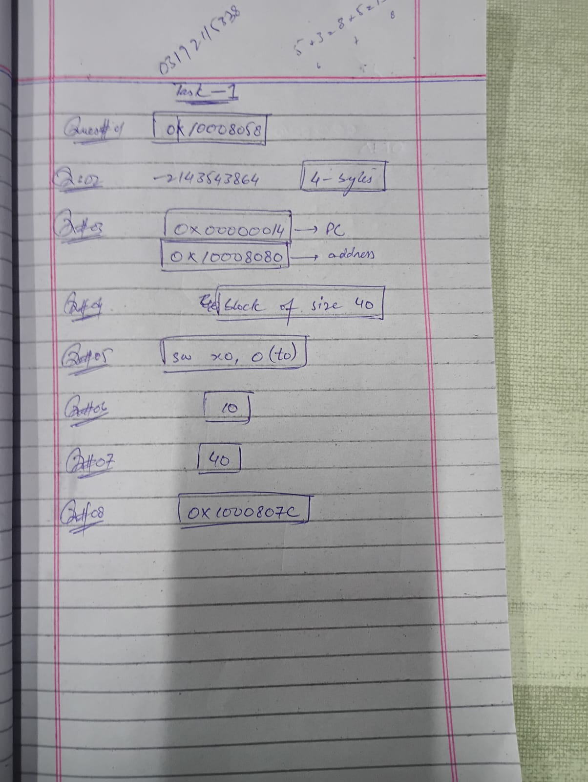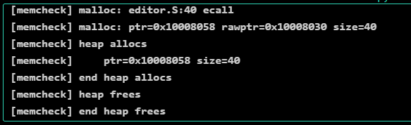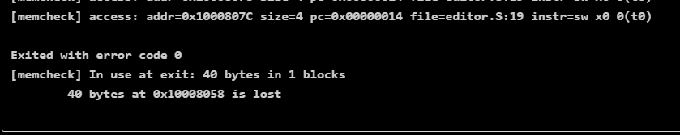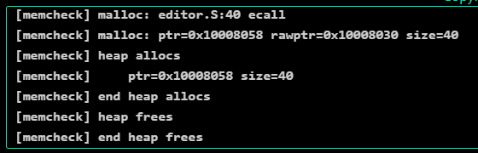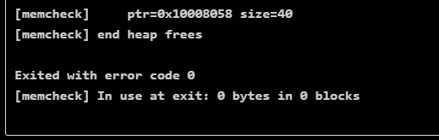

Task 2:
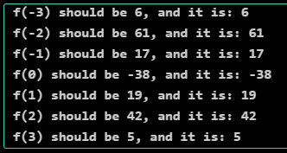

Task 3:
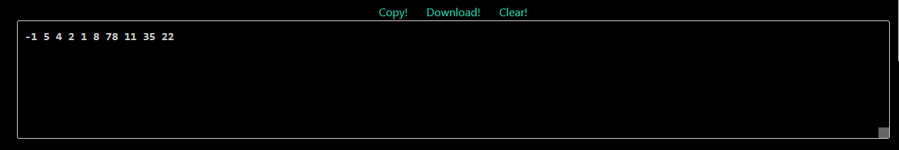

Task 4:
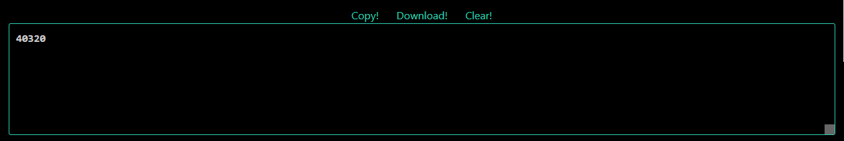

Task 5:
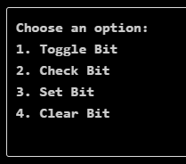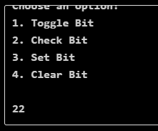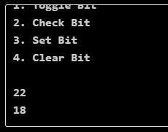

Critical Analysis: (Write you critical analysis / conclusion here)

In these lab tasks, the focus was on developing a deeper understanding of RISC-V assembly programming through progressively challenging exercises. Each task introduced new concepts such as analyzing assembly structure, working with arrays, handling data display, and performing bit-level operations. Collectively, they emphasized how low-level programming requires precise control of registers, memory, and instructions to achieve even simple outcomes. By practicing these different aspects, the labs provided a well-rounded foundation in assembly language, highlighting the importance of efficiency, accuracy, and step-by-step problem solving in system-level programming.

