



RISC-V Assembly

Lab Manual # 15
RISC-V Procedures and Instruction Formats
(Sorting using RISC-V Assembly language)

Name | Muddassir Ali Siddiqui
Instructor | Sir Imran & Sir Umer
Date | 20th Aug 2025

In-Lab Tasks: (Write your lab task & screenshots here)

Task 1:
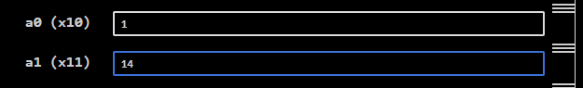

Task 2:
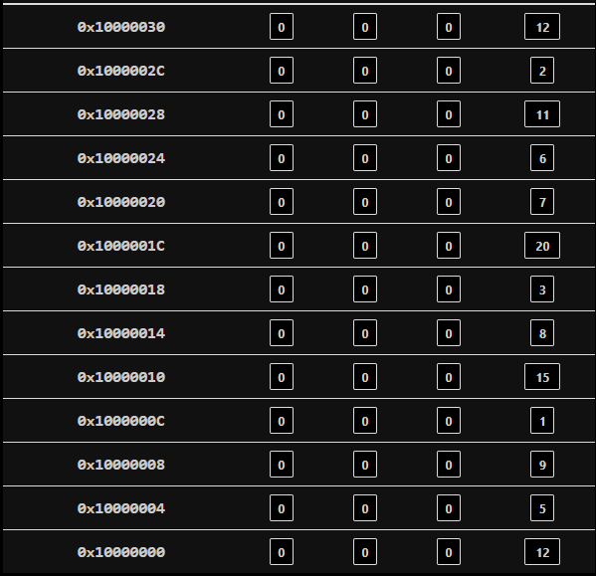
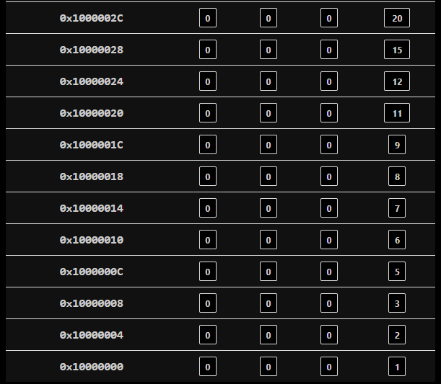
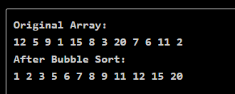

Task 3:
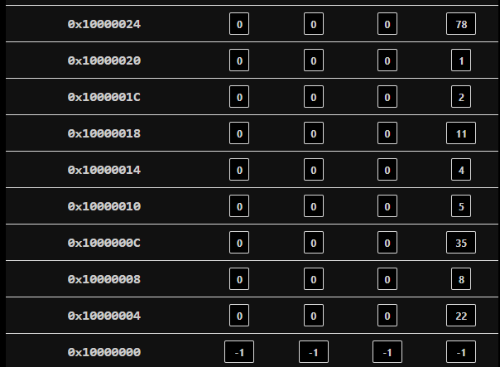
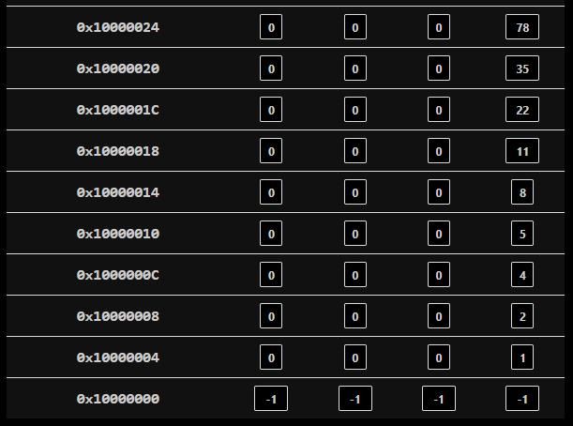
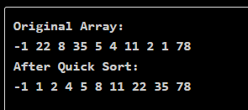

Critical Analysis: (Write you critical analysis / conclusion here)
In this lab, we explored three different algorithms implemented in RISC-V assembly. First, the GCD demonstrated how iterative arithmetic operations can efficiently solve mathematical problems. Next, the Bubble Sort algorithm was implemented to sort an array using repeated adjacent comparisons and swaps, which reinforced the use of loops and conditional branches but had higher time complexity.

Finally, the Quick Sort algorithm provided a more efficient divide-and-conquer approach, utilizing partitioning and recursion concepts for faster sorting compared to Bubble Sort. Overall, these tasks strengthened our understanding of control flow, memory access, and algorithmic efficiency in assembly programming.

