



Digital Logic Design

DLD Task: 4-bit ALU

Name | Muddassir Ali Siddiqui
Instructor | Sir Musaddiq Hussain & Sir Bilal
Date | 30th July 2025

- In-Lab Tasks: (Write your lab task & screenshots here)

Schematic:
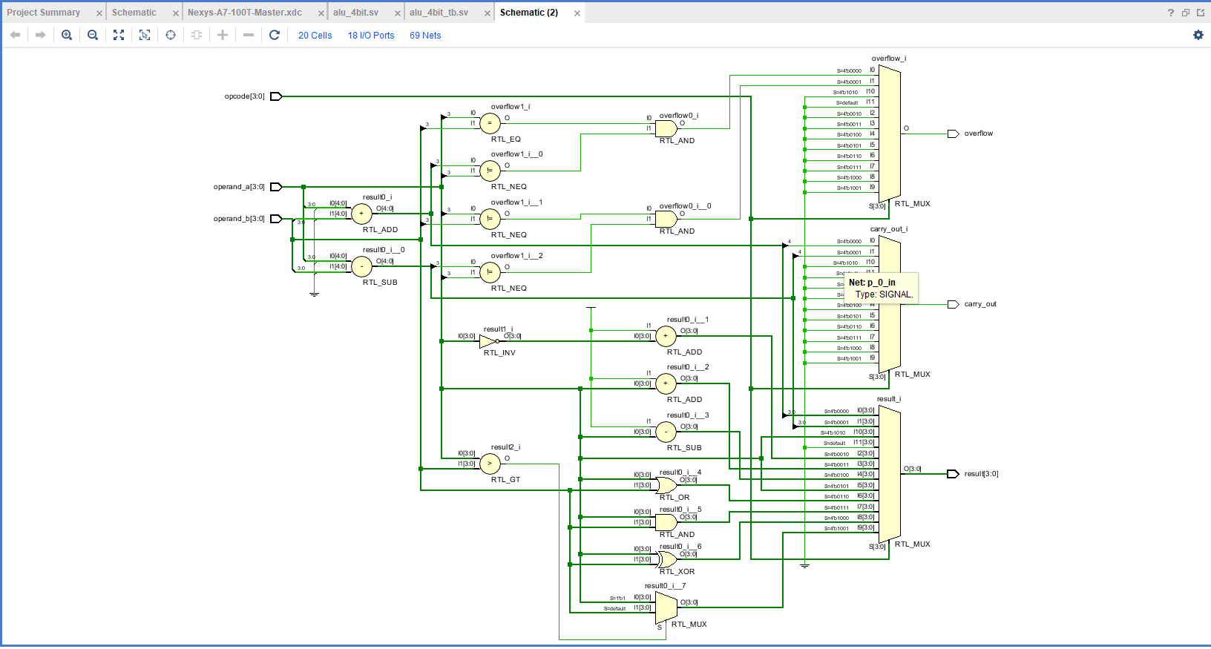

Bitstream Generation Popup:

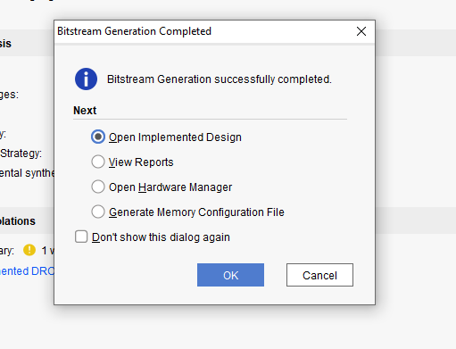

Area, Timing, and Power Reports:

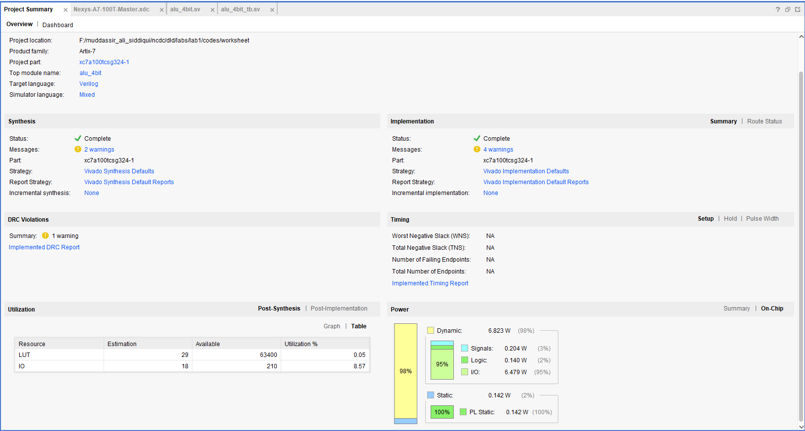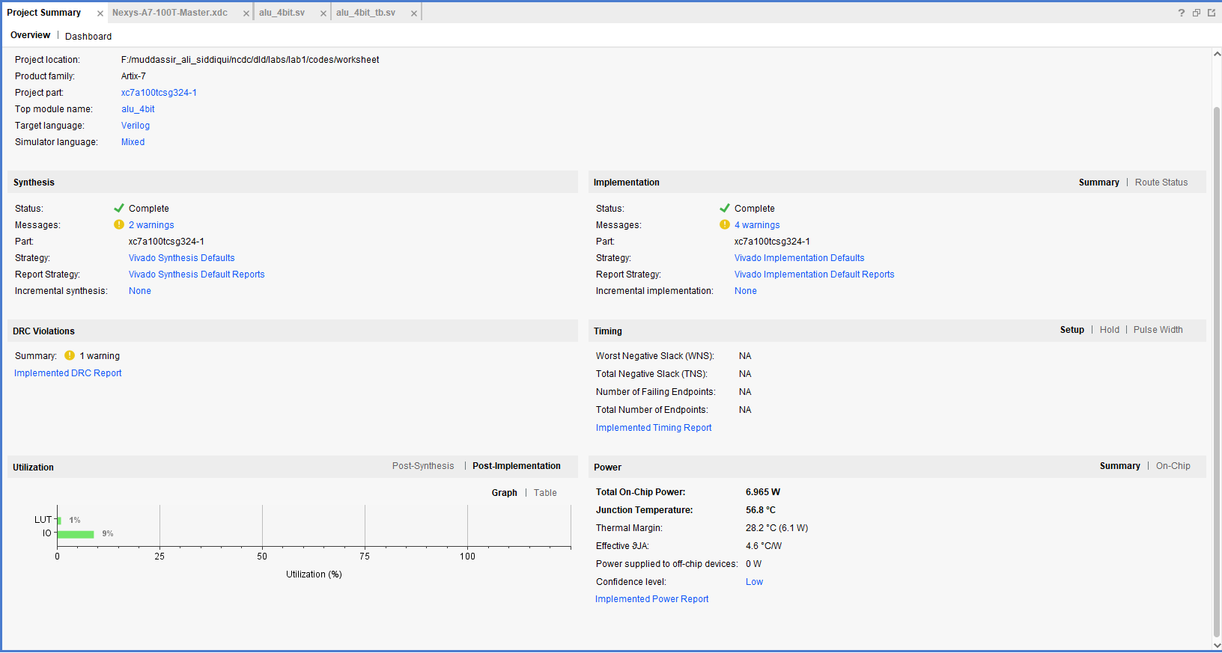

Waveform:

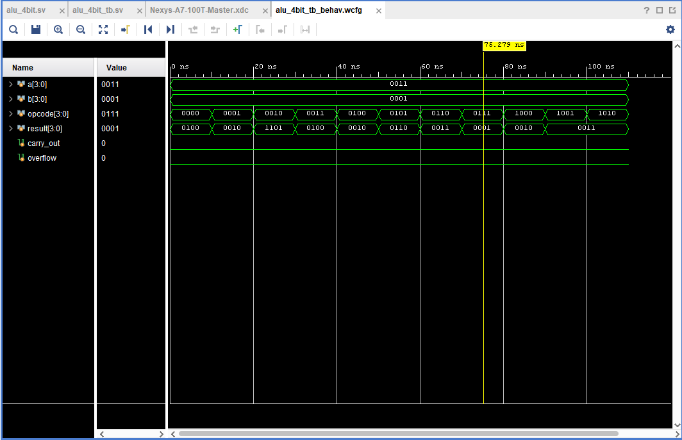

In the above waveform we assign operand_a = 0011 and operand_b = 0001, and result store the result of the operations.

- Critical Analysis: (Write you critical analysis / conclusion here)

In this task we design a 4-bit alu in which we assign 10 operations given in the manual by mux. The alu is the critical and important section of a processor.

