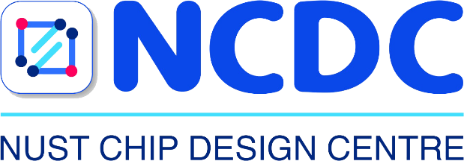

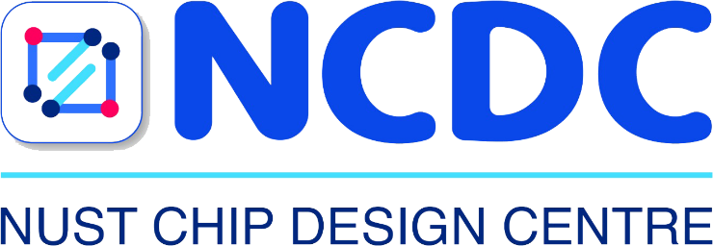

Digital Logic Design

Lab Manual # 11
Communication Protocols (UART using SV)

Name | Muddassir Ali Siddiqui
Instructor | Sir Musaddiq Hussain & Sir Bilal
Date | 8th August 2025

In-Lab Tasks: (Write your lab task & screenshots here)
