



Digital Logic Design

Lab Manual # 09
Sequential Circuits using System Verilog (Counters / Digital clocks)

Name | Muddassir Ali Siddiqui
Instructor | Sir Musaddiq Hussain & Sir Bilal
Date | 2nd Aug 2025

In-Lab Tasks: (Write your lab task & screenshots here)

FPGA Outputs:

Task 1:
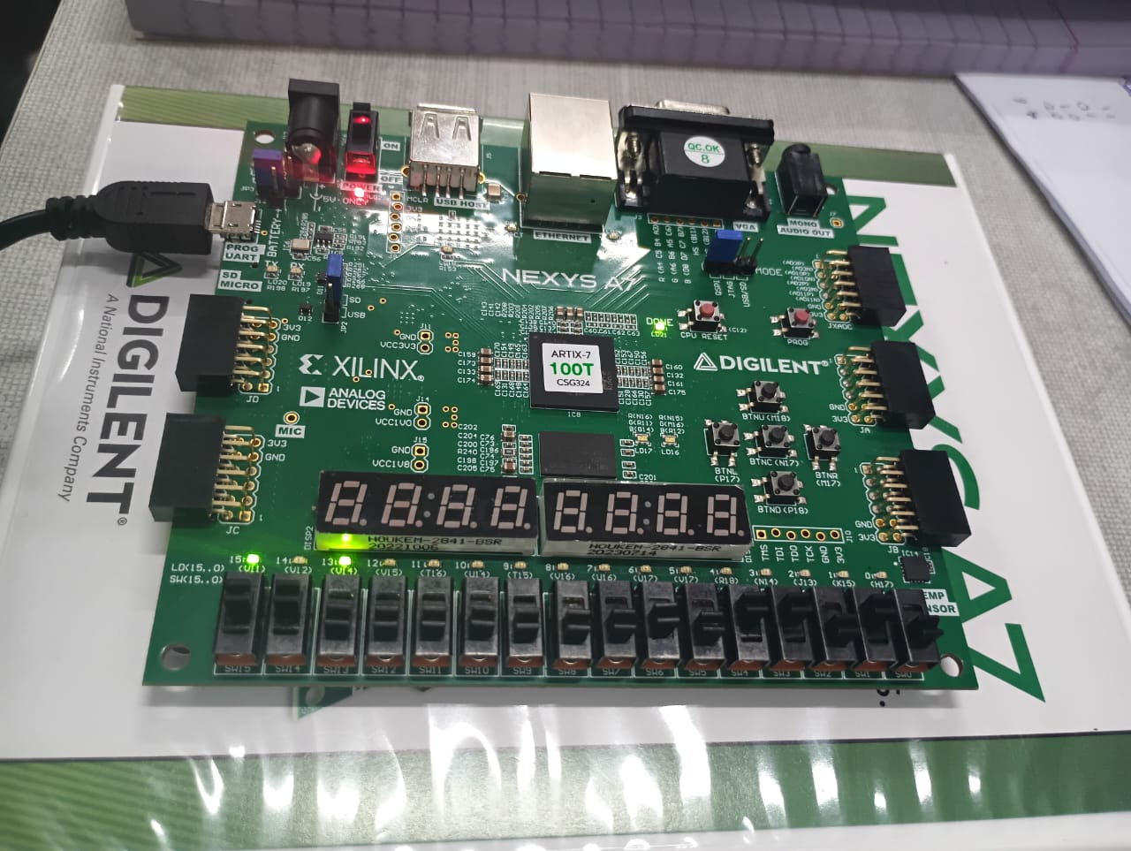

Task 2:
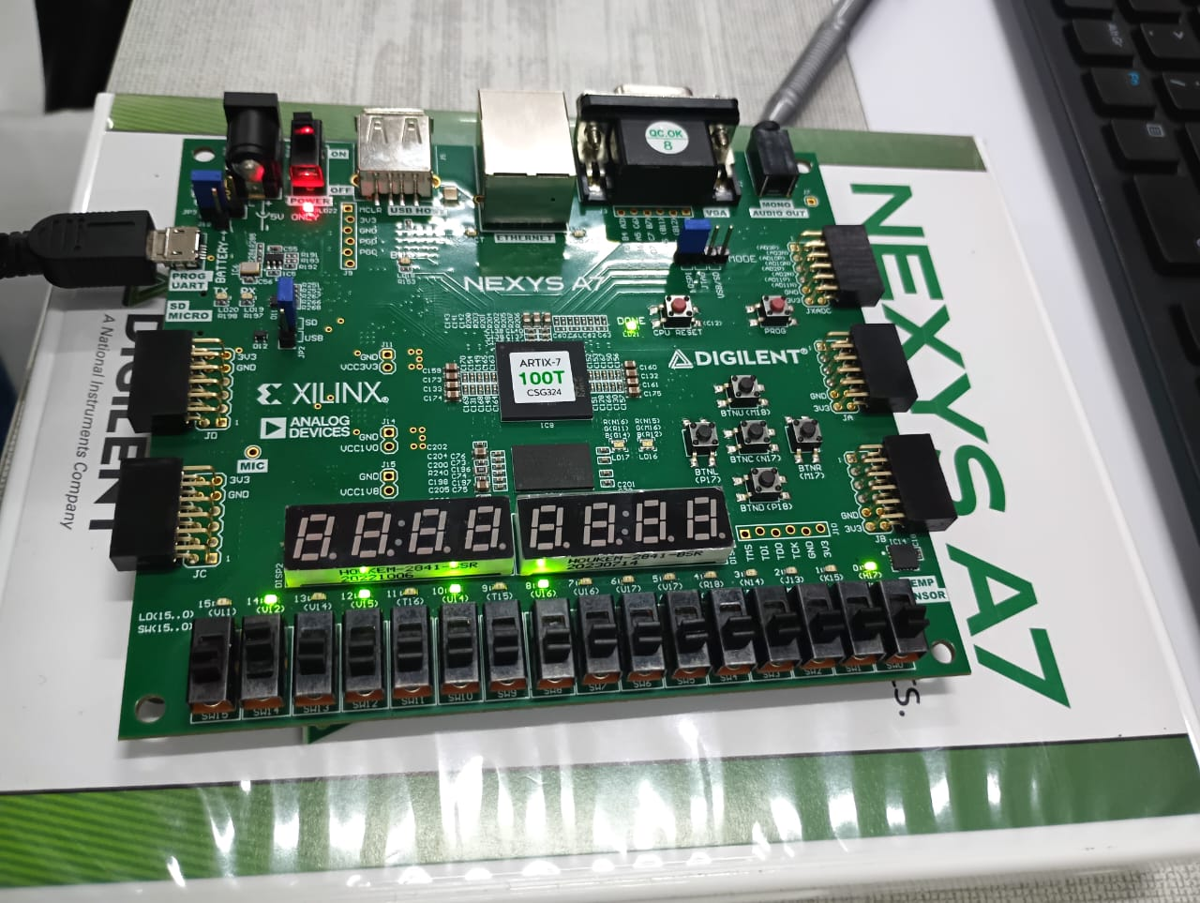

Task 3:
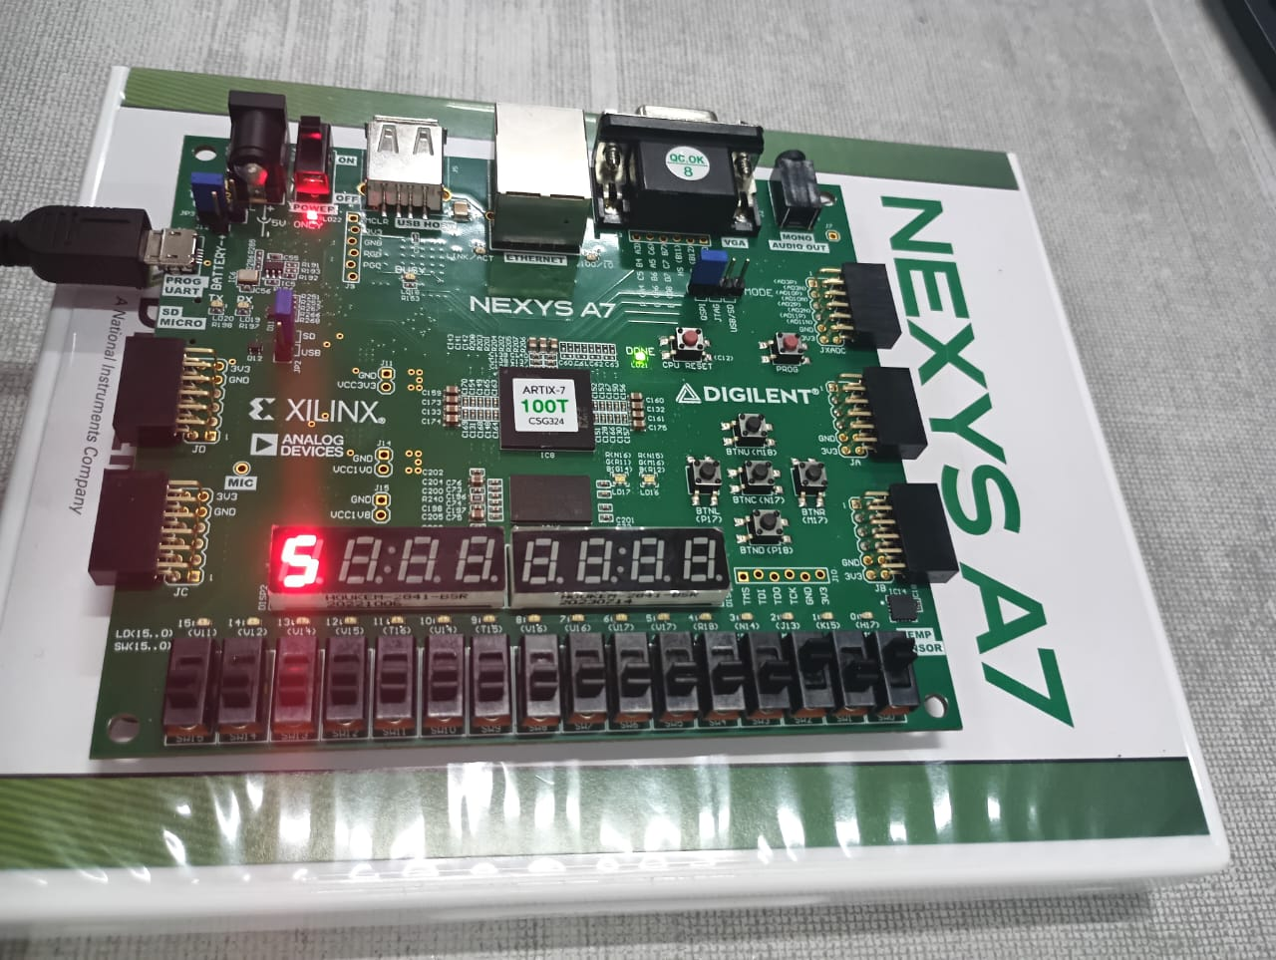

Task 5:
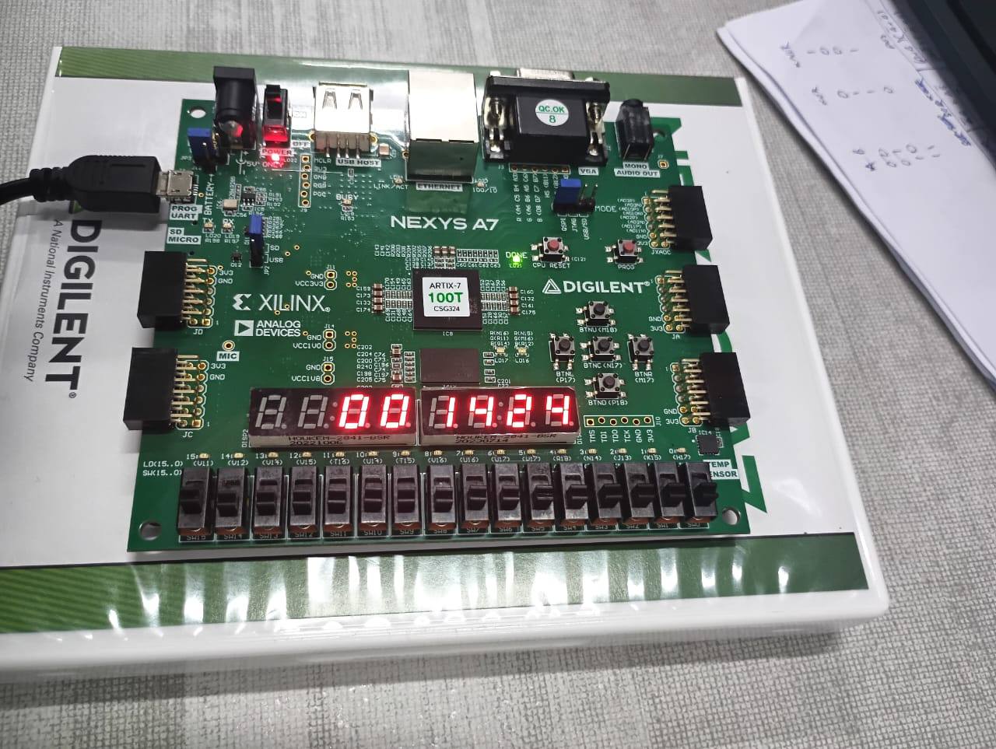

Vivado Screenshots:

Task 1:
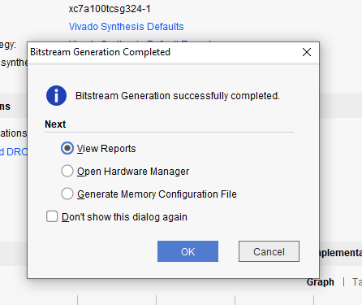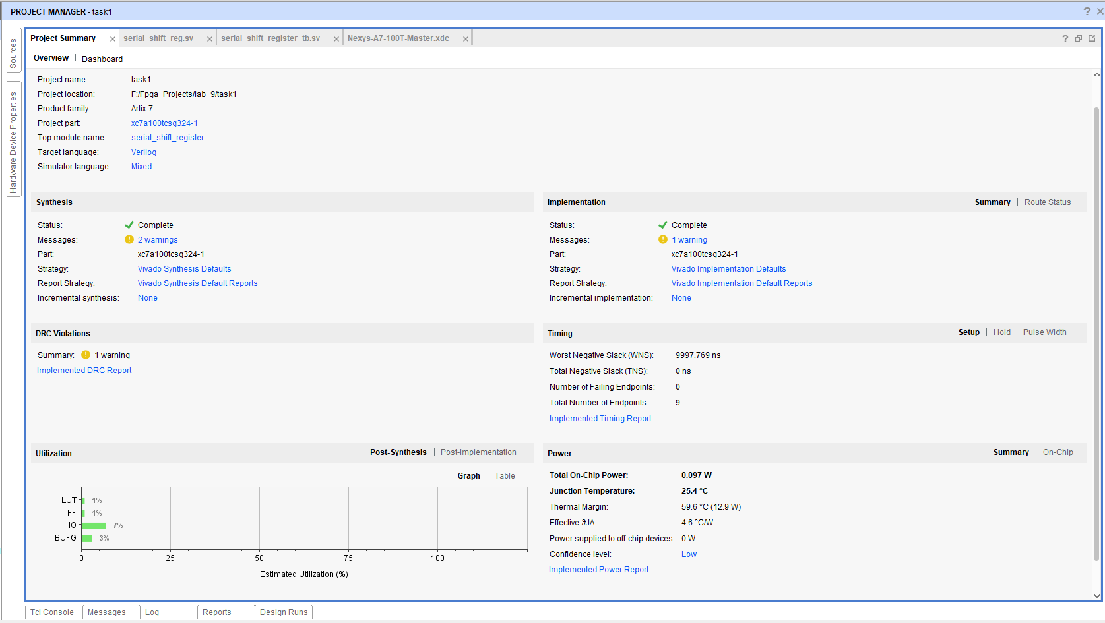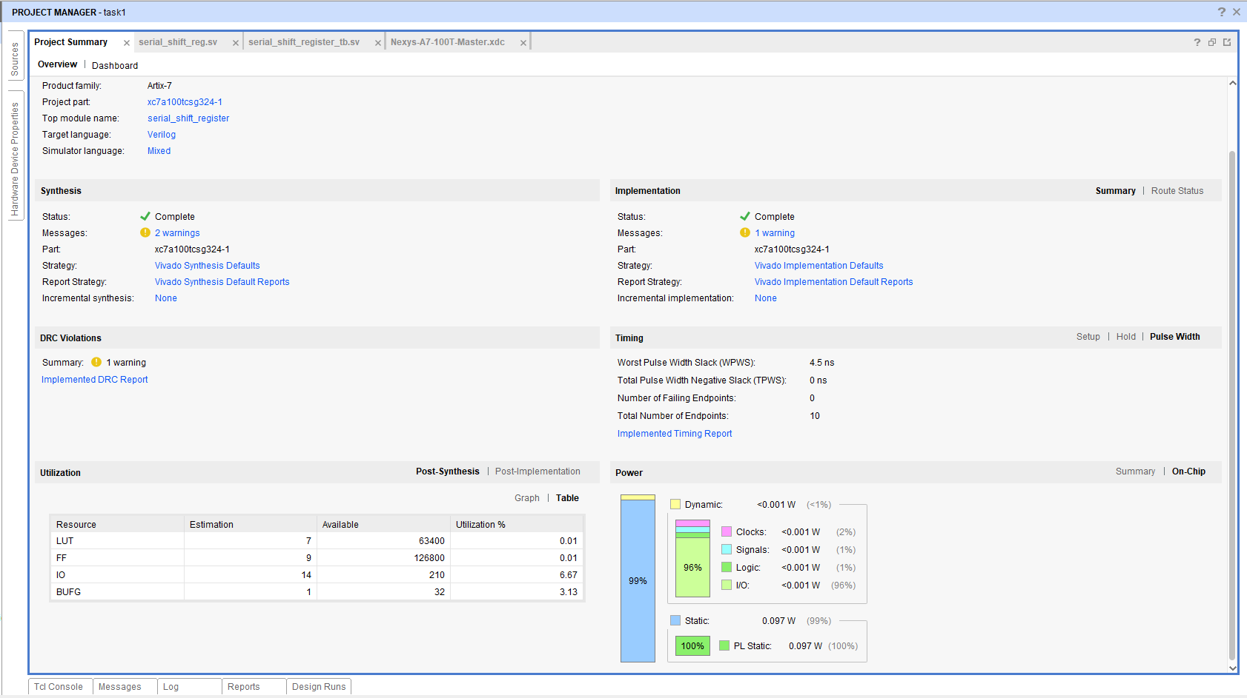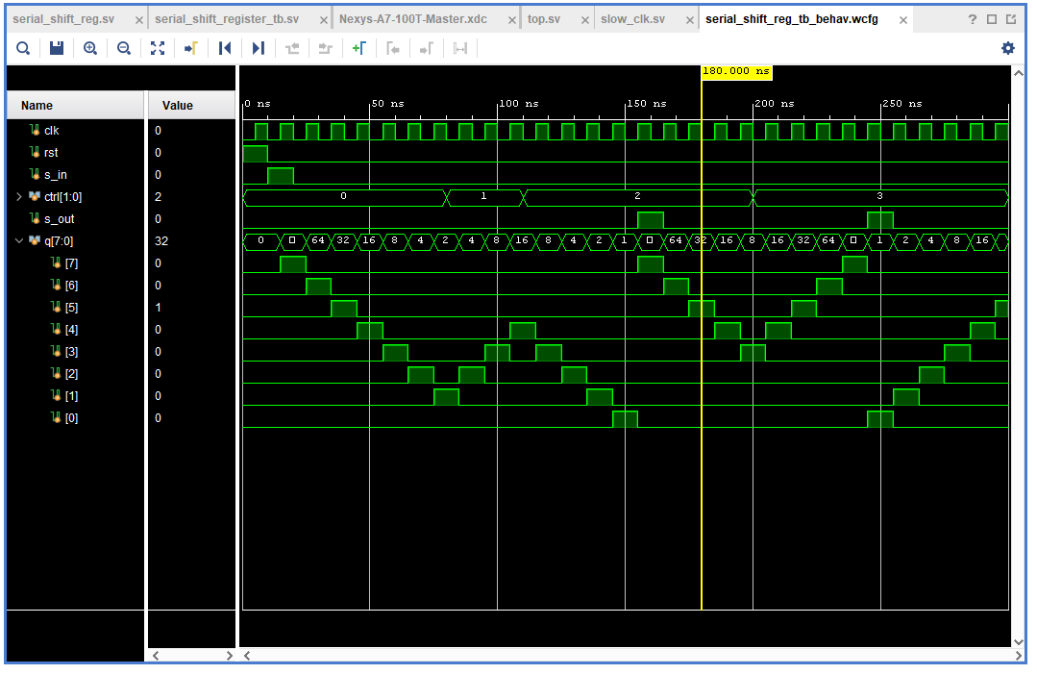

Task 2:
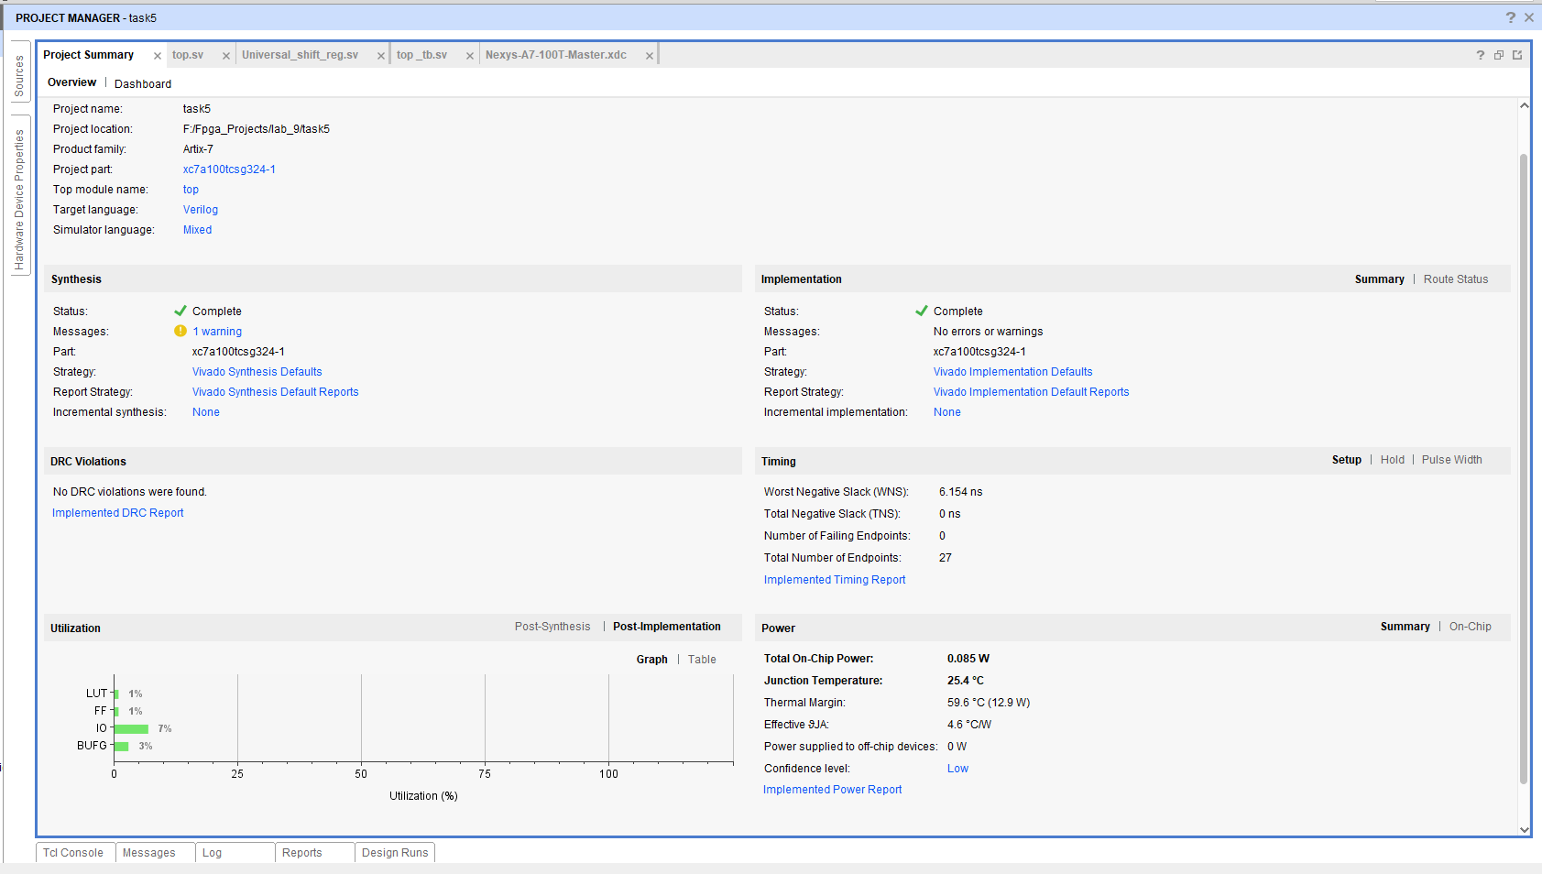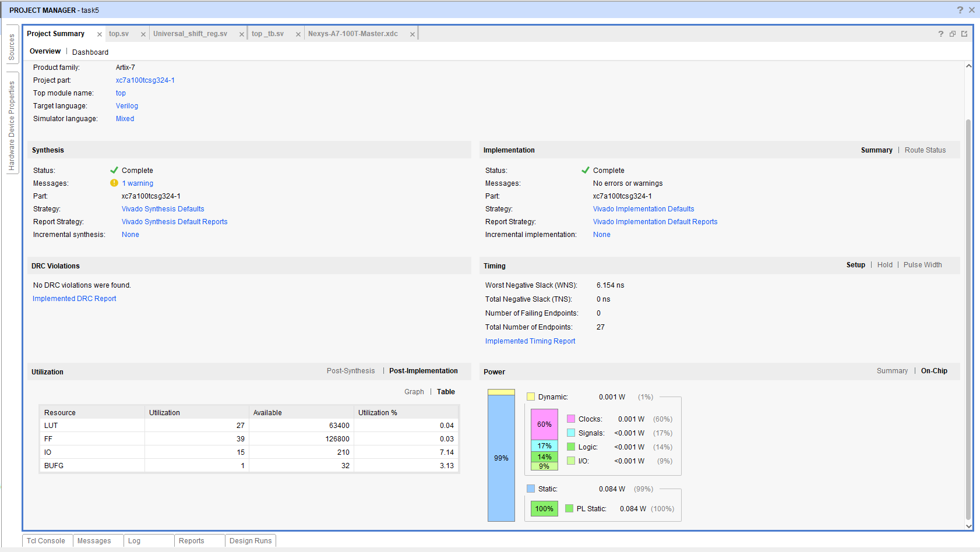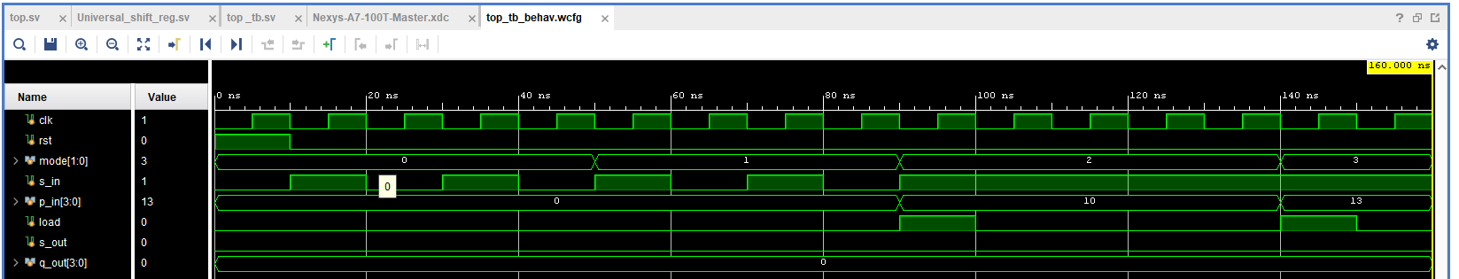

Task 3:
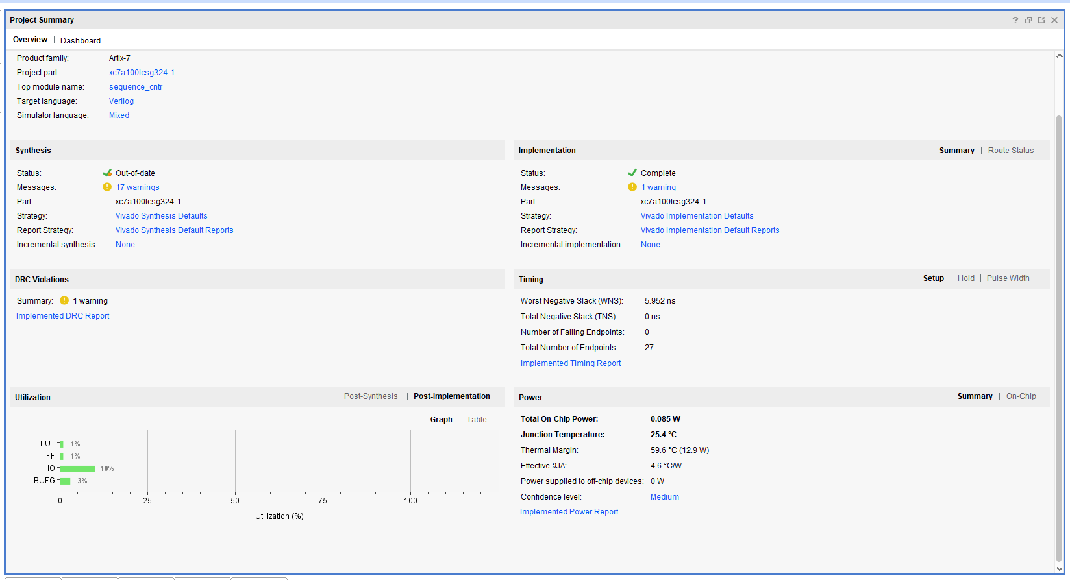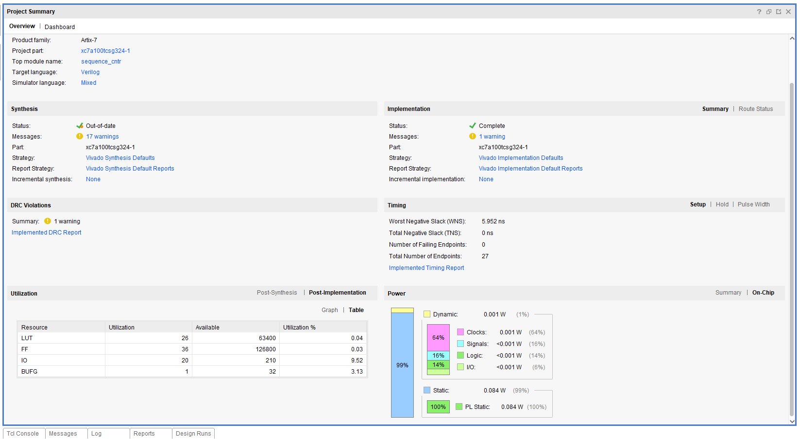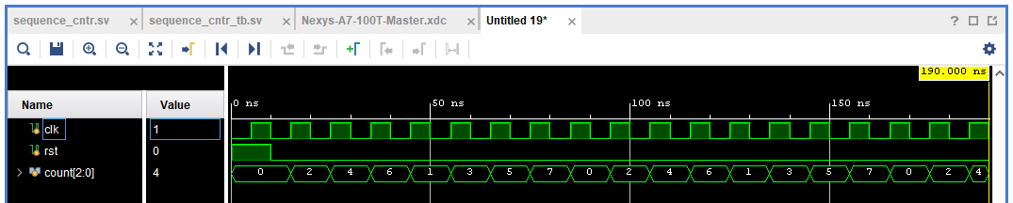

Task 4:
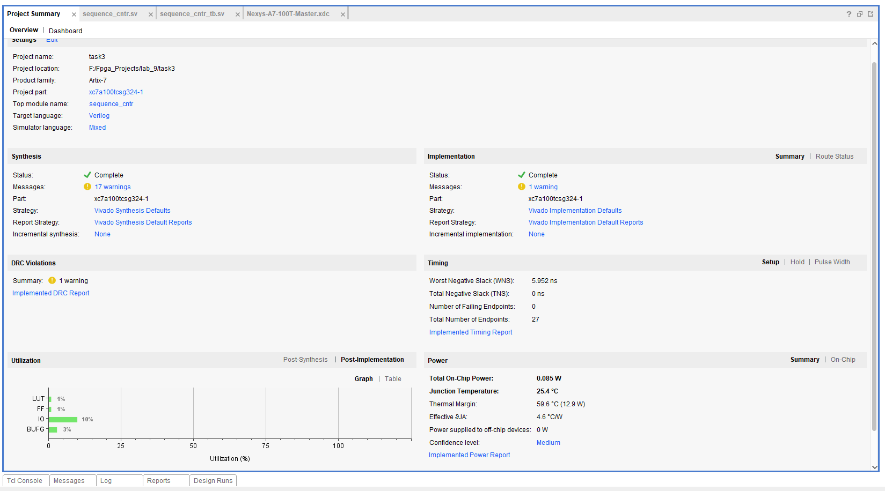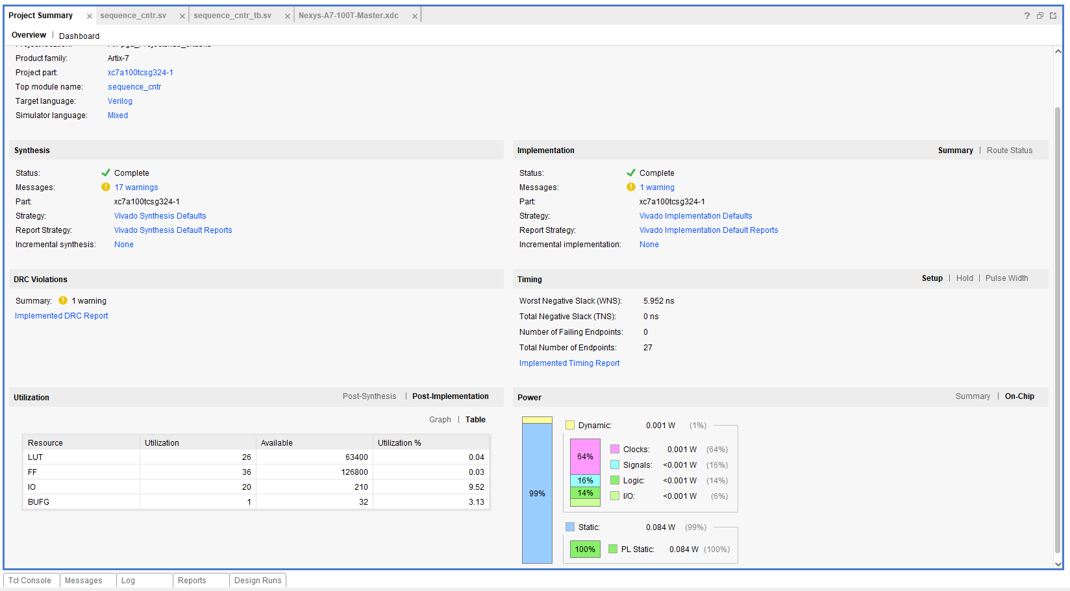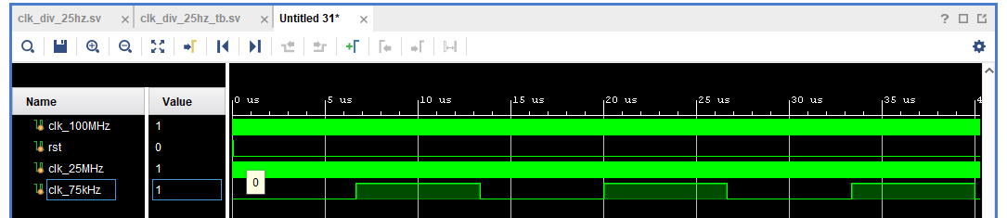

Task 5:
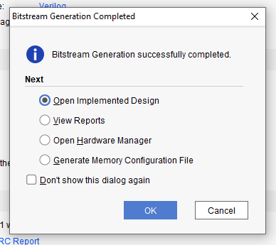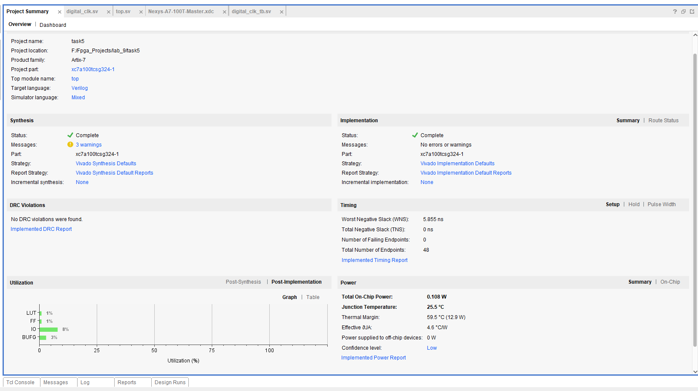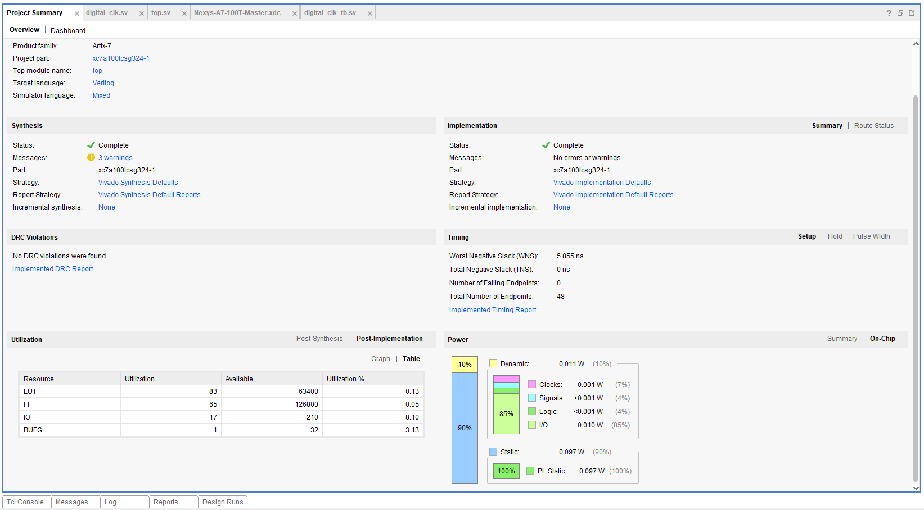

Critical Analysis: (Write you critical analysis / conclusion here)

In this lab we design in task 1 design a serial in and serial out and in task 2 design a universal shift registers with mux with 4 different shift operation piso, pipo, siso, sipo. In task 3 design a counter and in task 4 we design clk freq divider circuit. By the way I use this freq divider circuit in every lab task so that I could see the operations with the naked eye. And in the last we design a digital clock and display it on seven segments.

