



**Digital Logic Design**

**DLD Task: 4-bit ALU**

|  |  |
| --- | --- |
| **Name** | *Muddassir Ali Siddiqui* |
| **Instructor** | *Sir Musaddiq Hussain & Sir Bilal* |
| **Date** | *30th July 2025* |

1. **In-Lab Tasks: (***Write your lab task & screenshots here***)**

**Schematic:**

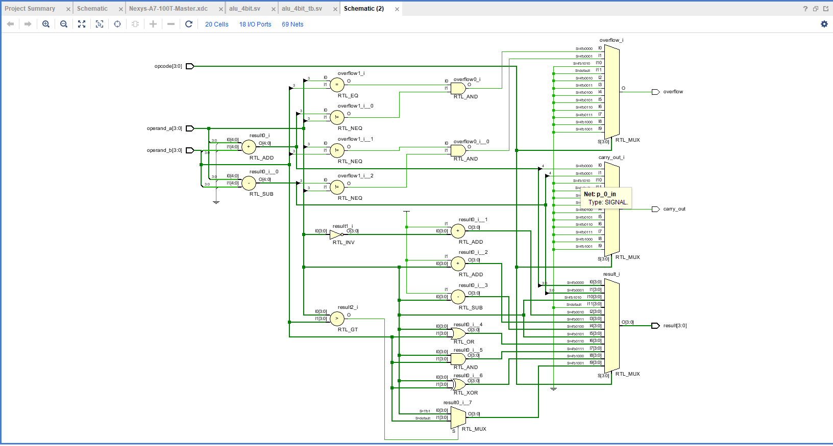

**Bitstream Generation Popup:**

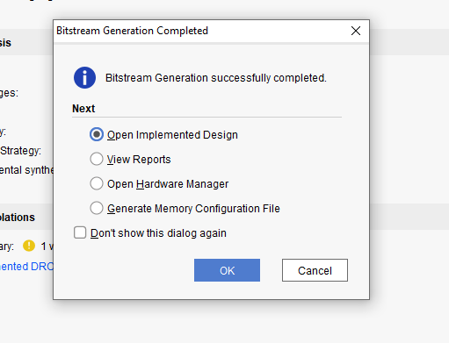

**Area, Timing, and Power Reports:**

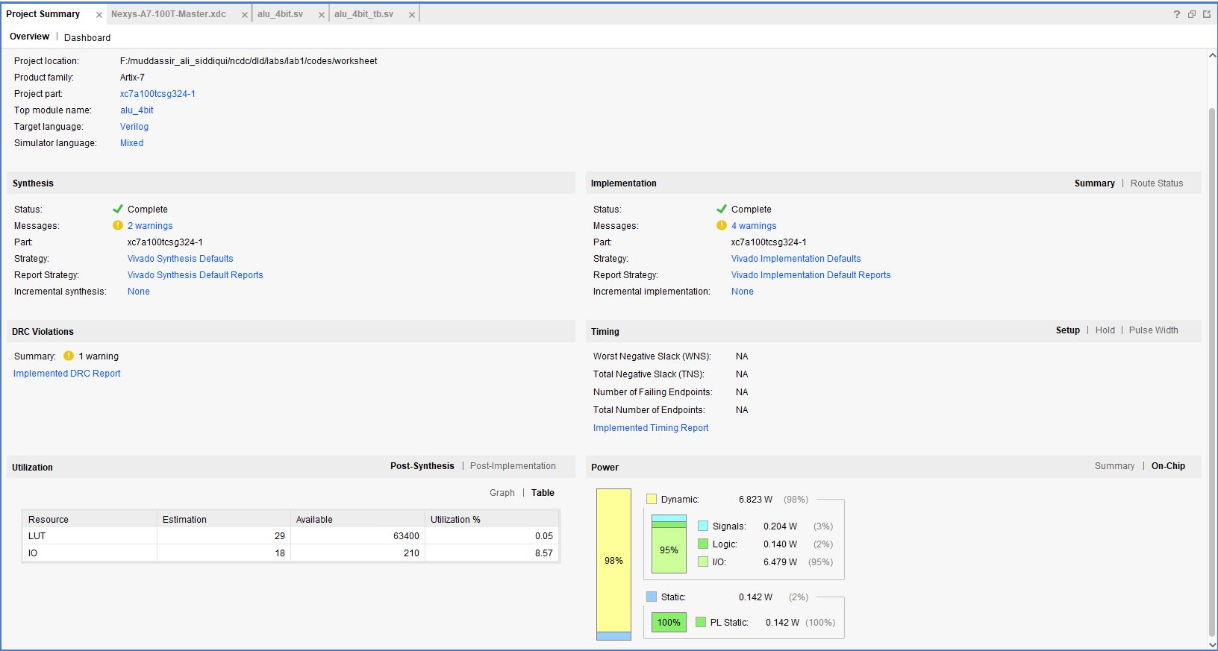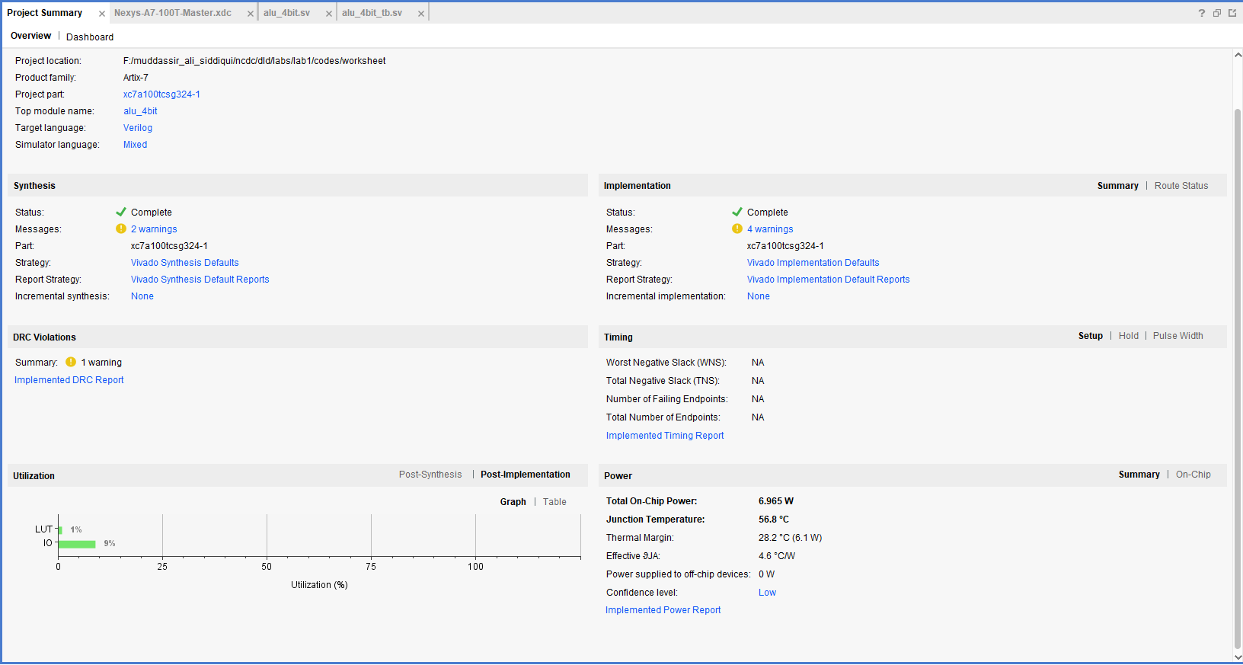

**Waveform:**

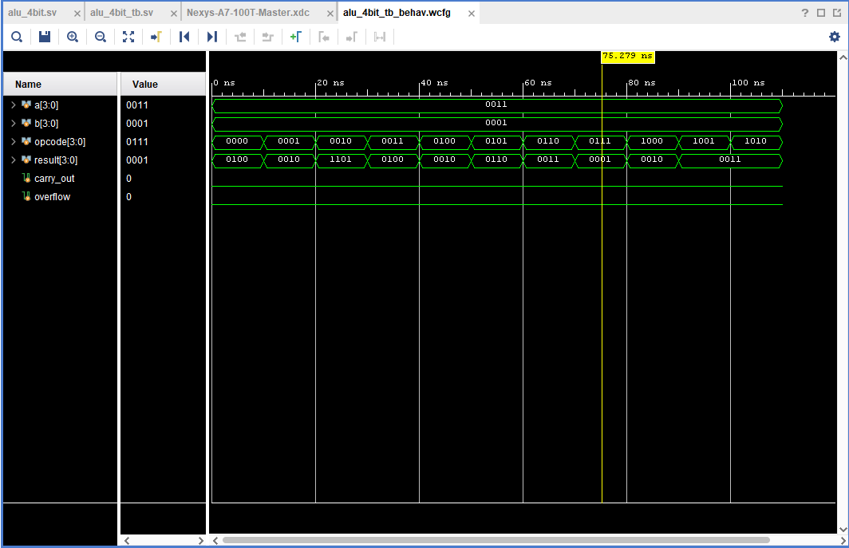

In the above waveform we assign operand_a = 0011 and operand_b = 0001, and result store the result of the operations.

1. **Critical Analysis: (***Write you critical analysis / conclusion here***)**

In this task we design a 4-bit alu in which we assign 10 operations given in the manual by mux. The alu is the critical and important section of a processor.