Digital Egypt Builders Initiative
Final Project

Real Estate Market Analysis & Prediction in Egypt
Presented by:
Student Name
Malak Mohamed Gaber
Malak Ahmed ElSayed
Ahmed Helmy Mohamed
Ali Ahmed Sherif

Project Supervisor
Mohamed Hamed Sayed
12/2025

Team : 17

Table of Contents

Table of Figures iii
List of Tables iv
Declaration v
Acknowledgement vi
Abstract 1
1. Introduction 2
2. Literature Review 3
3. Methods and Materials 4
4. Implementation 5
5. Research Results and Discussions 6
6. Conclusions and Future Work 7
References 8
Appendices 9
A.1 Appendix A 9
A.2 Appendix B 10

Table of Figures
Figure 1 —Air flow dag ETL design… page4
Figure 2 — Project Architecture Diagram… page5
Figure 3 — HDFS Directory Structure (Bronze, Silver, Gold Layers)…page7
Figure 4 Data Warehouse design page 8
Figure 5 — Real Estate AI Platform – Homepage UI Design….page11
Figure 6— Market Analytics & Property Matcher – UI Design (Dark Theme)…page9
Figure 7 — Power BI Dashboard …page12
Figure 8 — Superset Dashboard ….page13
Figure 9 RAG embeddings
Figure 10-11-12 Ai assistant Chatbot

List of Tables
Table 1: Table 1 Caption .

Declaration
I hereby declare that this project titled “Egypt Real Estate Data Pipeline, Analytics, and Recommendation System” is my own original work.
It has not been submitted previously to any university or institution, and all external sources have been properly acknowledged.
Student Name
Malak Mohamed Gaber
Malak Ahmed ElSayed
Ahmed Helmy Mohamed
Ali Ahmed Sherif

Abstract
This project analyzes residential real estate listings across key regions in Egypt with the aim of understanding market behavior, price variations, and location-driven trends. The study addresses the problem of limited market transparency by transforming raw property data into meaningful insights that support buyers, investors, and real estate decision-makers.
A structured data analysis methodology was applied, including data cleaning, feature engineering, and descriptive statistical exploration. Geographic, structural, and pricing variables such as property type, area, amenities, and price per square meter were examined to identify core patterns and regional differences. Visualization techniques were used to highlight pricing clusters, high-demand areas, and correlations between property characteristics and valuation.
In addition to exploratory analysis, a machine learning model was implemented to predict customer preferences based on historical patterns in the dataset. This predictive component provides insight into the types of properties a user is most likely to choose, thereby enhancing recommendation accuracy for real estate platforms.
The findings reveal clear pricing disparities between regions, strong associations between property features and value, and interpretable trends that can support strategic decision-making. The final dashboard and predictive model offer a comprehensive, data-driven view of the Egyptian property market.

Keywords: Real Estate Analytics, Price Prediction, Customer Preference Modeling, Egypt Housing Market, Data Visualization, Machine Learning.

Introduction

The rapid expansion of the Egyptian real estate sector has led to significant growth in property listings, investment opportunities, and customer demand. However, market transparency remains limited, making it difficult for buyers and investors to make informed decisions. This project addresses this gap by scraping live, real Egyptian property data and analyzing property characteristics, prices, locations, and amenities. It further builds predictive and recommendation models, as well as an AI-powered assistant to guide stakeholders.

Problem Statement
The real estate market faces several challenges:
- Limited transparency in property pricing
- Significant regional price variations
- Lack of structured analytical insights for stakeholders
- Difficulty in evaluating property value and customer preferences
Impact
- Buyers struggle to find properties that meet their budget and needs
- Investors lack reliable market intelligence
- Policymakers have insufficient data to inform housing and economic policies

Research Objectives
- To analyze property pricing trends across different regions in Egypt.
- To identify factors influencing price and price per square meter.
- To develop visual dashboards summarizing key market insights.
- To build a machine learning model that predicts customer preferences based on property characteristics.

Research Contribution
This study contributes a data-driven approach to understanding the Egyptian real estate market, providing:
- A clean and structured dataset
- A comprehensive analytical dashboard
- Predictive modeling for customer preference
- Insights supporting investment and strategic decisions

Methods and Materials

Data Engineering Pipeline (Airflow DAG)
To automate the end-to-end flow of data from online real estate platforms to the data lake and data warehouse, an Apache Airflow DAG was developed. The pipeline ensures reliable, repeatable, and scheduled ingestion of raw property data followed by cleaning, transformation, and loading into the analytics layer.
The pipeline consists of the following stages:
- Directory Creation
Creates all required local folders to temporarily store scraped data.
- Web Scraping Tasks
Automated scraping from multiple sources:
  - PropertyFinder
  - Bayut
  - Dubizzle
  - Fazwaz
Each task stores raw extracted JSON/CSV files locally.
- HDFS Folder Setup
Creates bronze, silver, and gold layers inside the Hadoop Data Lake and assigns permissions.
- Bronze Ingestion
All raw scraped data is ingested into the Bronze layer without any modifications.
- Data Cleaning Tasks
Cleaning scripts process bronze files and generate structured, deduplicated outputs in the Silver layer.
- Transformation Tasks
Business rules are applied to enrich the data (e.g., feature creation, formatting), and results are stored in the Gold layer.
- DWH Load
Finally, curated gold-layer datasets are loaded into the data warehouse tables for use in analytics dashboards and machine learning.
The following figure shows the complete DAG structure:
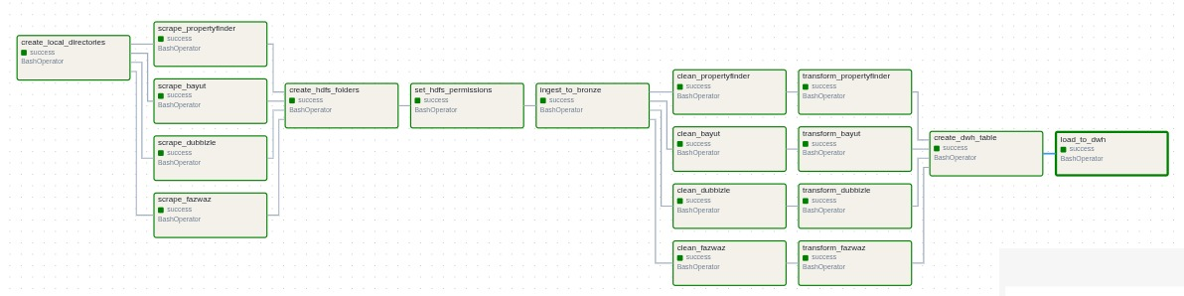
Figure 1 — Project Architecture Diagram

Data Lake Architecture (Bronze, Silver, Gold)
The data lake follows a layered architecture to organize data based on its processing stage:
- Bronze Layer → Raw, uncleaned data
- Silver Layer → Cleaned, standardized datasets
- Gold Layer → Analytics-ready, business-curated tables

Implementation

Introduction to System Implementation
This chapter presents the implementation phase of the real estate data platform.
The system integrates data ingestion, processing, transformation, storage, analytics, and AI components into one end-to-end pipeline.
Each module was implemented, tested, and connected to provide a fully automated and reliable data architecture capable of supporting dashboards and machine learning models.
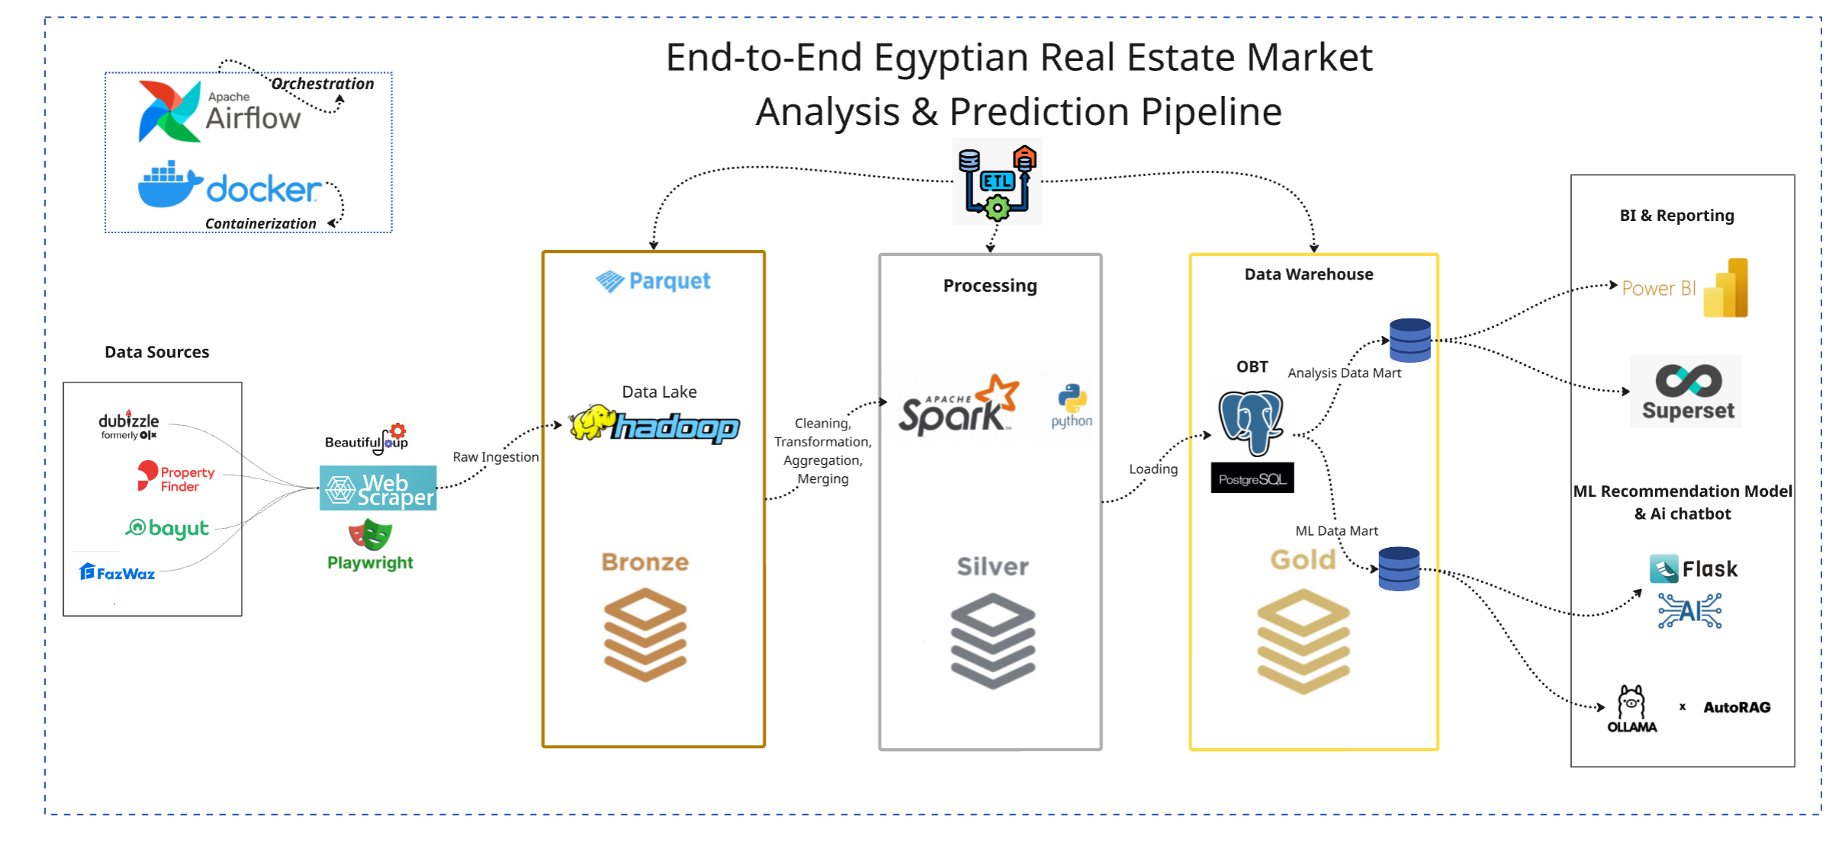

System Architecture Implementation
The implemented architecture follows a multi-layered data engineering approach consisting of:
- Scraping Layer – extracts data from online real estate platforms.
- Data Lake (HDFS) – stores raw, cleaned, and curated data (Bronze, Silver, Gold).
- Processing Layer (Apache Airflow) – orchestrates ingestion, cleaning, and ETL workflows.
- Data Warehouse Layer – stores analytics-ready tables for BI tools and ML models.
- Analytics Layer (Power BI & Superset) – visualizes trends, pricing, and market insights.
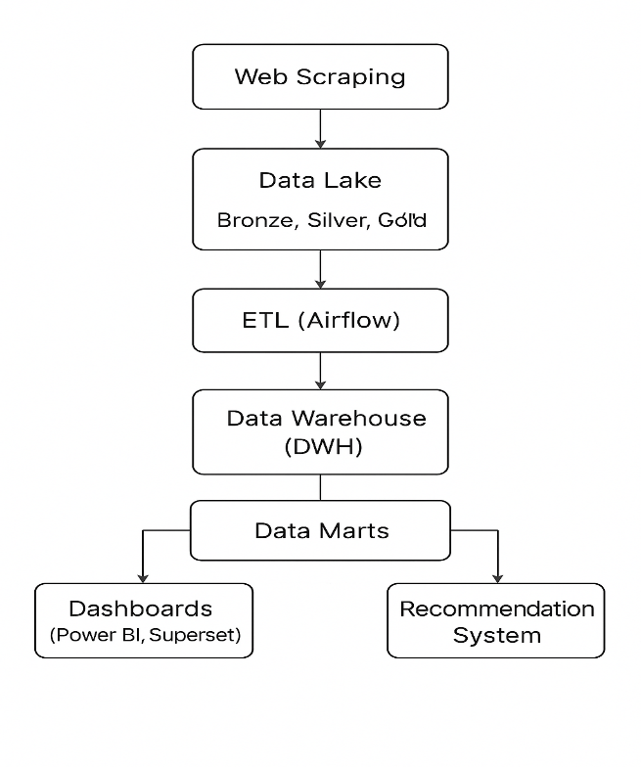
- Application Layer – UI showcasing property recommendation and market analytics features.
- Ai assistant chatobot – answer users inquiries – advice investors – recommend properties

Ingestion
Data ingestion scripts were implemented using Python and automated through Airflow.
Scrapers were built for:
- Bayut
- PropertyFinder
- Dubizzle
- Fazwaz
Each scraper collects structured real estate listing data and stores it temporarily in local directories before ingestion into the data lake.
Airflow executes scraping tasks sequentially to ensure data consistency and avoid site throttling.
Logs from Airflow confirm successful execution of each scraping job.

ETL Pipeline Implementation (Airflow DAG)
A complete DAG was implemented in Apache Airflow to automate all ETL tasks including:
- create_local_directories – prepares folders for downloading raw data
- scrape_ tasks* – executes scrapers for each platform
- create_hdfs_folders – builds Bronze, Silver, and Gold folders in HDFS
- set_hdfs_permissions – grants full permissions for ingestion
- ingest_to_bronze – moves raw data files into the Bronze layer
- clean_ tasks – performs data quality processes (null handling, duplicates removal)
- transform_tasks – filters, standardizes, transforms
- create_dwh_table – creates one big table
- creates data mart – creates analytical data mart and Model data mart
- load_to_dwh – loads Gold-layer data into the final analytical warehouse

Data Lake Implementation (HDFS Bronze/Silver/Gold)
The data lake follows a three-layer architecture to enable incremental data refinement:
- Bronze Layer– raw scraped data without any processing
- Silver Layer– cleaned, deduplicated, and standardized tables
- Gold Layer– analytics-ready curated datasets used for DWH loading and dashboards
All folders were created automatically through Airflow tasks.
Figure 3 — HDFS Directory Struc ture (Bronze, Silver, Gold Layers )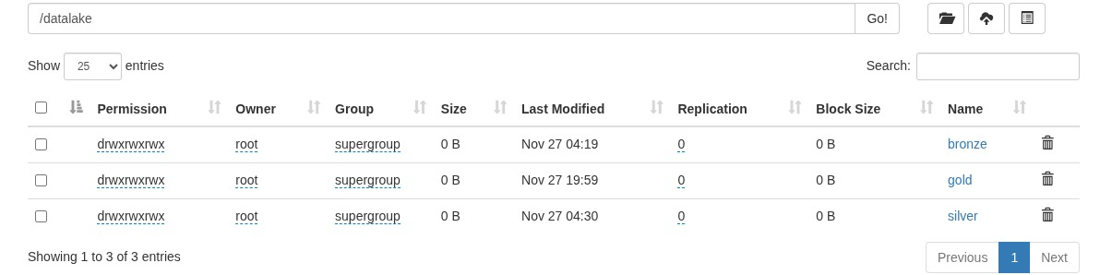

Data Cleaning & Transformation Implementation
Cleaning scripts were implemented in Python/ PySpark to:
- Remove duplicated listings
- Standardize numeric fields (price, area)
- Convert Boolean amenities into binary flags
- Generate the price_per_sqm metric
- Normalize region and city names
- Validate property types
Transformation scripts then enriched the dataset by:
- Creating derived attributes
- Unifying inconsistent formats between different platforms
- Mapping region/city hierarchies
- Preparing final tables for the DWH

Data Warehouse & Data marts
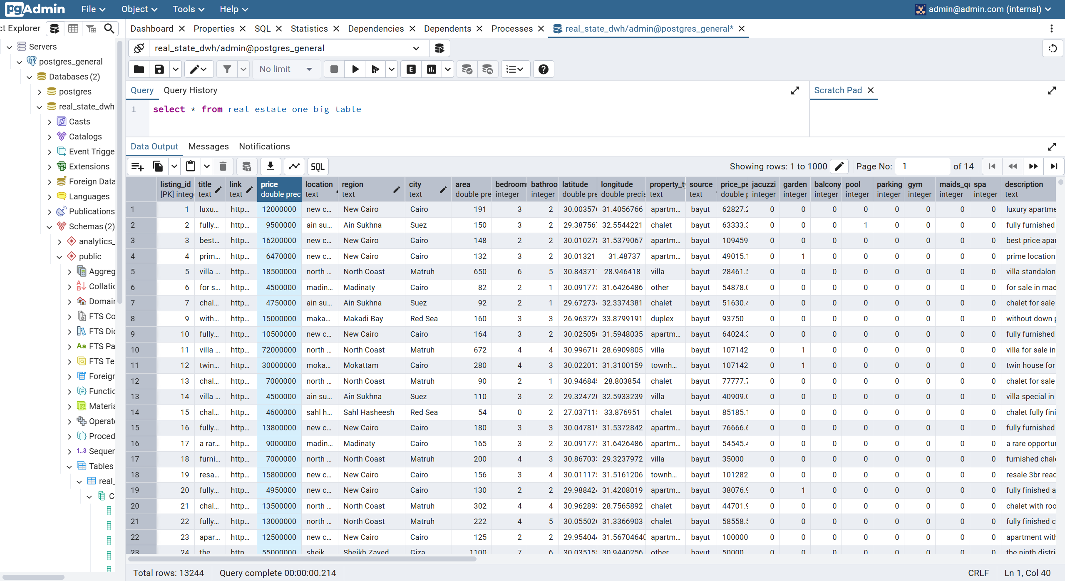

One Big Table as the Data Warehouse
We stored all real estate listings from all sources in one unified table to:
- Keep the architecture simple
- Avoid complex joins and speed up queries
- Have a single, consistent source of truth
- Make ETL loading easier and faster
- Apply indexing once on key fields (price, location, property type, source)
- Prepare all future analytics/ML use cases from one place
The OBT acts as the central clean repository for everything collected.

Why We Created Two Data Marts
We separated the data into two marts because Analytics and Machine Learning need different structures.

A) Analytics Data Mart
Used for dashboards (Power BI).
- Contains business fields for reporting (city, region, price, type, amenities)
- Optimized for aggregations and fast filtering
- Lighter and simpler than the DWH
- Prevents BI queries from slowing down the main warehouse
Purpose: Reporting, visualization, trends, insights

B) Machine Learning Data Mart
Used for training ML models and recommendations.
- Contains only clean numerical and categorical features
- Removes text, noise, and irrelevant columns
- Ensures no NULLs
- Stable schema for model retraining
- Faster processing and better model accuracy
Queries were executed to validate row counts and schema completeness.

Machine Learning Model Implementation
The system consists of two independent models working together inside one unified application:
- Analytics Model (Market Intelligence)
- Recommender Model (Property Recommendation Engine)

Recommender Model (KNN)
The recommender uses a k-Nearest Neighbors (KNN) algorithm with cosine similarity to find similar properties based on user input such as price, area, type, number of rooms, and amenities.

Hyperparameters:
- Algorithm: KNN
- Distance Metric: Cosine
- Neighbors searched: Up to 50 per city
- Feature weighting:
  - Price & Type ×3
  - Area, Beds, Baths ×2
A City-First filtering strategy ensures recommendations are searched only within the selected city.
A custom scoring function ranks results based on business logic (budget, property type, area, rooms, and optional amenity match).

Location Intelligence Model
This model computes statistical indicators for cities and regions, including average price, price range, average area, and most common property type. Each region is classified using city-level comparison:
- Hotspot: Average price > 120% of the city average
- Coldspot: Average price < 80% of the city average
- Average: Otherwise
The model is rule-based and saved as a serialized data structure for fast lookup during deployment.

Deployment
Both models are deployed using Flask, providing APIs for:
- Property recommendations
- Market analytics
The system runs as a unified web application serving all results in real time.

Figure 4 — Real Estate AI Platform – Homepage UI Design
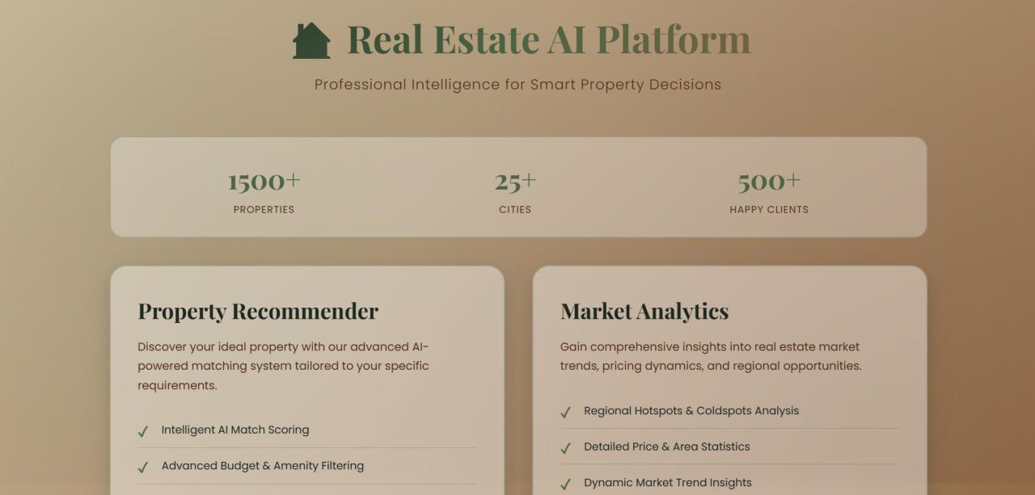

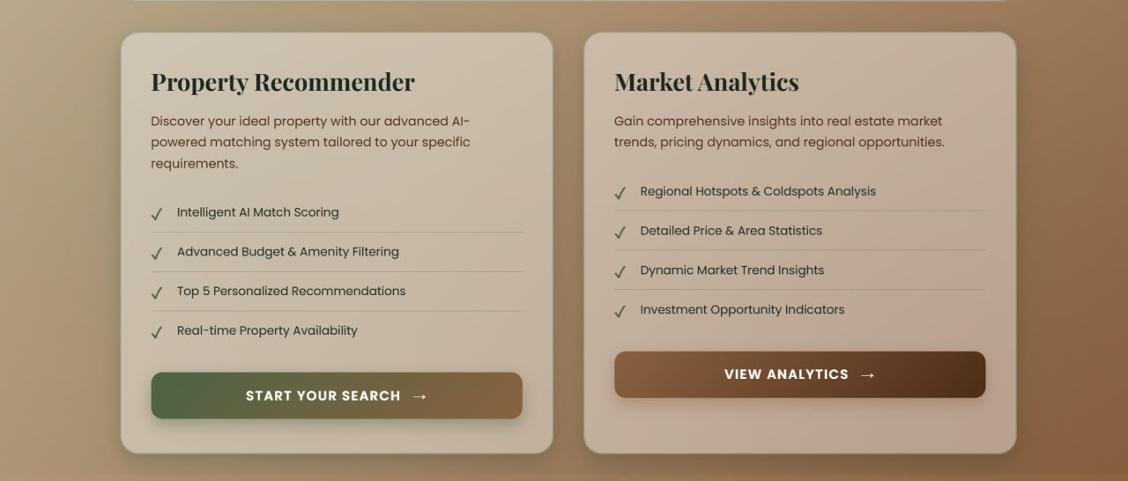
Figure 5 — Market Analytics & Property Matcher – UI Design (Dark Theme)…

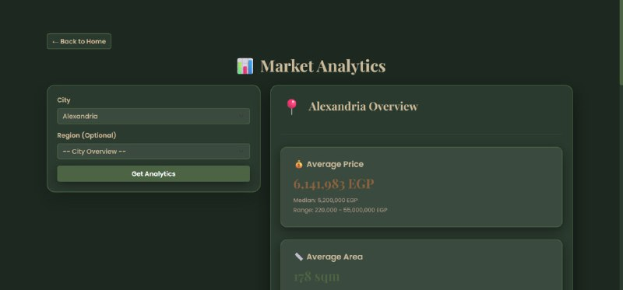

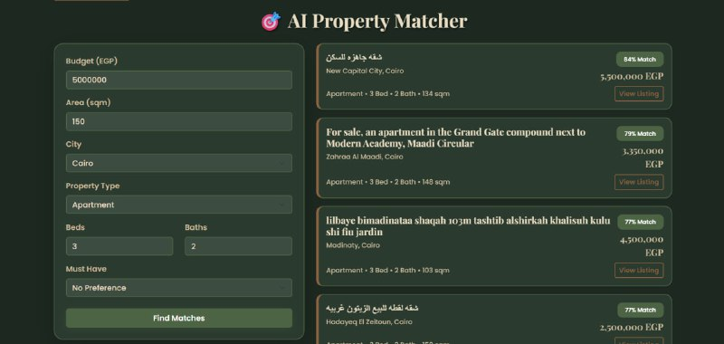

Business Intelligence Implementation (Power BI & Superset)
Power BI and Apache Superset were used to create interactive dashboards enabling:
- Price analysis across cities and regions
- Market segmentation by property type
- Price vs area relationships
- Summary KPIs (median price, median area, total listings)
- Filtering by region, source, or amenities

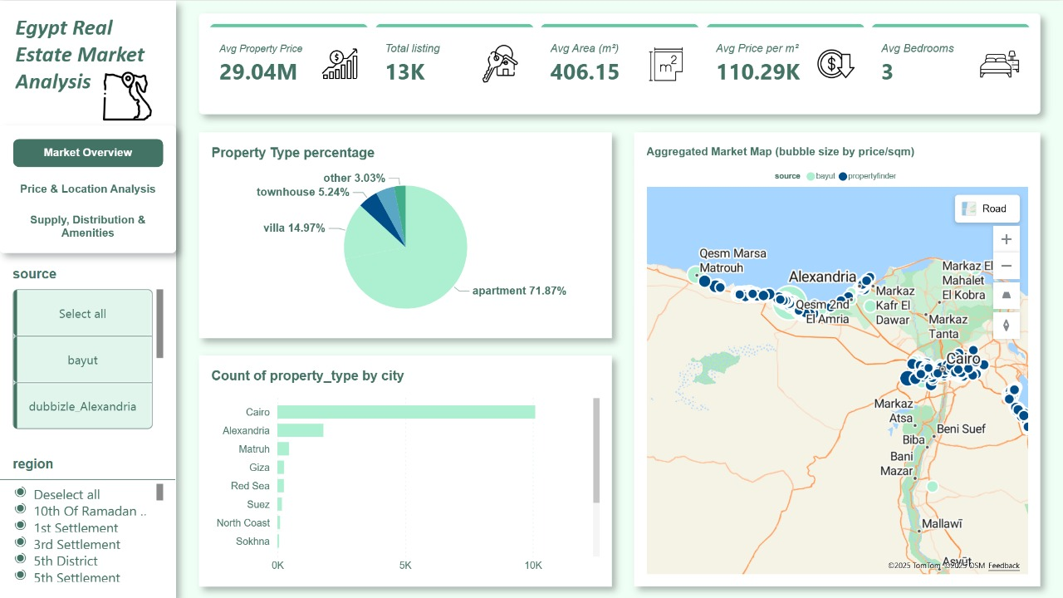
Figure 6 — Power BI Dashboard

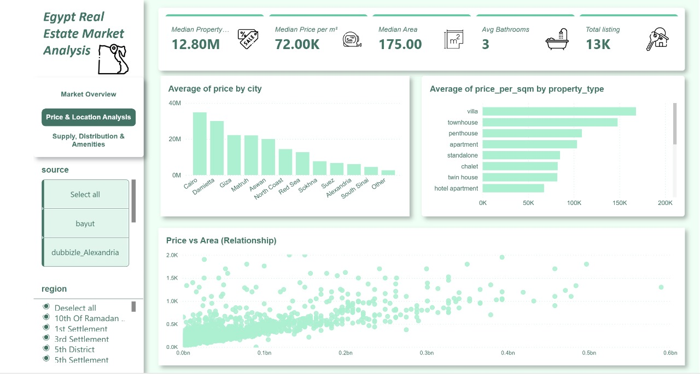

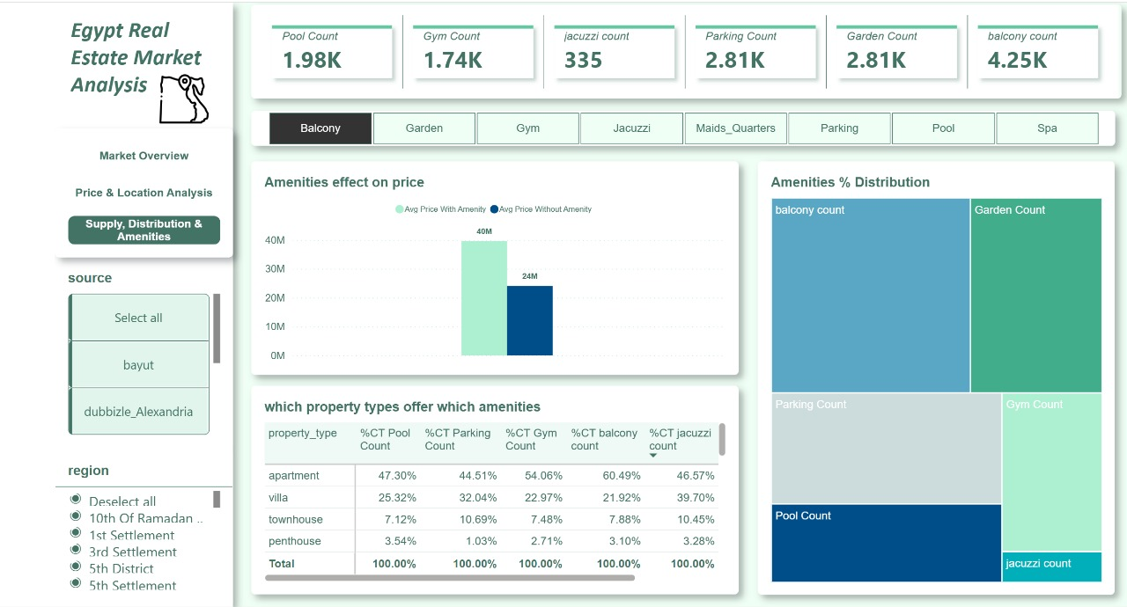

Figure 7— Superset Dashboard

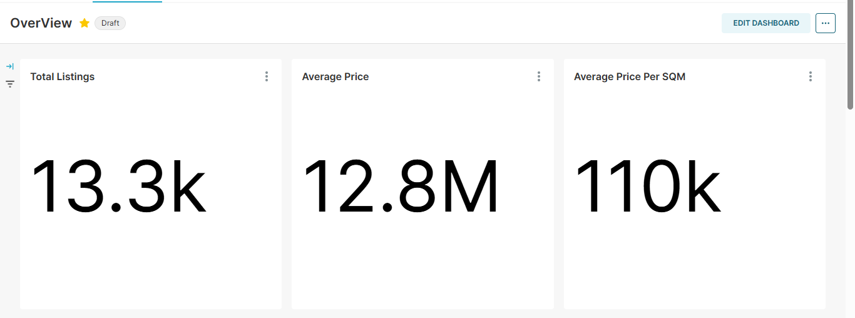

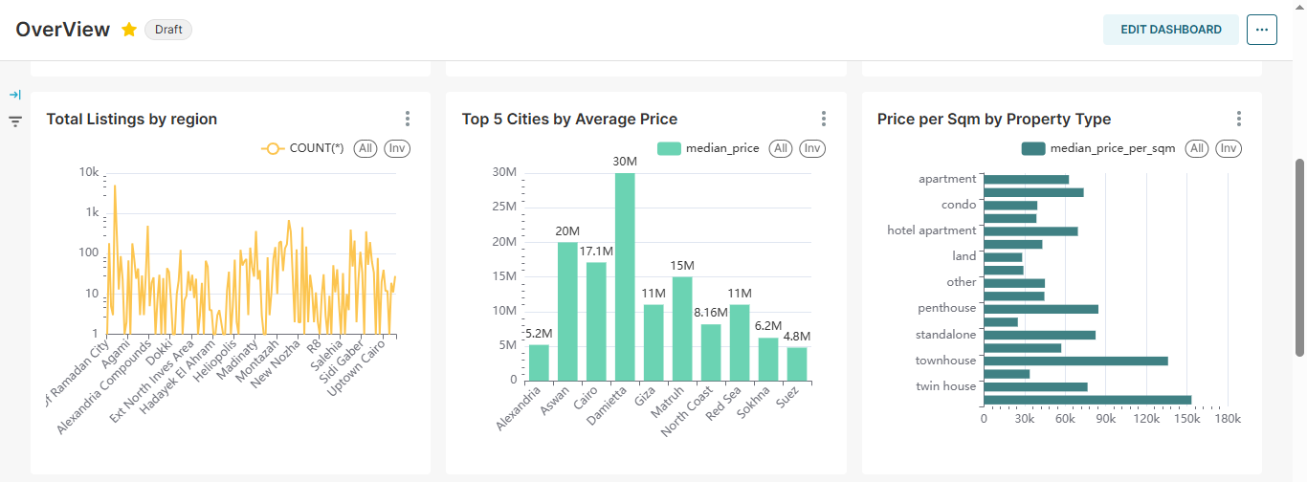

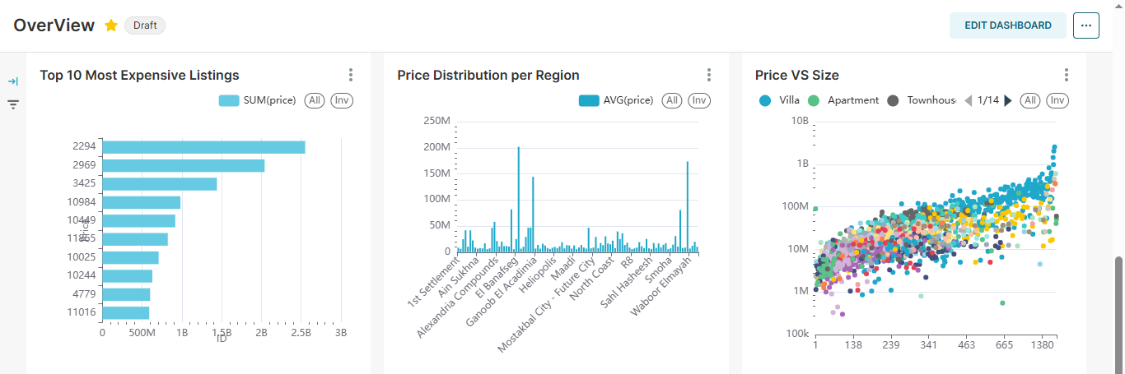

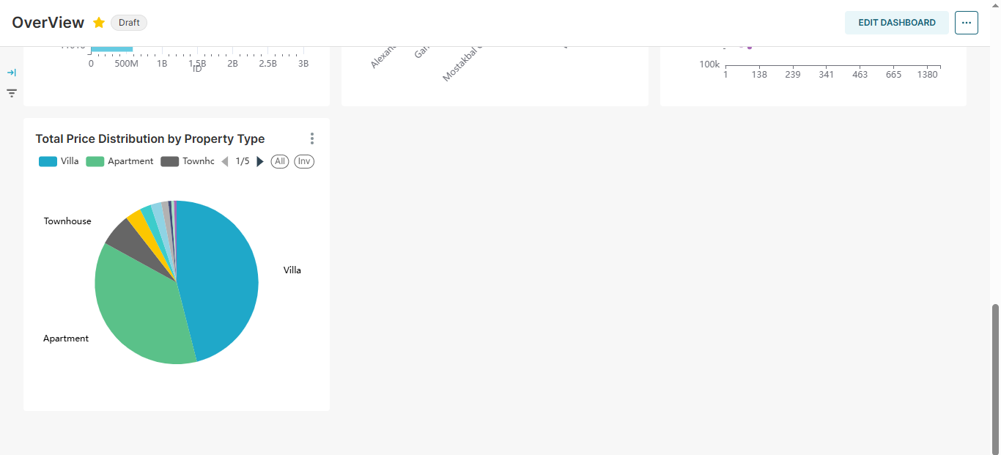

AI Assistant Chatbot(RAG+Ollama3)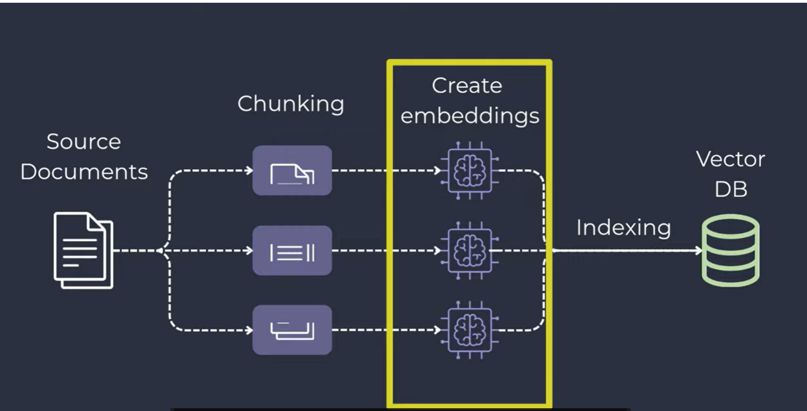
This chatbot is a hybrid Real Estate Expert System combining Retrieval-Augmented Generation (RAG) for property recommendations and Text-to-SQL for analytical queries.
Core Components & Tools:
- LLM: Local Ollama3 – intent detection, SQL generation, and final response formatting.
- Embeddings: SentenceTransformer all-MiniLM-L6-v2 – converts text to vectors for semantic search.
- Vector Database: FAISS – stores embeddings for fast similarity search of listings.
- Structured Data: PostgreSQL – holds the real estate dataset, queried via SQL.
Logic & Pipeline:
- RAG / Recommendation Path:
  - Converts user query to vector → searches FAISS → retrieves top 5 similar properties → Gemini LLM generates conversational recommendations.
- Text-to-SQL / Analytical Path:
  - Gemini LLM classifies intent → generates SQL for analytical queries → executes SQL on PostgreSQL → summarizes results in natural language.
Key Mechanisms:
- Intent-Driven Routing: Determines whether to run SQL, RAG, or conversational response.
- Prompt Engineering: Structured system instructions ensure consistent JSON-formatted outputs.
- Safety: SQL execution restricted to safe SELECT queries only.
- Modularity: Uses HuggingFace embeddings wrapper for LangChain-style integration and future scalability.




System Integration
All system components were integrated together:
- Scraped data → Data Lake
- Cleaned & transformed → Gold
- Gold → Data Warehouse
- DWH → Dashboards + ML Model
- ML Model → UI interface
This ensures data consistency, automated daily updates, and a unified analytics layer.

Summary
The implementation successfully delivered a complete data platform with:
- Automated ETL pipeline
- Structured data lake and data warehouse
- Business intelligence dashboards
- Machine learning prediction
- Front-end interface
The system is stable, scalable, and ready for future enhancements.

Research Results and Discussions
This chapter presents key results from the implemented real estate data platform. It covers:
• Data quality improvements
• Dashboard insights
• Platform comparisons
• Machine learning model performance
• RAG + Ollama assistant results
• AI-driven recommendations
The results demonstrate the value of a fully integrated pipeline from data ingestion → cleaning → analytics → AI recommendations.

Data Quality Improvements After Processing
After applying cleaning and transformation scripts in the Silver and Gold layers, the dataset showed a significant improvement in structure and consistency:
- Duplicate listings were removed, reducing noise in analytics.
- Missing values in price and area were handled using validation rules.
- Region and city names were standardized across different platforms.
- Amenities were converted into usable binary features.
- A derived feature (price_per_sqm) was successfully added, enabling more accurate comparisons.
These improvements created a reliable foundation for dashboards, modeling, and market analysis.

Market Insights from Dashboard Analysis
Interactive dashboards designed in Power BI and Superset revealed several meaningful market insights:

Price Variation Across Cities
Analysis showed that cities such as Cairo, Giza, and North Coast recorded the highest median property prices. Coastal regions like Suez and Red Sea displayed moderate pricing, making them more attractive for investment opportunities.

Property Type Pricing Differences
Villas and townhouses had the highest average price per sqm, followed by penthouses and apartments. Chalets displayed more affordable pricing, aligning with their smaller areas and tourism-oriented locations.

Relationship Between Price and Area
The correlation analysis visualized a nonlinear relationship between price and area. While larger units generally had higher prices, several outliers appeared, representing luxury properties with exceptional price-per-meter values.

Listing Distribution by Region
Regions in New Cairo and 6th of October represented the highest volume of listings across platforms, indicating strong development activity and demand.

Comparative Insights Between Platforms
By integrating multiple data sources (Bayut, PropertyFinder, Dubizzle, Rawaz), the system enabled a comparison across platforms:
- Bayut contributed the largest number of listings.
- Property types were more diverse on PropertyFinder.
- Dubizzle listings were smaller in area on average.
- Fazwaz showed more regional concentration in specific cities.
This comparison highlights the value of data unification across platforms.

Data Warehouse Query Results
Queries executed on the DWH confirmed:
- Correct loading of the Gold-layer curated dataset.
- Clean dimension tables for property type, region, city, and date.
- A consistent fact table with all numeric metrics validated.
Example validation results:
- Total listings in DWH: ~13,000
- Distinct cities: 20+
- Distinct property types: 8

Machine Learning Model Results
The AI model successfully predicted customer property preferences using categorical and numerical features. Results showed:
- Top Features: price, area, property_type, region
- Model Output: A ranked list of recommended property types based on user inputs
This model supports the recommender system and enhances user personalization.

Recommendation System Results
The AI-powered recommendation interface provided:
- A top-5 ranked list of properties or property types
- Intelligent match scoring based on user profile
- Filtering by budget, area, and amenities
- Real-time compatibility with the DWH

Recommendation System & RAG + Ollama Assistant Results
The AI-powered recommendation interface, integrated with RAG + Ollama LLM, provided:
• Top-5 ranked property recommendations
• Match scoring based on user profile
• Filtering by budget, area, and amenities
• Real-time compatibility with DWH
• Semantic, conversational interaction for property guidance
The RAG system leverages:
- FAISS Index → retrieves top similar properties
- Ollama LLM → generates human-like summaries, recommendations, and explanations
Example:
"Based on your preferences for 3-bedroom apartments in Giza under EGP 3M, these listings provide the best value with amenities including a pool, balcony, and gym."

Summary of Findings
The results confirm that:
- The pipeline significantly improved data reliability.
- Dashboards revealed clear market patterns and pricing trends.
- The DWH successfully unified all data sources.
- The AI model enhanced customer decision-making.
- The recommendation system provided a practical real-world use case.
These findings demonstrate the impact of building a full data engineering, analytics, and AI solution for real estate market intelligence.

Conclusions and Future Work

Conclusions
This project successfully developed a complete end-to-end real estate data platform that integrates data engineering, analytics, and artificial intelligence to support decision-making in the Egyptian property market. Through automated data ingestion pipelines, a structured Data Warehouse, and interactive dashboards, the system provides a unified, accurate, and analytics-ready dataset from multiple real estate platforms.
The implementation of an ETL pipeline using Airflow proved effective in automating scraping, validation, cleaning, and loading processes. The Data Warehouse design enabled consistent storage of facts and dimensions, allowing for efficient querying and reliable insights.
Power BI and Superset dashboards revealed deep market insights, including major pricing trends, comparisons across cities and property types, and distribution patterns across regions. These analytics can support investors, agents, and individuals in making informed decisions.
In addition, the machine learning model demonstrated the value of predicting user preferences, while the Recommendation System showcased how AI can personalize the user experience and improve property search efficiency.
Overall, the project illustrates the impact of combining data engineering and machine learning to build scalable, intelligent real estate analytics solutions.

Future Work
Although the project achieved strong results, several enhancements can be implemented to improve functionality, accuracy, and scalability in the future:

Expand Scraping to More Platforms
Including platforms like OLX, Aqarmap, and other major portals would enrich the dataset and increase model accuracy.

Add Real-Time Streaming Pipeline
Implementing Kafka or Spark Streaming would allow continuous live updates rather than batch-based ingestion.

Integrate GIS & Advanced Location Analytics
Using geospatial libraries (e.g., KeplerGL, Folium) can reveal advanced clustering and heatmap insights about supply, demand, and price hotspots.

Improve the AI Model with Deep Learning
CNN or transformer-based models could be used for:
- predicting customer preferences
- classifying property quality
- analyzing property images for price estimation

Add Price Prediction Model
Developing a regression model to predict property price or price_per_sqm would provide huge value for sellers and buyers.

Scale Data Warehouse to Cloud
Migrating to platforms like Snowflake, Google BigQuery, or AWS Redshift would support higher scalability, concurrency, and performance.

Build a Full Web Application
Connecting the recommendation model and dashboards into a single web platform would provide a complete customer-facing product.

Summary
This project sets a strong foundation for a robust real estate analytics ecosystem. With additional improvements in scalability, geospatial analysis, and AI capabilities, the system could evolve into a fully intelligent real estate decision-support platform.

