1. we check the IP address of the victim (metasploitable3):

Using the command:

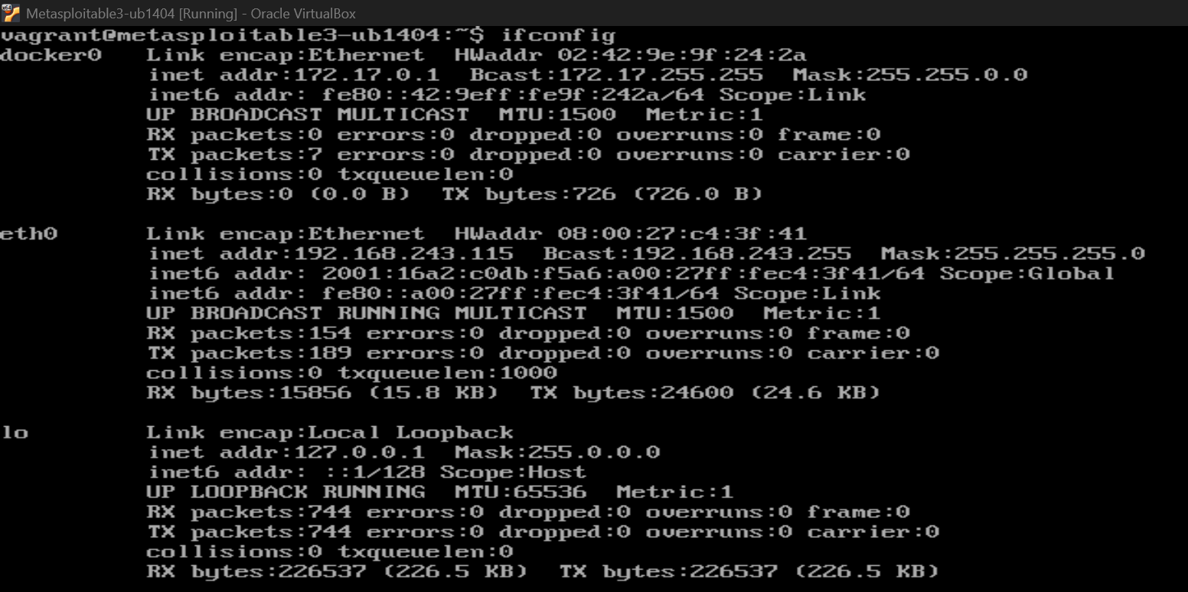

We get:

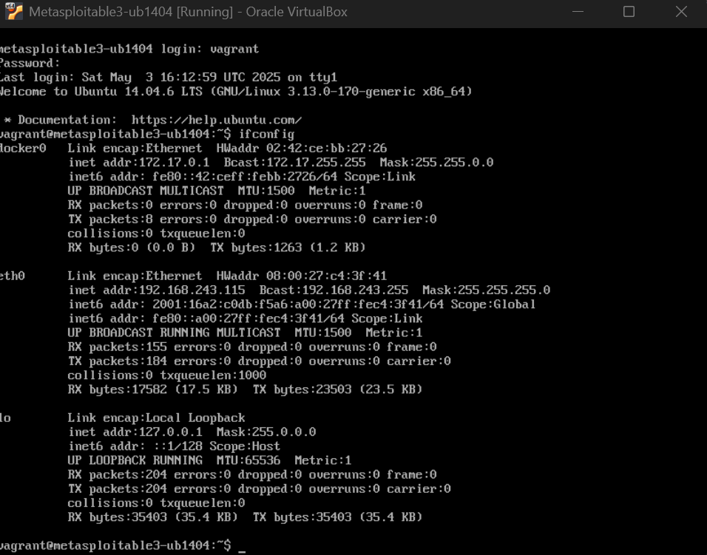

1. check the connectivity:
   1. main host side:

* 1. attacker side:

1. scanning the address (address has been changed):
   1. scan using nmap

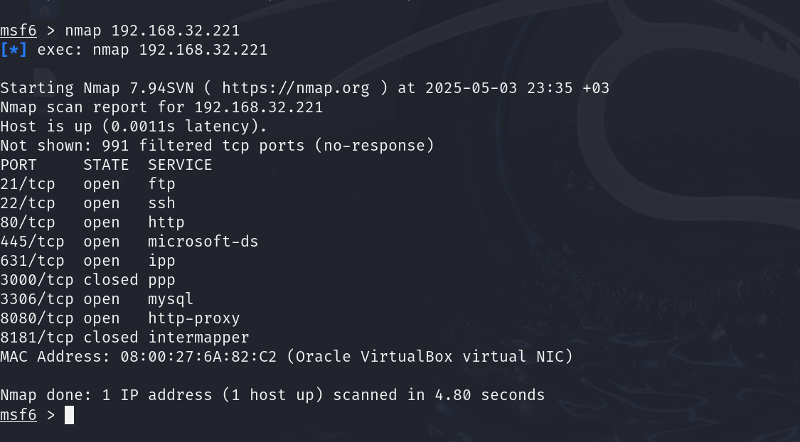

* 1. now lets work on ssh:



* + 1. lets search for the vesion using this file:

* + 1. lets search for vulnerability within ssh:

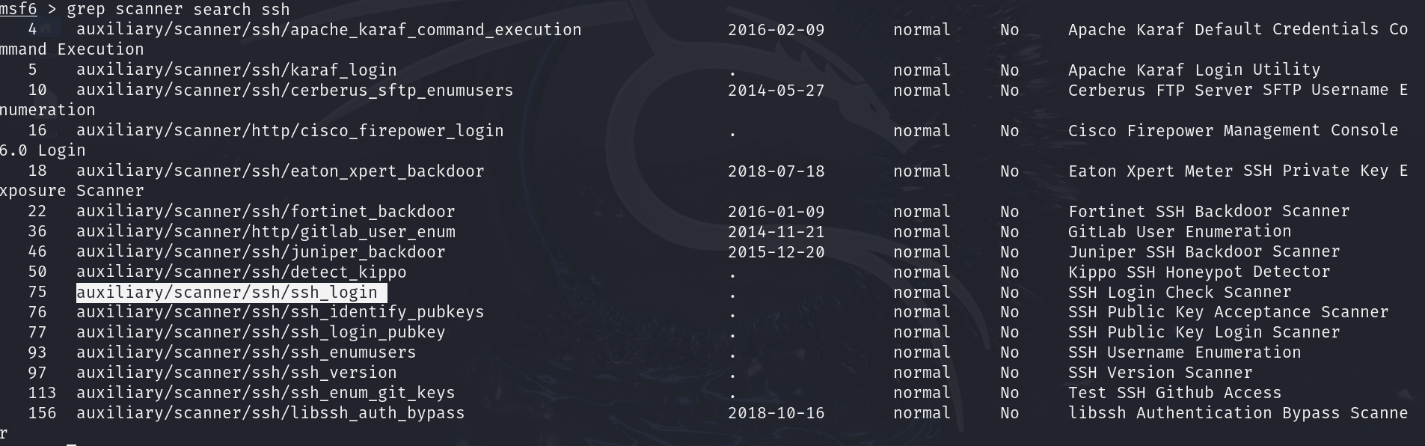

* + 1. setting the attack:

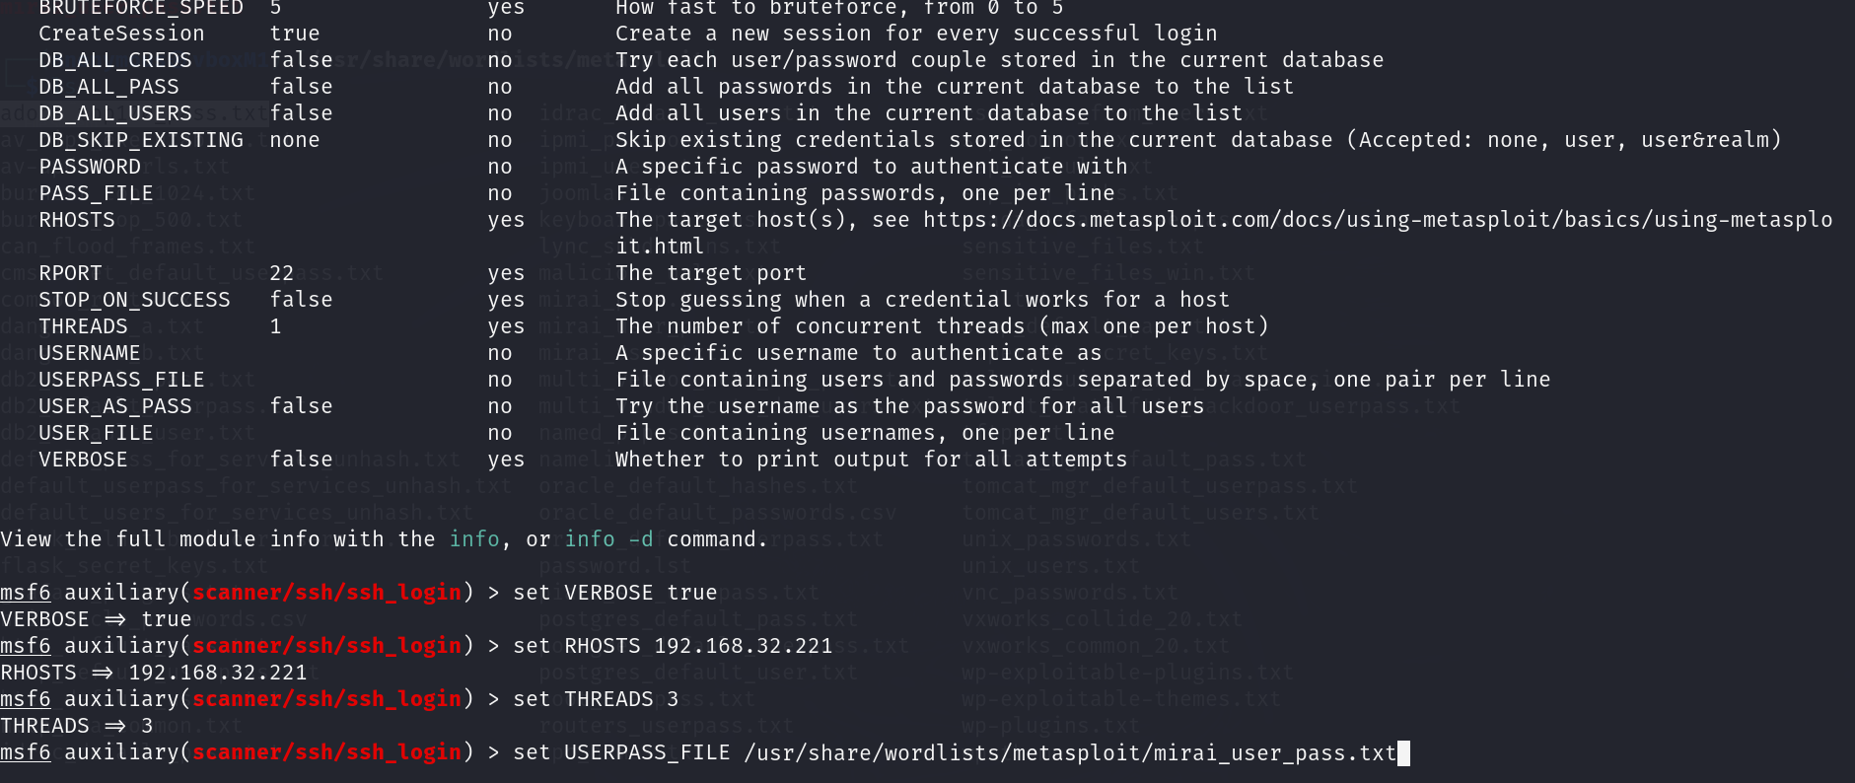

I ran two attacks and none of them worked:

