1. Setting up Splunk:
   1. Initiating Splunk:

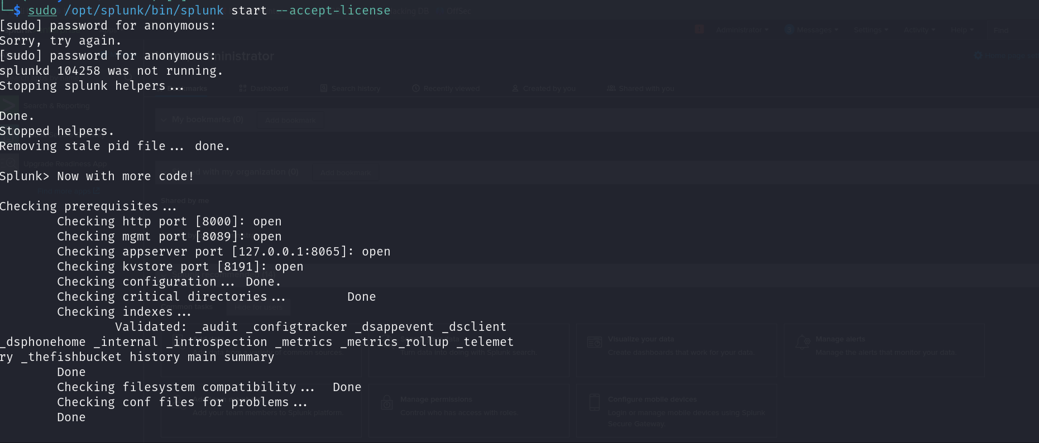

* 1. Log into the server as administrator:

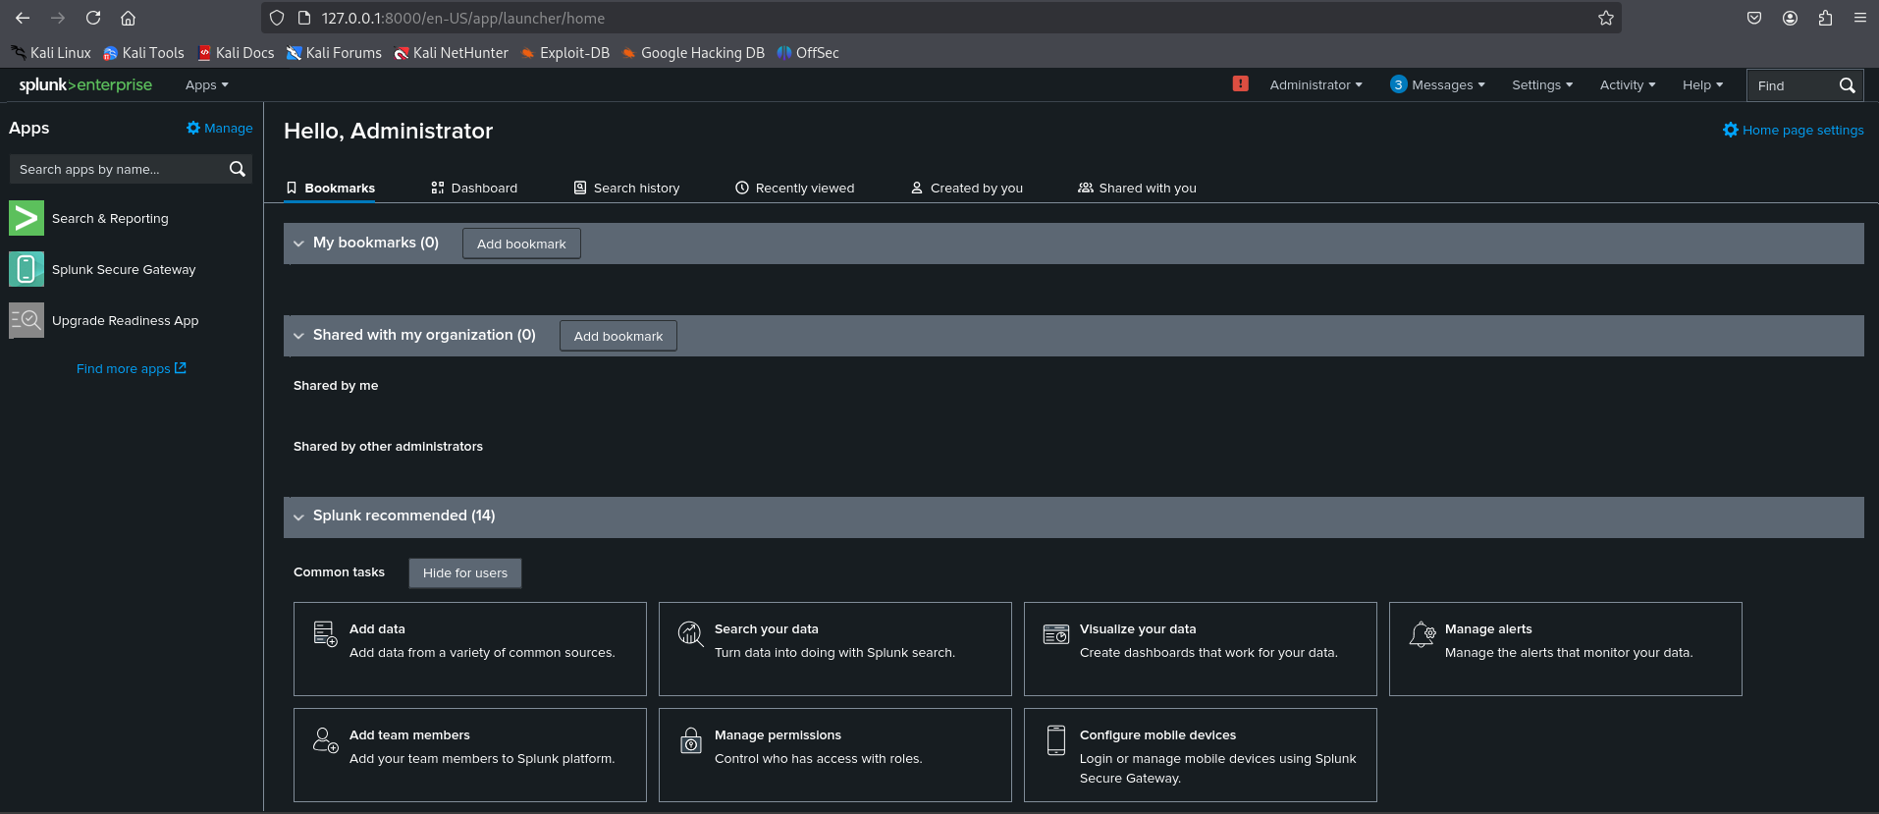

* 1. Configure Splunkforwarder:

Connect to the server:

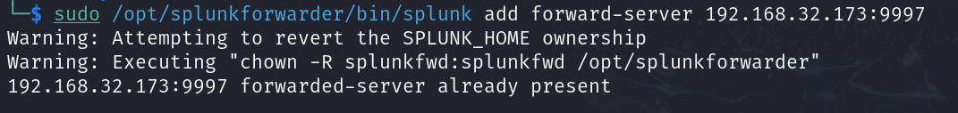

Add data input (logs):

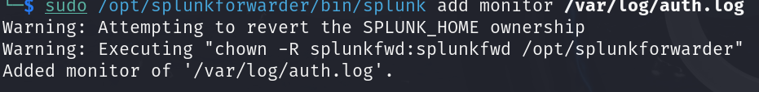

Checking the status:

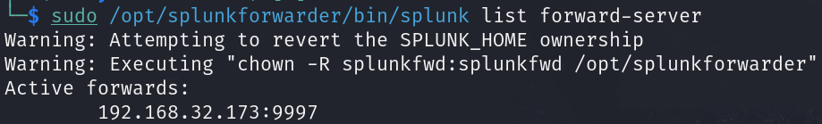

1. Problem faced:

Whenever I tried to search I am facing this error:

"Search not executed: the minimum free disk space 5000MB reached for /opt/splunkforwarder/bin/splunk/dispatch"