**Assignment 2 Report**

|  |  |
| --- | --- |
| Ali Awais Safdar | 369475 |
| Syed Usman Ali Shah | 386543 |

**1. Introduction**

This report outlines a deep learning assignment focused on image classification using transfer learning with various pre-trained models. The assignment involves preparing the data, constructing different model architectures using VGG16, ResNet18, ResNet50, and VGG19, training the models, and evaluating their performance on a validation dataset.

**2. Methodology**

**2.1 Data Preparation**

The assignment employs two directories: **Train** for training data and **Validation** for validation data. Images within these directories are pre-processed using an **ImageDataGenerator** with rescaling to normalize pixel values to the range [0, 1]. Both training and validation data are resized to a target size of (224, 224) and batched with a size of 32. The data generator is set to use categorical class mode, suitable for multi-class classification tasks.

**2.2 Transfer Learning with Different Models**

Four pre-trained models were utilized in the assignment:

* **VGG16**
* **ResNet18**
* **ResNet50**
* **VGG19** (Ultimately selected for best accuracy)

Each model's layers are initially set to non-trainable to preserve the learned features during transfer learning. The models are then modified with custom dense layers for classification. This approach allows for leveraging the knowledge encoded in these pre-trained models while adapting them to the specific classification task at hand. Below is the architecture of the model that we used and gave us the best accuracy.

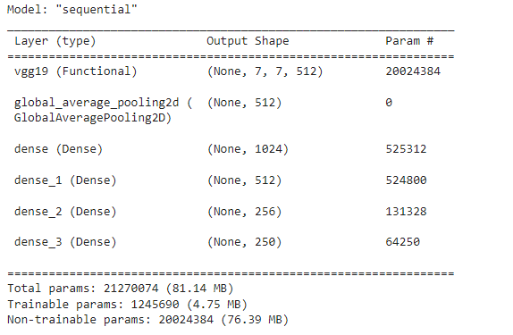

**2.3 Model Architecture Comparison**

The assignment explores varying architectures by adjusting the number of dense layers, units per layer, and activation functions. Despite these architectural differences, the core methodology remains consistent across all models, focusing on transfer learning and fine-tuning for image classification.

**3. Results and Discussion**

**3.1 Model Training and Evaluation**

All four models undergo training on the training dataset and evaluation on the validation dataset. Training involves optimizing the models' parameters using an appropriate optimizer and loss function. Metrics such as accuracy, precision, recall, and F1-score are used to assess the models' performance.

**3.2 Performance Comparison**

Upon evaluation, it is observed that the VGG19 model achieves the best accuracy among the tested models. Although VGG16, ResNet18, and ResNet50 exhibit competitive performance, VGG19 demonstrates superior classification capabilities for the specific dataset and task.

**4. Conclusion**

In conclusion, the assignment showcases the effectiveness of transfer learning with pre-trained models for image classification. By experimenting with different architectures and leveraging established models like VGG16, ResNet18, ResNet50, and VGG19, valuable insights are gained into model performance and architecture selection.

The selection of VGG19 based on its superior accuracy underscores the importance of model selection and fine-tuning in deep learning applications. Notably, while VGG19 excelled in accuracy, it was observed that VGG16, ResNet18, and ResNet50 architectures yielded significantly lower accuracies, indicating their limited suitability for the specific dataset and task.

These findings emphasize the need for thorough experimentation and evaluation of different architectures when applying deep learning techniques, as the success of a model can vary significantly based on factors such as dataset complexity, task requirements, and model design.