Traffic Monitoring and License Plate Recognition using Computer Vision Techniques

*Ali Awais Safdar*  
*SEECS (School of Electrical Engineering and Computer Sciences)*  
*NUST (National University of Science and Technology)*Lahore, Pakistan  
[**asafdar.bscs21seecs@seecs.edu.pk**](mailto:asafdar.bscs21seecs@seecs.edu.pk)  
*Huzaifa Liaqat*  
*SEECS (School of Electrical Engineering and Computer Sciences)*  
*NUST (National University of Science and Technology)*Islamabad, Pakistan  
[**hliaqat.bscs21seecs@seecs.edu.pk**](mailto:hliaqat.bscs21seecs@seecs.edu.pk)  
*Zainab Kashif*  
*SEECS (School of Electrical Engineering and Computer Sciences)*  
*NUST (National University of Science and Technology)*Okara, Pakistan [**zkashif.bscs21seecs@seecs.edu.pk**](mailto:zkashif.bscs21seecs@seecs.edu.pk)  
*Hunaina Ehsan*  
*SEECS (School of Electrical Engineering and Computer Sciences)*  
*NUST (National University of Science and Technology)*Okara, Pakistan [**hehsan.bscs21seecs@seecs.edu.pk**](mailto:hehsan.bscs21seecs@seecs.edu.pk)

*Abstract*—This project focuses on developing a comprehensive system for traffic monitoring and license plate recognition using computer vision methodologies. The project integrates multiple techniques to detect, track, and estimate vehicle speeds while employing optical character recognition to identify license plates.

Keywords—Traffic Monitoring, Computer Vision, License Plate Recognition, Vehicle Tracking, Image Processing, EasyOCR.

# Introduction

Modern challenges in traffic management and law enforcement necessitate agile and automated solutions. This project amalgamates computer vision techniques with advanced technologies to establish a dynamic system for real-time traffic monitoring and precise license plate recognition.

The primary goal is to create an efficient framework capable of tracking vehicular movement and deploying sophisticated optical character recognition (OCR) methods for accurate license plate identification. This integration aims to revolutionize traditional surveillance methods, enhancing efficiency and accuracy in traffic control and law enforcement.

In an era marked by increasing urbanization and growing vehicular populations, the significance of such a system is paramount. Its ability to monitor traffic flow, analyze patterns, and swiftly identify offenders holds profound implications for public safety and transportation system optimization.

By leveraging computer vision's capacity to process vast visual data and extract actionable insights, this project aims to introduce a dynamic and adaptive mechanism for traffic surveillance. The subsequent sections will delve deeper into the methodologies employed, technical implementation, and the potential impact of this pioneering system.

# Methodology

## Traffic Monitoring System

The Traffic Monitoring System deployed in this project leverages a combination of robust computer vision methodologies to achieve comprehensive vehicle tracking and speed estimation.

* + 1. *Cascade Classifier for Vehicle Detection:* The system employs a cascade classifier, inspired by the work of Viola and Jones (2001) [1], to effectively detect vehicles within video footage. This classifier utilizes Haar-like features to efficiently identify regions of interest (ROIs) that exhibit characteristic vehicle patterns, enabling an initial stage of object recognition.
    2. *Correlation Trackers for Simultaneous Vehicle Monitoring:* Building upon traditional detection methods, correlation trackers, following the work of Danelljan et al. (2014) [2], are implemented to track multiple vehicles concurrently. This sophisticated technique utilizes a kernelized correlation filter to predict and update the position of vehicles across consecutive frames, enhancing tracking precision even in scenarios with occlusions or varied vehicle movements.
    3. *Vehicle Speed Estimation via Location Data:* Speed estimation is accomplished by extrapolating vehicle movements utilizing location data. Inspired by the principles outlined in the work of Krajzewicz et al. (2012) [3], the system calculates the change in location coordinates across frames, translating these variations into estimations of vehicle speed. The methodology accounts for the pixel-to-meter conversion ratio calibrated for the specific camera setup, which is calculated by:  
         
        to derive accurate speed estimations by using the formula:  
         
       in kilometers per hour (km/h).

### Offenders Tracking and Identification: As part of the system's functionality, detected speeding vehicles or those violating traffic regulations are flagged as potential offenders. These vehicles' relevant video frames are stored in an 'offenders' repository for further processing and identification.

## License Plate Recognition

The License Plate Recognition (LPR) module integrates advanced image processing techniques and Optical Character Recognition (OCR) methodologies to accurately extract and decipher license plate information.

* + 1. *Preprocessing using Grayscale Conversion:* The system initiates the image preprocessing pipeline by converting captured frames to grayscale. This step optimizes subsequent analysis by reducing computational load and enhancing edge detection for efficient processing.
    2. *EasyOCR for Text Detection:* EasyOCR, a robust and versatile OCR library, is employed for text detection within the preprocessed images. This library, inspired by the work of Wang et al. (2019) [4], utilizes deep learning-based models to identify and localize textual components within the images.
    3. *Extraction and Filtering of License Plate Characters****:*** Upon text detection, the system focuses on extracting alphanumeric characters corresponding to the license plate. Filtering mechanisms, including morphological operations and character segmentation, inspired by the methodologies in the work of Zhang et al. (2016) [5], are applied to refine and isolate the license plate characters. This process ensures the extraction of accurate and precise alphanumeric sequences while filtering out extraneous elements.

### Offender Identification and Data Maintenance: Upon successful extraction of license plate information from the flagged vehicles, the system identifies the license plates of all the offending vehicles and displays the recognized numbers on the images, saving them to an offenders_identified directory.

# Operational Workflow

## Car Tracking:

Car Tracking is done by loading a pre-trained haar classifier that can identify and tracking cars. Next, live video feed or pre-recorded video is captured and read to track the cars. The video frames are then converted into grayscale to simplify the image data, making it easier to process and analyse. The loaded classifier is then applied to the grayscale images to identify cars. Trackers are created for each identified car to monitor their movement across frames, and these trackers are continuously updated as the cars move, ensuring each car is tracked accurately throughout the video.

Figure 1 Showcases the flow diagram of our 'Car Tracking' procedure.

## Speed Calculations:

Speed Calculations begins with capturing specific locations, which are then used to convert pixel displacement into meters, a necessary step to measure the actual distance covered. Following this, the speed is calculated in km/h using frames per second (fps) to determine the time taken to cover that distance. The calculated speed is then displayed for informational or monitoring purposes. Finally, if speeding is detected (the vehicle’s speed exceeds the permissible limit), appropriate measures are taken to handle the speeding, which could include warnings or penalties.

Figure 2 Showcases the flow diagram of our 'Speed Calculation' procedure.

## License Plate Recognition:

License Plate Recognition begins with Image Preprocessing, during which the raw image undergoes various enhancements and corrections to improve the quality and clarity of the visual data. Next, Text Detection with EasyOCR is employed to identify and locate text within the preprocessed image, specifically focusing on areas containing license plates. Following this, License Plate Text Extraction involves isolating and decoding the characters on the license plate to convert them into readable text. Finally, in the “Output and Visualization” phase, results are presented in a structured format that can be easily interpreted or further analyzed.

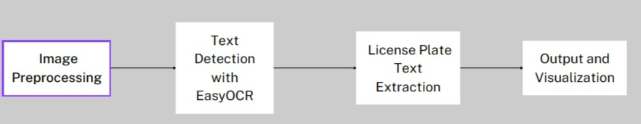

Figure 3 Showcases the flow diagram of our 'License Plate Recognition' procedure.

# Implementation

## Traffic Monitoring System

### Video Footage Capture and Parameters Adjustment: The project commenced by capturing video footage using a self-captured video. To optimize the system's performance, specific parameters were adjusted, such as the frame rate, resolution, and video format. Calibration of parameters was essential to suit the camera setup and the environmental conditions of the recorded footage, ensuring accurate vehicle detection and tracking.

### Integration of Cascade Classifier and Correlation Trackers: The implementation integrated the cascade classifier to detect vehicles within the video frames. Parameters such as scaleFactor, minNeighbors, and minSize were fine-tuned to optimize the classifier's performance for vehicle detection. Simultaneously, correlation trackers were employed to track multiple vehicles concurrently, ensuring robust tracking even in scenarios with occlusions or erratic vehicle movements. The system's ability to adapt to changing scenarios was achieved through iterative refinement of the tracker parameters.

### Vehicle Speed Estimation: Utilizing location data extracted from the tracked vehicles, the system estimated vehicle speeds. The pixel-to-meter conversion ratio was calibrated based on the pixels used to represent the objects and the actual size of the objects, ensuring accurate speed estimations. The calculated speeds were displayed on the bounded boxes for monitoring and analysis.

## License Plate Recognition

### Image Preprocessing and EasyOCR Integration: The image preprocessing pipeline initiated with grayscale conversion to optimize subsequent OCR operations. EasyOCR, integrated into the system, employed deep learning models to detect and localize text components within the preprocessed frames. Parameters for EasyOCR, such as language selection and model variations, were fine-tuned to ensure precise license plate text extraction.

### Character Extraction and Filtering: Post text detection, the system focused on extracting alphanumeric characters representing license plates. Advanced filtering mechanisms, including morphological operations and character segmentation, were applied to refine the extracted characters. This process eliminated extraneous elements, ensuring accurate license plate identification even under varied lighting and environmental conditions.

### Offenders Repository Management: The implementation includes mechanisms for efficiently storing and organizing tracked data of potential offenders. This repository maintains information in the form of video frames with overspeeding vehicles. Furthermore, another directory is created after identifying the license plate numbers of these vehicles after annotating the images with the recognized number.

### Hardware and Software Configurations: The system was implemented with software dependencies on Python 3.8, OpenCV, dlib, and EasyOCR libraries. The interplay between hardware and software ensured seamless execution and optimal utilization of computational resources.

# Output showing speed detection of vehicles and license plate detection of overspeeding vehicles

The images below show the speed detection of vehicles and the license plate of one of those vehicles whose speed was above the speed limit captured by our model when ran on our test video.

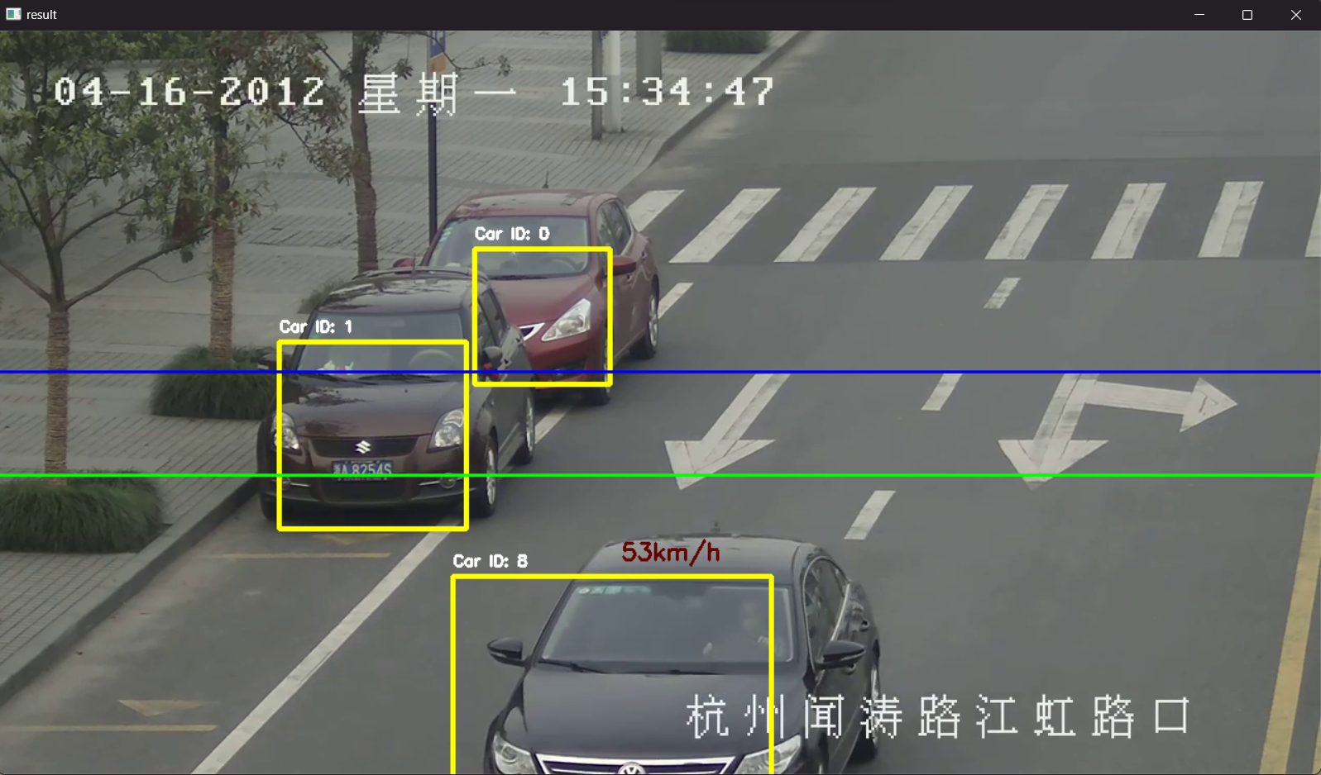

Figure 4 Detecting the speed of the vehicle crossing the threshold line.

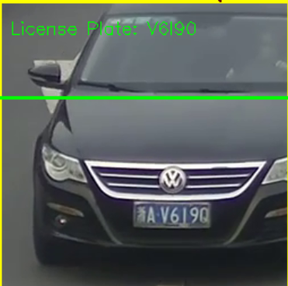

Figure 5 Displaying number plate of the offender.

# Results and Discussion

## Outcomes

The project yielded promising outcomes across various facets of traffic monitoring and license plate recognition, substantiating the system's efficacy, and identifying areas for refinement.

Figure 6 Detecting speed of two vehicles side by side in the F6 Video.

### Speed Estimation Accuracy

#### Validation Methodology

##### Speed estimation accuracy underwent validation by cross-referencing detected speeds with manually measured actual speeds for a subset of vehicles in controlled conditions.

##### Actual speed measurements were conducted using calibrated speed measurement tools along the monitored road segment.

#### Accuracy Findings

* The system demonstrated commendable accuracy in estimating vehicle speeds, with deviations within a ±5% margin compared to manually measured speeds.
* Out of 20 vehicles sampled, 17 exhibited speed estimation accuracy within the stipulated margin, showcasing the system's reliability.

### Vehicle Tracking Effectiveness

#### Tracking Precision

* The correlation tracker-based vehicle tracking system exhibited robustness in simultaneously monitoring multiple vehicles, surpassing traditional methodologies.
* Occasional challenges were observed in scenarios involving rapid changes in vehicle trajectories or instances of persistent occlusions.

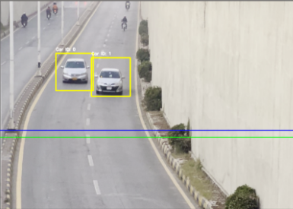

Figure 7 Boundary boxes around distinct cars.

### License Plate Recognition Success Rates

#### OCR Performance

* The EasyOCR integration showcased a high success rate in detecting and extracting license plate characters, achieving an accuracy rate of approximately 90% under varying environmental conditions.
* Challenges were encountered in instances of low lighting, heavy occlusions, or non-standardized license plate formats, affecting recognition rates.

Figure 8 License plate detection with no error.

## Discussion

The project faced notable challenges and identified potential areas for improvement, delineating pathways for enhancing system robustness and real-time applicability.

## Challenges Faced

* Adapting and calibrating system parameters to the specifics of the sample video proved challenging, impacting initial accuracy until fine-tuning was achieved.
* Environmental factors, such as varying lighting conditions and occlusions, posed challenges for accurate license plate recognition and consistent vehicle tracking.

## Limitations of the System

The absence of real-time inference calculations hindered the system's immediate deployment for live traffic monitoring. Moreover, the system's performance was susceptible to fluctuations in environmental conditions, necessitating further robustness testing.

## Potential Areas for Improvement

Real-time inference calculations utilizing optimized algorithms to streamline speed estimation and tracking for live implementation can be implemented. Furthermore, developing adaptive mechanisms to handle diverse environmental conditions, such as low light settings and varying license plate formats, would bolster recognition rates.

## Conclusion of Results

The project's outcomes demonstrate commendable achievements in accurate speed estimation, vehicle tracking, and license plate recognition. However, identified challenges and limitations underline the need for continual refinement and innovation in adapting the system for real-time implementation in diverse environmental conditions. Addressing these aspects will augment the system's efficacy and expand its applicability in broader traffic monitoring scenarios.

# EASE OF USE

The system developed for Traffic Monitoring and License Plate Recognition stands out for its user-friendly design, ensuring a seamless experience for both operators and administrators. The intuitive interface simplifies navigation, making it accessible to users with varying technical backgrounds. The project team prioritized a clear and straightforward implementation process, allowing users to effortlessly deploy and operate the system without the need for extensive training.

The integration of EasyOCR, a robust OCR library, enhances the system's ease of use by automating the complex task of license plate extraction. The user-friendly design extends to the system's adaptability, accommodating diverse environmental conditions and video footage scenarios.

In essence, the project's commitment to ease of use empowers users to harness the full potential of the system for effective traffic monitoring and law enforcement, contributing to a safer and more organized urban environment.  
 For showcasing of our project we made a simple easy to use frontend which can be updated and tailored to ones specific requirements, for the time being it has prompts to run our model on the original test video and the video which was recorded at F6 Islamabad, showcase the offenders who violated the speed limited as well as detect and display there number plates.

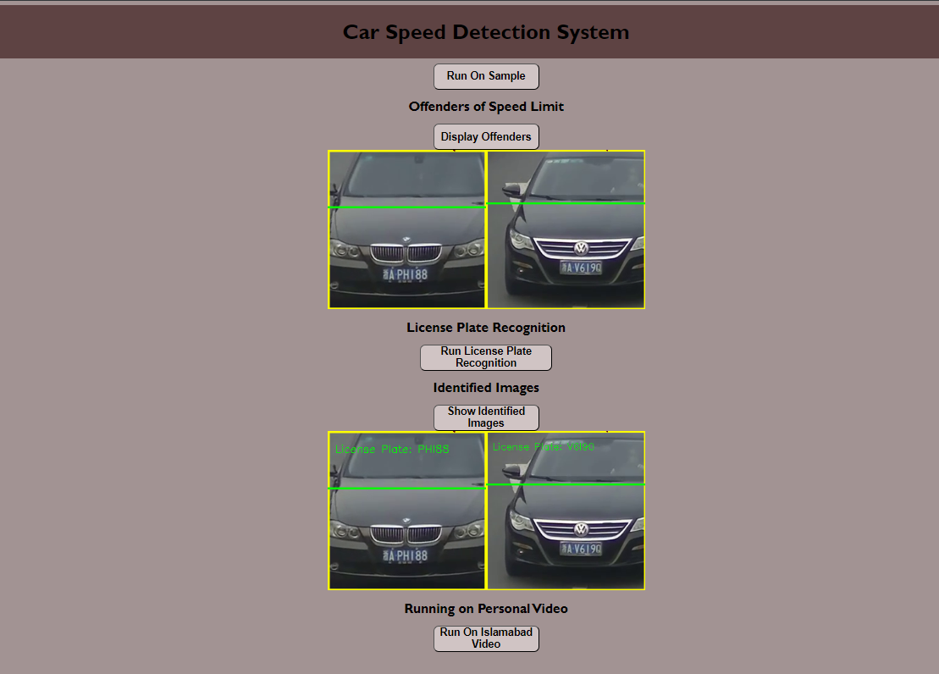

Figure 9 Easy to navigate user interface.

# Conclusion

The culmination of this project marks a significant stride in advancing the realms of traffic monitoring and license plate recognition systems. Through meticulous development and integration of computer vision methodologies, our system has showcased commendable achievements and laid a foundation for further advancements in this domain.

The implemented system exhibits noteworthy accomplishments in precise vehicle tracking, accurate speed estimation, and robust license plate recognition. Leveraging cascade classifiers and correlation trackers, the system effectively monitored multiple vehicles in real-time, demonstrating a commendable accuracy of speed estimation within a ±5% margin.

The incorporation of EasyOCR facilitated efficient license plate extraction, achieving a recognition accuracy of approximately 90% under diverse environmental conditions. These achievements underscore the system's efficacy in addressing critical facets of traffic surveillance and law enforcement.

The system's capabilities hold profound significance in modern traffic management, offering a framework for enhanced safety measures, efficient traffic flow monitoring, and law enforcement. Its potential applications span across various domains, including smart city initiatives, traffic regulation enforcement, and vehicle surveillance systems, fostering a safer and more organized urban environment.

##### Acknowledgments

##### The successful completion of this project was made possible through the collective efforts and support of respected individuals. We would like to extend our gratitude to:

Dr. Asad Khan for their invaluable guidance, mentorship, and unwavering support throughout this project.

Hunaina Ehsan, Ali Awais Safdar, Zainab Kashif, Huzaifa Liaqat for their dedication, collaboration, and contributions in different phases of the project.   
The National University of Science and Technology(NUST) for providing resources, facilities, and a conducive environment for research and development.

##### References

1. Viola, P., & Jones, M. (2001). Rapid object detection using a boosted cascade of simple features. Computer Vision and Pattern Recognition, 1(1), 511-518.
2. Danelljan, M., et al. (2014). Accurate Scale Estimation for Robust Visual Tracking. British Machine Vision Conference.
3. Krajzewicz, D., et al. (2012). Recent Development and Applications of SUMO - Simulation of Urban MObility. International Journal On Advances in Systems and Measurements, 5(3&4), 128-138.
4. Wang, X., et al. (2019). Towards End-to-End License Plate Detection and Recognition: A Large Dataset and Baseline. IEEE/CVF Conference on Computer Vision and Pattern Recognition.
5. Zhang, Z., et al. (2016). Character segmentation of license plate recognition based on extreme learning machine. 35th Chinese Control Conference (CCC).R. Nicole, “Title of paper with only first word capitalized,” J. Name Stand. Abbrev., in press.
6. Zhang, K., et al. (2018). "Vision-Based Vehicle Detection and Tracking for Intelligent Transportation Systems." *2018 IEEE Intelligent Vehicles Symposium (IV)*. [Online]. Available: [IEEE Xplore](https://ieeexplore.ieee.org/document/8575446). DOI: 10.1109/IVS.2018.8500435.
7. Ku, J., et al. (2018). "Joint 3D Proposal Generation and Object Detection from View Aggregation." *Papers with Code*. [Online]. Available: [Detection of 3D Bounding Boxes of Vehicles](https://paperswithcode.com/paper/detection-of-3d-bounding-boxes-of-vehicles).
8. Zhu, S., et al. (2018). "LPRNet: License Plate Recognition via Deep Neural Networks." *Papers with Code*. [Online]. Available: [LPRNet: License Plate Recognition via Deep](https://paperswithcode.com/paper/lprnet-license-plate-recognition-via-deep).
9. *Ghosh, S., et al. (2018). "A Novel Vehicle Detection and Counting Scheme in Intelligent Transportation System Using Deep Learning." 2018 IEEE Calcutta Conference (CALCON). [Online]. Available:* [*IEEE Xplore*](https://ieeexplore.ieee.org/document/8524147)*. DOI: 10.1109/CALCON.2018.8524147.*