**Software Requirements Specification**

**Document (SRS)**

Version 1.0

May 20, 2021

Store Management System

Obeda Al-Bitar

Amjad Bali

Muhammed Ali Bakkar

**Table of Contents**

**1. Introduction 3**

*1.1 Purpose 3*

*1.2 Scope 3*

*1.3 Definitions, Acronyms, and Abbreviations 3*

*1.4 References 4*

*1.5 Overview 4*

**2. The Overall Description 4**

*2.1 System Environment 4*

*2.2 Functional Requirement Specification 5* 2.2.1 Customer Use Case 5  
 Use Case: Create Account 5

2.2.2 Accountant Use Case 6

Use Case: Edit Product 6

Use Case: Calculate Seasonal Profit and Losses 7

2.2.3 Website Manager Use Case 8

Use Case: Add new Product to Website 8

*2.3 User Characteristics 9*

*2.4 Non-Functional Requirement 9*

**3. Specific Requirements 10**

*3.1 External Interfaces Requirements 10*

*3.2 Functions Requirements 10*

3.2.1 Create Account 10

3.2.2 Edit Product 10

3.2.3 Calculate Seasonal Profit and Losses 11

3.2.4 Add new Product to Website 11

*3.3 Detailed Non-Functional Requirements 12*

3.3.1 Logical Structure of the Data 12

3.3.2 Security 17

**1.Introduction**

**1.1 Purpose**

The purpose of this document is to describe the Managing System software. It will illustrate the purpose and complete declaration for the development of the system. It will also explain system constraints, interface, and interactions with other external applications. This document is primarily intended to be proposed to a customer for its approval and a reference for developing the first version of the system for the development team.

**1.2 Scope**

The software system will be a store management System. It will be designed to assist the Accountant to store buying and selling bills (date, customer name, supplier name, price, product, quantity) in the store and be able to save and edit the data in a local database, the application should store outlays and employees' salaries, the system must calculate profits and losses at the end of each season, and the system must update the prices of the products every day.

The system also must have a website, the customers should be able to create an account on the Website, and browse the products with details (price, available quantities, types, pictures) also the Website has the capability of presenting both summary and detailed information about the store.

**1.3 Definitions*, Acronyms, and Abbreviations.***

|  |  |
| --- | --- |
| ***Term*** | ***Definition*** |
| *Customer* | *Someone who interacts with the Website* |
| *Website manager* | *A person who manages the Store website* |
| *Database* | *Collection of all the information monitored by this system* |
| *Accountant* | *A person who manages the financial part of the system* |
| *Software Requirements Specification* | *A document that completely describes all of the functions of a proposed system and the constraints under which it must operate. For example, this document.* |
| *Stakeholder* | *Any person with an interest in the project who is not a developer.* |
| *SQL-Server* | *A software that is used for managing databases created by Microsoft.* |
| *Oracle* | *A software that is used for managing databases created by Oracle.* |
| *Https* | *A way used to connect to the internet with good security.* |

**1.4 References**

[1] IEEE Software Engineering Standards Committee, “IEEE Std 830-1998, IEEE Recommended Practice for Software Requirements Specifications”, October 20, 1998.

**1.5 Overview**

The next chapter, the Overall Description section, of this document gives an overview of the functionality of the product. It describes the informal requirements and is used to establish a context for the technical requirements specification in the next chapter.

The third chapter, Requirements Specification section, of this document is written primarily for the developers and describes in technical terms the details of the functionality of the product.

Both sections of the document describe the same software product in its entirety, but are intended for different audiences and thus use different language.

**2. The Overall Description**

**2.1 System Environment**

The system has three actors

The customer accesses the products through the internet.

The Website manager will edit product pages on the website.

The Accountant accesses the system directly.

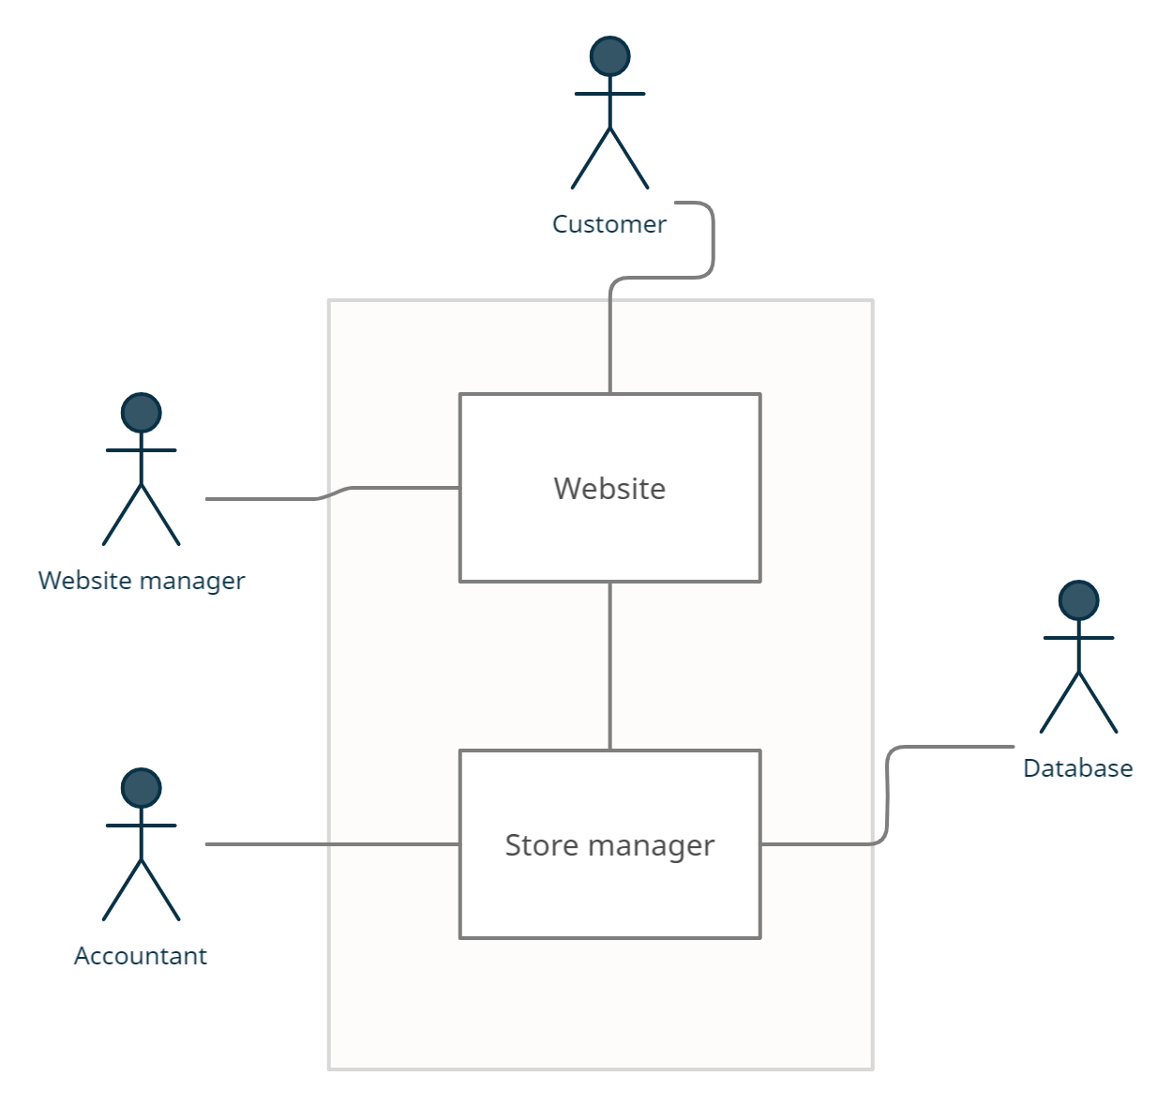

**2.2 Functional Requirement Specification**

This section outlines the use cases for each of the active readers separately., the Customer and the internet have one use case, while the Accountant and the Employee are the main actors in this system

**2.2.1 Customer Use Case**

Use Case: **Create account.**

**Diagram:**

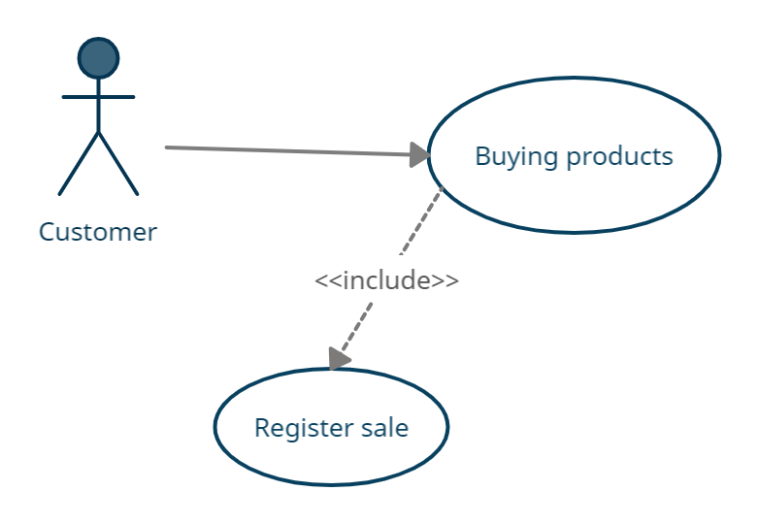

**Brief Description**

The Customer buys a product online, and the system will register the sale.

**Initial Step-By-Step Description**

Before this use case can be initiated, the Customer has already connected to the store website.

1. The Customer goes to the products page.

2. The Customer clicks on the purchase button.

3.The Customer enters his personal information and sends his information to the system.

4. The System checks if the Customer is already existing in the system.  
5. The System accepts the information and registers the sale.

**2.2.2 Accountant Use Case**

Use Case: **Register a Receipt.**

**Diagram:**

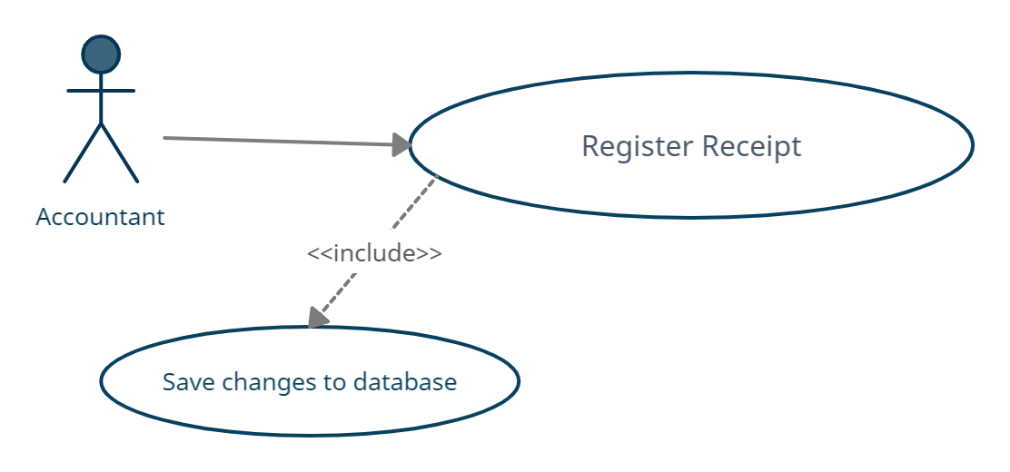

**Brief Description**

The Accountant enters a receipt data, and the system will save changes to Database.

**Initial Step-By-Step Description**

1. A Product must be sold or bought.

2. The Accountant will enter the Receipt details and select its type.

3.The System will update the details on the Database

Use Case: **Calculate seasonal profits and losses.**

**Diagram:**

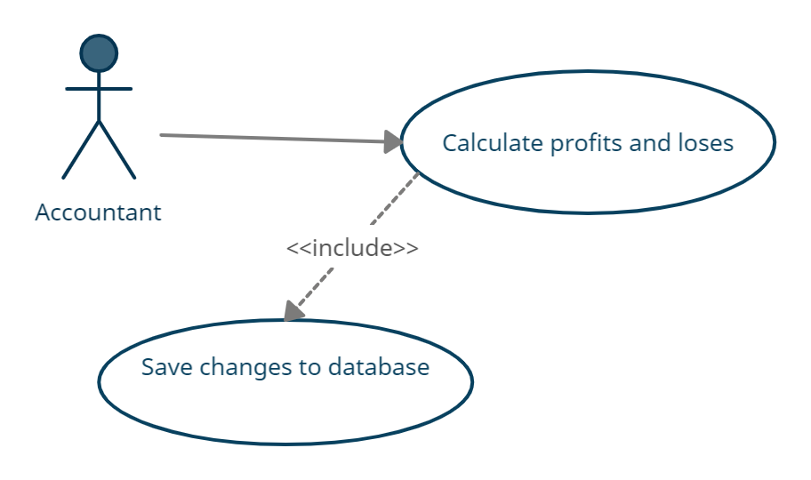

**Brief Description**

The Accountant will match the inventory with records then will calculate profits and losses.

**Initial Step-By-Step Description**

1. The Accountant checks if the records match the database records.

2. The Accountant will enter the result into the system.

3. The System will calculate profits and losses.

**2.2.3 Website Manager Use Case**

Use Case: **Add new products to the website :**

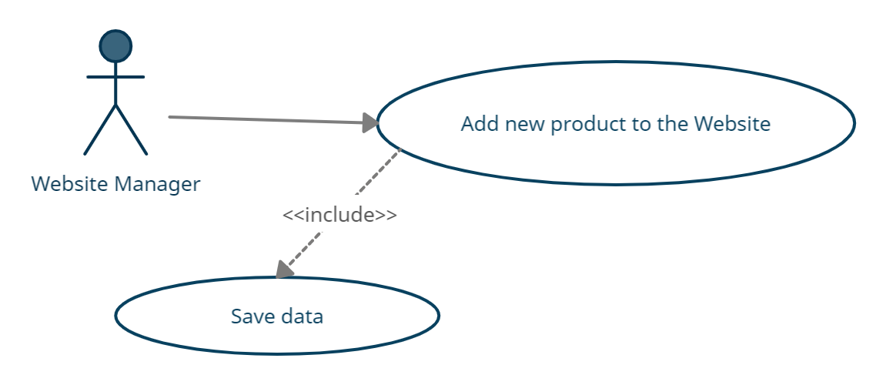

**Brief Description**

The Website Manger will Add new products to the website

**Initial Step-By-Step Description**

1.The Website Manager will add new products to the website

2.the he will update the website on the server

**2.3 User Characteristics**

The Customer expected to be Internet literate and be able to use a search engine.

The main screen of the Store Website will have the search function and a link toproductdetails.

The Accountant is expected to have a degree in economics and be Internet literate.

The website Manager is expected to be literate in web development.

**2.4 Non-Functional Requirements**

The system could work in a local network where the PCs are connected with each other locally.

The Database should use SQL-Server or Oracle.

The store website should use HTTPS protocol.

The operation system on the store PCs should run on Windows.

**3. Requirements Specification**

**3.1 External Interfaces Requirements**

The external link in the system is to the database every process in the system or the website should interact with the database, when the accountant add a new receipt the receipt should be saved in the database, when the customer buy from the website his

the receipt information saved in the database.

**3.2 Functional Requirement**

**3.2.1 Register a Receipt**

|  |  |
| --- | --- |
| **Use Case Name** | *Register* *Receipt* |
| **Trigger** | *The Customer buys a product, or the owner buys a new product.* |
| **Precondition** | *The Accountant must sign in to the system.* |
| **Basic Path** | *1.The Accountant will select the bill type (buy or sell).*  *2.The Accountant will enter the bill data and save it.* |
| **Alternative Path** | *In the event of a return of the goods, the Receipt will be modified.* |
| **Post Condition** | *The Receipt must be printed.* |
| **Exception Paths** | *Cancel the Receipt register* |
| **Other** | *None* |

**3.2.2 Create Account**

|  |  |
| --- | --- |
| **Use Case Name** | *Create Account* |
| **Trigger** | *The Customer wants to buy a product from the Website for the first time.* |
| **Precondition** | *The Customer must enter the sign-up page on the Website* |
| **Basic Path** | *1.The Customer must enter his email.*  *2.A password.*  *3.username.*  *4.phone number.*  *5.choose a payment method.*  *6.then, the Website has to validate the data.*  *7.then save it to Database.* |
| **Alternative Path** | *Log in with an old account* |
| **Post Condition** | *The Customer can buy products online.* |
| **Exception Paths** | *The Account is already created.* |
| **Other** | *None.* |

**3.2.3 Calculate Profits and Losses**

|  |  |
| --- | --- |
| **Use Case Name** | *Calculate Profits and Losses.* |
| **Trigger** | *End of each season.* |
| **Precondition** | *All receipts must be entered before the calculation starts.* |
| **Basic Path** | *1.Enter all products which are actually in the store.*  *2.compare it to the Database.*  *3.calculate all sales during the season.* |
| **Alternative Path** | *None.* |
| **Post Condition** | *Print all details of the calculation.* |
| **Exception Paths** | *None.* |
| **Other** | *This process can be delayed.* |

**3.2.4 Add new Products to the Website**

|  |  |
| --- | --- |
| **Use Case Name** | *Add new products to the Website.* |
| **Trigger** | *Add new products to the Database.* |
| **Precondition** | *All receipts must be entered before the calculation starts.* |
| **Basic Path** | *1.Select the new products which are not added to the Website.*  *2.add a page to each product with its details.*  *3.Save edits to the Website.* |
| **Alternative Path** | *Add a new product to the Website before it reaches the store.* |
| **Post Condition** | *Update the Website on the server.* |
| **Exception Paths** | *None.* |
| **Other** | *Add wrong details.* |

## 3.3 Detailed Non-Functional Requirements

**3.3.1 Logical Structure of the Data**

The logical structure of the data to be stored in the internal store management system database is given below**.**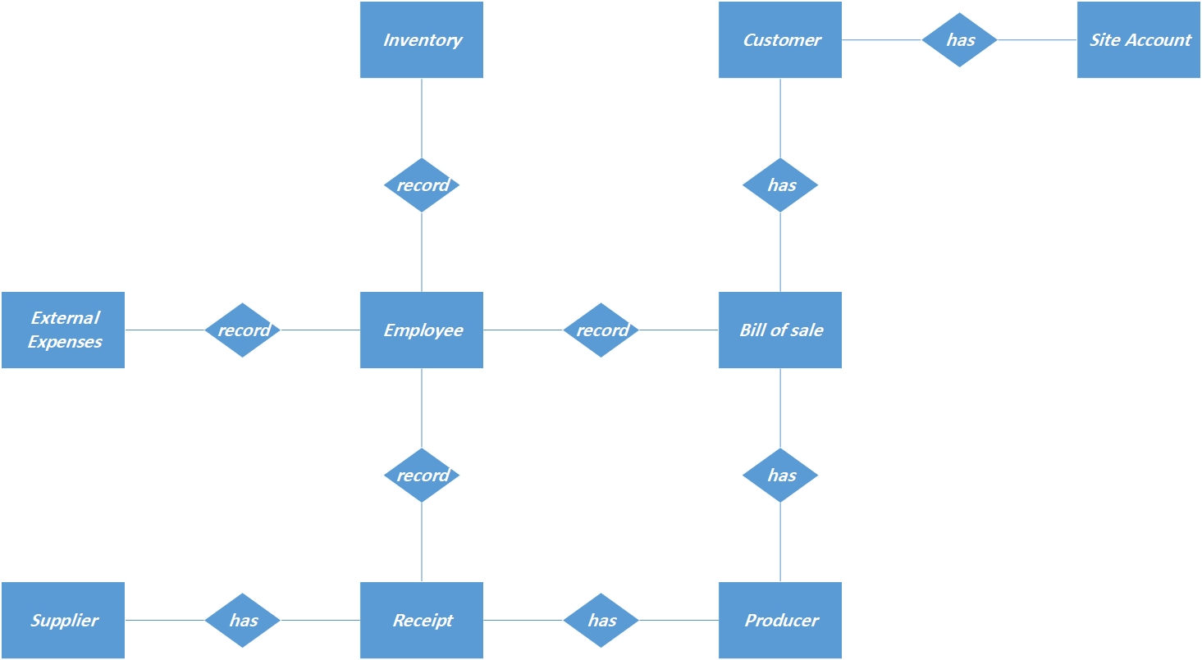

***Figure-Logical Structure of the Store Management System***

**The data descriptions of each of these data entities is as follows:**

**Employee Entity:**

|  |  |  |
| --- | --- | --- |
| **Data Item** | **Type** | **Description** |
| id | Number | ID Number of Employee |
| name | Text | Employee Name |
| salary | Number | Employee Salary |
| Specialty | Text | An Employee Specialty is an example (Worker or Accountant) |
| Phone number | Text | Employee Phone Number |

**Receipt Entity:**

|  |  |  |
| --- | --- | --- |
| **Data Item** | **Type** | **Description** |
| id | Number | A Number for the purchase invoice |
| Type | Text | Type of invoice |
| Date | Date | The Date of the invoice |
| Total Value | Number | The total invoice price |
| Remain Value | Number | The price paid from the invoice |

**Bill of Sale Entity:**

|  |  |  |
| --- | --- | --- |
| **Data Item** | **Type** | **Description** |
| id | Number | A Number for the sales invoice |
| Type | Text | Type of invoice |
| Date | Date | The Date of the invoice |
| Total Value | Number | The total invoice price |
| Remain Value | Number | The price paid from the invoice |

**Client Entity:**

|  |  |  |
| --- | --- | --- |
| **Data Item** | **Type** | **Description** |
| id | Number | Client private ID |
| Name | Text | Client Name |
| Phone number | Number | Client Phone Number |
| Total Value | Number | The total invoice price |
| Remain Value | Number | The price paid from the invoice |

**Account Entity:**

|  |  |  |
| --- | --- | --- |
| **Data Item** | **Type** | **Description** |
| id | Number | Client private ID on the site |
| User Name | Text | Client username |
| Password | Number | Password |
| Email | Text | Email |
| Image | Image | Image |
| Payment Method | Text | How to pay bills |

**Supplier Entity:**

|  |  |  |
| --- | --- | --- |
| **Data Item** | **Type** | **Description** |
| id | Number | A number for the product supplier |
| Name | Text | Name of Supplier |
| Phone number | Number | Supplier Phone Number |
| Email | Text | Supplier Email |
| Total Value | Number | The total invoice price |
| Remain Value | Number | The price paid from the invoice |

**Producer Entity:**

|  |  |  |
| --- | --- | --- |
| **Data Item** | **Type** | **Description** |
| id | Number | Product number |
| Name | Text | Product name |
| Type | Text | Product type |
| Amount | Number | The quantity of the product |
| Image | Image | A picture of the product |
| Purchasing Price | Number | Product purchase price |
| Selling Price | Number | Product sell price |

**Inventory Entity:**

|  |  |  |
| --- | --- | --- |
| **Data Item** | **Type** | **Description** |
| id | Number | Inventory number |
| Date | Date | The Date of inventory |
| Budget | Number | Budget after doing your inventory is an example (loss or profit) |

**External Expenses Entity:**

|  |  |  |
| --- | --- | --- |
| **Data Item** | **Type** | **Description** |
| id | Number | External Expenses Number |
| Name | Text | External Expenses name |
| Type | Text | External Expenses type |
| Price | Number | External Expenses price |

**3.3.2 Security**

The server on which the Store website will have its own security to prevent unauthorized write/delete access ,There is no restriction on read access.

The website should have an authentication system to prevent identity theft.

The payment system on the Store Website should be on an external system.

The Store manager should also have an authentication and authorization system built internally in it to prevent any mistake in the system.