**NLP Steps:**

* Data Acquisition (collection)
* Text Preparation
  + Text cleanup
  + Basic preprocessing
  + Advance Preprocessing
* Feature Engineering
  + (tf-idf)
  + Bag Of Words (BOW)
  + (word2vec)
  + Glove
  + Etc
* Modeling
  + Model building
  + Evaluation
* Deployment
  + Monitoring
  + Model Update

**Data Acquisition**

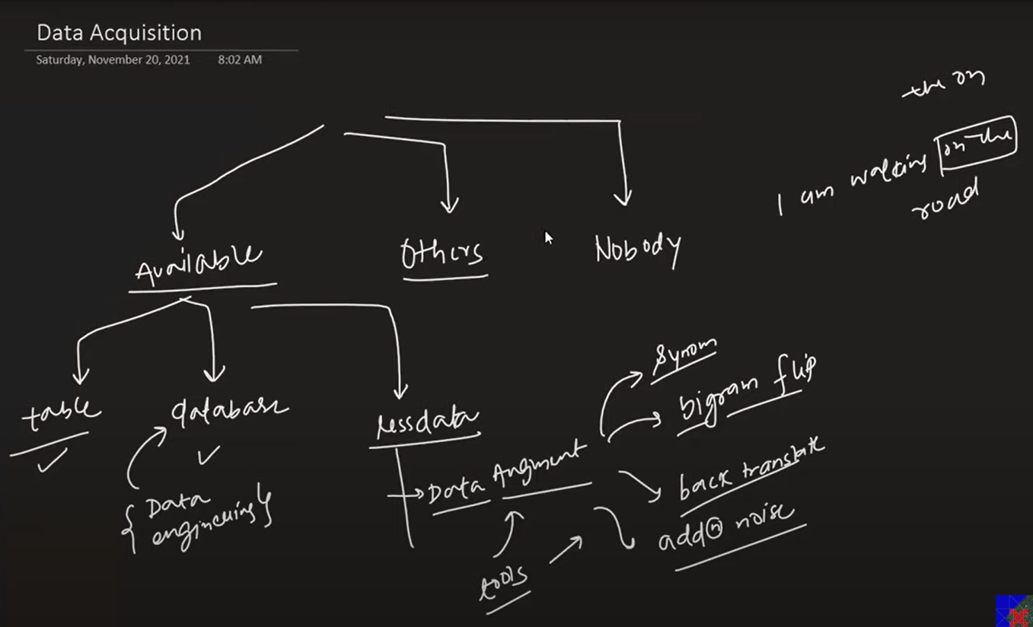

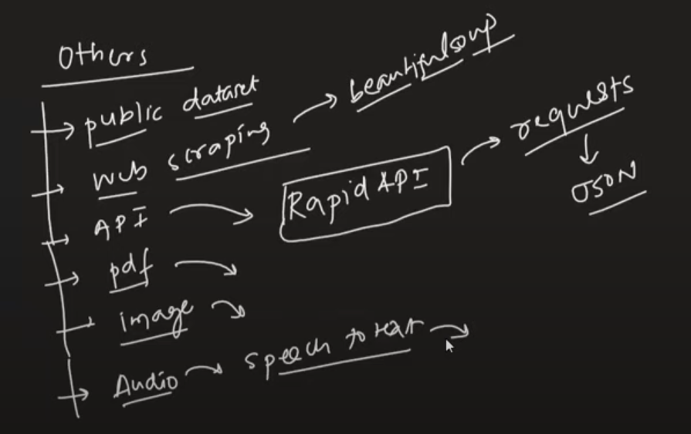

**Text Preprocessing**

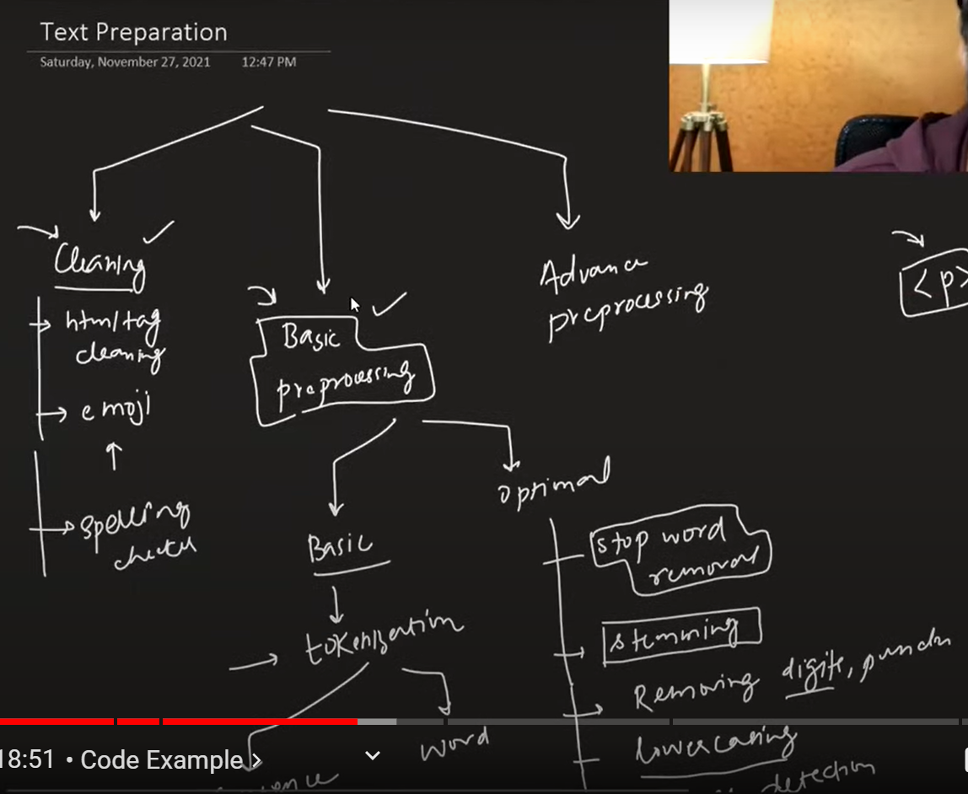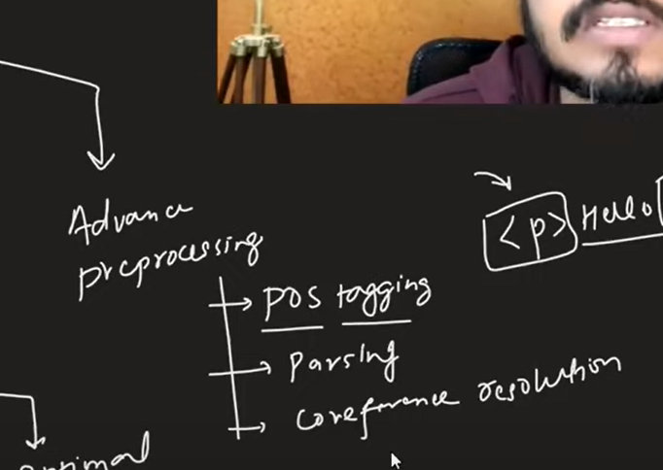

**Feature Engineering**

Creating Features from domain knowledge expanding columns of datasets.

**Modeling**

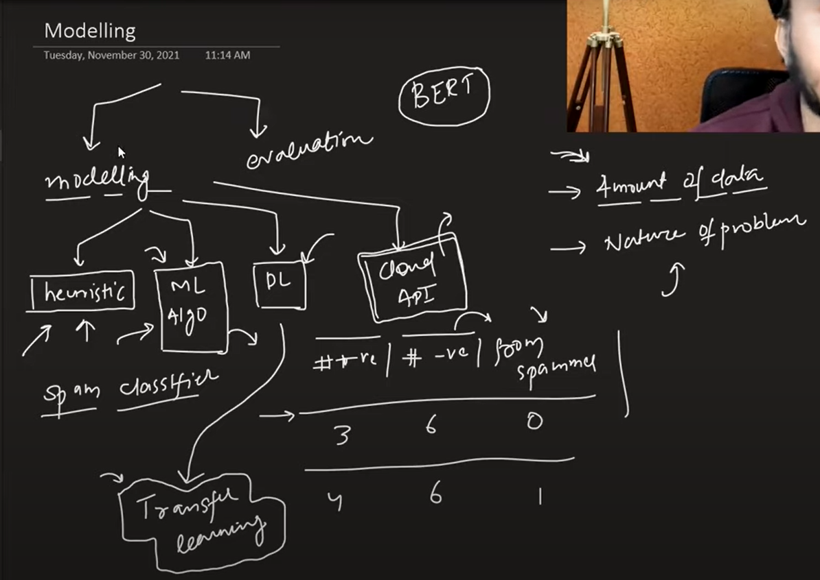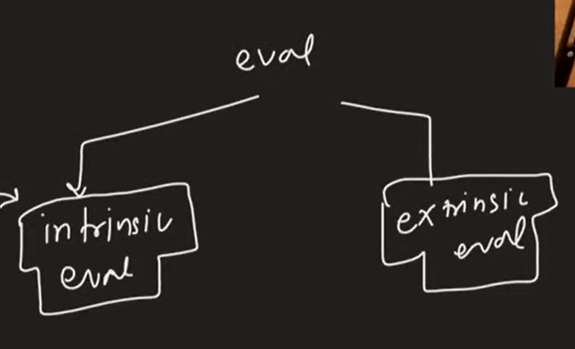

**Deployment**

