Source Analysis
This document explains what the business asked for and what data the sources give us. Read it first: the other documents build on it.

1 What the business wants
The company runs a B2B platform. Client companies use it to buy products from suppliers for their own customers. The business wants a data warehouse that answers three questions:
# | Question | Where the answer is
R1 | What are the top 5 devices our clients use? | mart.mart_top_devices
R2 | In the country with the most logins, which products sell best? | mart.mart_top_products_top_country
R3 | What were the total sales per month over the last year? | mart.mart_monthly_sales
The answers must be correct, the same every time the data is the same, and easy to check down to single rows.

2 What the system must do
# | The system must | How it does it
1 | Copy the B2B database into the warehouse | pipeline/extractor.py
2 | Read the web server log and keep only the IP, user, time and browser | pipeline/log_parser.py
3 | Store the data in a form that is easy to report on | A star schema (dw) and report views (mart)
4 | Cope with large data | Data is streamed in, never held in memory all at once
5 | Never lose a bad row without a trace | Bad rows are saved in etl.rejected_rows with the reason
6 | Restart after a failure | Each step is saved on its own; a new run continues or starts over
7 | Load everything once, then only what changed | Full load and incremental load
8 | Record what every run did | The etl tables
9 | Keep old versions of companies, products and customers | History tables (SCD type 2)
10 | Show the answers on a dashboard | Metabase
11 | Keep testing apart from the live numbers | Two warehouses: DEV and PROD
Two more rules apply to the whole project: every step can be run twice and give the same result, and everything can be rebuilt from zero with one command.
Not included: which page a visitor opened, exact location from an IP address (a small lookup file is used instead), and real-time loading.

3 The sources
The brief gives two sources:
Source | What it is | Where | Size
B2B platform database | PostgreSQL database with the companies, products and orders | Database b2b_source, schema b2b | 1,200 orders, 3,027 order lines
Web server log | A text file with one line for every page opened on the website | ~/b2b_weblogs/access.log | 10,610 lines
We add one small lookup file of our own: sources/csv/ip_country.csv (20 rows). The log has an IP address but no country, and report R2 needs the country. The file turns an IP address into a country (see section 7). It is reference data we keep ourselves, not a source the business sends.
The data is generated by the scripts in seed/ with a fixed random seed (42), so every rebuild makes the same rows. Dates are set relative to the day of the build, so monthly totals change with the build date, but the counts in these documents do not.

4 How the source tables connect
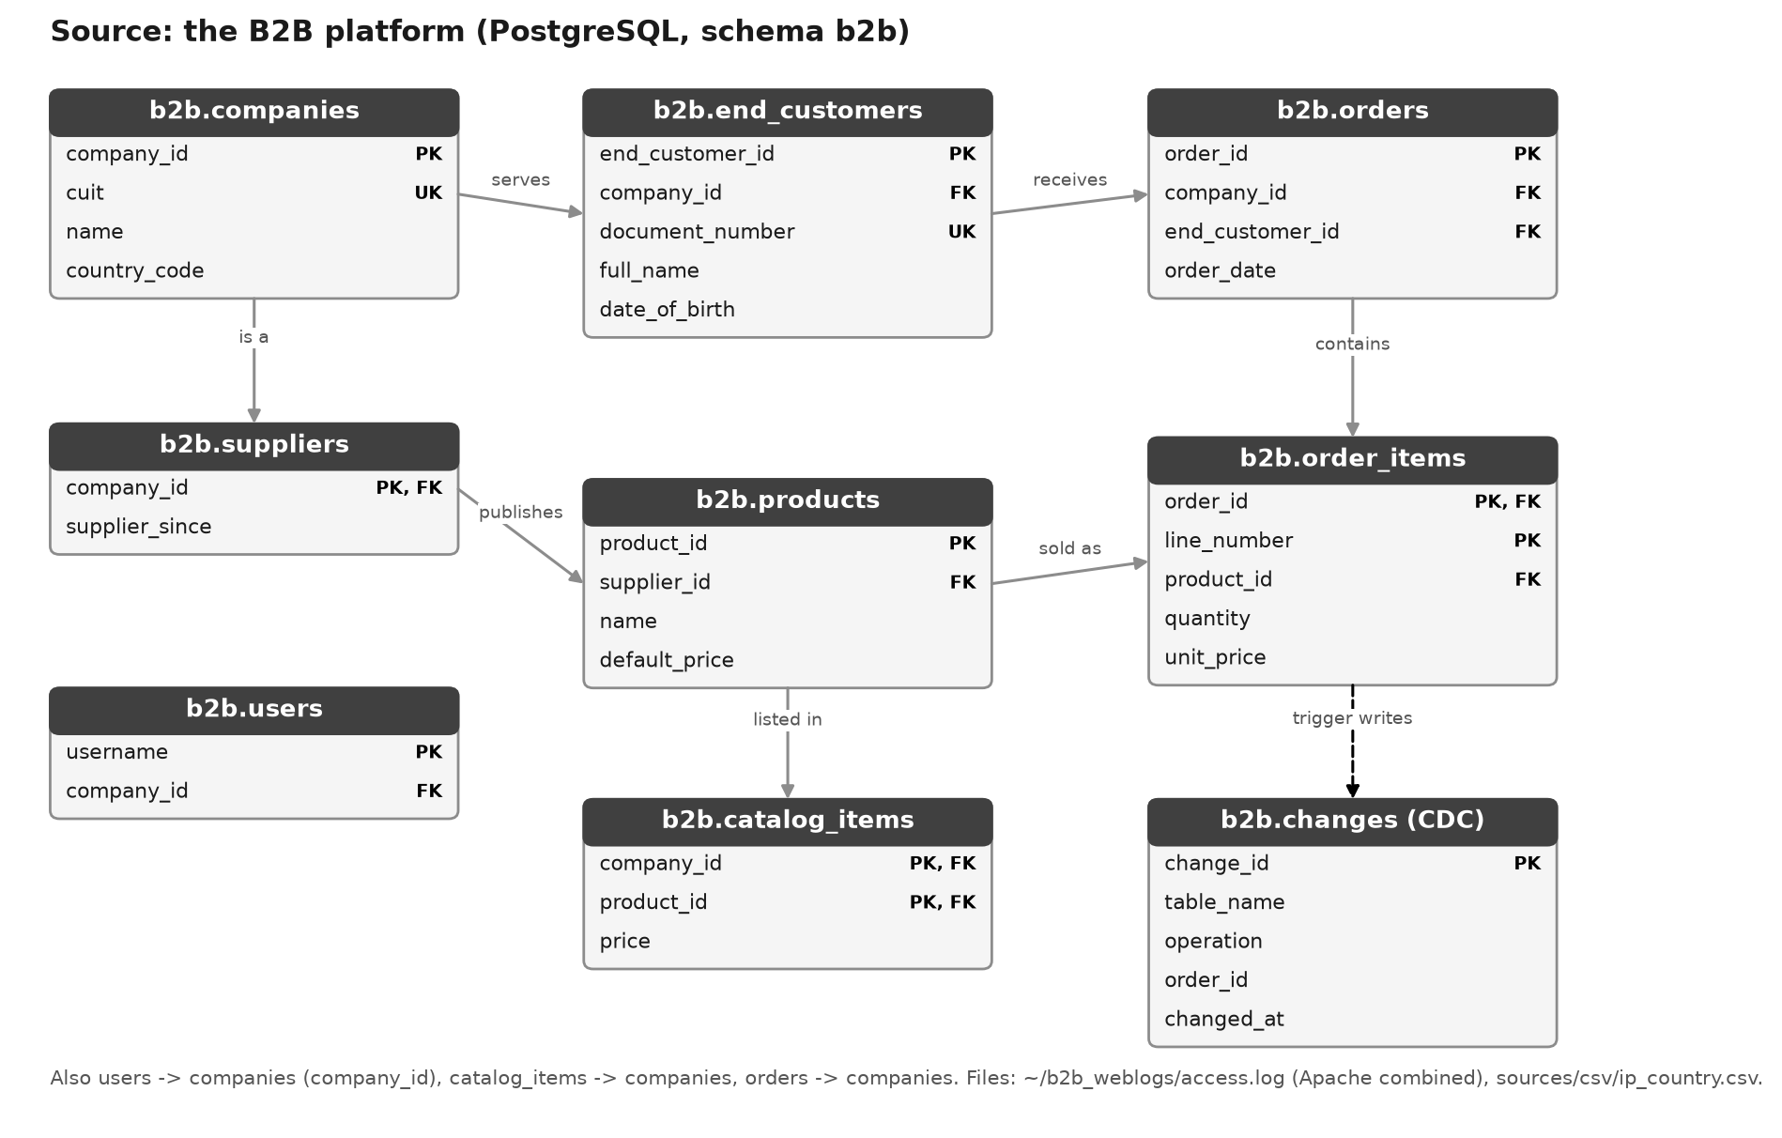
Figure 1 - The source tables and how they connect
In plain words:
- A company has many end customers, website users and orders.
- A supplier is a company that also sells products. The first 5 companies are suppliers.
- Each company has its own price list (catalog_items): which products it sells, and at what price.
- An order belongs to one company and one end customer. It has one or more order lines.
- Each order line is one product, with a quantity and the price paid.
- b2b.changes is filled automatically: every time an order or order line is added, changed or deleted, a trigger writes one row. The incremental load reads it to find what changed.

5 The source tables
Table | One row is | Rows | Key | Other columns
b2b.companies | one client company | 30 | company_id | cuit, name, country_code
b2b.suppliers | one company that also sells products | 5 | company_id | supplier_since
b2b.end_customers | one person who receives the goods | 150 | end_customer_id | company_id, document_number, full_name, date_of_birth
b2b.products | one product, with its list price | 60 | product_id | supplier_id, name, default_price
b2b.catalog_items | one product on one company's price list | 450 | company_id + product_id | price
b2b.orders | one order | 1,200 | order_id | company_id, end_customer_id, order_date
b2b.order_items | one line of an order | 3,027 | order_id + line_number | product_id, quantity, unit_price
b2b.users | one website login name | 60 | username | company_id
b2b.changes | one change to an order or an order line | 4,227 | change_id | table_name, operation, order_id, changed_at
Every column, with its type and meaning, is in 04 Source-to-Target Mapping (sheet Data Dictionary).

6 The web server log
Every time someone opens a page, the web server writes one line like this:
181.20.3.44 - user007 [10/Oct/2025:13:55:36 -0300] "GET /catalog HTTP/1.1" 200 5123 "-" "Mozilla/5.0 (iPhone; ...)"
We keep four parts of each line and ignore the rest:
Part | Example | Why we keep it
IP address | 181.20.3.44 | Tells us the country
Username | user007 | Tells us the user, and so the company
Time | 10/Oct/2025:13:55:36 -0300 | Tells us when, and lets us group pages into logins
Browser text (user agent) | Mozilla/5.0 (iPhone; ...) | Tells us the device
What is a login? The log has no login page, so we count visits. A visit is all the pages one user opens without a break of more than 30 minutes. Example: user007 opens 5 pages between 10:00 and 10:12, then comes back at 15:00. That is 2 logins.
From log lines to logins (fresh build):
Step | Lines
Lines in the file | 10,610
- broken lines (cut off), refused | 106
= lines loaded | 10,504
- visitors who did not log in (username '-'), left out | 966
- username that does not exist (ghost_user), refused | 202
- users of a refused company, refused | 323
= good lines | 9,013
Grouped into logins | 2,548

7 The IP to country file
The file links the first number of an IP address to a country. For example, 181 means Argentina. It covers 10 countries: Argentina, Brazil, Chile, Colombia, Spain, Mexico, Peru, Paraguay, United States, Uruguay. An IP whose first number is not in the file gets the country Unknown (code XX). In the fresh build this happens to 145 lines. A real project would use a proper IP location database.

8 Problems found in the data
The sources contain bad data on purpose, so we can show that the warehouse finds it.
Problem | Table | Rows | What the warehouse does
Tax number (CUIT) is not 11 digits | companies | 1 | Refuses the company and everything that belongs to it
Document number is missing | end_customers | 2 | Refuses the person
List price is missing | products | 1 | Refuses the product
List price is below zero | products | 2 | Refuses the product
Company price is zero | catalog_items | 4 | Refuses the price
Order date is missing | orders | 12 | Refuses the order
Order date is in the future | orders | 12 | Refuses the order
Quantity is zero | order_items | 30 | Refuses the line
Price is missing | order_items | 30 | Refuses the line
Log line is cut off | web log | 106 | Refuses the line
Username does not exist | web log | 202 | Refuses the line
IP is not in the lookup file | web log | 145 | Keeps the line with country Unknown
A bad row is never deleted. It is saved in etl.rejected_rows with the reason. A row that depends on a refused row is refused too.
Example: company 30 has the tax number "30-30-X". The company is refused, and so are its 5 end customers, its 46 orders, its price list and the 323 log lines of its users. Each is saved with the reason "company was rejected".
A check after every load proves that nothing went missing: for every table, rows in = good rows + refused rows. Every rule is listed in 04 Source-to-Target Mapping (sheet Reject Rules).

9 Assumptions
Question | What we assumed
What is a login? | One visit: a user's pages with no break longer than 30 minutes
Which country is a login from? | The country of the visitor's IP address
Which country is a sale from? | The country of the company that ordered, as it was on the order day
What is the most popular product? | The one with the most units sold
What is the last year? | The last 12 full months. The current month is left out because it is not finished
Which time zone? | Buenos Aires time for all business dates
How do we find changed orders? | The source has no 'last changed' column, so a trigger records every change to orders and order lines

10 Words used in these documents
Word | Meaning
Raw | The first layer: an exact copy of the source, every column stored as text
Staging | The second layer: rows that passed the checks, with proper types (numbers, dates)
dw (star schema) | The third layer: fact and dimension tables, built for reporting
Mart | The last layer: views that give each report its answer
Fact | A table of things that happened, with numbers. Example: sales
Dimension | A table that describes a fact: who, what, when, where. Example: product
Grain | What one row of a table means. Example: one order line
SCD type 2 | A way to keep old versions of a row, each with a 'valid from' and 'valid to' date
CDC | Change data capture: recording what was added, changed or deleted, so only that is loaded
Watermark | A bookmark: how far a table has been loaded
CUIT | The Argentine tax number of a company (11 digits)
DEV / PROD | The test warehouse and the live warehouse

