Logical Model
This document shows how the data is organised for reporting, without database details. Those are in 03 Physical Model.

1 The idea in short
The warehouse uses a star schema. It has two kinds of tables:
- A fact table records something that happened, with numbers. Example: a sale.
- A dimension table describes it: who, what, when and where. Example: the company, the product and the day.
Each fact row points to one row in each of its dimensions. Drawn on paper, the facts sit in the middle with the dimensions around them, like a star. This shape keeps report queries short: a fact joins straight to the things that describe it.
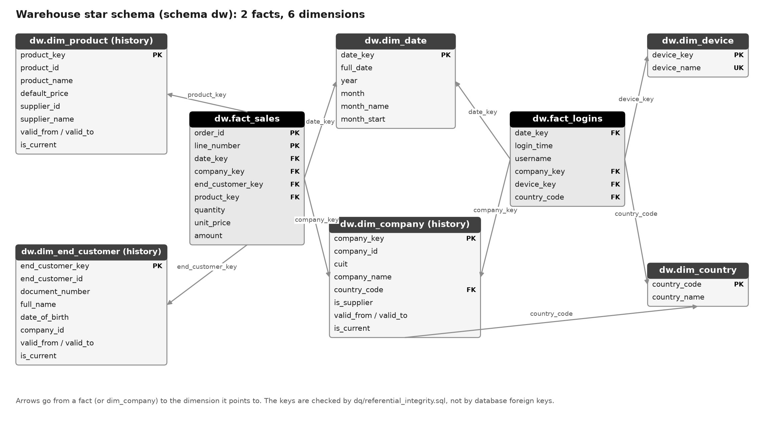
Figure 1 - The star schema: 2 facts in the middle, 6 dimensions around them

2 The two facts

2.1 Sales (fact_sales)
One row = one order line, that is, one product on one order. This is the most detailed level the source has, so any total can be built from it: per day, per month, per company or per product.
Example: an order with two lines becomes two rows (made-up values):
Order | Line | Day | Company | Product | Quantity | Price paid | Amount
100 | 1 | 2026-05-03 | Austral Supplies S.A. | Steel Bolt | 5 | 30.00 | 150.00
100 | 2 | 2026-05-03 | Austral Supplies S.A. | Basic Cable | 2 | 48.00 | 96.00
In the real table, day, company and product are stored as keys that point to the dimensions. The numbers are quantity, unit_price (the price paid) and amount = quantity x unit_price. Rows in a fresh build: 2,567.

2.2 Logins (fact_logins)
One row = one login, that is, one visit of a logged-in user. The web log has one line per page, so the lines are grouped: a new login starts when the user's previous line is more than 30 minutes older. The login keeps the time, device and country of its first line.
Example: user007 opens pages at 10:00, 10:05 and 10:12, then again at 15:00. That gives 2 rows in fact_logins: one at 10:00 and one at 15:00.
The number we count is simply the rows (logins). Rows in a fresh build: 2,548.

3 The six dimensions
Dimension | One row is | Example | Keeps old versions? | Rows
dim_date | one calendar day | 2026-05-03, May, 2026 | no | 4,018
dim_country | one country | AR Argentina; XX Unknown | no | 11
dim_company | one version of a client company | Austral Supplies S.A., AR | yes | 29
dim_product | one version of a product | Basic Tape, list price 24.57 | yes | 57
dim_end_customer | one version of a person who receives goods | Maria Gomez | yes | 143
dim_device | one kind of device | iPhone, Windows PC | no | 8
There are 29 companies and not 30 because company 30 was refused for a bad tax number. Products and end customers are fewer for the same reason: refused rows do not reach the warehouse.
The calendar runs from 2020-01-01 to 2030-12-31. The devices are: Android Phone, Android Tablet, iPad, iPhone, Linux PC, Mac, Other, Windows PC.

4 Which fact uses which dimension
Dimension | Sales | Logins
Date | the order day | the login day
Company | the company that ordered | the company of the user
Country | the country of the company | the country of the IP address
Product | the product sold | -
End customer | the person who receives the goods | -
Device | - | the device of the visit
Date, company and country are shared by both facts, so sales and logins can be compared. For example: logins and sales of the same company in the same month.

5 How the tables connect
From | Points to | Using
fact_sales | dim_date | date_key
fact_sales | dim_company | company_key
fact_sales | dim_end_customer | end_customer_key
fact_sales | dim_product | product_key
fact_logins | dim_date | date_key
fact_logins | dim_company | company_key
fact_logins | dim_device | device_key
fact_logins | dim_country | country_code (from the IP)
dim_company | dim_country | country_code (the company's country)
Every link is "many to one": many sales can point to the same product.
The database does not enforce these links with foreign keys, because the tables are emptied and refilled on every run and foreign keys would get in the way. Instead, a check (dq/referential_integrity.sql) tests all nine links after every load and stops the run if any row points nowhere.

6 Keeping history
Some things change. A company gets a new name; a product gets a new price. We want an old sale to show what was true on the day of the sale. So for company, product and end customer we keep every version. This is called a slowly changing dimension, type 2 (SCD 2).
Example: the price of product 1 went up by 10%. The table now holds two versions:
product_key | product_id | name | list price | valid_from | valid_to | is_current
1 | 1 | Basic Tape | 24.57 | 1900-01-01 | 2026-10-22 | no
58 | 1 | Basic Tape | 27.03 | 2026-10-22 | 9999-12-31 | yes
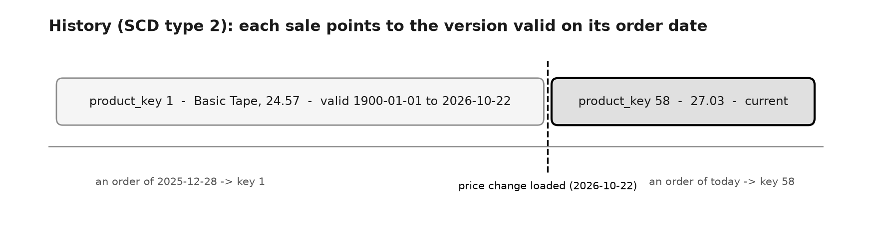
Figure 2 - Each sale points to the version that was valid on its day
The rules:
- On each load, compare the current version with the source.
- If something changed, close the current version (valid_to = today) and add a new one (valid_from = today, valid_to = 9999-12-31).
- The first version starts on 1900-01-01, so it also covers old orders.
- Each sale points to the version that was valid on its order day. A sale from December 2025 points to key 1; a sale from today points to key 58.
The price actually paid is stored on the order line (unit_price), so amounts never depend on this history. Date, country and device keep no history: a day never changes, and countries and devices are fixed lists.

7 How the three reports are answered
R1 - Top 5 devices: count the logins per device and keep the 5 biggest.
R2 - Best products in the top login country:
- Count the logins per country (from the IP address) and pick the biggest. Unknown is not allowed to win.
- Take the sales of companies from that country.
- Add up the units sold per product and keep the 5 biggest.
R3 - Sales per month, last year: add up the amount per month for the last 12 full months. The current month is left out because it is not finished.

8 Main design choices
Choice | Why
Keep the most detailed level in both facts | Any total can be built from it; a new report needs no new table
A login is a visit with a 30-minute gap | The log has no login page; a visit is the closest thing to a login
New warehouse keys for the dimensions with history | The source id repeats once per version, so it cannot be the key
Two meanings of country | R2 asks for the country with the most logins (IP) and then its sales (the company's country)
Links checked by a test, not by foreign keys | The tables are emptied and refilled on every run

