Development
This document explains how the pipeline is built, and how to run it, release it and look after it.

1 The big picture
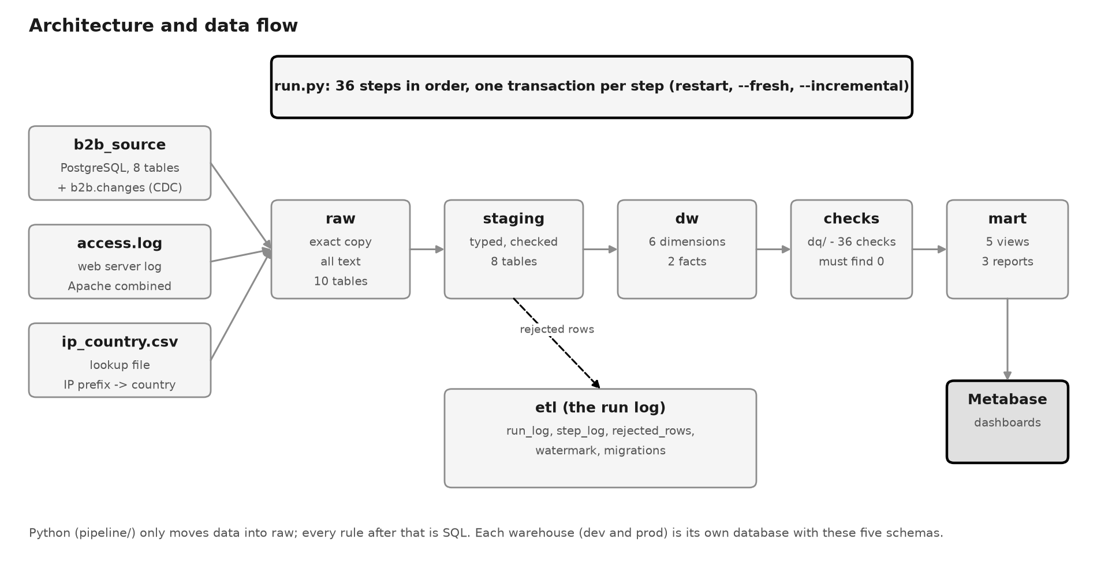
Figure 1 - How the data flows
In one sentence: Python copies the sources into the warehouse, and SQL does everything else.
- Raw: copy each source as it is. Every column is stored as text, so nothing can fail to load.
- Staging: check every row. Good rows get proper types; bad rows are saved in etl.rejected_rows with the reason.
- Star schema (dw): build the dimensions and the facts.
- Checks: run 36 data quality checks. If any check finds a problem, the run stops here.
- Marts: the report views read the star schema.
- Dashboard: Metabase shows the report views.
This style is called ELT: Extract and Load first, then Transform inside the database.

2 The tools
Part | Tool | Why
Database | PostgreSQL 16 in Docker | Free, standard SQL, fast bulk copy, runs the same on every machine
Pipeline | Python 3.12 (psycopg 3, PyYAML) | Small and readable: moves data, reads the log, runs the SQL files
Rules | Plain SQL files | Every rule can be read and tested on its own
Dashboard | Metabase in Docker | Ready-made charts on top of the report views
Tests | pytest and SQL checks | Proof after every load
Release | GitHub Actions | Tests every change and loads PROD after a merge

3 Where things are
Path | What it holds
run.py | The main program: the list of steps in order, and the restart logic
config.yaml | Connection settings and how much data to generate
pipeline/ | The Python helpers: copy tables, read the log, run SQL files, write the run log, keep the watermarks
sql/ | One SQL file per table, in a folder per layer (raw, staging, dimensions, facts, marts), plus setup.sql and migrations/
dq/ | The data quality checks
sources/ | The source tables (schema.sql) and the IP to country file
seed/ | Scripts that make the test data, and scripts that change it for demos
tests/ | The automated tests
demo/ | One script per feature, for a demonstration
.github/workflows/ | ci.yml (tests every push to dev) and deploy.yml (loads PROD)

4 DEV and PROD
 | DEV | PROD
What for | Building, testing and demos | The live numbers
Database | b2b_warehouse_dev | b2b_warehouse_prod
Git branch | dev | main
Who loads it | You: python run.py | GitHub, after a merge to main
The setting B2B_ENV picks the warehouse. Without it the pipeline always uses DEV, so PROD cannot be loaded by mistake. Both warehouses read the same sources.

5 How one run works
run.py has a list of 36 steps (STEPS) and runs them in order: 10 raw, 8 staging, 6 dimensions, 2 facts, 5 checks and 5 marts. The order matters: a staging table comes after the tables it checks against.
- Create any schema or etl table that is missing, and apply any new migration.
- Decide: is this a new run, or the continuation of a run that failed?
- For each step: write "running" in etl.step_log, run the SQL file (and the Python part, if any), then save (commit).
- If a step fails: undo that step only, mark the step and the run as failed, show the error and stop.
- At the end, mark the run as success and show how many rows were refused.
Each step is one transaction: it is saved completely or not at all. The log is written on a second connection, so a log line is kept even when its step is undone.
Restart example: fact_sales fails. The 24 steps before it are already saved. The next python run.py sees the failed run, skips those 24 steps and starts again at fact_sales.
Command | What it does
python run.py | A full load. If the last run failed, it continues that run
python run.py --fresh | Gives up a failed run and starts again from step 1
python run.py --incremental | Brings in only what changed in orders, order lines and the log
python run.py --fail-at STEP | Fails on purpose at that step, to show the restart
B2B_ENV=prod python run.py | Loads PROD instead of DEV

6 How each layer works

6.1 Raw
Each raw SQL file creates its table (all columns text) and empties it. Then Python streams the source table into it with COPY, piece by piece, so a big table never has to fit in memory. The log file is read one line at a time. A pattern picks out the IP, username, time and browser text; a line that does not match is refused.

6.2 Staging
Every staging file follows the same five parts. Here is the one for companies, shortened:
-- 1. the clean table, with proper types
CREATE TABLE IF NOT EXISTS staging.stg_companies (company_id integer PRIMARY KEY, cuit text NOT NULL, ...);
-- 2. start empty, and forget this step's old refused rows
TRUNCATE staging.stg_companies;
DELETE FROM etl.rejected_rows WHERE step_name = 'stg_companies';
-- 3. give every row a reason to refuse it (empty = the row is good)
CREATE TEMP TABLE checked ON COMMIT DROP AS
SELECT r.*, CASE WHEN replace(r.cuit, '-', '') !~ '^[0-9]{11}$' THEN 'CUIT is not 11 digits' END AS reject_reason
FROM raw.raw_companies r;
-- 4. bad rows go to the refused table
INSERT INTO etl.rejected_rows (step_name, reason, row_data)
SELECT 'stg_companies', reject_reason, to_json(c)::text FROM checked c WHERE reject_reason IS NOT NULL;
-- 5. good rows go to staging, cleaned
INSERT INTO staging.stg_companies
SELECT company_id::integer, replace(cuit, '-', ''), trim(name), upper(country_code) FROM checked WHERE reject_reason IS NULL;
A row is also refused when the row it belongs to was refused. For example, an order of a refused company gets the reason "company was rejected". All rules are in 04 Source-to-Target Mapping.

6.3 Dimensions with history
dim_company, dim_product and dim_end_customer are never emptied. On each load, two statements run:
- Close what changed: if the current version differs from the source, set valid_to = today and is_current = false.
- Add what is missing: every row that has no current version (because it is new, or was just closed) gets a new version that is valid from today.
The first version of a row is valid from 1900-01-01, so it also covers old orders. The other dimensions (date, country, device) are rebuilt on every run.

6.4 Facts
fact_sales is rebuilt from the good order lines. Each line is linked to the versions that were valid on its order day:
JOIN dw.dim_product p ON p.product_id = i.product_id
AND o.order_date::date >= p.valid_from
AND o.order_date::date < p.valid_to
fact_logins groups the log lines of each user into visits: a line starts a new login when the user's previous line is more than 30 minutes older.

6.5 Checks
Each file in dq/ returns a list of checks with the number of bad rows. Every number must be 0, or the run stops before the marts.
File | Checks | What it makes sure of
no_row_lost.sql | 9 | raw rows = good rows + refused rows, for every table; every good order line reaches fact_sales
reject_rate.sql | 8 | no step refused more than 20% of its rows, which would mean a broken source
duplicates.sql | 6 | nothing appears twice, and each company, product and customer has one current version
null_checks.sql | 4 | amounts, usernames and names are filled in
referential_integrity.sql | 9 | every fact row points to a dimension row that exists

6.6 Marts
mart_sales and mart_logins are wide views: a fact with all the names joined in, so the dashboard needs no joins. The three report views read them. Views hold no data, so they always show the current tables.

7 The incremental load (CDC)
The problem. A full load copies everything again. To save work, we want to read only what changed. But the source has no "last changed" column. Looking for higher order ids would find new orders, but miss old orders that were edited or deleted.
The solution. The source records every change itself. A trigger on orders and on order lines writes one row to b2b.changes for every insert, update or delete. For example:
change_id | table_name | operation | order_id
4228 | orders | INSERT | 1201
4229 | order_items | UPDATE | 584
4230 | orders | DELETE | 707
The pipeline keeps a bookmark (the watermark): the last change_id it has loaded. An incremental run then:
- Reads the watermark, for example 4,227.
- Finds the orders changed after it: 1201, 584 and 707.
- Deletes those orders from raw.
- Copies them again from the source, as they are now. Order 707 no longer exists, so it stays deleted.
- Saves the new watermark, in the same transaction as the rows.
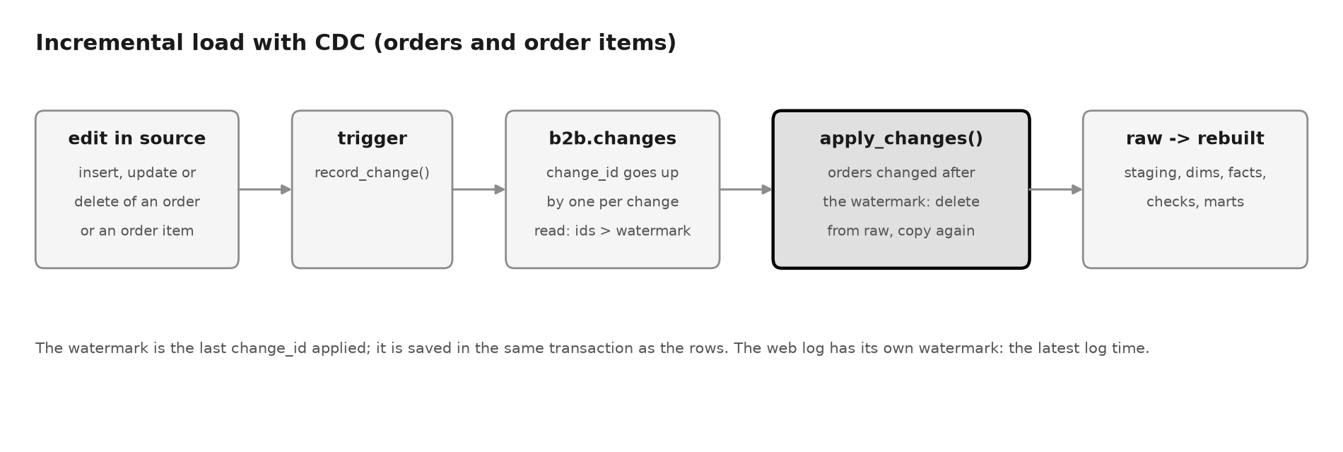
Figure 2 - The incremental load
The web log works more simply: only lines later than the last loaded time are added. Staging and the facts are rebuilt as usual; the saving is in reading the sources.
Known limit: a change saved by a very slow transaction can get a lower change_id than the watermark and be missed. Tools that read PostgreSQL's own change stream avoid this.

8 Changing a table that already exists
When a table needs a new shape, a numbered file goes into sql/migrations/. run.py applies each new file once per warehouse and writes it down in etl.migrations. The list of migrations is in 03 Physical Model.

9 Releasing a change
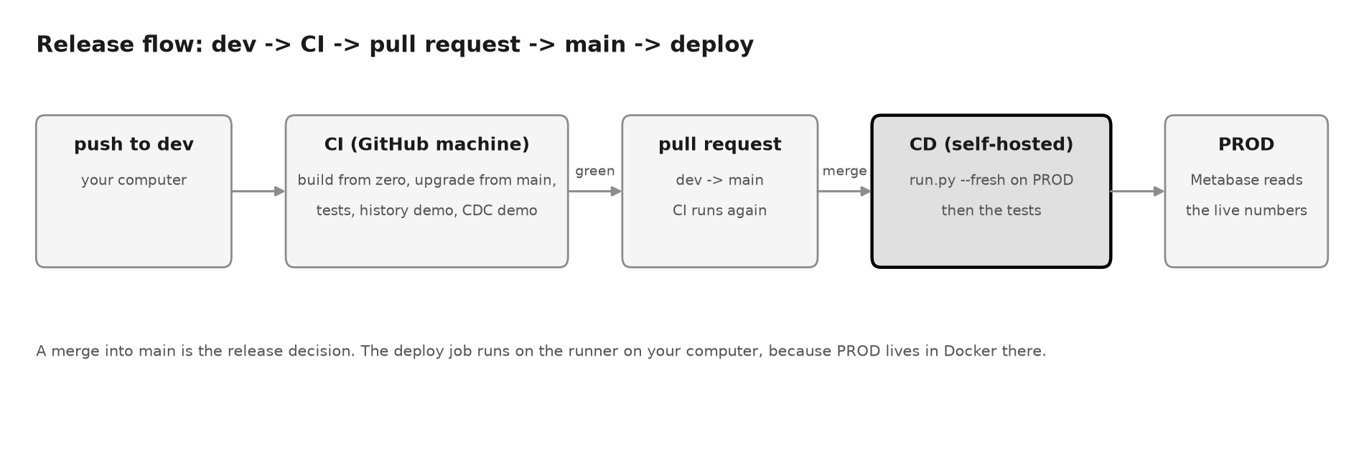
Figure 3 - From a change on dev to PROD
- Work on the dev branch. Run python run.py and python -m pytest -q.
- Push. GitHub runs CI: it builds the warehouse with the previous release, upgrades it with the new code, runs the tests and two demos. CI must be green.
- Open a pull request from dev to main. CI runs again.
- Check that Docker and the runner on your computer are running.
- Merge. GitHub loads PROD with run.py --fresh and runs the tests on it.
To undo a release that only changed code, revert the merge on main; the deploy then loads PROD with the previous code. A revert does not undo a migration: PROD keeps the new table shape, and the old code may fail on it. Undo such a release with a new release that fixes the problem. Everything can be reloaded from the sources except the history in the three history tables, so back those up before a risky change.

10 Everyday commands
Task | Command
Start the database and Metabase | docker compose up -d
Build everything from zero | ./rebuild_everything.sh
Load DEV | python run.py
Load only what changed | python run.py --incremental
Start over after a failure | python run.py --fresh
Run the tests | python -m pytest -q
Show what is in the warehouse | ./demo/show_database.sh
Demos | ./demo/history.sh, ./demo/incremental_load.sh, ./demo/failure_and_restart.sh

11 Watching the pipeline
Everything the pipeline does is written in the etl tables:
Question | Query
Did the last run work? | SELECT run_id, load_type, status, started_at, finished_at FROM etl.run_log ORDER BY run_id DESC LIMIT 5
Which step failed, and why? | SELECT run_id, step_name, error_message FROM etl.step_log WHERE status = 'failed' ORDER BY step_log_id DESC LIMIT 5
What was refused, and why? | SELECT step_name, reason, count(*) FROM etl.rejected_rows GROUP BY 1, 2
How far is the incremental load? | SELECT table_name, value, updated_at FROM etl.watermark
The dashboard has cards for these too. In GitHub, a red run means a failed test or load. Missing today: nothing sends a message when a run fails outside GitHub. A scheduled check of etl.run_log with an e-mail would be the next step.

12 When something goes wrong
What you see | Why | What to do
The run stops at reject_rate | A source sent mostly bad rows | Look at etl.rejected_rows for that step, fix the source, then python run.py --fresh
A fix has no effect after a failure | python run.py continues the failed run and skips the steps already done | python run.py --fresh
relation b2b.changes does not exist | The source was built before the change table was added | ./rebuild_everything.sh
--incremental says 'no watermarks yet' | There was no full load yet | Nothing: that run becomes a full load
The deploy waits and never starts | Docker or the runner is not running | Start Docker, then ./run.sh in ~/actions-runner
The dashboard shows old numbers | Metabase keeps old results, or reads the other warehouse | Refresh, and check which database the card uses

13 Security and personal data
Topic | Today | Better
Access | The pipeline and the dashboard use the database owner | A read-only user for the dashboard, limited to the mart views
Passwords | Local defaults in config.yaml | Environment variables or a secret store, outside git
Personal data | Names, documents and birth dates of end customers are in dw; refused rows keep the whole row | Leave personal fields out of the marts; delete old refused rows
Growth | The etl tables grow with every run | Keep, for example, 90 days

14 Known limits
Limit | Why
History starts on the day of the load, not the day of the change | The source does not say when a row changed
Staging and facts are rebuilt on every run | Simple and always correct; the incremental load saves time on reading the sources
Country comes from the first number of the IP | A small lookup file instead of a real IP location database
Device comes from a few text rules | Enough for this brief; a library would be more exact
The country list is built from the IP lookup file, so every company's country must be in it | Kept small on purpose. dq/referential_integrity.sql stops the run if a company's country is missing; a real project would use a full country list (ISO codes)

