Physical Model
This document shows how the model from 02 Logical Model is built in PostgreSQL: the databases, the layers, and every warehouse table with its columns.

1 The databases
One PostgreSQL 16 server, running in Docker (container b2b-postgres, port 5432), holds three databases:
Database | What it is
b2b_source | The source: the B2B platform tables (schema b2b)
b2b_warehouse_dev | The DEV warehouse, for building and testing
b2b_warehouse_prod | The PROD warehouse, with the live numbers
The two warehouses are identical in shape. The pipeline creates and upgrades them itself (sql/setup.sql and sql/migrations/). They use Buenos Aires time, so "today" is the business day. Which one is loaded is chosen by the setting B2B_ENV (DEV unless it says prod).

2 The layers
Each warehouse has five schemas, one per layer. Data moves from left to right:
Schema | What it holds | Tables | How it is loaded
raw | An exact copy of the two sources and the lookup file, every column as text | 10 | Emptied and copied again on a full run. An incremental run only brings in what changed in orders, order lines and the log
staging | Rows that passed the checks, with proper types | 8 | Emptied and rebuilt from raw on every run
dw | The star schema: dimensions and facts | 8 | Rebuilt on every run, except the 3 history tables, which are only added to
mart | Views that give each report its answer | 5 views | A view holds no data; it reads the dw tables when it is opened
etl | What the pipeline records about itself | 5 | Kept between runs; each run adds its own rows
Example: one order on its way. Order 100 is a row in b2b.orders. It is copied to raw.raw_orders, where every value is text. In staging.stg_orders its date becomes a real date and its ids become numbers, after it passes the checks. Each of its lines becomes one row in dw.fact_sales. Finally, its amount is counted in its month in mart.mart_monthly_sales.
Every table is made by one SQL file with the same name. For example, sql/staging/stg_orders.sql builds staging.stg_orders.

3 The star schema tables (dw)
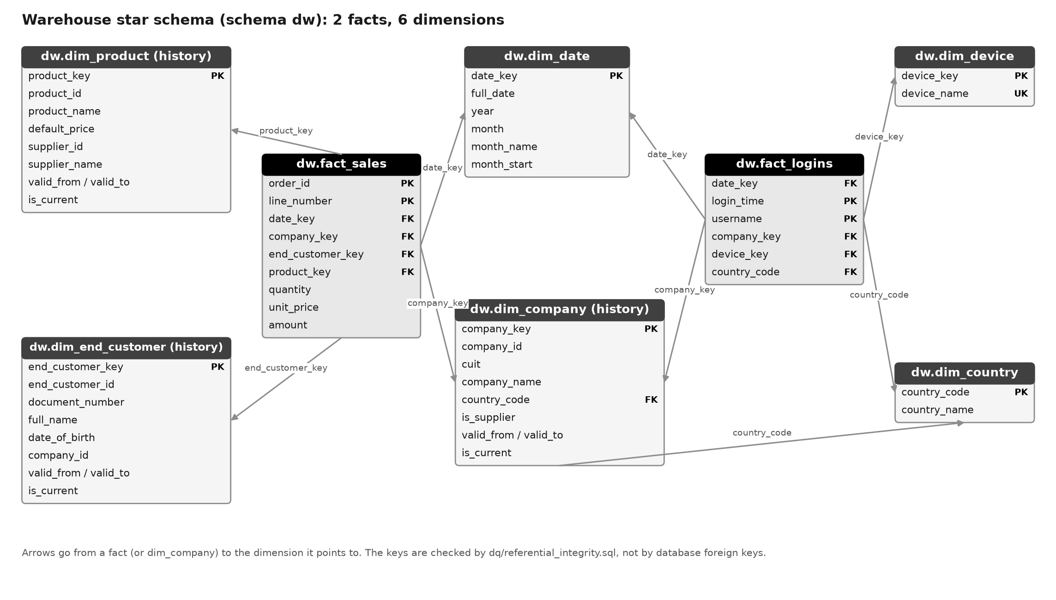
Figure 1 - The tables of the star schema
In the column lists, PK = primary key (unique for every row) and UK = unique.

3.1 dw.dim_date
One row per calendar day. Rows in a fresh build: 4,018.
Column | Type | Can be empty | Key | Meaning
date_key | integer | no | PK | The day as a number YYYYMMDD, for example 20261022
full_date | date | no |  | The calendar day
year | integer | no |  | Calendar year
month | integer | no |  | Month number (1-12)
month_name | text | no |  | Month name, for example October
month_start | date | no |  | First day of the month (used to group by month)

3.2 dw.dim_country
One row per country, plus XX = Unknown. Rows in a fresh build: 11.
Column | Type | Can be empty | Key | Meaning
country_code | text | no | PK | Two-letter country code ('XX' = unknown)
country_name | text | no |  | Country name ('Unknown' for XX)

3.3 dw.dim_company
One row per version of a company. Keeps history. Rows in a fresh build: 29.
Column | Type | Can be empty | Key | Meaning
company_key | integer | no | PK | Warehouse key of one company version (surrogate key)
company_id | integer | no |  | Source company id
cuit | text | no |  | Tax number, digits only
company_name | text | no |  | Company name (as it was in that version)
country_code | text | no |  | Country where the company is registered
is_supplier | boolean | no |  | True when the company is also a supplier
valid_from | date | no |  | First day this version is valid
valid_to | date | no |  | Day this version stopped being valid; 9999-12-31 while current
is_current | boolean | no |  | True for the current version

3.4 dw.dim_product
One row per version of a product. Keeps history. Rows in a fresh build: 57.
Column | Type | Can be empty | Key | Meaning
product_key | integer | no | PK | Warehouse key of one product version (surrogate key)
product_id | integer | no |  | Source product id
product_name | text | no |  | Product name
default_price | numeric(12,2) | no |  | List price of the product
supplier_id | integer | no |  | Source id of the supplier company
supplier_name | text | no |  | Name of the supplier company
valid_from | date | no |  | First day this version is valid
valid_to | date | no |  | Day this version stopped being valid; 9999-12-31 while current
is_current | boolean | no |  | True for the current version

3.5 dw.dim_end_customer
One row per version of an end customer. Keeps history. Rows in a fresh build: 143.
Column | Type | Can be empty | Key | Meaning
end_customer_key | integer | no | PK | Warehouse key of one end-customer version (surrogate key)
end_customer_id | integer | no |  | Source end-customer id
document_number | text | no |  | Identity document number
full_name | text | no |  | First and last name
date_of_birth | date | yes |  | Date of birth
company_id | integer | no |  | Source id of the company that serves this person
valid_from | date | no |  | First day this version is valid
valid_to | date | no |  | Day this version stopped being valid; 9999-12-31 while current
is_current | boolean | no |  | True for the current version

3.6 dw.dim_device
One row per kind of device. Rows in a fresh build: 8.
Column | Type | Can be empty | Key | Meaning
device_key | integer | no | PK | Warehouse key of a device kind
device_name | text | no | UK | Device kind worked out from the browser text (iPhone, Windows PC ...)

3.7 dw.fact_sales
One row per order line. Rows in a fresh build: 2,567.
Column | Type | Can be empty | Key | Meaning
order_id | integer | no | PK | Source order id
line_number | integer | no | PK | Line number inside the order
date_key | integer | no |  | Day as a number YYYYMMDD; points to dim_date
company_key | integer | no |  | The company version valid on the order day (points to dim_company)
end_customer_key | integer | no |  | The end-customer version valid on the order day (points to dim_end_customer)
product_key | integer | no |  | The product version valid on the order day (points to dim_product)
quantity | integer | no |  | Units ordered
unit_price | numeric(12,2) | no |  | Price per unit charged on the order line
amount | numeric(14,2) | no |  | quantity x unit_price

3.8 dw.fact_logins
One row per login (visit). Rows in a fresh build: 2,548.
Column | Type | Can be empty | Key | Meaning
date_key | integer | no |  | Day as a number YYYYMMDD; points to dim_date
login_time | timestamptz | no | PK | Time of the first page of the visit (with time zone)
username | text | no | PK | Login name
company_key | integer | no |  | The company version valid on the login day (points to dim_company)
device_key | integer | no |  | The device of the visit (points to dim_device)
country_code | text | no |  | Country of the visitor's IP address ('XX' = not in the lookup file); points to dim_country

4 The raw and staging tables
Each source table has a raw table, and most have a staging table. This shows how many rows each one holds in a fresh build:
Source | Raw table | Rows | Staging table | Good rows | Refused
companies | raw.raw_companies | 30 | staging.stg_companies | 29 | 1
suppliers | raw.raw_suppliers | 5 | staging.stg_suppliers | 5 | 0
end_customers | raw.raw_end_customers | 150 | staging.stg_end_customers | 143 | 7
products | raw.raw_products | 60 | staging.stg_products | 57 | 3
catalog_items | raw.raw_catalog_items | 450 | staging.stg_catalog_items | 408 | 42
orders | raw.raw_orders | 1,200 | staging.stg_orders | 1,116 | 84
order_items | raw.raw_order_items | 3,027 | staging.stg_order_items | 2,567 | 460
users | raw.raw_users | 60 | (used as a lookup) | - | -
ip_country.csv (lookup) | raw.raw_ip_country | 20 | (used as a lookup) | - | -
access.log | raw.raw_web_logs | 10,504 | staging.stg_web_logs | 9,013 | 525
For every staging table, raw rows = good rows + refused rows. The web log is the only exception: its 966 lines from visitors who did not log in are left out on purpose. The users table and the IP file have no staging table; the staging step of the web log uses them to look up the company and the country.
Raw columns are always text, so a bad value can never stop the copy. Staging columns have proper types. Every column of both layers is listed in 04 Source-to-Target Mapping.

5 The report views (mart)
A view holds no data: each time it is opened, it runs its query on the current tables.
View | What it shows | Rows | Columns
mart.mart_sales | fact_sales with every name joined in: one wide row per order line | 2,567 | order_id, line_number, order_date, order_month, company_name, country, product_id, product_name, supplier_name, end_customer_name, quantity, amount
mart.mart_logins | fact_logins with every name joined in: one wide row per login | 2,548 | login_time, login_date, login_month, username, company_name, device, country
mart.mart_top_devices | Report R1: the 5 devices with the most logins | 5 | device, logins
mart.mart_top_products_top_country | Report R2: the top login country and its 5 best-selling products | 5 | country, country_logins, product_name, total_quantity, total_amount
mart.mart_monthly_sales | Report R3: sales and orders of the last 12 full months | 12 | month, total_sales, orders

6 The pipeline tables (etl)
The pipeline writes down everything it does, so a run can be checked and restarted.
Table | What it holds | Columns
etl.run_log | One row per run: when, full or incremental, and how it ended | run_id, started_at, finished_at, status, load_type
etl.step_log | One row per step of a run; a restart reads it to skip the steps already done | step_log_id, run_id, step_name, started_at, finished_at, status, row_count, error_message
etl.rejected_rows | Every refused row, with its step and the reason | step_name, reason, row_data, rejected_at
etl.watermark | How far each growing table has been loaded (for the incremental load) | table_name, value, updated_at
etl.migrations | Which one-time changes this warehouse has had | file_name, applied_at

7 Keys and indexes
Every dw table has a primary key, and the database makes sure it is unique. In the two facts the key is the grain: order_id + line_number in fact_sales, username + login_time in fact_logins. The links between facts and dimensions are checked by a test instead of foreign keys (see 02 Logical Model, section 5). One index was added by hand: on date_key in both fact tables, because reports often filter by date.

8 Changing a table that already exists
CREATE TABLE IF NOT EXISTS does nothing when the table is already there. So when a table needs a new shape, a numbered file is added to sql/migrations/. The pipeline runs each file once per warehouse and writes it down in etl.migrations.
File | What it changes
001_company_history.sql | dim_company starts keeping history. Old tables are dropped and the same run rebuilds them
002_run_log_load_type.sql | Adds the column load_type (full or incremental) to etl.run_log
003_product_and_customer_history.sql | Products and end customers start keeping history. Their tables are dropped and rebuilt in the same run
004_fact_logins_key.sql | fact_logins gets its primary key (username + login_time). The table is dropped and rebuilt in the same run

9 Naming rules
Object | Rule | Example
SQL file | The file name is the step name and the table name | sql/staging/stg_orders.sql -> staging.stg_orders
Raw table | raw_ + source table name | raw.raw_orders
Staging table | stg_ + source table name | staging.stg_orders
Dimension / fact | dim_ / fact_ + what it holds | dw.dim_company, dw.fact_sales
Report view | mart_ + report name | mart.mart_monthly_sales
Warehouse key | _key | company_key
Source id | _id | company_id

