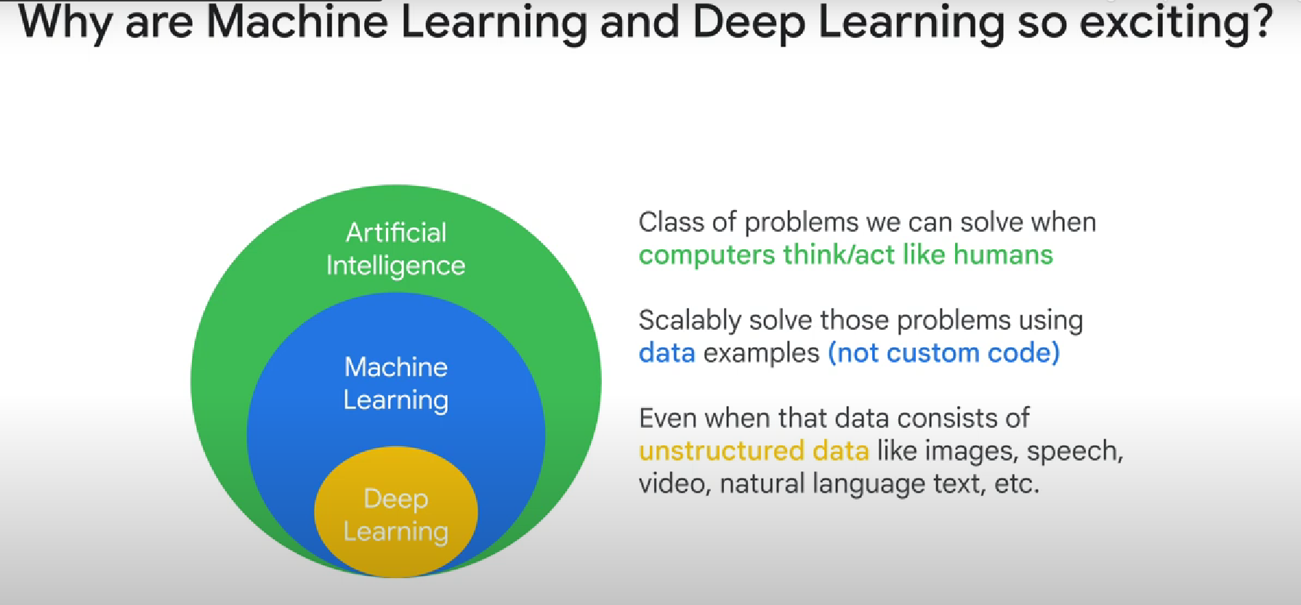

Ad-Hoc VS Data-driven business decisions

Ad-hoc: data analyst that looks at all the data and tries to reach conclusions

Data-driven decisions: based on ML models

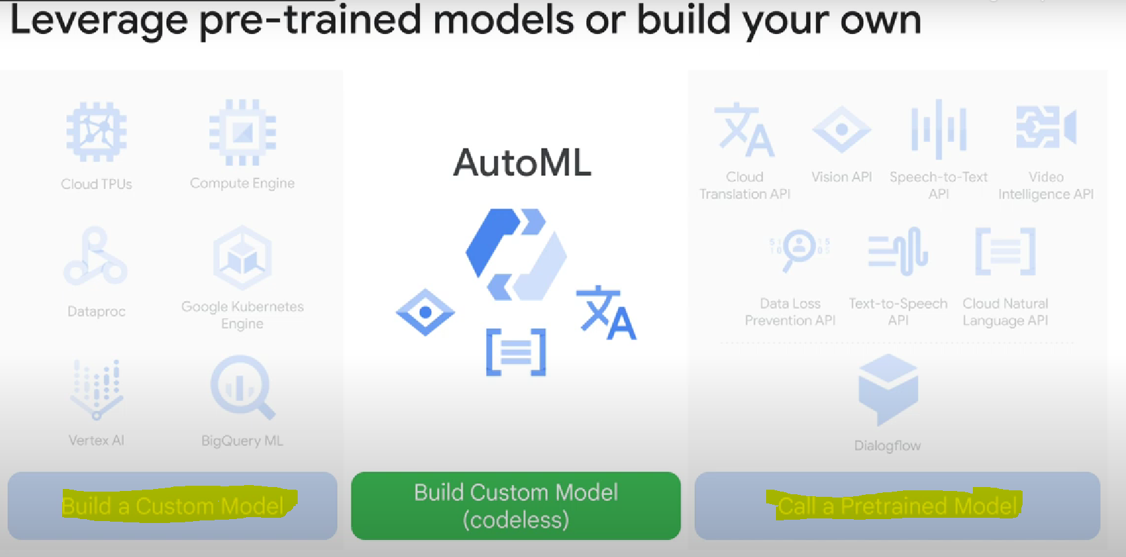

Unstructured data: audio, images, videos, etc...

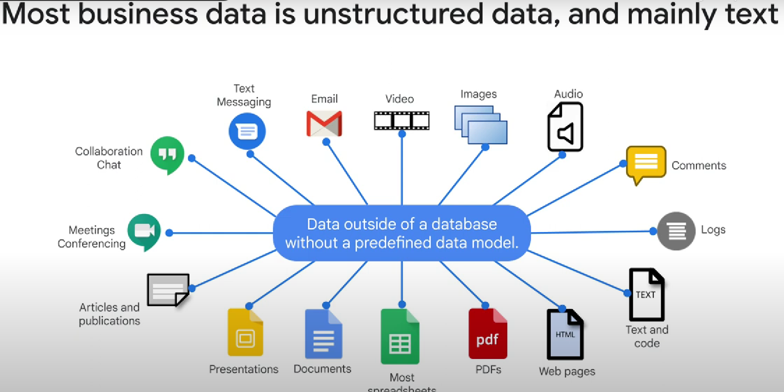

Enriching unstructured data = labelling it

