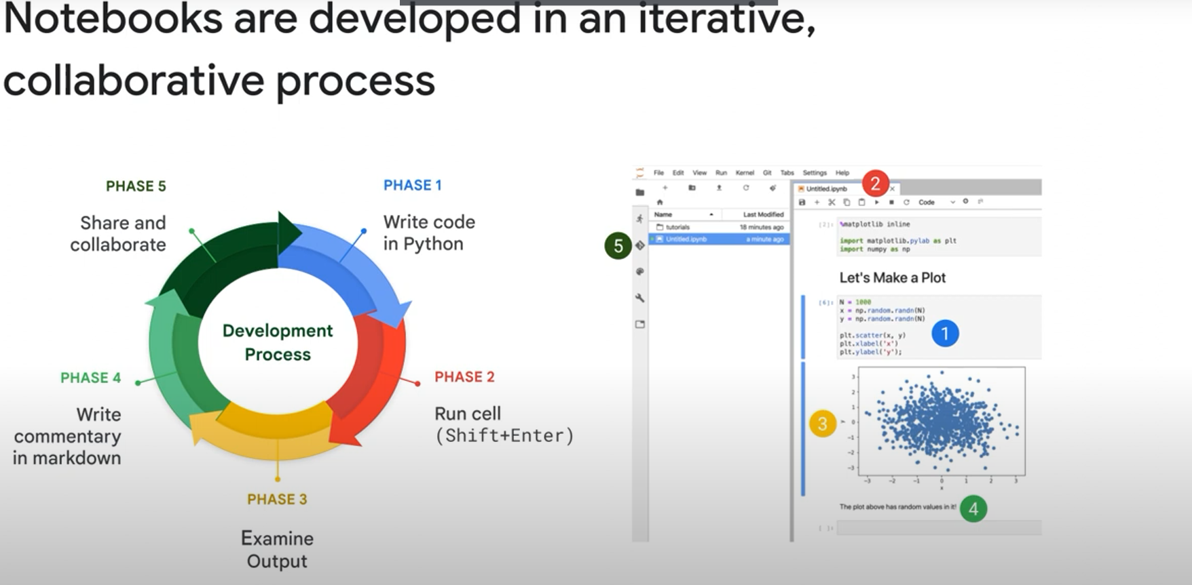

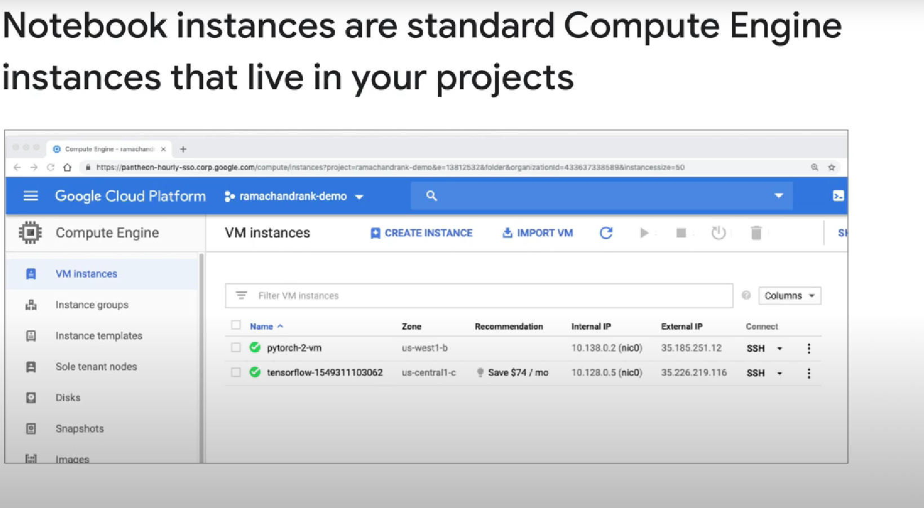

Notebooks are kind of like VMs. You can add GPUs to your notebook after creating it.

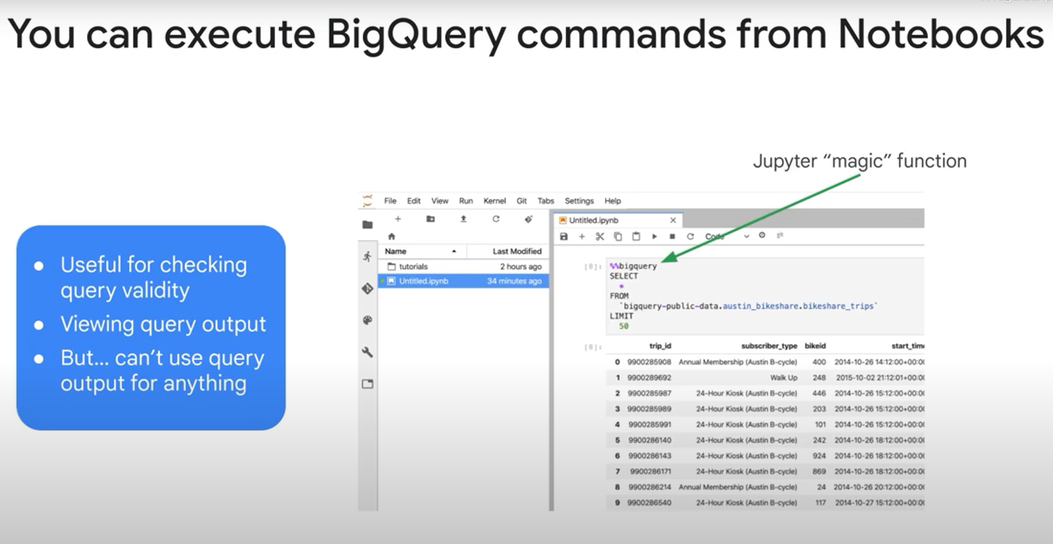

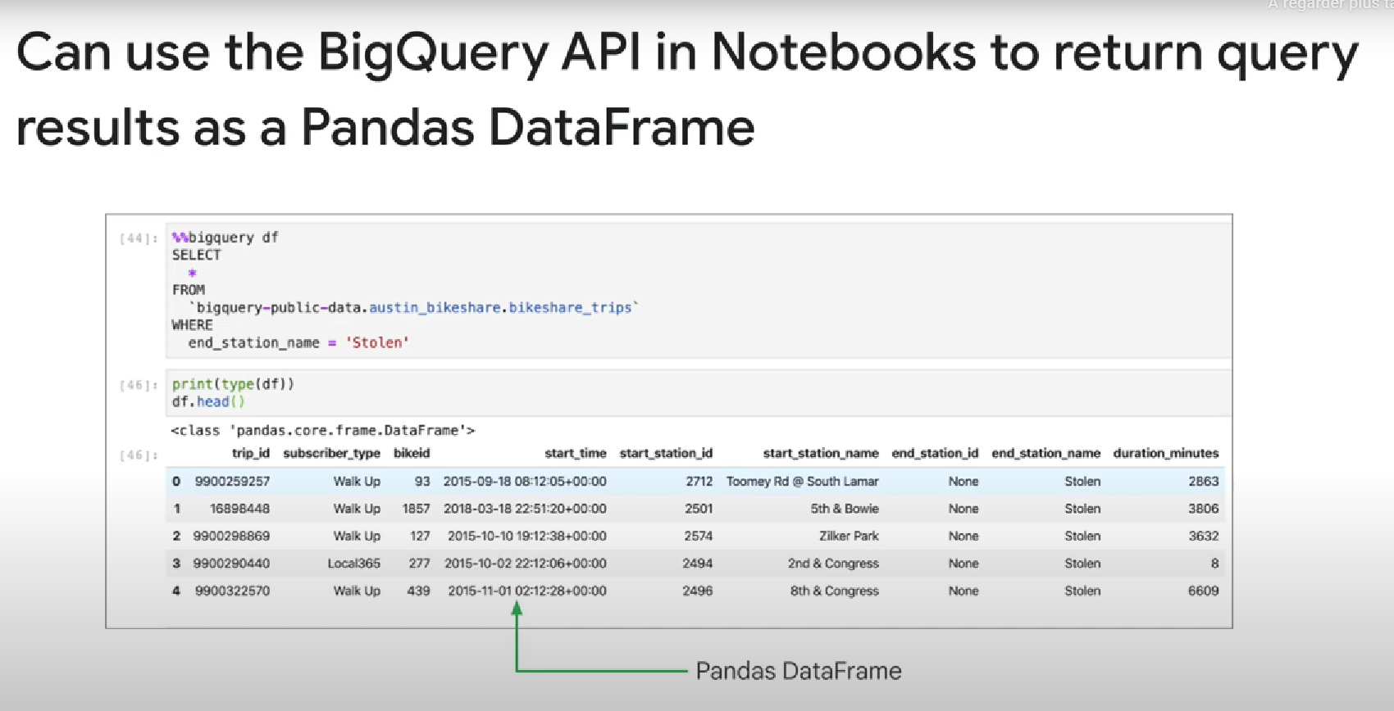

Magic functions can allow you to execute bigquery queries inside a notebook.

You can also save the output of the query to a dataframe.

Keep in mind that notebooks’ have limited memory, so don’t query LARGE quantities of data. Instead, use samples of that data.

