DST Airlines DataOps
DataOps Project | June 2026 Batch | LIORA
Project team: Hassan Salam Banayeem | Ali Doghan
Monitoring contributor: Kristian
Updated from verified main deployment | 31 July 2026
LATEST VERIFIED MAIN CI/CD: SUCCESS
The latest main pipeline passed 81 tests, Terraform validation, GHCR publication, Trivy gates, temporary Kind deployment, and smoke tests.

Table of Contents
Select a section title to jump directly to that section. Page numbers refer to this reviewed edition.
1. Executive summary | 3
2. Application architecture | 4
3. Docker and environments | 5
4. Testing | 5
5. CI/CD pipeline - Step 5 | 6
6. Kubernetes - Step 4 | 7
7. Terraform and Proxmox - Step 6 | 8
8. Monitoring - Step 7 | 9
9. Security and DevSecOps - Step 8 | 9
10. Disaster recovery - Step 9 | 10
11. Setup and operations | 11
11.1 Docker development | 11
11.2 Kubernetes | 11
11.3 Terraform on Proxmox | 11
12. Next steps | 12
13. Conclusion | 13
Appendix A. Evidence map | 13

1. Executive summary
DST Airlines is a containerized flight-delay analytics platform. The application combines a FastAPI backend, a Dash/Plotly dashboard, three databases, machine-learning utilities, weather integration, and a DevOps delivery stack.
The strongest completed area is Step 5, CI/CD. GitHub Actions runs 81 tests, validates Terraform, builds and scans API/dashboard images, publishes immutable SHA tags to GHCR, deploys to a temporary Kind cluster, and smoke-tests both web services. The latest verified main run completed the full pipeline successfully.
Important scope statement
Kind is temporary Kubernetes validation inside CI and disappears after the workflow. The separately deployed Proxmox environment is persistent and serves the live dashboard/API; CI does not currently promote releases to it automatically.

Repository-level configuration was clarified: committed credentials are classroom/demo defaults, production replacements must be protected, Terraform supports Docker over SSH, Grafana provisioning was repaired, and deployment/backup scripts were added. A persistent Proxmox deployment is now live; production hardening remains.

2. Application architecture
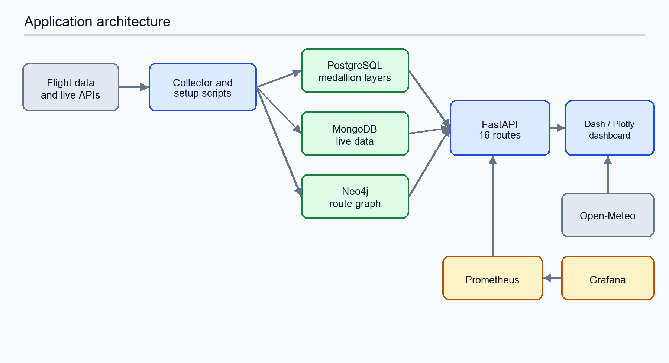
Figure 1. Rendered architecture corresponding to the editable Mermaid diagram in README.md.
Data collection and setup scripts feed PostgreSQL, MongoDB, and Neo4j. FastAPI exposes 16 HTTP routes and supplies the dashboard. PostgreSQL contains the analytical schema, MongoDB supports flexible/live data, and Neo4j stores route relationships. The dashboard also calls Open-Meteo for live weather.
Component | Responsibility | Important files
Collector | Kaggle/OpenSky collection and transformation. | collector/collector.py
API | Health, analytics, routes, live data, and prediction endpoints. | api/main.py
Dashboard | Seven-page Dash/Plotly user interface and API client. | dashboard/*.py
PostgreSQL | Bronze, silver, and gold analytical data. | database/sql/init.sql
MongoDB | Live flights, API responses, and prediction records. | database/db_setup.py
Neo4j | Airport nodes, route relationships, paths, and graph queries. | load_neo4j.py
Monitoring | API metrics, Prometheus scrape, Grafana dashboard. | monitoring/

3. Docker and environments
The API and dashboard have production-oriented Dockerfiles. The API also has a development Dockerfile that runs Uvicorn with reload. Docker Compose coordinates databases and application services.
Configuration | Services | Purpose
docker-compose.dev.yml | PostgreSQL, MongoDB, Neo4j, API, dashboard | Local development; reload/debug and source mount.
docker-compose.prod.yml | Databases, API, dashboard, Prometheus, Grafana | Production-oriented stack; private DB ports and loopback web binding.
docker-compose.yml | Above plus pgAdmin, Mongo Express, Prometheus, Grafana | Full local demonstration stack.

- The Dockerfiles use Python 3.11 slim and are single-stage builds.
- Named volumes preserve database and monitoring data across container restarts.
- The development and production Compose files use separate container and volume names.
- A Compose production configuration is not the same as a hosted production environment.
Credential workflow
Committed values are classroom/demo defaults. Production replacements must be unique and stored in protected GitHub/server/Kubernetes secret configuration, not committed to Git.

4. Testing
The repository contains 81 tests. The 47 API tests exercise FastAPI routes against a seeded PostgreSQL service. The 34 dashboard tests exercise the API client, mappings, fallback data, and summary logic using mocked HTTP responses.
Suite | Count | CI dependencies | Current gaps
API | 47 | PostgreSQL 16, schema, deterministic seed | No coverage threshold; several external systems are not exercised.
Dashboard | 34 | Mocked HTTP responses and local fallback data | No browser-level end-to-end test.

python -m pip install -r api/requirements.txt \
-r dashboard/requirements.txt -r requirements-test.txt
cd dashboard && python -m pytest -q test_data.py
The latest main GitHub Actions run passed all 81 tests and the complete CI/CD workflow. GitHub provides the verified test, Terraform, image, security, Kind deployment, and smoke-test evidence.

5. CI/CD pipeline - Step 5
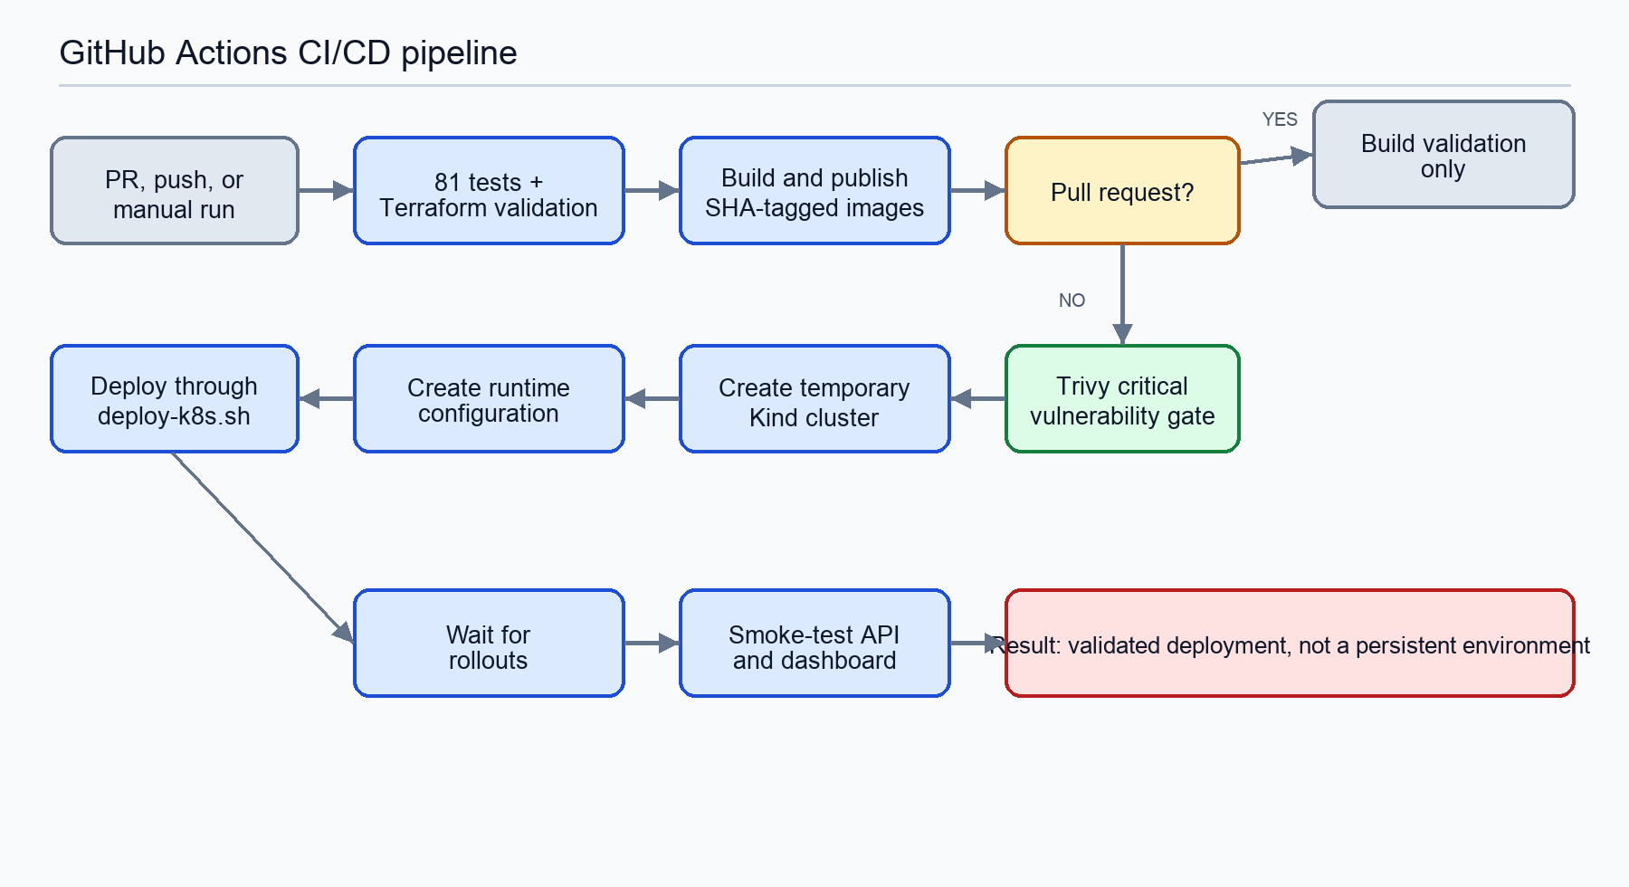
Figure 2. CI/CD flow. The source Mermaid diagram is maintained in README.md.
The workflow is stored at .github/workflows/ci-cd.yml. It triggers for pull requests and pushes involving main, dev, or dev-ali, and it can be started manually.
- Start PostgreSQL 16 and apply init.sql plus test_seed.sql.
- Install Python dependencies and run all 81 tests.
- Check Terraform formatting and validate the configuration.
- Build the API and dashboard images with Docker Buildx.
- For non-pull-request runs, log in to GHCR with GITHUB_TOKEN.
- Publish both images with the immutable Git commit SHA.
- Scan both images and fail on fixed critical vulnerabilities.
- Create a temporary Kind cluster and local registry.
- Mirror the GHCR images to the Kind registry and inject image names.
- Deploy runtime configuration and workloads through deploy-k8s.sh.
- Wait for rollouts, smoke-test the API and dashboard, and print diagnostics on failure.
Pipeline behavior | Pull request | Push/manual run
Tests | Yes | Yes
Terraform validation | Yes | Yes
Build images | Yes | Yes
Push to GHCR | No | Yes
Trivy critical gate | No | Yes
Deploy to Kind | No | Yes
Smoke tests | No | Yes
Persistent deployment | No | No - Proxmox is deployed separately

What remains for a complete deployment strategy
Persistent demonstration: Proxmox now hosts the live dashboard and API. Still required for production: HTTPS, protected GitHub Environments, environment-specific configuration, and reviewer approval.

6. Kubernetes - Step 4
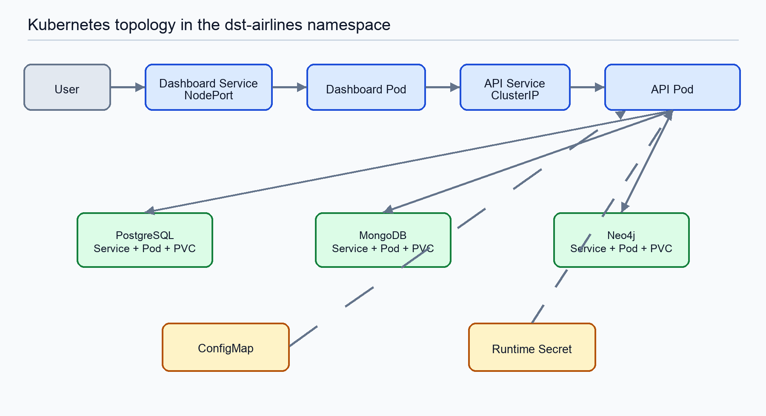
Figure 3. Current Kubernetes resource relationships inside the dst-airlines namespace.
Kubernetes manifests define Deployments and Services for the API, dashboard, and three databases. Database PVCs preserve data. API and dashboard probes and resource limits support basic operational checks.
Resource | Implemented | Limitation
Namespace | dst-airlines | No dev/prod namespace separation.
API/dashboard | Deployment, Service, probes, resource limits | One replica; placeholder image names outside CI.
Databases | Deployment, ClusterIP Service, PVC | One replica; no backup controller or HA.
Configuration | ConfigMap, Secret template, deploy script | Runtime values remain external to Git.
External access | Dashboard NodePort | No Ingress, DNS, or TLS.

- Kind is used in CI because it is fast and disposable; it validates Kubernetes deployment and is deleted when the workflow finishes.
- Minikube can run the same manifests locally but is not used by the workflow.
- Monitoring does not currently have Kubernetes manifests.
- No Helm chart, autoscaling, NetworkPolicy, RBAC policy, or PodDisruptionBudget is defined.

7. Terraform and Proxmox - Step 6
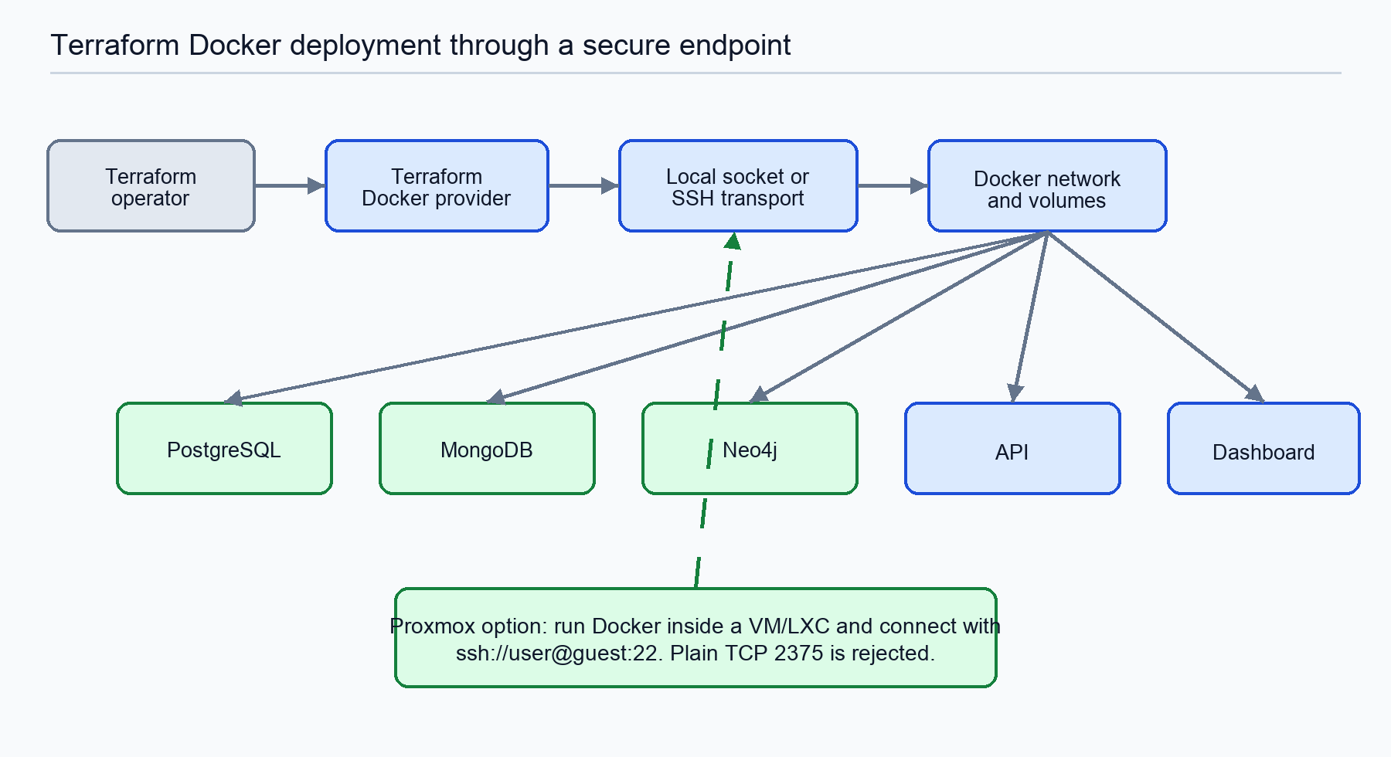
Figure 4. Terraform resources using a local Unix socket or SSH to a Proxmox Docker guest.
Terraform uses the kreuzwerker/docker provider to manage the Docker network, volumes, databases, API, and dashboard. The persistent Proxmox-hosted environment is live and was verified on 31 July 2026: dashboard HTTP 200 on port 8050 and API HTTP 200 on port 8000.
- Terraform manages Docker inside the Proxmox guest; it does not provision the Proxmox host, VM/LXC, or a Kubernetes cluster.
- It does not provision monitoring, firewall rules, TLS, a load balancer, or backup storage.
- Plain Docker TCP endpoints are rejected; local Unix socket and SSH are supported.
- Terraform formatting and validation now run in GitHub Actions.
How Proxmox fits
Proxmox now provides the persistent Docker host for the live demonstration. It supports Step 2 as a hosted environment and Step 6 through Terraform-over-SSH. Kind still covers Kubernetes validation for Step 4, and CI/CD does not yet deploy automatically to Proxmox.

8. Monitoring - Step 7
FastAPI exposes Prometheus metrics at /metrics. Prometheus is configured to scrape the API every 15 seconds, and Grafana includes a provisioned Prometheus data source and dashboard JSON.
Area | Implemented | Not implemented or not verified
Metrics | FastAPI request metrics | No business or database metrics.
Collection | Prometheus scrape configuration | No Kubernetes deployment or service discovery.
Visualization | Grafana data source and dashboard JSON | Provisioning mount conflict corrected.
Alerting | None | No alert rules, notifications, SLOs, or escalation.
Logging | Container logs | No aggregation, retention, or tracing.

9. Security and DevSecOps - Step 8
The repository contains a Kubernetes Secret template, excludes environment files from Docker build contexts, uses GITHUB_TOKEN for GHCR, scans images in CI, and enables Dependabot. Python modules no longer contain password defaults; committed environment values are classroom/demo credentials that must be replaced for production.
Control or finding | Current state | Remaining action
Tracked runtime secret files | Classroom/demo defaults committed | Replace with unique protected values before production.
Docker TCP 2375 | Removed and rejected | Verify the old endpoint is disabled and review host access.
Password defaults in Python | Removed | Provide runtime values through protected configuration.
Image and dependency scanning | Trivy gate + Dependabot | Review Dependabot updates and recurring Trivy results.
Repository hygiene | Bytecode removed; ignore rules repaired | Keep generated files out of future commits.
Public production controls | Live Proxmox demo over HTTP | Add HTTPS, firewall review, NetworkPolicy, and RBAC.

Credential warning
Every committed credential must be treated as public. Demo values are acceptable for coursework only; production must use unique protected secrets and immediate rotation if a real service ever reused a committed value.

10. Disaster recovery - Step 9
DISASTER_RECOVERY.md documents backup and restore procedures for PostgreSQL, MongoDB, and Neo4j; container recovery; Kubernetes rollback; GHCR SHA rollback; Terraform recreation; and recovery order. The backup script creates timestamped files, checksums, and retention cleanup.
Capability | Current state | Gap
Database backup | Automated script with retention | Schedule it and copy encrypted backups off-host.
Restore | Commands documented | No automated restore test or integrity verification.
Container recovery | Docker restart and Kubernetes Deployment behavior | No persistent multi-node cluster validation.
Rollback | Kubernetes and SHA image procedures documented | No release promotion record or automated rollback.
RTO/RPO | Targets stated in plan | Not measured through a recovery exercise.

The corrected plan states that single-node Minikube/Kind cannot reschedule workloads after node failure. A multi-node cluster and storage strategy are required for that behavior.

11. Setup and operations

11.1 Docker development
git clone https://github.com/kboroz/dst-airlines-DataOps.git
cd dst-airlines-DataOps
git switch main
cp .env.dev.example .env.dev
# Replace every credential placeholder in .env.dev.
docker compose --env-file .env.dev -f docker-compose.dev.yml up --build -d
Create local environment values first and do not commit real secrets. The dashboard is available on port 8050 and FastAPI documentation on port 8000 at /docs.

11.2 Kubernetes
The verified route is the GitHub Actions Kind job. For Minikube, build the two ci-tagged images, create .env.k8s from its example, and run the same deployment script used by CI.
minikube start --driver=docker
eval "$(minikube docker-env)"
docker build -t dst-airlines-api:ci ./api
docker build -t dst-airlines-dashboard:ci ./dashboard
cp .env.k8s.example .env.k8s
# Replace password and DATABASE_URL placeholders.
./scripts/deploy-k8s.sh
Do not commit a populated Secret. The README contains the complete example command and explains the required keys.

11.3 Terraform on Proxmox
The implemented persistent environment runs Docker in a Proxmox VM/LXC and exposes the dashboard at the verified endpoint below. Terraform supports management over SSH; plain Docker TCP port 2375 must remain disabled.
Verified live dashboard: http://51.158.200.169:8050 | API: http://51.158.200.169:8000
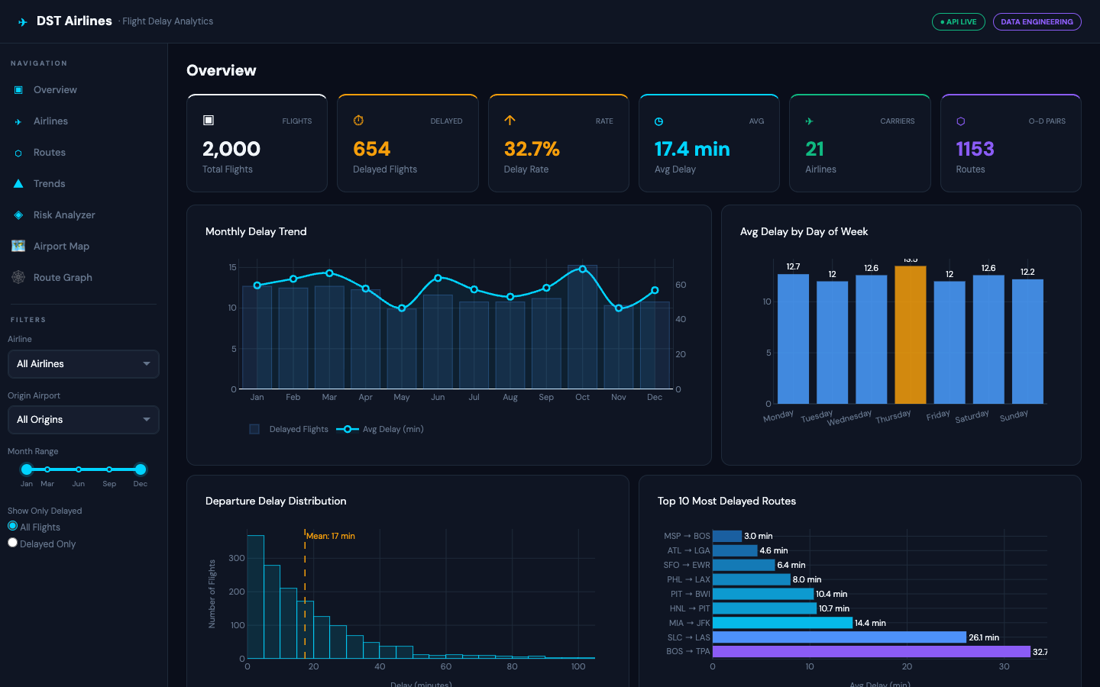
Figure 5. Live Proxmox-hosted DST Airlines dashboard, verified 31 July 2026.
cp terraform/terraform.tfvars.example terraform/terraform.tfvars
# Set docker_host = "ssh://docker-user@proxmox-guest:22"
# Set deployment host, immutable GHCR image tags, and strong passwords.
cd terraform
terraform init
terraform plan
terraform apply

12. Next steps
Next steps are to rotate all classroom/demo credentials, enable HTTPS, review firewall exposure, add protected GitHub production environments with approval controls, deploy monitoring persistently with alerting, pin immutable image digests, and complete a documented backup-and-restore exercise.

13. Conclusion
The project demonstrates a modern DataOps delivery system with verified CI validation and a persistent Proxmox-hosted demonstration. Step 5 is implemented: tests, Terraform validation, GHCR, Trivy, Kind deployment, and smoke tests pass. Kind proves Kubernetes deployability; Proxmox keeps the dashboard and API continuously reachable.
The remaining production actions are unique protected credentials, HTTPS, firewall review, approved release controls, monitoring alerts, and a restore exercise. The current Proxmox Docker deployment is persistent but does not replace the Kubernetes validation required by Step 4.

Appendix A. Evidence map
Evidence | Purpose
.github/workflows/ci-cd.yml | CI/CD source of truth
.github/dependabot.yml | Automated dependency update configuration
api/test_api.py; dashboard/test_data.py | 81 automated tests
k8s/*.yaml | Kubernetes resources
scripts/deploy-k8s.sh | Shared local/CI Kubernetes deployment
scripts/backup_databases.sh | Database backup and retention automation
terraform/*.tf | Remote Docker infrastructure definitions
monitoring/ | Prometheus and Grafana configuration
trivy-report-*.json | Point-in-time vulnerability scan evidence
SECURITY.md | Security notes
DISASTER_RECOVERY.md | Recovery procedures
README.md | Operational overview and editable Mermaid diagrams

