

Ain Shams University

Faculty of Engineering

Department of Computer Engineering and Software Systems

**Semantic Web of Arts**

**Team Members**

|  |  |
| --- | --- |
| Ali Sayed Attia Elganzory | 18P2073 |
| Mohamed Ahmed Hassan Elsayed | 18P3206 |
| Youssef Ahmed Ibrahim Abdelkader | 18P7042 |

Table of Contents

Introduction 3

Ontology 3

Hierarchies 3

Graph 4

Queries 5

Query 1 5

Results 5

Query 5

Query 2 6

Results 6

Query 6

Query 3 7

Results 7

Query 7

Query 4 8

Results 8

Query 8

Query 5 9

Results 9

Query 9

Desktop Application 10

Web Application 11

# Introduction

This project illustrates the different aspects of creating a semantic web construct. This semantic web presents the ontology of fine arts like books, paintings, and their corresponding authors.

To define the abstract entities (classes) and the concrete individuals along with the other detailed properties, a Resource Description Framework (RDF) is used to write an OWL file. This has been carried out using a visual tool called Protégé.

A desktop application is created to retrieve the created (semantic) information or more formally *query* it. The application accepts any query, processes it using the Apache Jena library, and then displays the results in a tabular format. For further illustration purposes, a simple web application has been created.

# Ontology

There are mainly two categories of classes: persons embodied in the authors and artworks like books and paintings. Each author has a data property of their birth year. Each artwork has an object property of the author and a data property of its publication year.

## Hierarchies

## Graph

# Queries

## Query 1

List all the authors and the years they were born in.

### Results

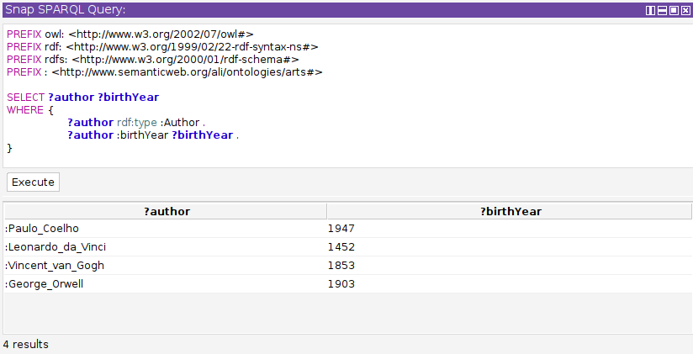

### Query

PREFIX owl: <http://www.w3.org/2002/07/owl#>

PREFIX rdf: <http://www.w3.org/1999/02/22-rdf-syntax-ns#>

PREFIX rdfs: <http://www.w3.org/2000/01/rdf-schema#>

PREFIX : <http://www.semanticweb.org/ali/ontologies/arts#>

SELECT ?author ?birthYear

WHERE {

?author rdf:type :Author .

?author :birthYear ?birthYear .

}

## Query 2

List all books and their publication year.

### Results

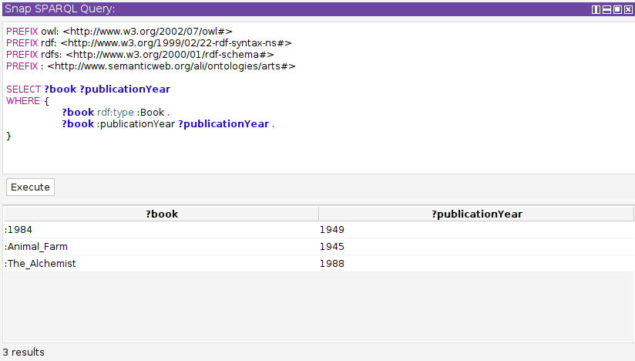

### Query

PREFIX owl: <http://www.w3.org/2002/07/owl#>

PREFIX rdf: <http://www.w3.org/1999/02/22-rdf-syntax-ns#>

PREFIX rdfs: <http://www.w3.org/2000/01/rdf-schema#>

PREFIX : <http://www.semanticweb.org/ali/ontologies/arts#>

SELECT ?book ?publicationYear

WHERE {

?book rdf:type :Book .

?book :publicationYear ?publicationYear .

}

## Query 3

List all paintings and their publication year.

### Results

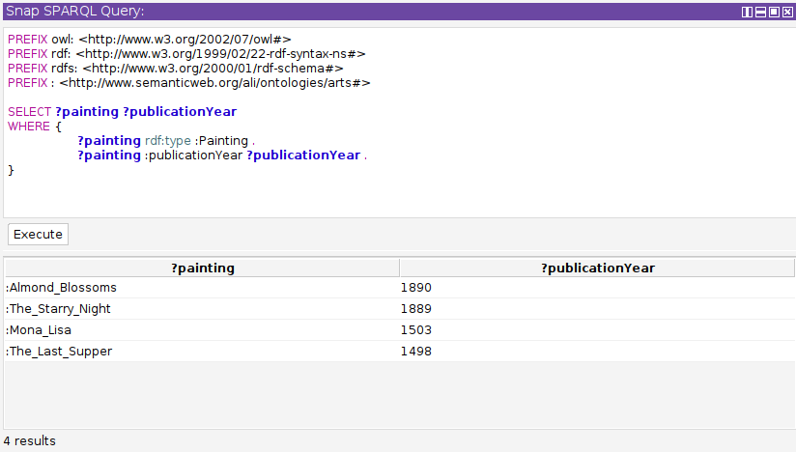

### Query

PREFIX owl: <http://www.w3.org/2002/07/owl#>

PREFIX rdf: <http://www.w3.org/1999/02/22-rdf-syntax-ns#>

PREFIX rdfs: <http://www.w3.org/2000/01/rdf-schema#>

PREFIX : <http://www.semanticweb.org/ali/ontologies/arts#>

SELECT ?painting ?publicationYear

WHERE {

?painting rdf:type :Painting .

?painting :publicationYear ?publicationYear .

}

## Query 4

List all books and paintings, their authors, and publication year.

### Results

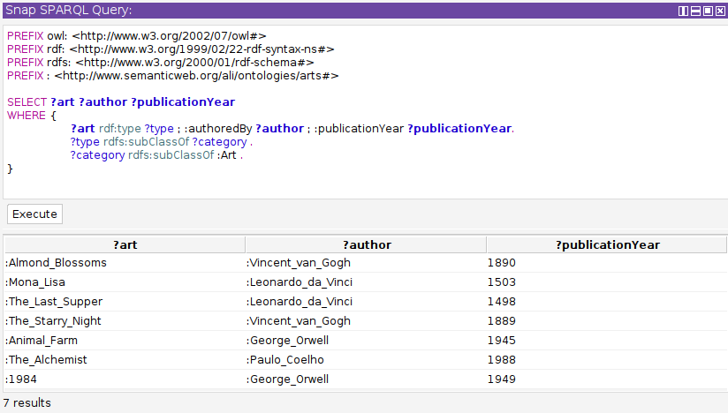

### Query

PREFIX owl: <http://www.w3.org/2002/07/owl#>

PREFIX rdf: <http://www.w3.org/1999/02/22-rdf-syntax-ns#>

PREFIX rdfs: <http://www.w3.org/2000/01/rdf-schema#>

PREFIX : <http://www.semanticweb.org/ali/ontologies/arts#>

SELECT ?art ?author ?publicationYear

WHERE {

?art rdf:type ?type ; :authoredBy ?author ; :publicationYear ?publicationYear.

?type rdfs:subClassOf ?category .

?category rdfs:subClassOf :Art .

}

## Query 5

List all authors that are born after the year 1500.

### Results

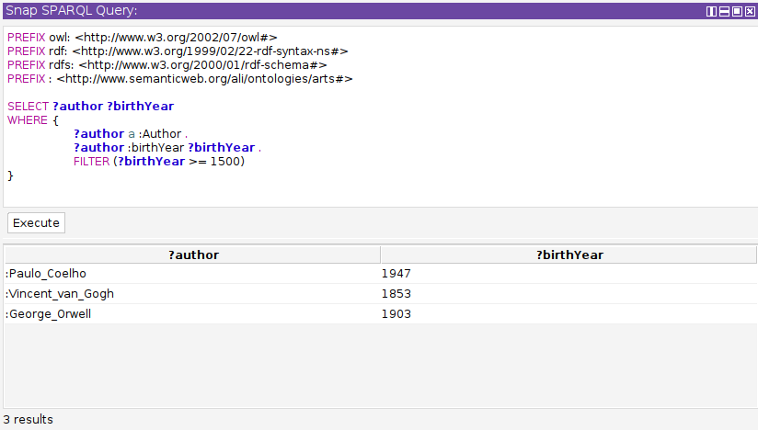

### Query

PREFIX owl: <http://www.w3.org/2002/07/owl#>

PREFIX rdf: <http://www.w3.org/1999/02/22-rdf-syntax-ns#>

PREFIX rdfs: <http://www.w3.org/2000/01/rdf-schema#>

PREFIX : <http://www.semanticweb.org/ali/ontologies/arts#>

SELECT ?author ?birthYear

WHERE {

?author a :Author .

?author :birthYear ?birthYear .

FILTER (?birthYear >= 1500)

}

# Desktop Application

# Web Application

