Barton C# DAL Component + REST API

Verification guide

# Setup

Please follow the Barton/docs/README.md to setup/run the application.

The DB will be the same as for the node js application, so please use InsiteGatewayAdminTool/README.md steps to setup and populate the DB.

# Verification

## Import the collection and environment from **docs** folder.

## Get All Tags

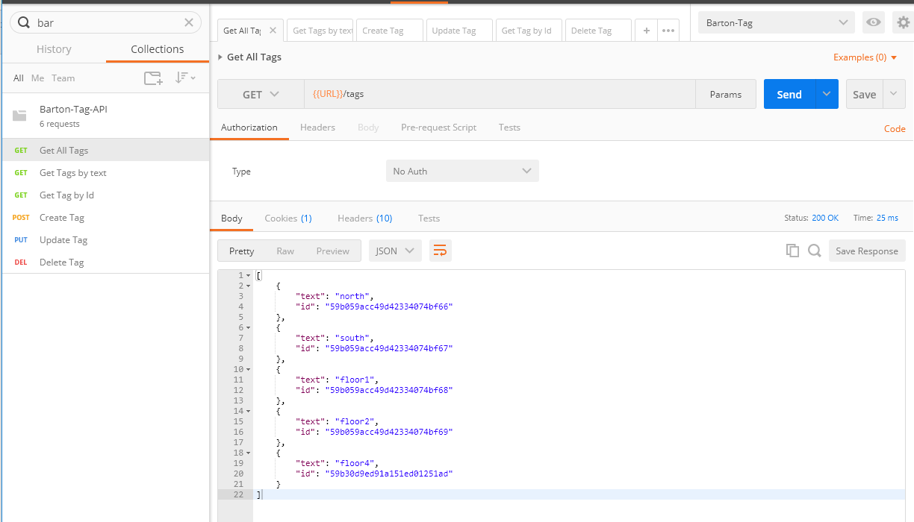

## Get Tags by text

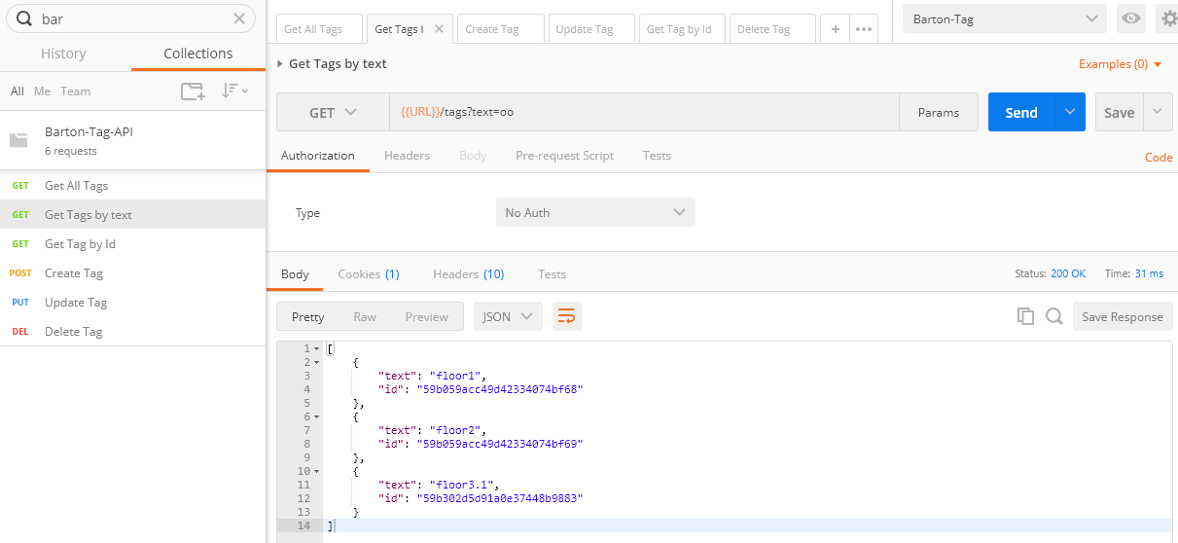

## Get Tag by Id:

Make sure the id exists (check it by Get All Tags)

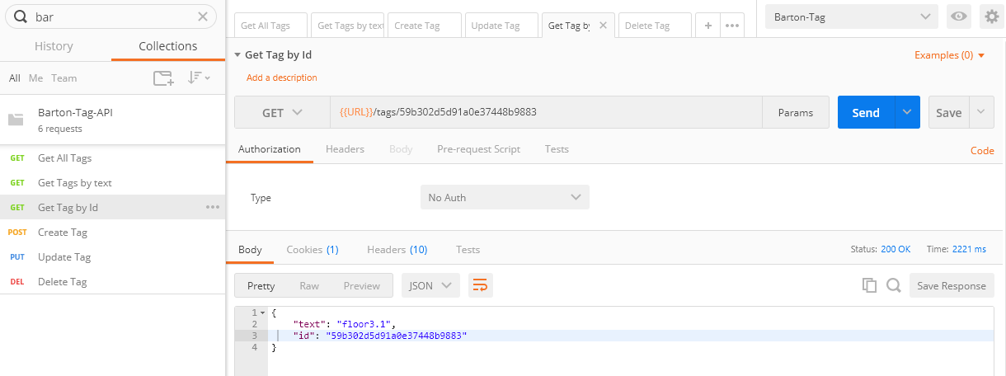

## Create Tag

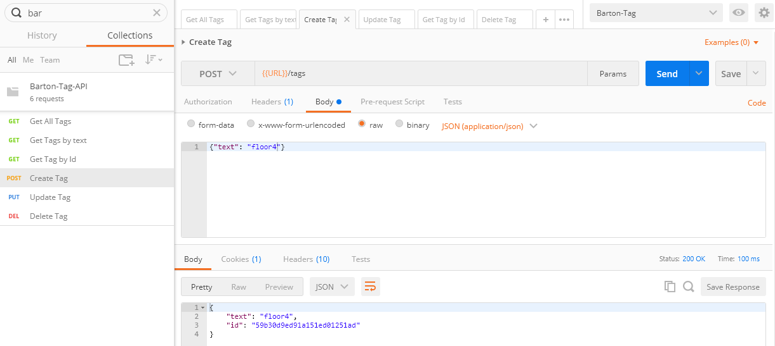

## Update Tag

Make sure the id exists (check it by Get All Tags)

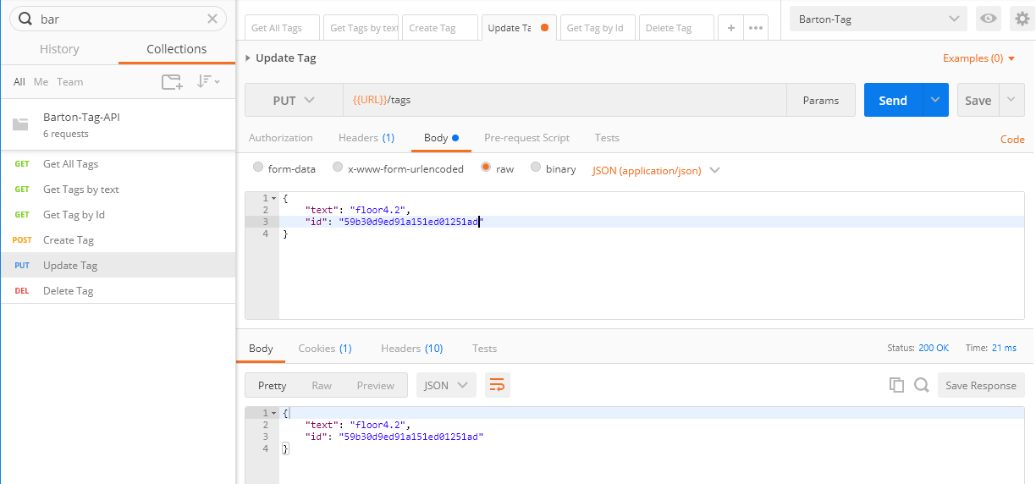

## Delete Tag

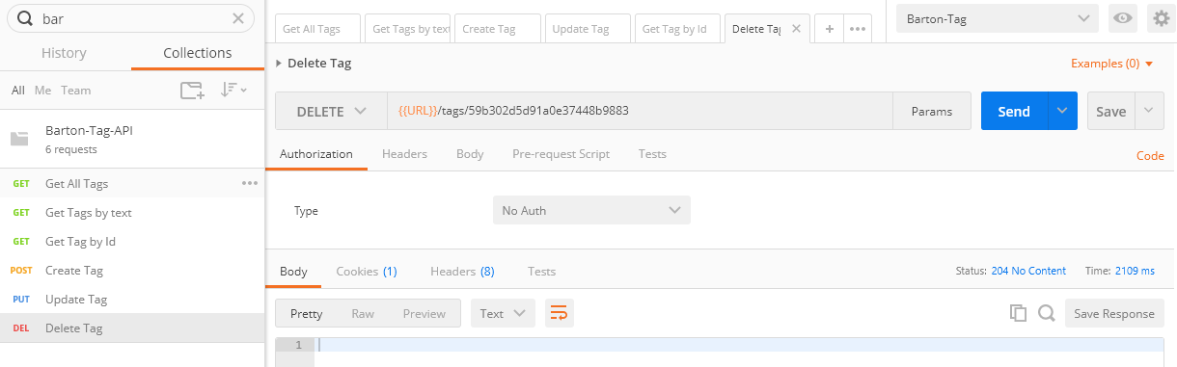

In case the ID was not found:  
