Republic of Iraq  Ministry of Higher Education and Scientiﬁc Research  University of Kufa  Faculty of Computer Science and Mathematics  Department of Computer Science |  | 
Understanding Computer Visual Display Technology

By
Ali Haider Hassan
Al-Hussein Ali Salah
Muntazeir Karar Hadi

Supervised by
Asst. Lect. Abbas Mohammed Ali

2026 A.D 1446 A.H
Table of Contents
1. Introduction 3
3. Historical Development of Display Devices 5
4. How a VDU Works (Simplified Explanation) 6
5. Main Types of Display Technologies 7
6. Specifications and Connectivity 8
1 6.1 Common Ports 8
7. Daily Life Applications 8
8. Ergonomics and Health Considerations 8
9. Future Trends 9
10. Conclusion 9
References 9

1. Introduction
A Visual Display Unit (VDU) is the main screen used to show information from a computer system. It is one of the most important output devices because it turns digital data into a form that humans can see and understand. In a typical computer system, users enter data using input devices such as the keyboard and mouse, and the system presents results to the user through output devices. In the course notes, output is described as information made available to the user via the display and the printer.
Today, VDUs exist in many forms: desktop monitors, laptop screens, tablets, smartphones, televisions, and display panels in vehicles and factories. Because modern life depends on visual information (text, images, video, and interactive interfaces), the VDU has become essential in education, business, engineering, and entertainment.

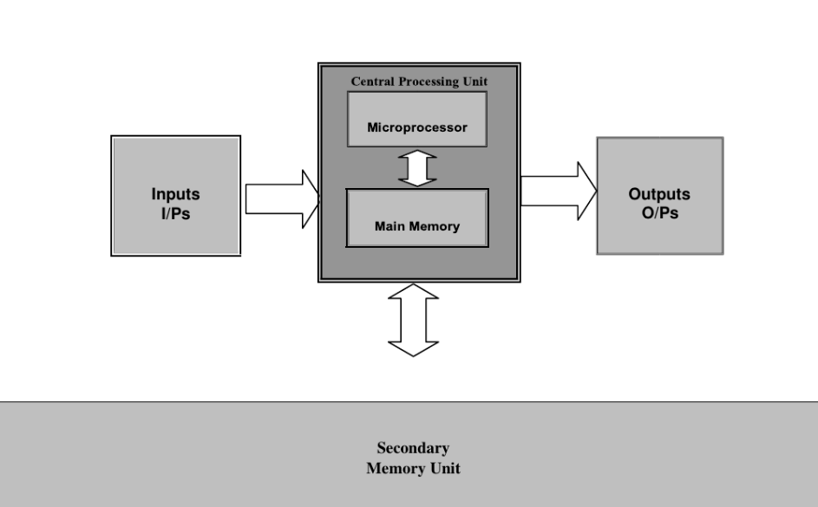
Figure 1. Computer system structure (inputs, processing, outputs, and memory).

The diagram shows the basic flow: inputs enter the system, the CPU and memory process the data, and outputs present the results. The VDU is the most direct output device because it can show results immediately, including numbers, text, and pictures.

2. Definition and Role of the VDU
Definition: A Visual Display Unit (VDU) is an electronic device that displays output from a computer or other digital system. It transforms electrical signals into visible light patterns so the user can read text, view images, and interact with software.
Role in the computer system:
- It provides human-readable output (text, numbers, images, video).
- It supports interaction with the operating system and applications.
- It helps with monitoring processes (programming, design, data analysis, and system control).
- In some devices, the screen is also an input device when it is touch-sensitive.

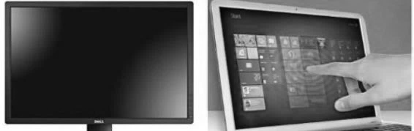
Figure 2. Examples of a monitor and a touch screen device.

The skills material explains that the screen transfers visual information such as texts, images, and videos to the user. It also notes that screens are separated in desktop computers but integrated in laptops and smart devices; some are touch-sensitive, so they can work as input and output.

3. Historical Development of Display Devices
The development of VDUs is connected to the development of computers. Early computers did not have modern graphical displays. Output was often printed on paper or shown using simple lights and indicators. Later, text terminals became common, allowing users to see characters on a screen.
A short timeline:
- 1950s–1970s: CRT (Cathode Ray Tube) technology was widely used for television and computer terminals. CRT displays are large and heavy, but they can show smooth motion.
- 1980s–1990s: Improved CRT monitors became standard in personal computers.
2000s: Flat-panel LCD monitors became popular because they are thin, light, and use less power.
- 2010s–today: LED-backlit LCD is the most common type. OLED and other advanced displays are used in phones and high-end devices.

In the course notes about computer generations, CRT-based technology appears among the hardware technologies of early generations, which shows that display-related technologies developed alongside other computer hardware improvements.

4. How a VDU Works (Simplified Explanation)
A display shows an image using many small points called pixels. Each pixel can produce light (or control light), and together the pixels form images and text. The computer’s graphics system (GPU or integrated graphics) prepares the image as a frame. Then the monitor refreshes the screen many times per second.
Basic steps:
- The application creates visual content (window, text, image, video).
- The operating system and GPU convert it into a frame (pixel values).
- The frame is sent to the monitor through a video interface (for example HDMI or DisplayPort).
- The monitor’s controller drives the panel to show the pixels on the screen.
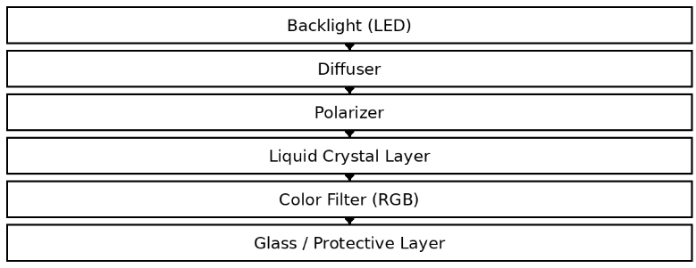

Figure 3. Simplified structure of an LCD/LED monitor.

For LCD/LED monitors, a backlight produces white light. The liquid crystal layer controls how much light passes for each pixel. A color filter creates red, green, and blue subpixels. By changing the intensity of each subpixel, the monitor produces full-color images.

5. Main Types of Display Technologies
VDUs can be classified by the display technology used to produce the image. The most common types are:
- CRT (Cathode Ray Tube): Uses an electron beam to hit phosphor on a glass screen. Pros: good motion. Cons: heavy and high power.
- LCD: Uses liquid crystal cells to control light from a backlight. Pros: thin and sharp text. Cons: viewing-angle and contrast limits in some models.
- LED Monitor: An LCD that uses LED backlight; it is the most common type today.
- OLED: Each pixel emits its own light. Cons: higher cost and possible burn-in.
- Touch Screens: Add a touch layer for direct interaction.

Technology | Thickness/Weight | Power Use | Image Quality | Common Uses
CRT | Thick / Heavy | High | Good motion | Old PCs
LCD/LED | Thin / Light | Low–Medium | Sharp text | Most monitors
OLED | Very thin | Medium | Excellent contrast | Phones, TVs

Choosing the best VDU depends on the purpose. For office work and programming, an lcd/led monitor with good resolution is usually enough. For gaming, a higher refresh rate can improve motion smoothness.

6. Specifications and Connectivity
To evaluate a VDU, we look at several specifications:
- Resolution: The number of pixels on the screen.
- Pixel density (PPI): Higher density gives sharper text and images.
- Color capability: How many colors and how accurate they are.
- Refresh rate (Hz): Updates per second.
- Brightness and contrast: Important for clear viewing in different lighting.
The skills material highlights resolution and color capability as important characteristics when discussing output quality, which are also essential for understanding display quality.

- 6.1 Common Ports
A VDU needs a connection to receive video (and sometimes audio). Common ports include HDMI, DisplayPort, VGA/DVI, and USB-C (Alt Mode).

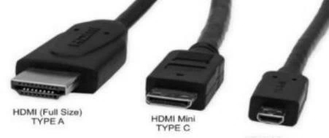
Figure 4. HDMI connector types.

7. Daily Life Applications
VDUs are used daily in education, business, communication, entertainment, engineering, medicine, and public services (ATMs and kiosks).

8. Ergonomics and Health Considerations
Long use of a screen can cause eye strain. Good practices: reduce reflections, keep a suitable distance, place the top of the screen near eye level, and take regular breaks (20-20-20 rule).

9. Future Trends
Future displays will likely focus on higher efficiency, better HDR, new technologies such as Micro LED, flexible screens, and immersive AR/VR displays.

10. Conclusion
The VDU is a key part of a computer system because it connects the machine to the user through visual output. From CRT to LCD/LED and OLED, displays have become thinner, clearer, and more interactive. Knowing the basic types, specifications, and ports helps users choose the right screen.

References
Abbas, M. A. (2024). University of Kufa. Kufa: Faculty of Computer Science and Mathematics.
Abd, S. S. (2024). University of Shatrah. Dhi Qar: Engineering college .


جمهورية العراق
وزارة التعليم العالي والبحث العلمي
جامعة الكوفة
كلية علوم الحاسوب والرياضيات
قسم علوم الحاسوب

فهم تقنية وحدة العرض في الحاسوب

اعداد
علي حيدر حسن
الحسين علي صالح
منتظر كرار هادي

بإشراف
م. د عباس محمد علي

1446 هجرية 2026 ميلادي

