1. Write an algorithm and draw the flowchart to read three numbers, then find the summation between them?

Sol:
Algorithm:

- Start
- Read: n1, n2, n3
- Print: (n1+n2+n3)
- End
Flowchart:
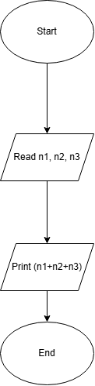

2. Write an algorithm and draw the flowchart to read three numbers, then find the smallest number between them?

Sol:
Algorithm:

- Start
- Declare: min
- Read: n1, n2, n3
- Set: min = n1
- If: (n2 < min) Then: min = n2
- If: (n3 < min) Then: min = n3
- Print: min
- End

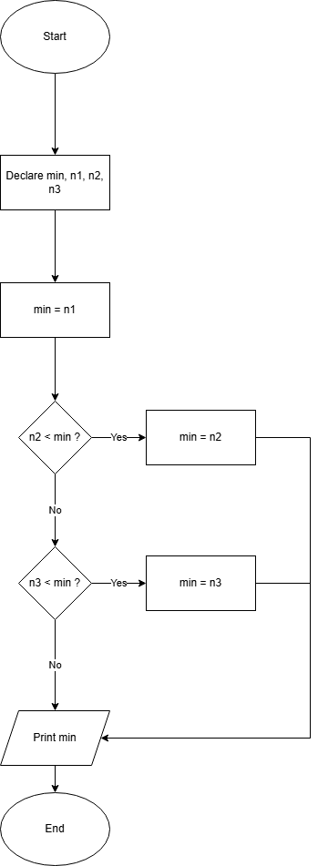
Flowchart:

3. Write an algorithm to calculate the value of Y from the following equation? Y = 1/(X ²- 81)

Sol:
Algorithm:

- Start
- Read: x
- Set: Y = 1/(X ²-81)
- Calculate: Y
- Print: Y
- End

Flowchart:
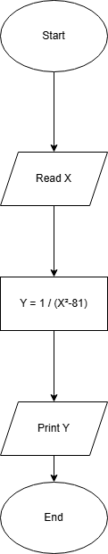

4. Write an algorithm to calculate the area of square?

Sol:
Algorithm:

- Start
- Read: x
- A = (x)(x)
- Calculate: A
- Print: A
- End

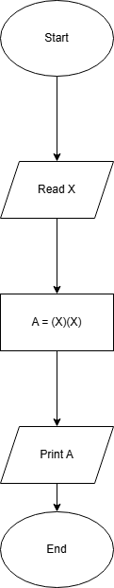
Flowchart:

5. Write an algorithm and draw the flowchart to find the odd and even number between (1-10)?

Sol:
Algorithm:

- Start
- Set: i = 1
- Decision: i <= 10
  - No: End
  - Yes:
    - Decision: i%2 == 0 ?
      - Yes: print i + “is even”
      - No: Print: i + “is odd”
    - Process: i = i+1
    - Go back to Decision: i <= 10

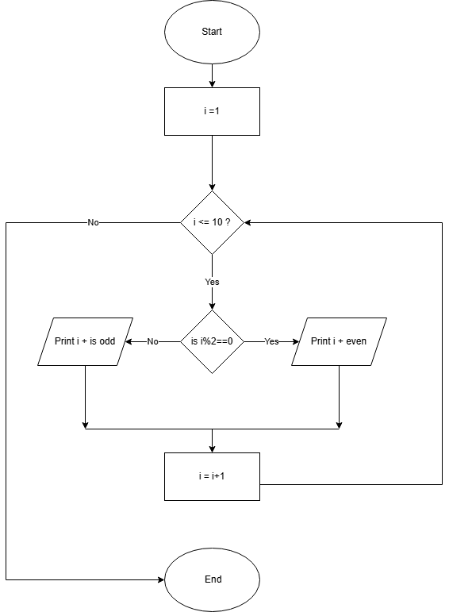
Flowchart:

