Republic of Iraq  Ministry of Higher Education and Scientiﬁc Research  University of Kufa  Faculty of Computer Science and Mathematics  Department of Computer Science |  | 
Insert Tab in Microsoft Word

By
Ali Haider Hasan

Supervised by
Asst. Lect. Tabark

2025 A.D 1446 A.H
Table of Contents
1. Introduction 3
2. Concept of the Insert Tab 3
3. Main Groups in the Insert Tab 4
3.1 Pages Group 4
3.2 Tables Group 5
3.3 Illustrations Group 6
3.4 Links Group 7
3.5 Header & Footer Group 7
3.6 Text Group 8
3.7 Symbols Group 9
4. Practical Importance of the Insert Tab 9
5. Conclusion 10
References 10

1. Introduction
Microsoft Word is one of the most widely used word processing applications. It allows users to create, edit, format, and design professional documents efficiently. Among its important features is the Insert Tab, which plays a major role in enriching documents with elements such as pages, tables, pictures, shapes, charts, text elements, and symbols.
This report explains the Insert Tab, its main groups, tools, and practical uses for students and professional document preparation.

2. Concept of the Insert Tab
The Insert Tab provides tools that allow users to add different objects to a document instead of using plain text only. These tools make documents more meaningful, structured, and visually clear. Through this tab, users can insert pages, tables, illustrations, links, headers and footers, text objects, and symbols. All these elements enhance document presentation and usability.
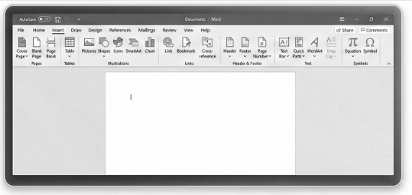
(Figure 1: Insert Tab Overview)

3. Main Groups in the Insert Tab

3.1 Pages Group
This group allows users to manage document pages. It includes:
- Cover Page: Adds a professional title page containing document name, author, date, and other information.
- Blank Page: Inserts an empty page in the document.
- Page Break: Starts a new section or page to control text flow.
These tools help in structuring reports and academic projects in an organized way.

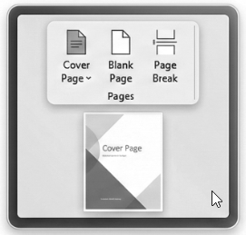
(Figure 2: Pages Group)

3.2 Tables Group
The Tables group helps users create structured data presentations inside documents.
Users can:
- Insert tables using grid selection.
- Draw custom tables.
- Add or delete rows and columns.
- Apply table styles and formatting (borders, shading, styles).
Tables are useful for schedules, data comparison, and organizing information clearly.

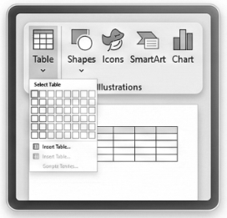
(Figure 3: Tables Group)

3.3 Illustrations Group
This group allows inserting visual content to support text understanding, including:
- Pictures: Insert images from the device.
- Online Pictures / Icons: Insert images from the internet or built-in icons.
- Shapes: Add arrows, boxes, flowchart shapes, etc.
- SmartArt: Insert diagrams to illustrate relationships or processes.
These elements make documents attractive and easier to understand.

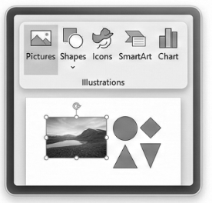
(Figure 4: Illustrations Group)

3.4 Links Group
This group allows the user to insert:
- Hyperlinks
- Cross References
Links help connect the document with external websites, email addresses, or internal document parts.

3.5 Header & Footer Group
This group is used to insert:
- Header: Information at the top of the page.
- Footer: Information at the bottom of the page.
- Page Numbering
These tools are essential in academic and official documents.
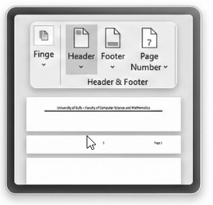
(Figure 5: Header & Footer Group)

3.6 Text Group
This group provides tools to insert different text elements such as:
- Text Box
- WordArt
- Drop Cap
- Signature Line
- Date & Time

These tools help highlight important parts and provide professional text styling.

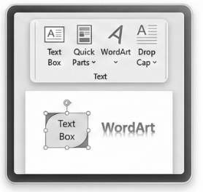
(Figure 6: Text Group)

3.7 Symbols Group
This group includes:
- Equation Tool for mathematical expressions.
- Symbol Tool for inserting special characters.
This is especially useful for scientific, engineering, and academic reports.
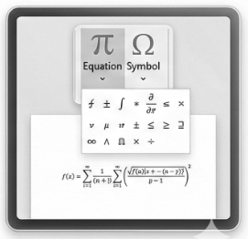
(Figure 7: Symbols Group)

4. Practical Importance of the Insert Tab
The Insert Tab is essential in:
- Preparing academic reports.
- Designing official documents.
- Creating visually rich assignments.
- Improving document readability and professionalism.
Without it, Word would remain just a plain typing tool without interactive and structured content.

5. Conclusion
The Insert Tab in Microsoft Word is a powerful feature that transforms plain text documents into professional, organized, and visually meaningful documents. By using its tools, students can enhance their academic work, improve clarity, and present information in a structured and attractive format. Mastering this tab is an important skill in computer literacy and academic document preparation.

References
Microsoft. (2013). Word 2013 Help and Training. Retrieved from Microsoft Support: https://support.microsoft.com
University of Kufa – Faculty of Computer Science and Mathematics. (n.d). Microsoft Word 2013 Practical Training Guide. Najaf: University of Kufa.

