Lecture # 4
Homework
Use print( ) with code to get the following output
Int A=20;
Int B=30;
Output: The result is: 50
package Lecture4;
public class sum_a_b_50_hw {
public static void main(String[] args) {
int A = 20;
int B = 30;
System.out.println("Display output with a & b integers");
System.out.print("The result is: " + (A + B));
}
}

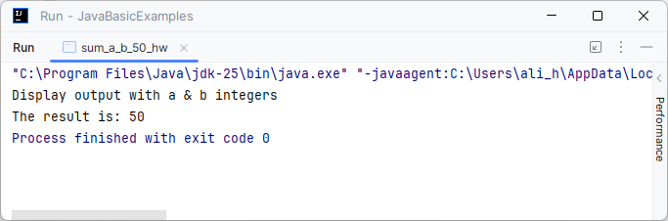

Lecture # 6
1. Write a program in Java to read four numbers from the user, then find the
summation between them?
package Lecture6;
import java.util.Scanner;
public class summation_four_numbers_hw {
public static void main(String[] args) {
int number, sum = 0;
String msg, invalid_input_msg;
Scanner input = new Scanner(System.in);
msg = "Enter an integer value for number ";
invalid_input_msg = "Invalid input! Please enter an integer.";
for (int i = 1; i <= 4; i++) {
System.out.print(msg + i + ": ");
while (!input.hasNextInt()){
System.out.println(invalid_input_msg);
input.next(); // discard invalid input
System.out.print(msg + i + ": ");
}
number = input.nextInt();
sum += number;
}
input.close();
System.out.println("The sum is: " + sum);
}
}

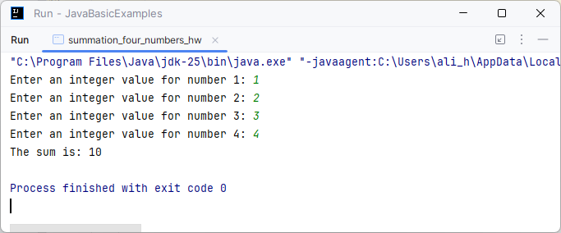

2. Write a program in Java to read four numbers from the user, then find the
largest number between them?
package Lecture6;
import java.util.Scanner;
public class LargestFourIntegersHW {
public static void main(String[] args) {
Scanner input = new Scanner(System.in);
String msg;
int number, largest_number = 0;
msg = "Enter a value for number ";
for (int i = 1; i <= 4; i++) {
System.out.print(msg + i + ": ");
number = input.nextInt();
if (number > largest_number)
largest_number = number;
}
input.close();
System.out.println("The largest number is " + largest_number);
}
}

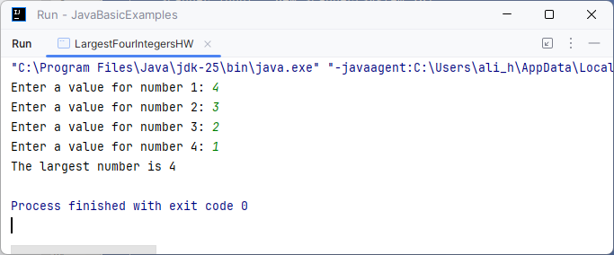

3. Write a program in Java to calculate the value of Y from the following
equation?
Y = 1/X ² – 81.
package Lecture6;
import java.util.Scanner;
public class CalculateValueOfYHW {
public static void main(String[] args) {
String program_name, input_msg, invalid_input_msg, result_msg;
float x, result;
Scanner input = new Scanner(System.in);
program_name = "Y=1/(X²-81)";
input_msg = "Enter a value for X: ";
System.out.println(program_name);
System.out.println();
System.out.print(input_msg);
x = input.nextFloat();
input.close();
result = 1 / ((x * x) - 81);
result_msg = "The Value of Y is: " + result;
System.out.println(result_msg);
}
}

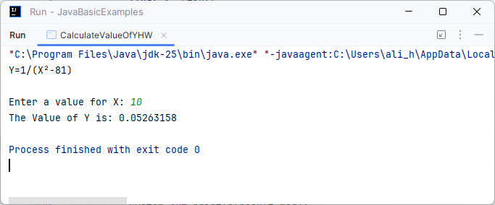

4. Write a program to print the student average as follows:
average >100 and average < 0 print “The average is out of range”
average >=0 and average < 50 print “The average is Fail”
average >=50 and average <= 59 print “The average is Accepted”
average >=60 and average <= 69 print “The average is Medium”
average >=70 and average <= 79 print “The average is Good”
average >=80 and average <= 89 print “The average is Very Good”
average >=90 and average <= 100 print “The average is Excellent”
package Lecture6;
import java.util.Scanner;
public class student_average_cal_hw {
public static void main(String[] args) {
Scanner input = new Scanner(System.in);
float student_average;
String msg;
System.out.print("Enter student average: ");
student_average = input.nextFloat();
input.close();
if (student_average < 0 || student_average > 100)
msg = "Out of Range";
else if (student_average >= 0 && student_average < 45)
msg = "Fail";
else if (student_average > 45 && student_average < 50)
msg = "Passed by carve";
else if (student_average >= 50 && student_average < 60)
msg = "Accepted";
else if (student_average >= 60 && student_average < 70)
msg = "Medium";
else if (student_average >= 70 && student_average < 80)
msg = "Good";
else if (student_average >= 80 && student_average < 90)
msg = "Very Good";
else if (student_average >= 90)
msg = "Excellent";
else
msg = "Invalid Input";
System.out.println("The Result of Your Average is: " + msg);
}
}

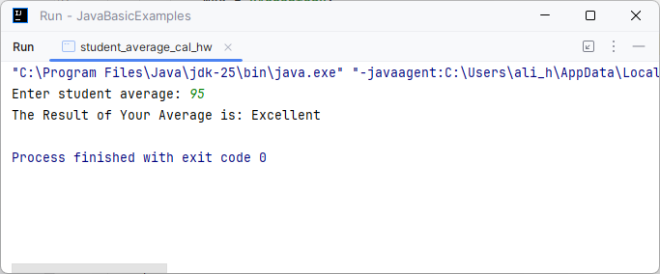

Lecture # 7
1. Write a program to print the student average as follows: using switch case statement:
average >100 and average < 0 print “The average is out of range”
average >=0 and average < 50 print “The average is Fail”
average >=50 and average <= 59 print “The average is Accepted”
average >=60 and average <= 69 print “The average is Medium”
average >=70 and average <= 79 print “The average is Good”
average >=80 and average <= 89 print “The average is Very Good”
average >=90 and average <= 100 print “The average is Excellent”
package Lecture7;
import java.util.Scanner;
public class StudentAverageFinderSwitch {
public static void main(String[] args) {
Scanner input = new Scanner(System.in);
System.out.print("Enter Student Average: ");
int student_average = input.nextInt();
input.close();
if (student_average < 0 || student_average > 100) {
System.out.println("Out of Range");
return;
}
String result = switch (student_average / 10) {
case 10 -> "Excellent";
case 9 -> "Excellent";
case 8 -> "Very Good";
case 7 -> "Good";
case 6 -> "Medium";
case 5 -> "Accepted";
default -> "Fail";
};
System.out.println("The Average is " + result);
}
}

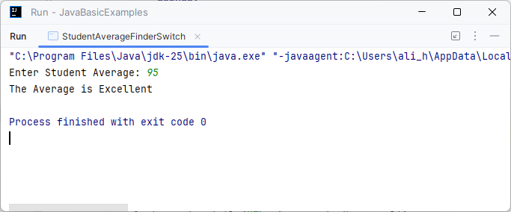

2. Write a program in Java to read number a month of the year, then print the
name of the month?
package Lecture7;
import java.util.Scanner;
public class NameOfMonthSwitchHW {
public static void main(String[] args) {
Scanner input = new Scanner(System.in);
System.out.print("Enter Month number in the year: ");
int month = input.nextInt();
input.close();
String monthName = switch (month) {
case 1 -> "January";
case 2 -> "February";
case 3 -> "March";
case 4 -> "April";
case 5 -> "May";
case 6 -> "June";
case 7 -> "July";
case 8 -> "August";
case 9 -> "September";
case 10 -> "October";
case 11 -> "November";
case 12 -> "December";
default -> "Invalid";
};
System.out.println("The name of the month is: " + monthName);
}
}

