21F-9288

Ali Hassan

6E

Task#1

<!DOCTYPE html>

<html>

<head>

<title>First Page</title>

</head>

<body>

<h1>Ali Hassan</h1>

<h1>21F-9288</h1>

<p>My name is Ali Hassan and I study in Fast CFD Campus and I am doing Web Developing Lab </p>

</body>

</html>

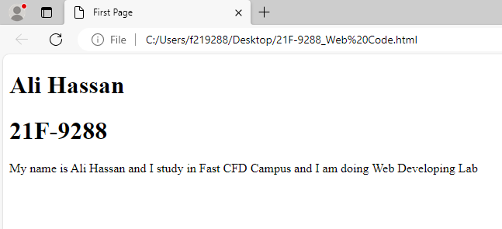

Task#2

<!DOCTYPE html>

<html>

<body>

<p style="font-size:25px"><b>The text is Bold</b>.</p>

<p style="font-size:25px"><strong>The text is strong</strong></p>

<p style="font-size: 40px;">This Text is big</p>

<p style="font-size: 25px;"><i>This Text Is Italic</i></p>

<p style="font-size: 25px;"><em>This Text Is Emphsized</em></p>

<p style="font-size: 25px;"><code>This is computer output</code></p>

<p style="font-size: 25px;">This Is <sub>Subscript</sub> and <sup>Superscript</sup></p>

</body>

</html>

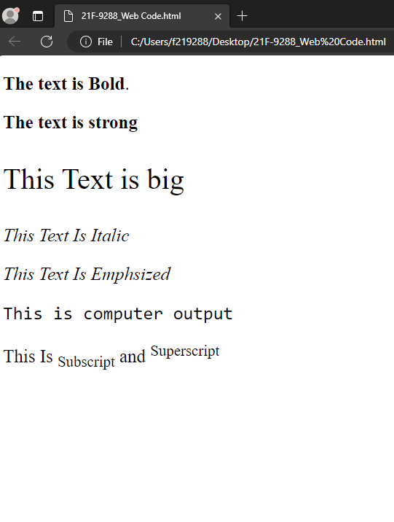

Task#3

<!DOCTYPE html>

<html>

<body>

    <img src="download.png" alt="Fast NU Logo" width="500" height="500">

</body>

</html>



Task#4

<!DOCTYPE html>

<html>

<body>

    <a href="https://www.nu.edu.pk/" target="https://www.nu.edu.pk/"><img src="download.png" alt="Fast NU Logo" width="500" height="500"></a>

</body>

</html>

 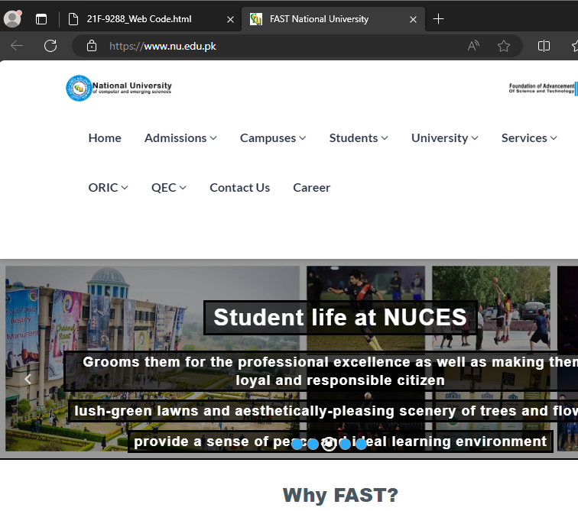

Task#5

<!DOCTYPE html>

<html>

<body>

<h1>Unordered List</h1>

<h2>We Have books on variety of languages</h2>

<ul>

  <li>Oracle</li>

  <li>Java</li>

  <li>Html</li>

  <li>CSS</li>

</ul>

<h1>Ordered List</h1>

<h2>Follow these steps to install Java</h2>

<ol>

  <li>Download the software</li>

  <li>Extract to a folder</li>

  <li>Double click the executeable to run</li>

</ol>

</body>

</html>

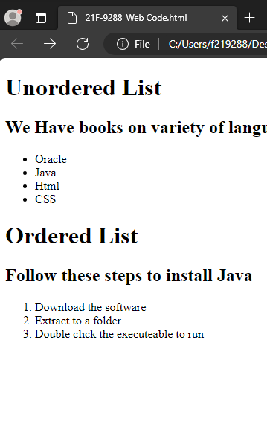

Task#6

Task#7

Task#8

<!DOCTYPE html>

<html>

<body>

<form action>

  <label for="username">Username:</label><br>

  <input type="text" id="username" name="username"><br>

  <label for="pwd">Password:</label><br>

  <input type="password" id="pwd" name="pwd"><br><br>

  <input type="submit">

  <input type="Reset">

</form>

</body>

</html>

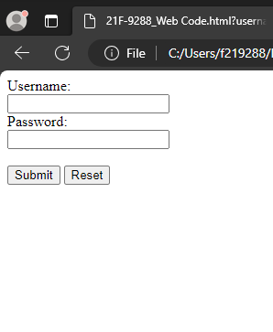

Task#9