LAB 1 RTL WITH VERILOG
Name: Ali Irfan
Roll No: 22FA-036-CE

Question 1) Demux 1:4
Design code:
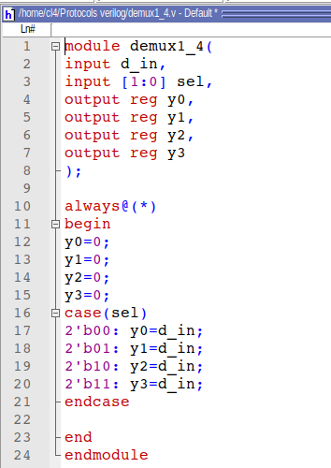

Testbench code:
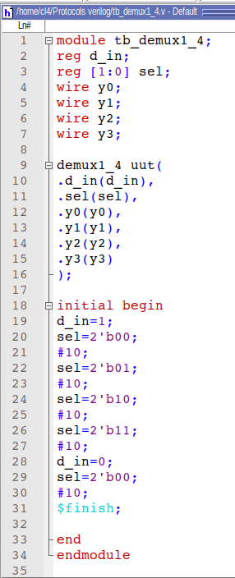

QuestaSim Waveform:

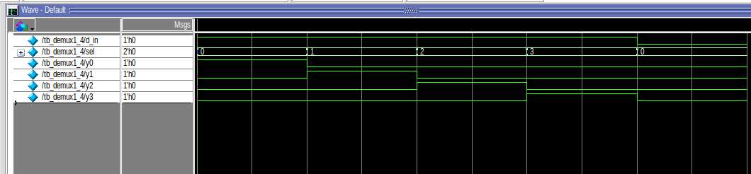
FPGA Commands:
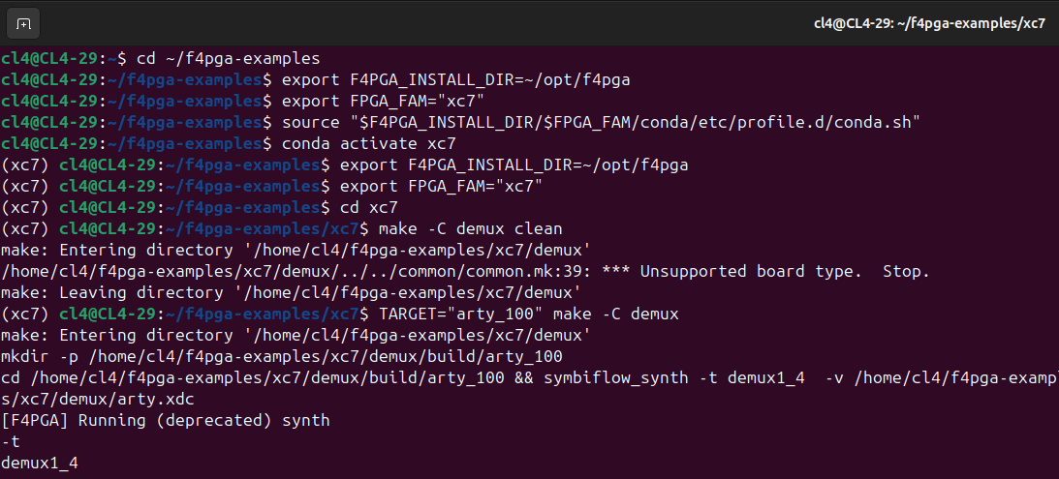

Question 2) Decoder 2:4
Design code:
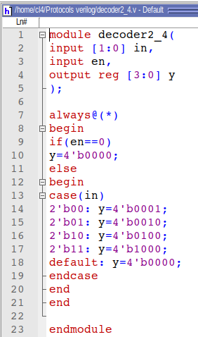

Testbench code:
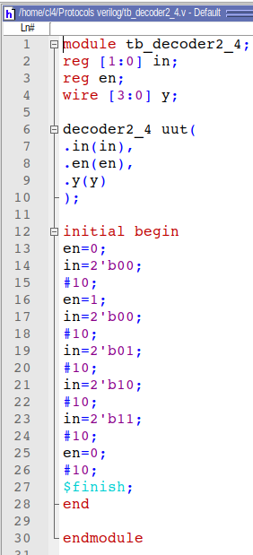

QuestaSim Waveform:

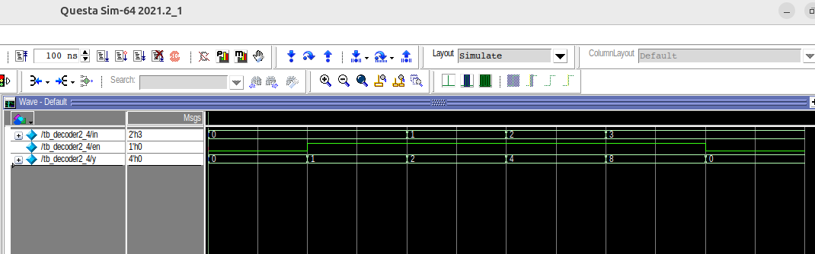
FPGA Commands:
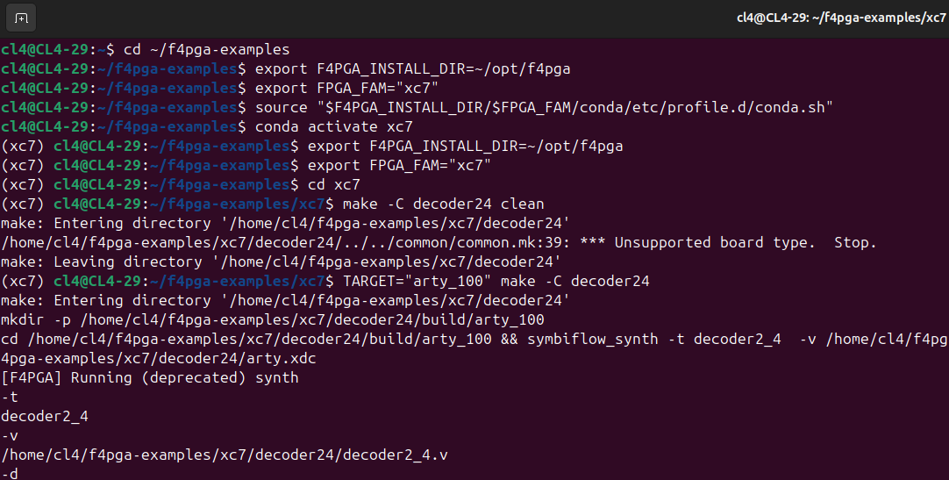

Question 2) Decoder 3:8
Design code:
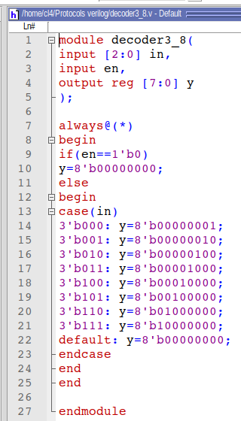

Testbench code:
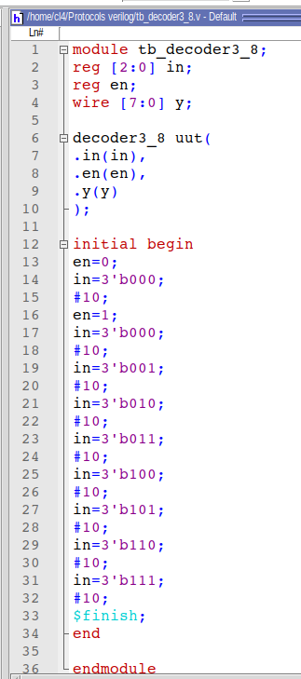

QuestaSim Waveform:

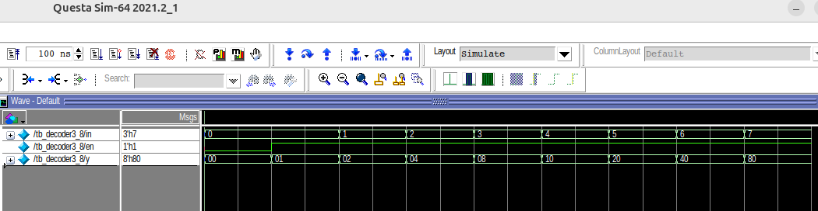
FPGA Commands:
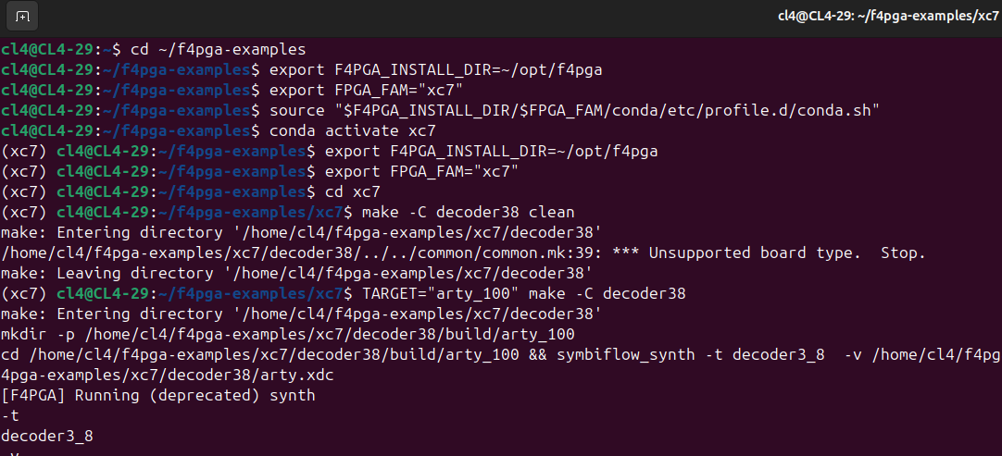

Question 3) Encoder 4:2
Design code:
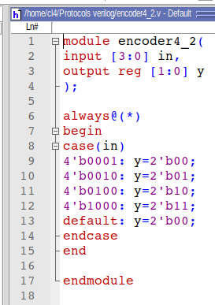
Testbench code:
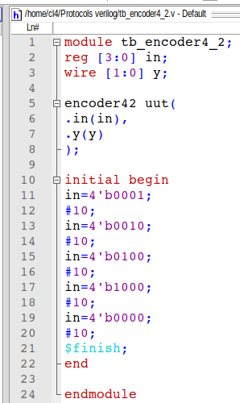
QuestaSim Waveform:

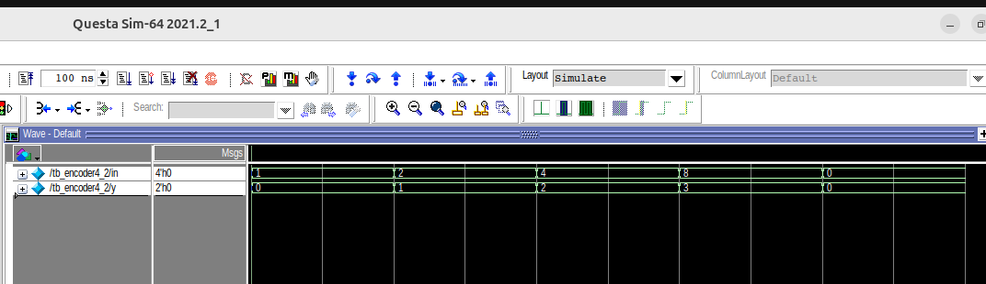
FPGA Commands:
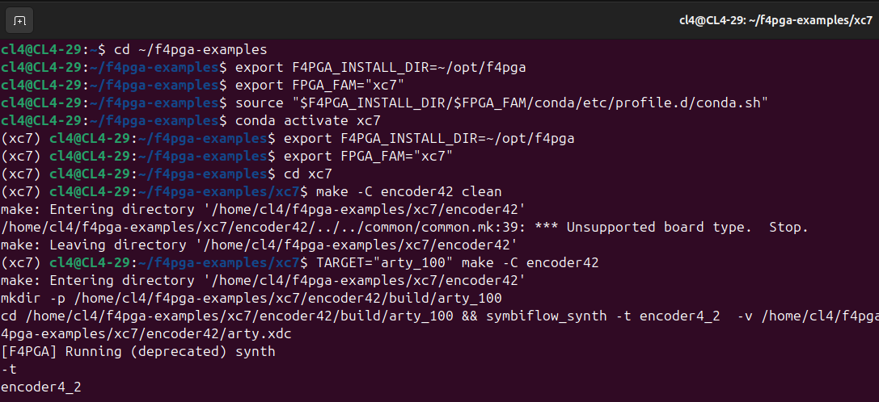

Question 3) Priority Encoder 4:2
Design code:
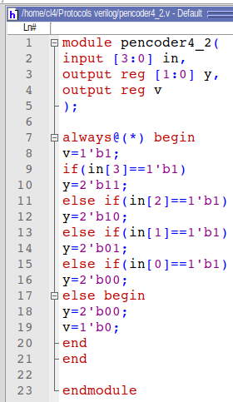

Testbench code:
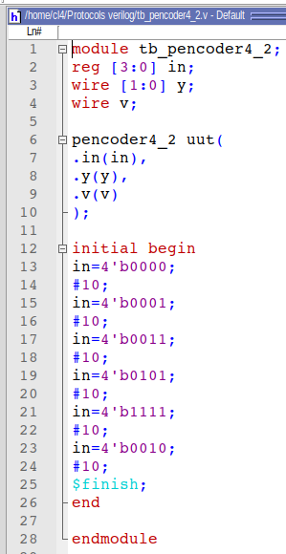
QuestaSim Waveform:

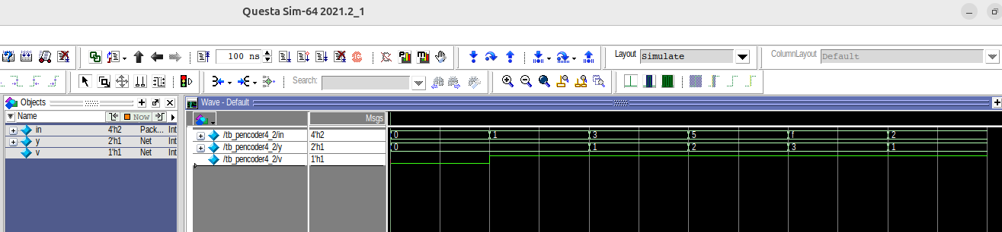

FPGA Commands:

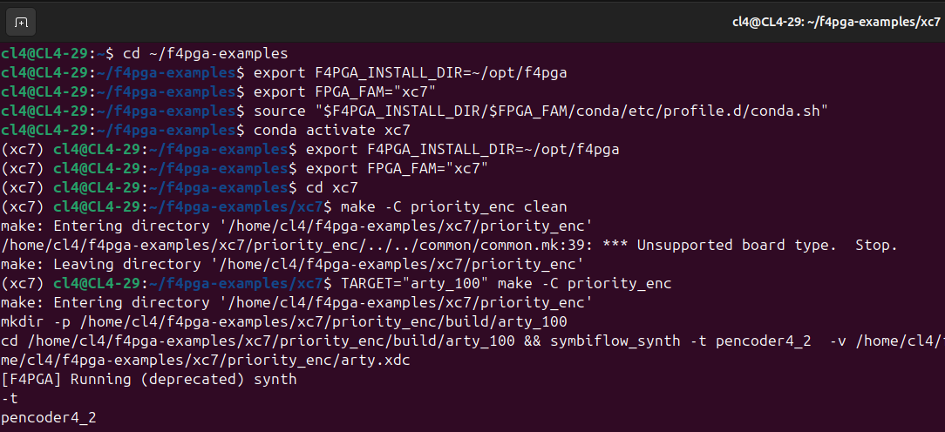

Question 4) Comparator
Design code:
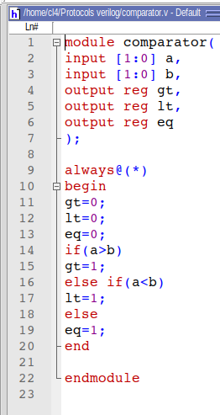

Testbench code:
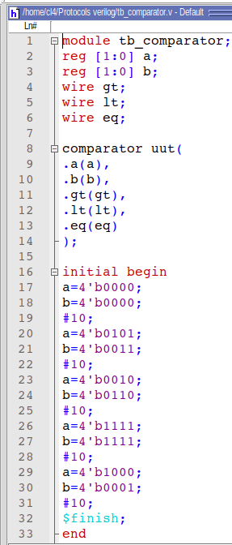

QuestaSim Waveform:

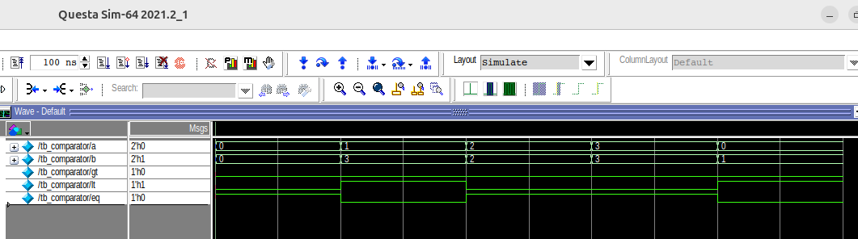

FPGA Commands:

