LAB 2 RTL WITH VERILOG
Name: Ali Irfan
Roll No: 22FA-036-CE

Question 1) JK Flip-Flop with synchronous reset
Design code:
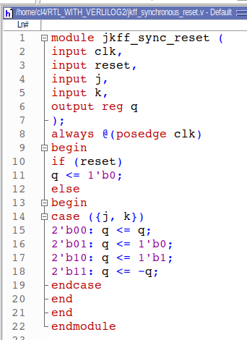

Testbench code:
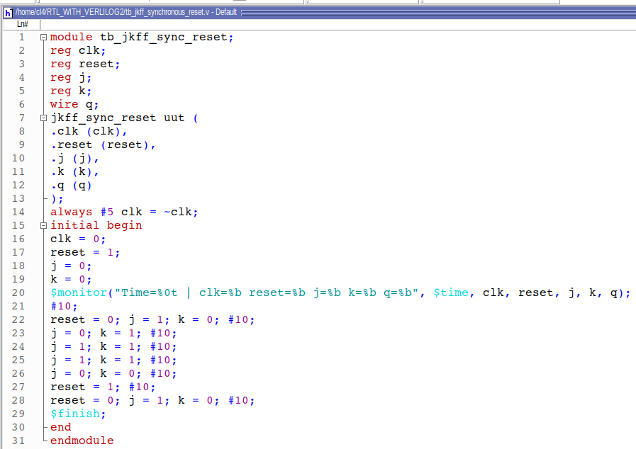

QuestaSim Waveform:

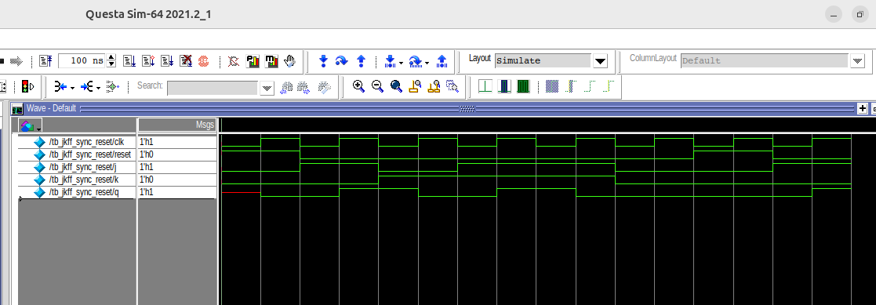

FPGA Commands:
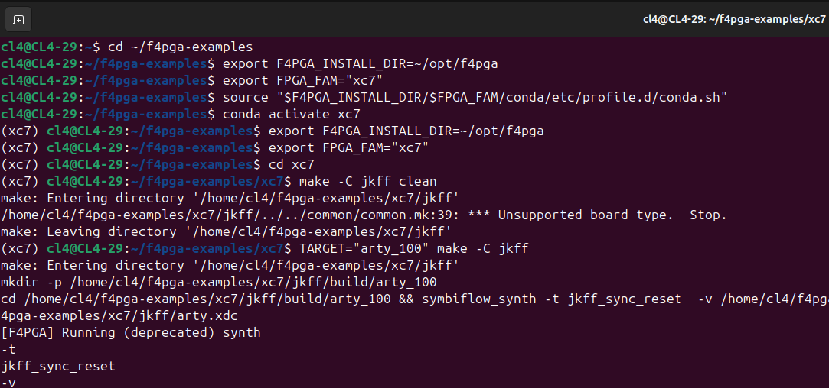

Question 2) T Flip-Flop with asynchronous reset
Design code:
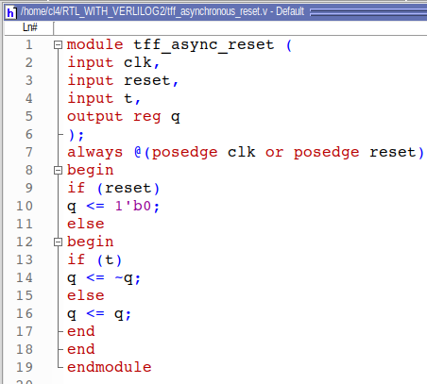

Testbench code:
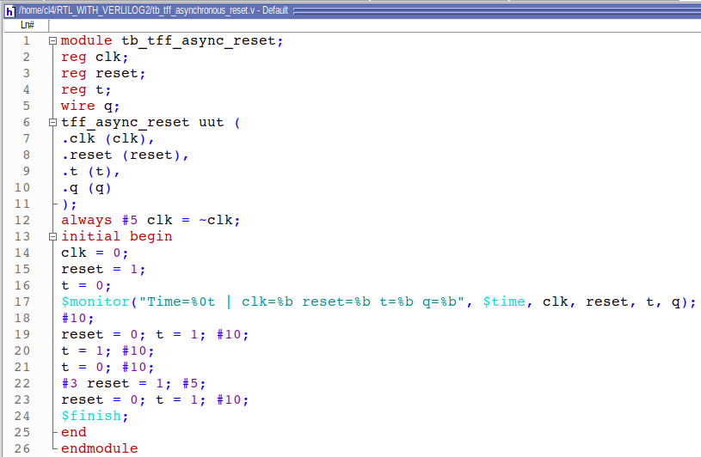

QuestaSim Waveform:

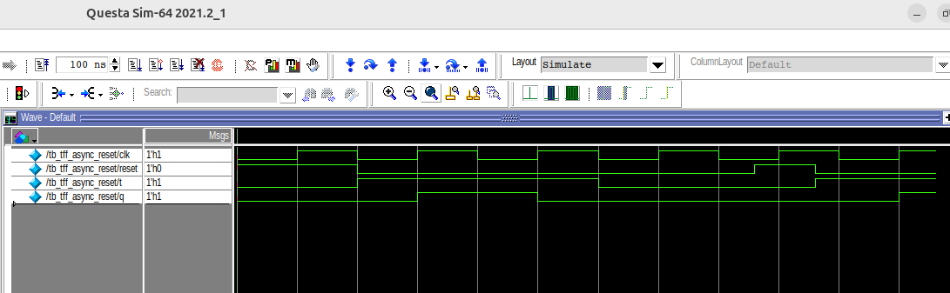

FPGA Commands:
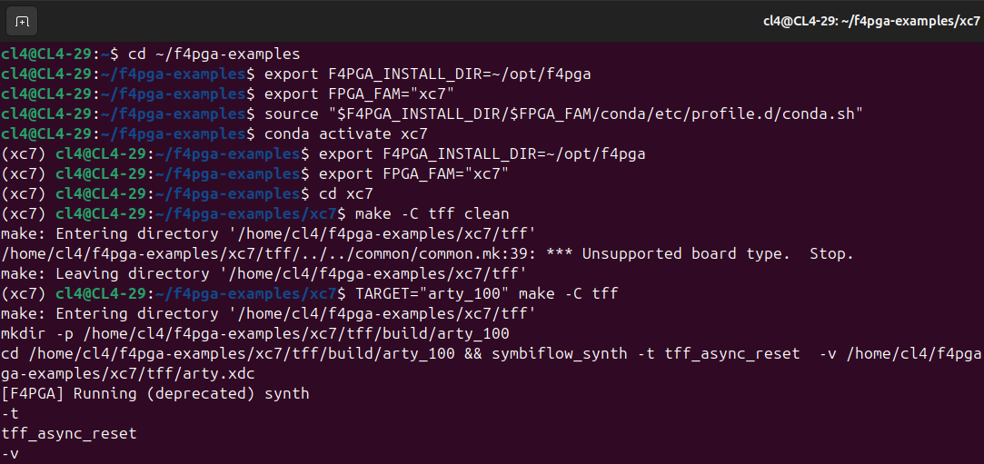

Question 3) 8-bit Shift Register with parallel load and enable.
Design code:
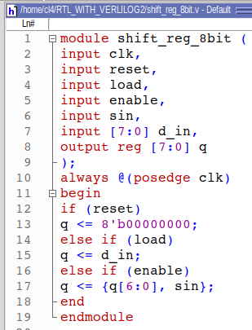

Testbench code:
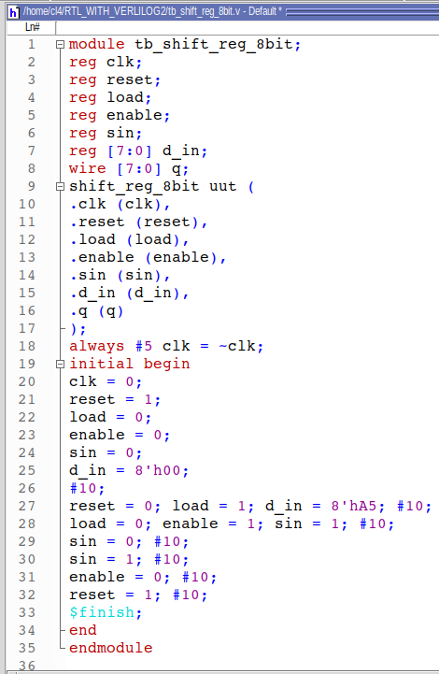

QuestaSim Waveform:
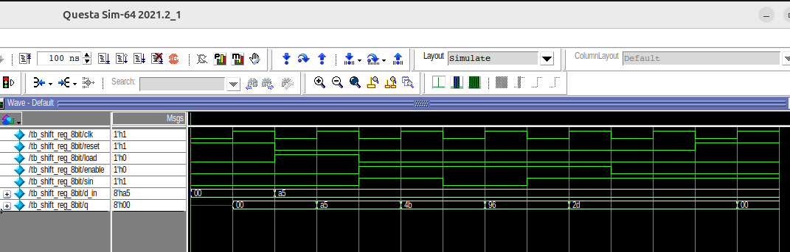
FPGA Commands:
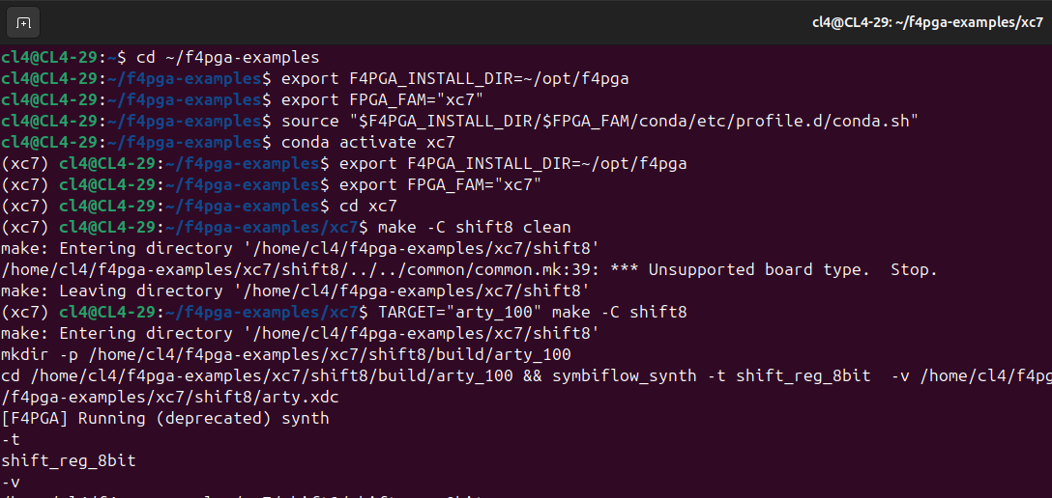

Question 4) 4-bit Up/Down Counter
Design code:
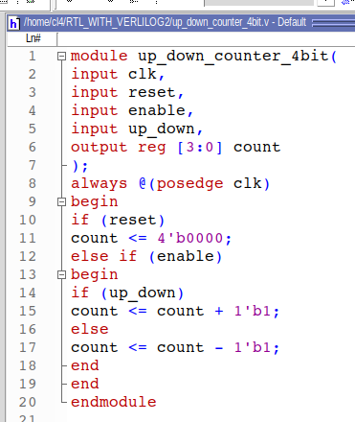
Testbench code:
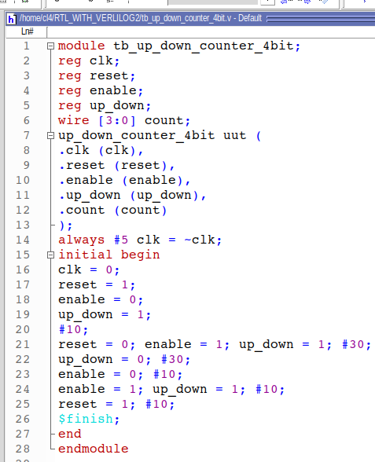
QuestaSim Waveform:

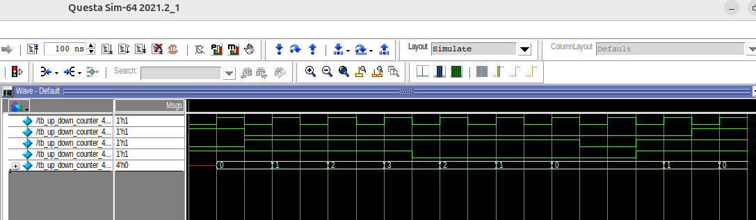

FPGA Commands:
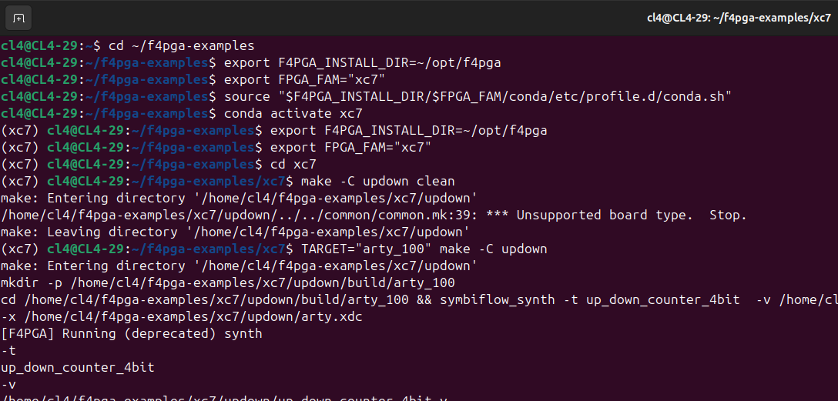

Question 5) Modified 32-bit ALU
Design code:
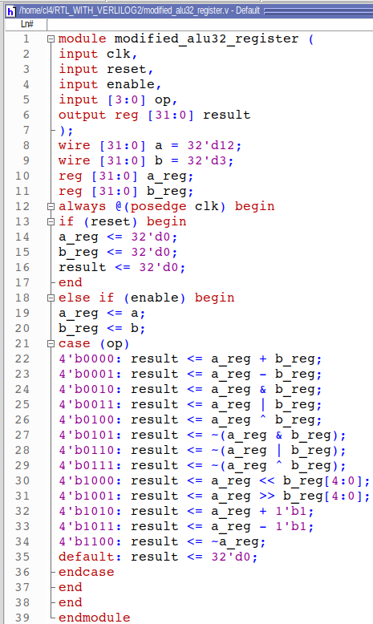
Testbench code:
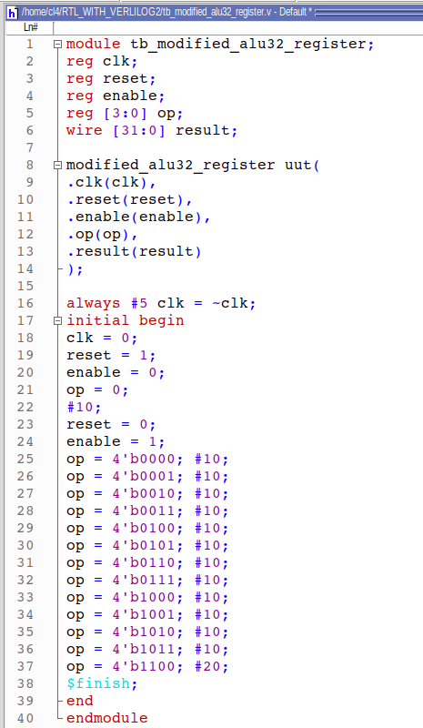

QuestaSim Waveform:

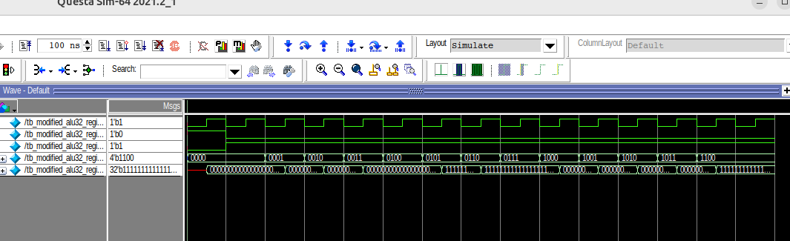

FPGA Commands:

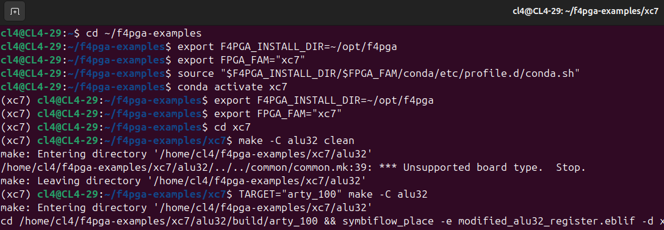

Question 6) Modified 32-bit Pipelined Multiplier
Design code:
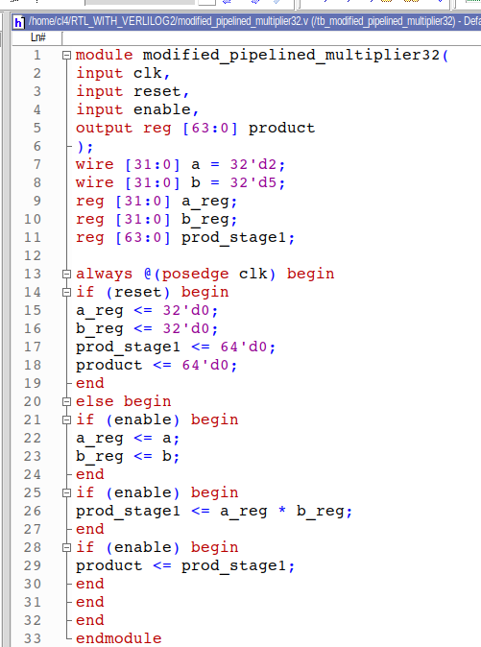

Testbench code:
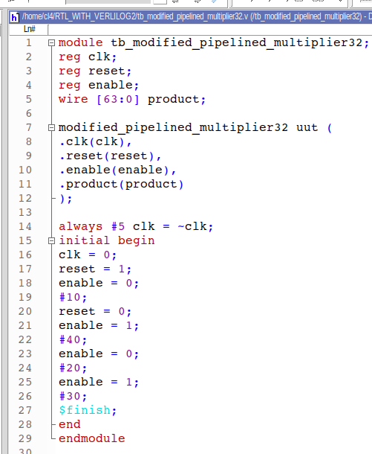

QuestaSim Waveform:

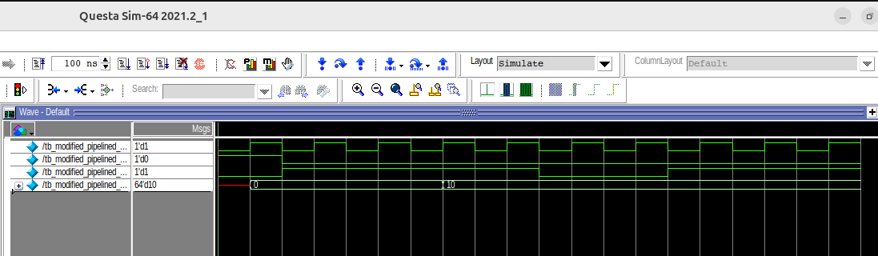

FPGA Commands:

