**Unit Two: Caring for Ourselves**

**Lesson 8: Cleanliness and Hygiene**

Name: __________________________________ Date: _______________________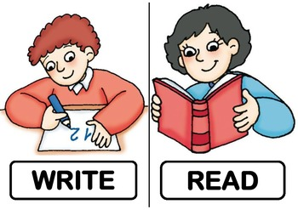

* **Look at these pictures. Write the command in the space provided.**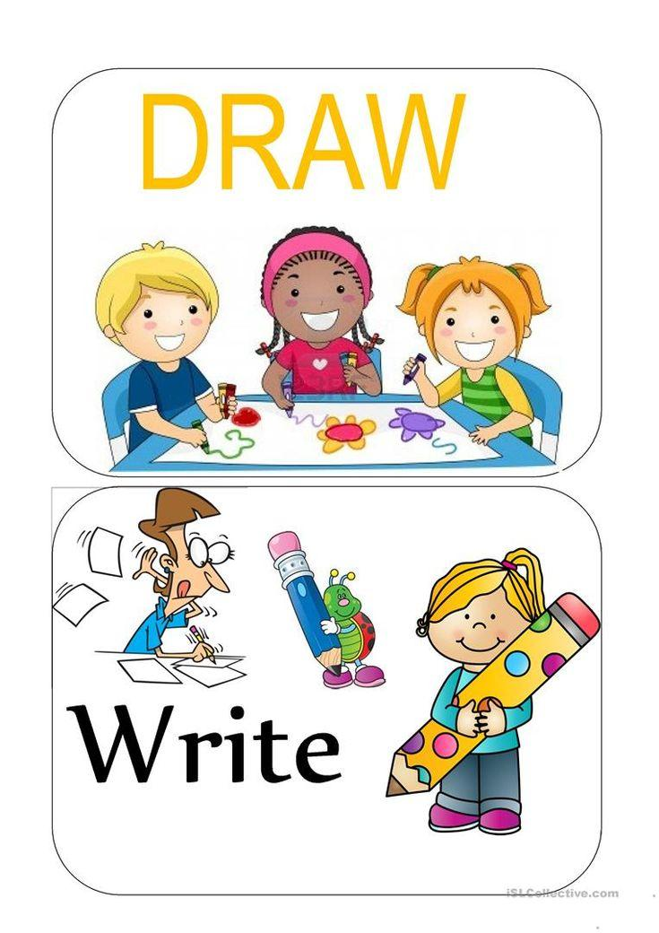

____________________________________ ___________________________________

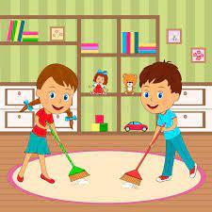

______________________________________ ___________________________________

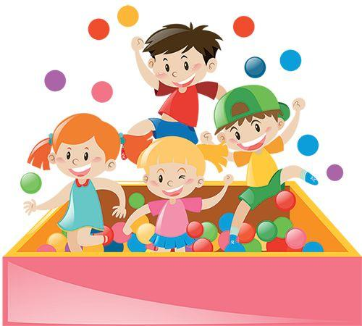

____________________________________ _____________________________________

Name: ____________________________________ Date: ____________________

1. **Read the words in the box. Write the words that begin with soft C in the left column and the words that begin with hard C in the right column*.***

| cinnamon | cake | carrot | cereal | cup |
| --- | --- | --- | --- | --- |
| corn | circus | celery | caterpillar | crab |
| cent | city | car | certain | candy |
| cell | care | cycle | cinema | close |

| **Words with Soft C** | **Words with Hard C** |
| --- | --- |
|  |  |
|  |  |
|  |  |
|  |  |
|  |  |
|  |  |
|  |  |
|  |  |
|  |  |
|  |  |

1. **Now, read the words in the word box and circle the hard G words and underline the soft G words.**

| germ | gum | ginger | good | go | great | giant |
| --- | --- | --- | --- | --- | --- | --- |
| giraffe | garden | gentle | gel | gym | glue | gun |

Name: ____________________________________ Date: ____________________

1. **Label each sentence as a *statement*, *command*, *exclamatory*, or *question.***
2. We are going on a picnic today. _______________________
3. Where do you like to go on a vacation? _______________________
4. This castle is wonderful! _______________________
5. Close the door when you leave the room. _______________________
6. Does your mom bake a cake? _______________________
7. What a great man he is! _______________________
8. Please, clean up your room. _______________________
9. Wash your hands after you eat. _______________________
10. It is cool outside! _______________________
11. They will be happy for you. _______________________
12. **Write 4 types of sentences on the topic of *hygiene*.**
13. Statement: ________________________________________________________
14. Command: ________________________________________________________
15. Question: _________________________________________________________
16. Exclamatory: ______________________________________________________